Artificial Intelligence – Final Project

Week 3 Report
Data Preparation & Modeling Approach
Real-time Sign Language Alphabet Recognition Web App
Item | Details
Group | …
Members | …
Tutor | …
Dataset | Sign Language MNIST (Kaggle) – 24 static ASL letters
Repository | https://github.com/… (fill in)
Date | …

1. Executive Summary
This week we built the full data pipeline for the project and trained five baseline models on Sign Language MNIST (28×28 grayscale hand images, 24 static ASL letters). The baselines give the target the Week 4 deep-learning model must beat.
- Data pipeline: quality review, cleaning, label remapping, scaling, a leakage-free train/validation split, HOG features and data augmentation.
- Key finding: a normal random validation split leaks near-duplicate images. Every model scored ≈100% on validation but only 70–91% on the test set. A group-based split fixes this; validation now tracks test within 2–8 points.
- Best baseline: MLP on HOG features, 90.6% test accuracy, 0.899 macro-F1 (9.4% error rate). Hand-crafted shape features add about 15 points over raw pixels, which motivates a CNN.
- Main errors: visually similar hand shapes – N→S (15.8%), V→W (15.3%), U→K (13.2%).
- Week 4: train the CNN with augmentation, tune it on the group validation split, and start the MediaPipe-landmark model for the web app.

2. Weekly Status
Fields marked “…” are to be completed by the team before the presentation.
Item | This week
What | Data preprocessing pipeline, leakage-free validation split, five baseline models, model-selection justification
When | Pipeline and baselines completed in Week 3; CNN training scheduled for Week 4
Why | Baselines set the bar the deep-learning model must beat; the pipeline is reused by every later model
Who | … (member → task)
How much | … planned hours vs. hours spent, the gap, and the action taken
Top risks | Validation leakage (found and fixed, Section 4); domain gap between Kaggle images and real webcam frames
Major changes | Validation split changed from random to group-based
Key issues | CNN not yet benchmarked; MediaPipe landmark dataset still to be built

3. Data Preprocessing Pipeline
The pipeline is implemented in src/data.py and runs end-to-end with one command. All randomness is seeded (seed = 42).
Stage | What it does
1. Load | Read the two Kaggle CSV files (label + 784 pixel columns)
2. Quality checks | Missing values, duplicates, label range, class balance, pixel range
3. Cleaning | Drop NaN rows, duplicate rows and out-of-range labels
4. Transformation | Remap labels 0..25 (without 9 and 25) to 0..23; scale pixels to [0, 1]; reshape to 28×28
5. Split | Group-based stratified train/validation split; official test set kept aside
6. Features / augmentation | Raw pixels or HOG for baselines; random augmentation for the CNN

3.1 Data Quality Review
Check | Result
Size | Train 27,455 images · Test 7,172 images · 784 pixels + label
Missing values | 0 in train and test
Exact duplicates | 0 within train, 0 within test, 0 shared between train and test
Labels | 24 classes; J (9) and Z (25) absent by design because they require motion
Pixel range | 0–255 (valid)
Class balance (train) | 957 (E) to 1,294 (R) per letter – max/min ratio 1.35, mildly imbalanced
Class balance (test) | 144 (R) to 498 (E) – distribution differs from train, so macro-F1 is reported alongside accuracy
Hidden issue | Near-duplicate images: the training set was created by augmenting ~1,704 original photos (Section 4)
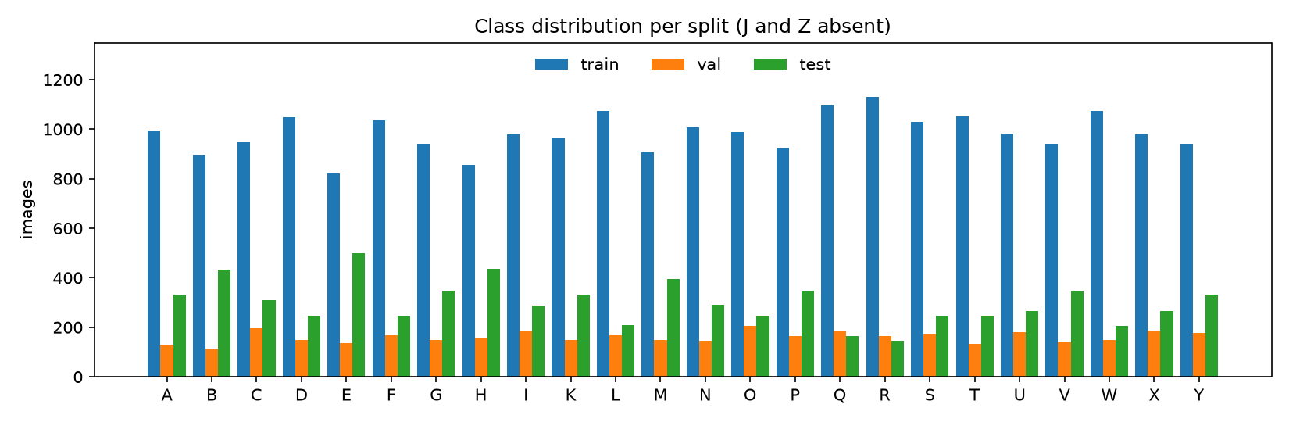
Figure 1. Number of images per letter in the train, validation and test splits.
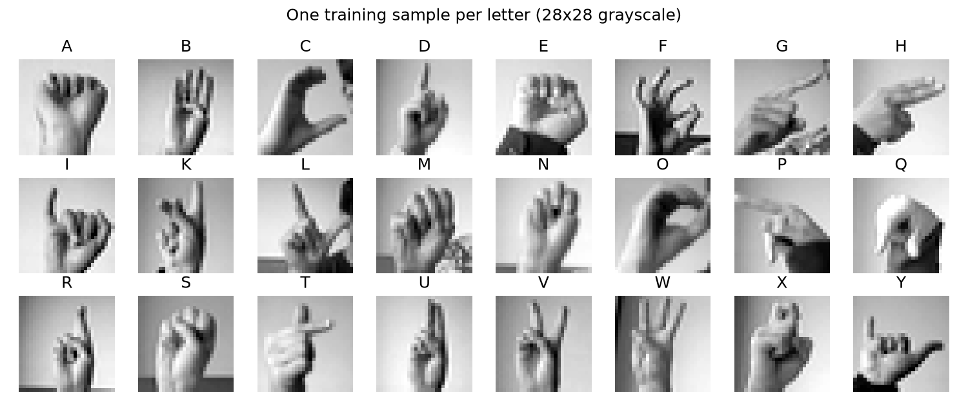
Figure 2. One training image per letter (28×28 grayscale).

3.2 Cleaning and Transformation
- The dataset has no missing values or duplicates, but the pipeline still removes them so it stays safe if the data source changes.
- Labels are remapped to contiguous indices 0..23, which the softmax output layer requires.
- Pixels are scaled to [0, 1]. Models that need standardisation compute the per-pixel mean and standard deviation on the training split only, to avoid leaking information from validation or test.

3.3 Splitting Strategy
Split | Images | Use
Train | 23,607 | Fitting the models
Validation | 3,848 | Model selection and hyperparameter tuning (group-based, Section 4)
Test (official) | 7,172 | Final reporting only – never used to choose a model

3.4 Feature Engineering
Feature set | Dimension | Rationale
Raw pixels | 784 | Simplest input; reference point
HOG (9 orientations, 4×4 cells, 2×2 blocks) | 1,296 | Captures finger edges and contour direction; less sensitive to lighting and skin tone than raw intensity

3.5 Data Augmentation (for the Week 4 CNN)
Random rotation ±10°, shift ±2 px, zoom 0.9–1.1, brightness ±15% and contrast ±15% simulate the variation of a real webcam. Horizontal flip is disabled, because it turns a right-hand sign into a left-hand sign.
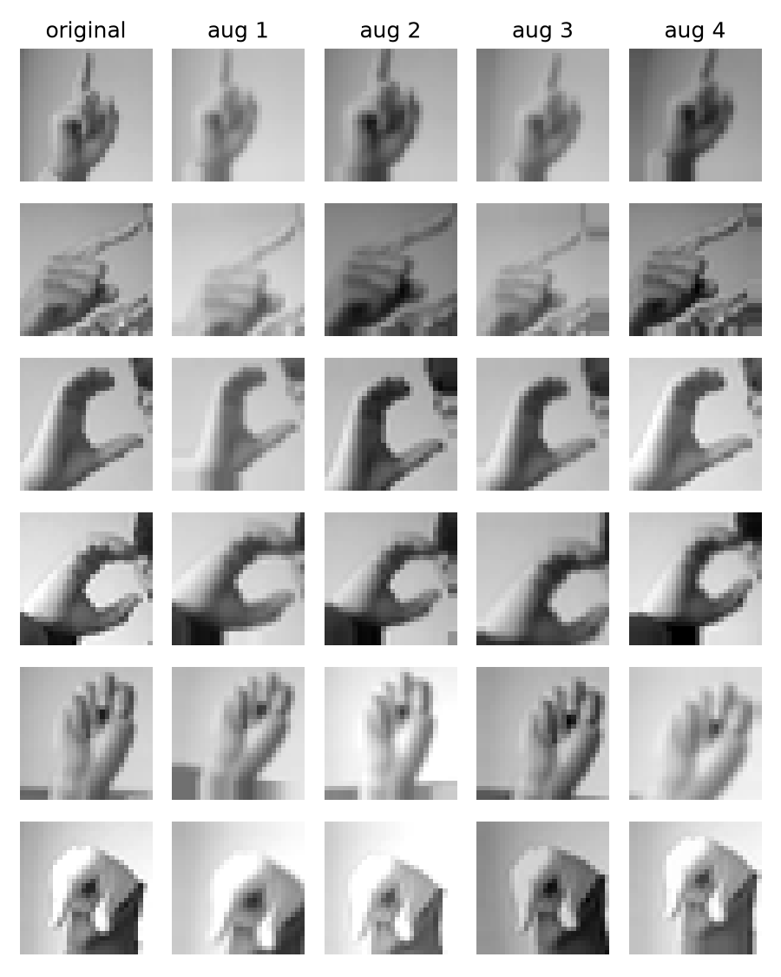
Figure 3. Original images (left) and four random augmentations of each.

4. Key Finding: Random Validation Split Leaks Data
With a standard stratified random split, every baseline reached about 100% validation accuracy but only 70–91% on the test set. Validation could not tell the models apart and was useless for model selection.
Cause. The Kaggle training set holds roughly 16 augmented copies of each of ~1,704 original photos. A random split places copies of the same photo in both train and validation, so the model is evaluated on images it has effectively already seen.
Fix – group-based split. For each letter we cluster its images into 70 groups (≈ 1,704 photos ÷ 24 letters) using 10×10 thumbnails and Ward linkage, so that copies of one photo fall into the same group. We then hold out 15% of the groups of each letter as validation. Classes stay balanced and no photo appears on both sides.
Logistic Regression (pixels) | Validation accuracy | Test accuracy | Gap
Random split | 1.000 | 0.699 | +0.301
Group split | 0.743 | 0.699 | +0.044

After the fix, validation scores stay within 2–8 points of the test scores for every model, and the ranking on validation almost matches the ranking on test (only the top two swap, and they are within 1 point on validation). All later models use this split.

5. Baseline Model Metrics
All models were trained on the same group-based split. Accuracy and macro-F1 are reported for both validation and the official test set.
Model | Features | Val acc | Val F1 | Test acc | Test F1 | Error rate | Train (s)
Majority class (floor) | – | 0.043 | 0.003 | 0.020 | 0.002 | 98.0% | 0.0
Logistic Regression | Pixels | 0.743 | 0.742 | 0.699 | 0.682 | 30.1% | 7.0
Random Forest (200 trees) | Pixels | 0.849 | 0.846 | 0.810 | 0.792 | 19.0% | 10.4
MLP 256-128 | Pixels | 0.837 | 0.837 | 0.760 | 0.735 | 24.0% | 7.3
Linear SVM | HOG | 0.939 | 0.937 | 0.886 | 0.880 | 11.4% | 160.6
MLP 256-128 | HOG | 0.930 | 0.930 | 0.906 | 0.899 | 9.4% | 14.0
F1 = macro-averaged F1. Error rate = 1 − test accuracy. Inference cost is below 0.02 ms per image for every model, far inside the 33 ms per-frame budget for 30 FPS.
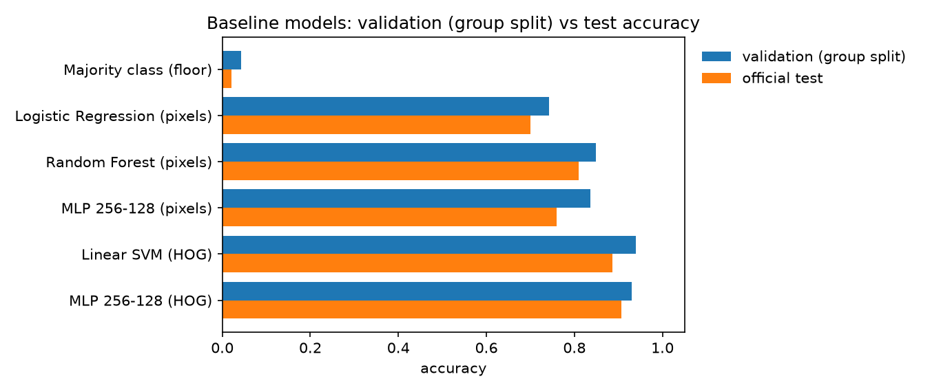
Figure 4. Validation (group split) versus test accuracy for each baseline.

5.1 Interpretation
- Features matter more than the classifier. Replacing raw pixels with HOG raises the MLP from 0.760 to 0.906 test accuracy (+15 points). Shape and edge information is what separates the letters – exactly what a CNN learns automatically.
- Two strong baselines. Linear SVM + HOG is best on validation; MLP + HOG is best on test. They are within 1 point on validation, and the MLP trains about 11× faster. MLP + HOG (test macro-F1 0.899) is the target the Week 4 CNN must beat.
- Validation is now trustworthy. The validation–test gap of the best model is only 2.4 points.

5.2 Error Analysis (MLP + HOG, test set)
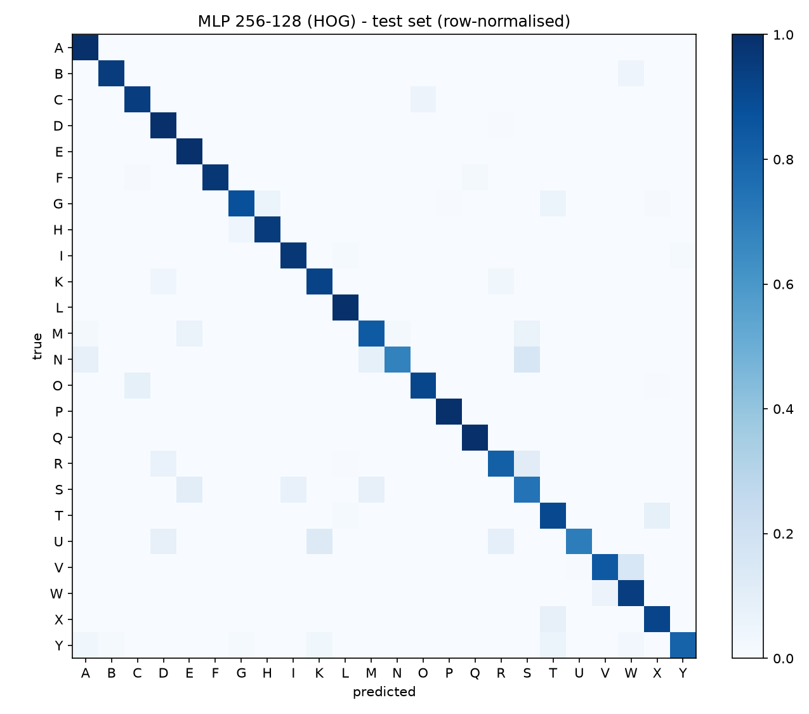
Figure 5. Row-normalised confusion matrix of the best baseline on the test set.
True → Predicted | Rate | Why they look alike
N → S | 15.8% | Closed fist; only the thumb position differs
V → W | 15.3% | Two versus three raised fingers
U → K | 13.2% | Two raised fingers; K adds the thumb between them
R → S | 11.1% | Crossed fingers versus a fist
S → E | 10.2% | Both are fist-like shapes
U → R | 9.0% | Two fingers held together versus crossed

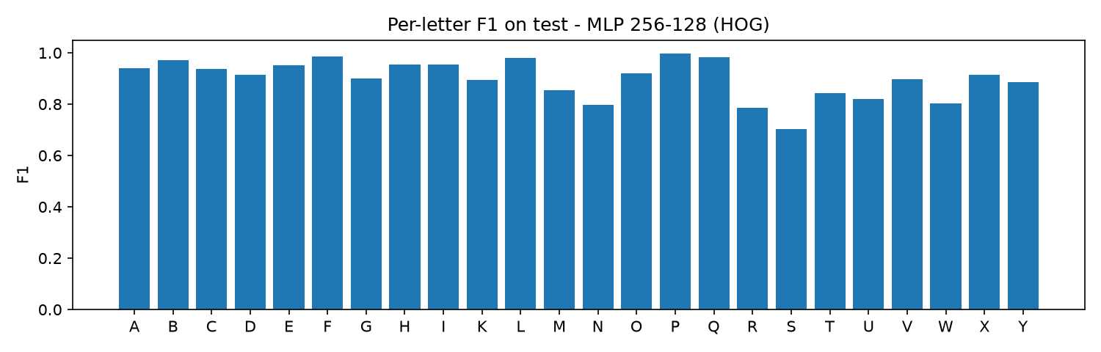
Figure 6. F1 score per letter on the test set for the best baseline.
Weakest letters (F1): S 0.70, R 0.79, N 0.80, W 0.80, U 0.82. Strongest: P, F, Q, L (≥ 0.98). Errors concentrate in two families: fist-based letters (A, E, M, N, S, T) and two/three-finger letters (U, V, W, R, K). This answers research question 2.

6. Model Selection Justification
Candidate | Role | Reason
Logistic Regression, Random Forest | Baselines | Fast and interpretable lower bound
MLP + HOG | Strong baseline | Shows the value of shape features; current best
CNN (main model) | Week 4 | Learns local spatial patterns (finger edges, contours) directly from pixels instead of fixed HOG features. Convolution and pooling tolerate small shifts. Small enough (~0.4 M parameters) to export to ONNX and run in the browser at > 30 FPS
MLP on 21 MediaPipe landmarks | Week 4 (web app) | Landmarks remove background, lighting and skin-tone effects, so the model is robust on real webcams and very cheap to run. Needs a landmark dataset because MediaPipe cannot detect hands reliably in 28×28 images
LSTM / RNN | Not chosen | The 24 letters are static images with no time dimension; only relevant if J and Z are added
Large pretrained CNN (ResNet, etc.) | Not chosen | 28×28 grayscale input is too small to benefit, and the model is too heavy for real-time inference in the browser

7. Planned Modelling Tasks – Week 4
# | Task | Success criterion
1 | Train the CNN with and without augmentation | Test macro-F1 > 0.899 (beats MLP + HOG)
2 | Tune learning rate, dropout, batch size and epochs on the group validation split, with early stopping | Best configuration chosen on validation only
3 | Error analysis on N/S/M and U/V/W/R/K: confusion matrix and gallery of misclassified images | Lower error rate on these pairs than the baseline
4 | Build a landmark dataset with MediaPipe Hands and train an MLP on normalised landmarks | Working landmark model and its metrics
5 | Export the best model to ONNX and measure in-browser speed | > 30 FPS (research question 3)

8. Risks and Limitations
- Domain gap: Kaggle images are cropped and evenly lit, while real webcam frames vary in background, lighting and hand size. Test accuracy on Kaggle does not guarantee webcam accuracy. Mitigation: augmentation, landmark model, and a small test set of the team’s own webcam images.
- J and Z are out of scope: they require motion and are absent from the dataset.
- Approximate grouping: the group split recovers original photos by clustering, not from true photo IDs. Its validity is supported by the small validation–test gap.
- Same people in train and test: the dataset has a limited number of signers, so results may not generalise to new users.

9. Reproducibility
Place the two Kaggle CSV files in data/raw/ and run from the project root:
pip install -r requirements.txt
python -m src.data # quality checks + preprocessing
python -m src.eda # data figures
python -m src.train_baselines # baseline models and metrics
File | Purpose
src/config.py | Paths, seed, label mapping
src/data.py | Loading, quality review, cleaning, group-based split
src/features.py | Raw-pixel and HOG features
src/augment.py | Image augmentation
src/eda.py | Data-understanding figures
src/train_baselines.py | Baseline training, metrics and error analysis
src/train_cnn.py | Week 4 CNN (PyTorch) with ONNX export

