ONLINE CRYPTOGRAPHY COURSE

VICTOR NYARIBO

5/19/2021

## a) Data Analytic Question

The aim of this project is to identify individuals most likely to click on an online cryptography course advert.

## b) Success Metrics

* Successful Loading the data.
* Successful Handling missing data.
* Successful Outliers detection.
* Successful Outlier Visualization.
* Successful Handling outliers.
* Successful Univariate analysis.
* Successful Bivariate analysis.

## c) Context

Internet has become the most prominent and accessible way to spread the news about an event or to pitch, advertise and sell a product, globally. The success of any advertisement campaign lies in reaching the right class of target audience and eventually convert them as potential customers in the future. Businesses are predominantly charged based the number of clicks that they received for their advertisement while some websites also bill them with a fixed charge per billing cycle. This creates a necessity for the advertising firms to analyze and study these influential factors to achieve the maximum possible gain through the advertisements. Additionally, it is equally important for the businesses to customize these factors rightly to achieve the maximum clicks.

## d) Data Understanding

Variables

* Daily Time Spent on a Site: Time spent by the user on a site in minutes.
* Age:Customer’s age in terms of years.
* Area Income: Average income of geographical area of consumer.
* Daily Internet Usage: Average minutes in a day consumer is on the internet.
* Ad Topic Line: Headline of the advertisement.
* City: City of the consumer.
* Male: Whether or not a consumer was male.
* Country: Country of the consumer.
* Timestamp: Time at which user clicked on an Ad or the closed window.
* Clicked on Ad: 0 or 1 is indicated clicking on an Ad.

## e) Experimental Design

* Formulation of the research question.
* Loading the data.
* Exploratory Data Analysis.
* Solution Implementation.
* Challenging the solution.
* Follow up .

## Data Importation

advertising<-df <- read.csv("http://bit.ly/IPAdvertisingData",header =T)

## converting data.frame data into data.table

advertising<-as.data.table(advertising)  
class(advertising) #checking class

## [1] "data.table" "data.frame"

## Data Columns

#advertising%>%head(2)  
kable(colnames(advertising))

|  |
| --- |
| x |
| Daily.Time.Spent.on.Site |
| Age |
| Area.Income |
| Daily.Internet.Usage |
| Ad.Topic.Line |
| City |
| Male |
| Country |
| Timestamp |
| Clicked.on.Ad |

## Delete unneccessary columns

|  |
| --- |
| x |
| Daily.Time.Spent.on.Site |
| Age |
| Area.Income |
| Daily.Internet.Usage |
| City |
| Male |
| Country |
| Clicked.on.Ad |

## Check for missing values

library(Amelia)

## Warning: package 'Amelia' was built under R version 4.0.5

## Loading required package: Rcpp

## ##   
## ## Amelia II: Multiple Imputation  
## ## (Version 1.7.6, built: 2019-11-24)  
## ## Copyright (C) 2005-2021 James Honaker, Gary King and Matthew Blackwell  
## ## Refer to http://gking.harvard.edu/amelia/ for more information  
## ##

missmap(advertising,main="Missing Values in Data Set")

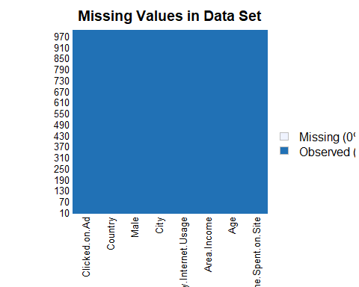

## Tibbles

A tibble is a special kind of data.frame used by dplyr and other packages of the tidyverse. Tidyverse is a set of packages for data science that work in harmony because they share common data representations and API design. When a data.frame is turned into a tibble its class will change.

class(advertising)

## [1] "data.table" "data.frame"

advertising <- tbl_df(advertising)

## Warning: `tbl_df()` is deprecated as of dplyr 1.0.0.  
## Please use `tibble::as_tibble()` instead.  
## This warning is displayed once every 8 hours.  
## Call `lifecycle::last_warnings()` to see where this warning was generated.

class(advertising)

## [1] "tbl_df" "tbl" "data.frame"

## Data Overview

## Rows: 1,000  
## Columns: 8  
## $ Daily.Time.Spent.on.Site <dbl> 68.95, 80.23, 69.47, 74.15, 68.37, 59.99, ...  
## $ Age <int> 35, 31, 26, 29, 35, 23, 33, 48, 30, 20, 49...  
## $ Area.Income <dbl> 61833.90, 68441.85, 59785.94, 54806.18, 73...  
## $ Daily.Internet.Usage <dbl> 256.09, 193.77, 236.50, 245.89, 225.58, 22...  
## $ City <chr> "Wrightburgh", "West Jodi", "Davidton", "W...  
## $ Male <int> 0, 1, 0, 1, 0, 1, 0, 1, 1, 1, 0, 1, 1, 0, ...  
## $ Country <chr> "Tunisia", "Nauru", "San Marino", "Italy",...  
## $ Clicked.on.Ad <int> 0, 0, 0, 0, 0, 0, 0, 1, 0, 0, 1, 0, 1, 0, ...

## Data preview

## # A tibble: 6 x 8  
## Daily.Time.Spen~ Age Area.Income Daily.Internet.~ City Male Country  
## <dbl> <int> <dbl> <dbl> <chr> <int> <chr>   
## 1 69.0 35 61834. 256. Wrig~ 0 Tunisia  
## 2 80.2 31 68442. 194. West~ 1 Nauru   
## 3 69.5 26 59786. 236. Davi~ 0 San Ma~  
## 4 74.2 29 54806. 246. West~ 1 Italy   
## 5 68.4 35 73890. 226. Sout~ 0 Iceland  
## 6 60.0 23 59762. 227. Jami~ 1 Norway   
## # ... with 1 more variable: Clicked.on.Ad <int>

# Univariate analysis of a continuous variables

## `stat_bin()` using `bins = 30`. Pick better value with `binwidth`.

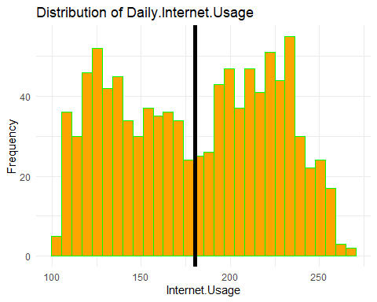

## `stat_bin()` using `bins = 30`. Pick better value with `binwidth`.

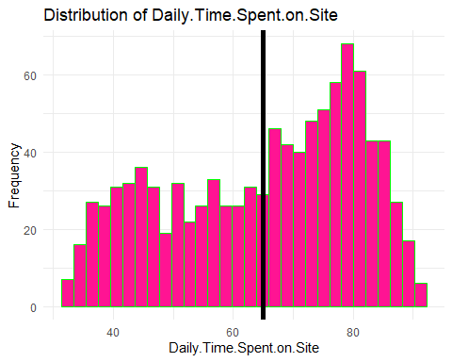

## `stat_bin()` using `bins = 30`. Pick better value with `binwidth`.

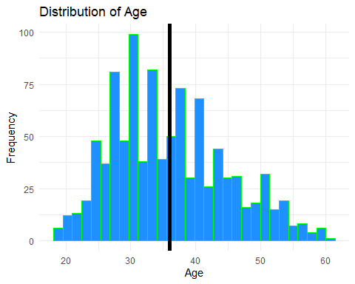

## `stat_bin()` using `bins = 30`. Pick better value with `binwidth`.

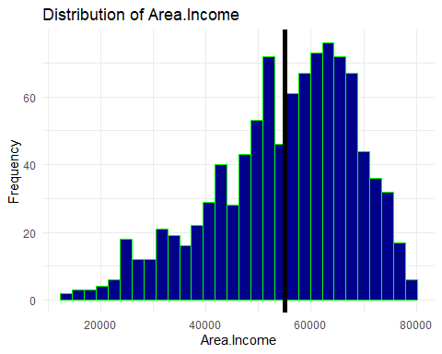

# Bivariate analysis of a continuous variable with respect to a categorical variable

## `stat_bin()` using `bins = 30`. Pick better value with `binwidth`.

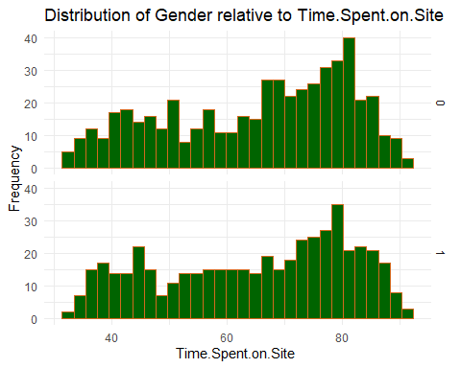

## `stat_bin()` using `bins = 30`. Pick better value with `binwidth`.

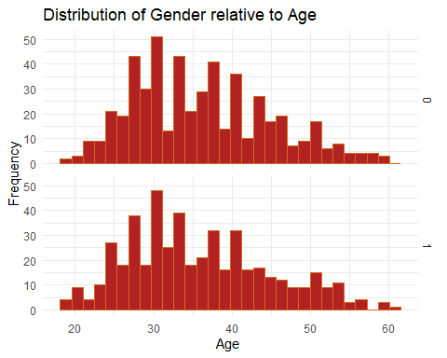

## `stat_bin()` using `bins = 30`. Pick better value with `binwidth`.

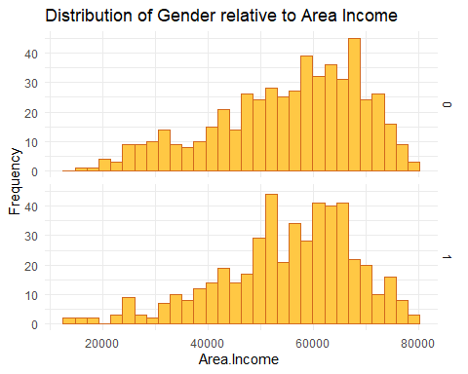

# Bivariate analysis of a continuous variable with respect to another continuous variable

## `geom_smooth()` using formula 'y ~ x'

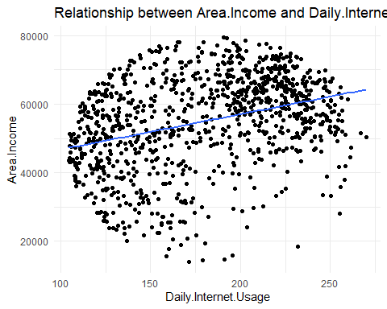

## `geom_smooth()` using formula 'y ~ x'

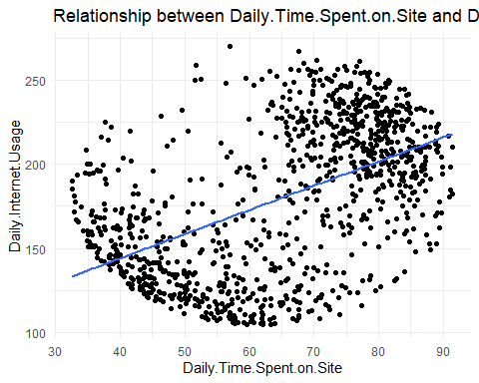

# Correlation Matrix for the advertising dataset

## Warning: package 'ggcorrplot' was built under R version 4.0.5

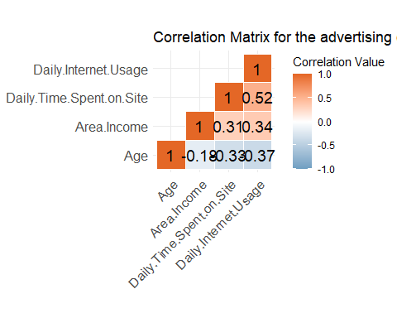

# ADVERTISMENT CLICK PREDICTION

## Warning: The `i` argument of ``[`()` can't be a matrix as of tibble 3.0.0.  
## Convert to a vector.  
## This warning is displayed once every 8 hours.  
## Call `lifecycle::last_warnings()` to see where this warning was generated.

## [1] 800 8

## [1] 200 8

## Estimate Std. Error  
## (Intercept) 28.539761626135504713 3.23173708770935e+00  
## Daily.Time.Spent.on.Site -0.209449998795019660 2.48023961540229e-02  
## Age 0.163584666495930675 2.77224203993907e-02  
## Area.Income -0.000135571297307931 2.08435153968182e-05  
## Daily.Internet.Usage -0.063791830530828597 7.70452267583184e-03  
## z value Pr(>|z|)  
## (Intercept) 8.83109016964139 1.03660378176928e-18  
## Daily.Time.Spent.on.Site -8.44474854342035 3.04700621244281e-17  
## Age 5.90080751028240 3.61726735628530e-09  
## Area.Income -6.50424339306153 7.80853823289852e-11  
## Daily.Internet.Usage -8.27979009406201 1.23392588716862e-16

## `geom_smooth()` using formula 'y ~ x'

## Warning: glm.fit: algorithm did not converge

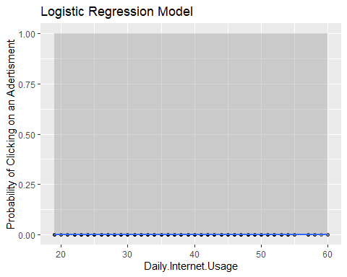

## Feature importance and Logistic Regression

## List of 1  
## $ axis.line:List of 6  
## ..$ colour : chr "darkblue"  
## ..$ size : num 0.5  
## ..$ linetype : chr "solid"  
## ..$ lineend : NULL  
## ..$ arrow : logi FALSE  
## ..$ inherit.blank: logi FALSE  
## ..- attr(*, "class")= chr [1:2] "element_line" "element"  
## - attr(*, "class")= chr [1:2] "theme" "gg"  
## - attr(*, "complete")= logi FALSE  
## - attr(*, "validate")= logi TRUE

## Warning in countrycode(advertising_data$Country, origin = "country.name", : Some values were not matched unambiguously: Antarctica (the territory South of 60 deg S), Bouvet Island (Bouvetoya), British Indian Ocean Territory (Chagos Archipelago), French Southern Territories, Heard Island and McDonald Islands, Micronesia, Saint Martin, South Georgia and the South Sandwich Islands, United States Minor Outlying Islands

## [1] "Logistic Regression Confusion/Clarity Matrix)"

## Class_predict  
## 0 1  
## 0 425 9  
## 1 16 415

## [1] "Logistic Regression Accuracy: 97.1098265895954"

Variable Importance:

|  |  |  |  |
| --- | --- | --- | --- |
|  | Overall | varnames | var_categ |
| Daily.Time.Spent.on.Site | 8.379334095222884 | Daily.Time.Spent.on.Site | Location |
| Age | 6.527516885189965 | Age | Location |
| Area.Income | 6.724826176192777 | Area.Income | Location |
| Daily.Internet.Usage | 8.633131371671141 | Daily.Internet.Usage | Location |
| Male | 0.582364607079277 | Male | Location |
| continent3 | 0.227296062920125 | continent3 | Location |
| continent4 | 0.098716143074804 | continent4 | Location |
| continent5 | 1.117696233696151 | continent5 | Location |

