**FUNCTIONS CONCEPT IN JS**

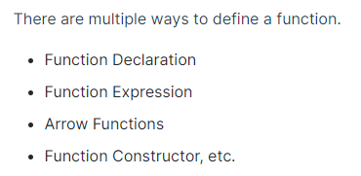

Arrow functions types:

* Simple expression
* One parameter
* No parameter

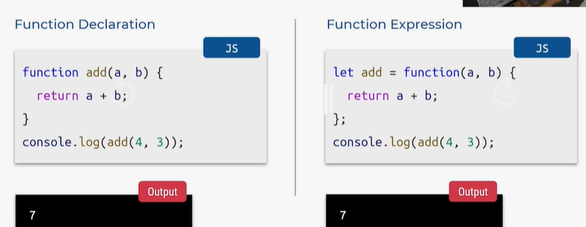

**FUNCTION DECLARATION:**

* Function = keyword
* Add = function name
* Inside brackets = passed arguments
* Inside curly brackets = block of code pettam with return keyword
* Add of ane method ni call chesam with values passed for above arguments inside console.log

**FUNCTION EXPRESSION:**

* Let add = variable create chesam
* Function = keyword ki direct ga arguments pass chesam

**ARROW FUNCTION:**

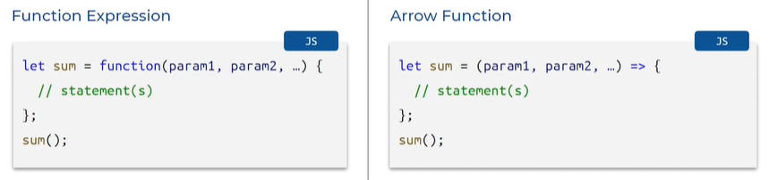

* Alternative to function expression
* Function keyword ledu straight away arguents
* Fat arrow => Arrow symbol
* petti block of code
* return ki variable create chesam

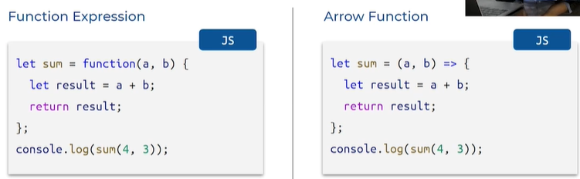

* Let Sum = variable
* a,b = arguments
* arrow function
* curly braces lo block of code
* result ki variable create chesam

**ARROW FUNCTION SIMPLE EXPRESSIONS:**

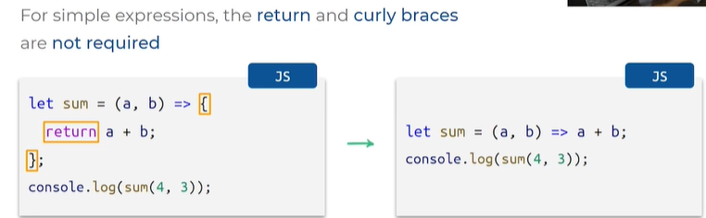

* Return thisesi st away a+b
* Simple expression we return only value
* Remove flower braces , return



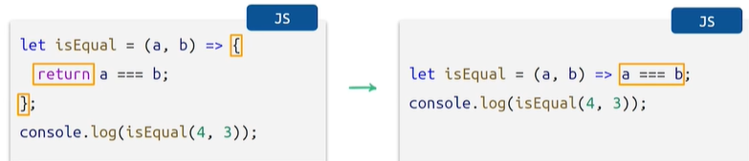

**ARROW FUNCTION WITH ONE PARAMETER:**

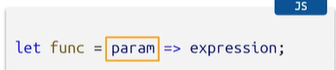

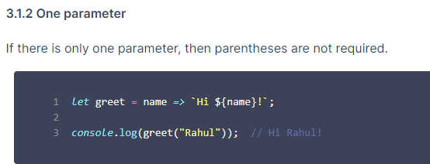

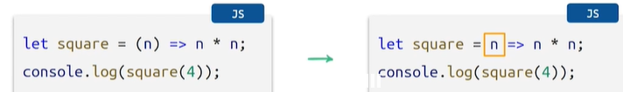

**ARROW FUNCTION WITH NO PARAMETER:**

* Brackets undali

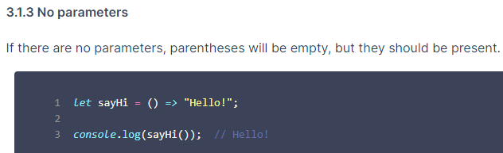

**FUNCTION DECLARATION:**

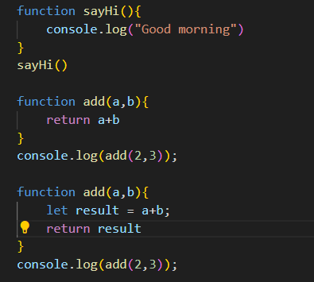

Defining and calling function

Return keyword usage

**FUNCTION EXPRESSION:**

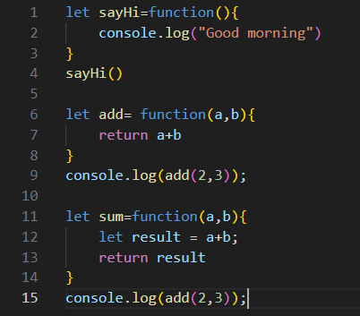

Created variable with let

Return keyword usage

**ARROW FUNCTION:**

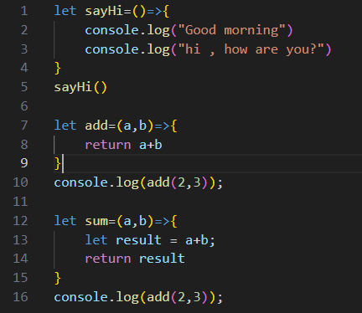

Same like function expression

Removed function keyword

**ARROW FUNCTION SIMPLE EXPRESSION:**

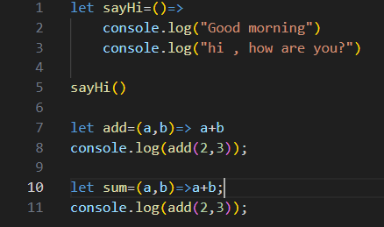

Same like arrow functions

Return and curly braces are not required

**ARROW FUNCTION ONE PARAMETER:**

* Okka value ni return cheyali ante use cheyali for eg:square

**ARROW FUNCTION NO PARAMETER:**

* Brackets undali kani danilo parameters(arguments/values)undav kani brackets undali

**FACTORY AND CONSTRUCTOR FUNCTIONS**

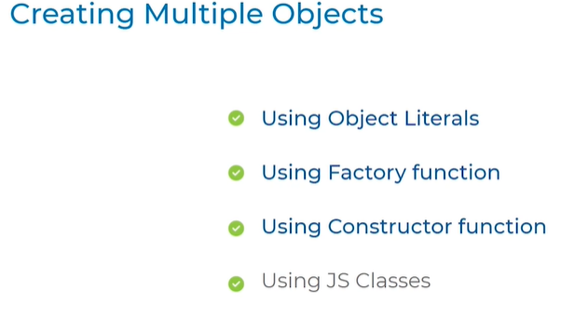

* Multiple objects can be created by using the above methods

**1.Object literals:**

* Object is car
* With diff values and attributes

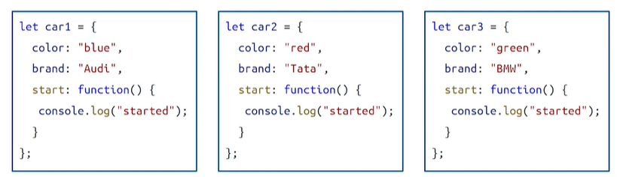

**2.using factory functions:**

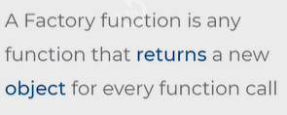

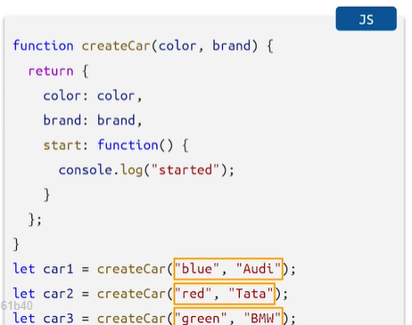

* Create car = function name
* Braket lo mana properties pass chesamu
* Value manam arguments laga kinda pas chesatham factory functions lo
* Return color property and colon arguments lo pass chese value
* To create object below car1 car2 car3 arguments passed

**Print objects in this way:**

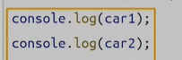

**SIMPLIED FACTORY FUNCTIONS:**

* Remove value and colon function
* Follow right side simplied syntax

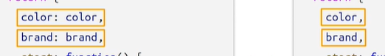

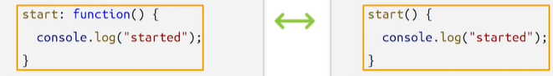

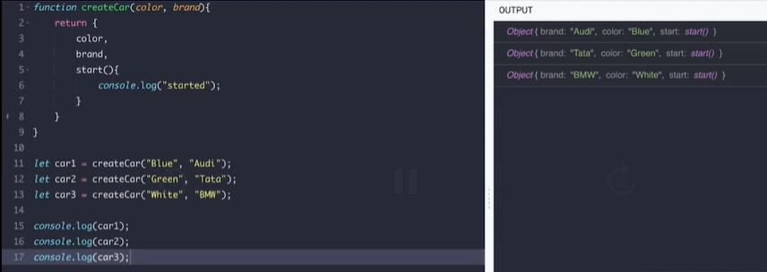

**CONSTRUCTOR FUNCTIONS:**

New operator is used to call function with objects which return new objects [ also called instance]

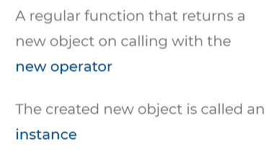

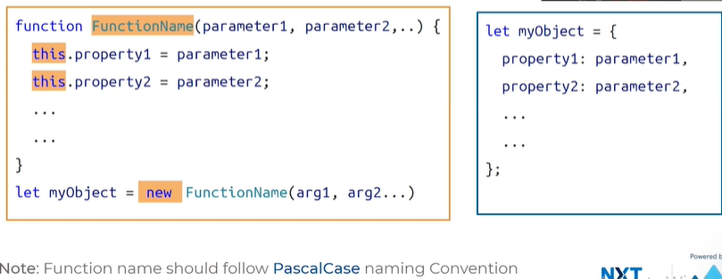

Function follows = pascal case 1st letter is upperletter every time

Arguments = property values

Proeprty ni set cheyadanki this.porprty 1 and dani value

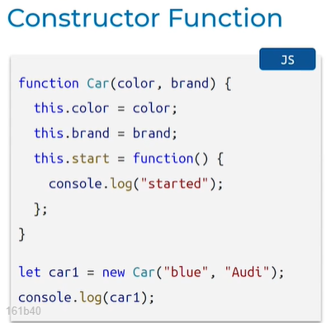

* Car = function
* New car = function call passed parameters
* Values given
* New = this variable created = assign empty
* This.property = this object with dot notation assigndffi vales for properties
* New ante return avthni

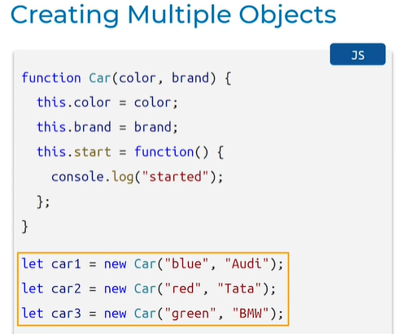

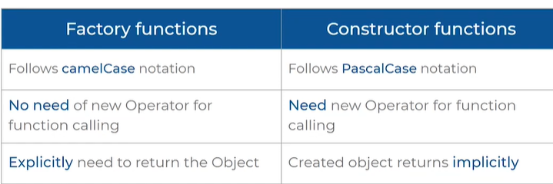



.length = returns property

.typeOf = function

|  |  |  |  |  |  |
| --- | --- | --- | --- | --- | --- |
| **declaration** | **expression** | **Arrow** | **Simple.exp** | **One parameter** | **No parameter** |
| **Return keyword** | **Factory** | **Constructor**  **This.**  **New** |  |  |  |



Area = length * width

Convert degree Fahrenheit to degree Celsius:

return (5 / 9) * (fahrenheit - 32);

function toCelsius(Fahrenheit){

    result =  (5/9) * (Fahrenheit -32);

}

// console.log(toCelsius(10)); defined and called function

//declaring variable

let Fahrenheit = 10;

console.log(`${Fahrenheit} is the value of`,toCelsius(Fahrenheit) ,'degree celsius');

//tocelsius ane function fahrenheit ane variable declare chesina value tho call chesam

Numeric number convert to days : formula

**Math.floor(seconds / (3600 * 24)).**