Akkutte effekter av apné og bikarbonat på sykkelprestasjon
Anders Nybakk
2026-01-01
Table of contents

Anerkjennelser
Tekst…

Sammendrag
Tekst…

1. Teori

1.1 Utholdenhetsprestasjon

1.1.1 VO2max

1.1.2 Utnyttingsgrad

1.1.3 Arbeidsøkonomi

1.2 Apné

1.3 Bikarbonat

1.4 Målsetting, problemstilling og hypotese

2. Innledning

3. Metode

3.1 Deltakere
Table 3.1: Deltakeroversikt
Mål | Kvinner (n = 3) | Menn (n = 7) | Gruppe (n = 10)
Alder (år) | 21.3 (1.2) | 21.0 (1.6) | 21.1 (1.4)
Kroppsmasse (kg) | 57.8 (6.5) | 78.2 (6.3) | 72.1 (11.6)
Høyde (cm) | 168.3 (6.4) | 185.0 (7.1) | 180.0 (10.4)
HF-maks (bpm) | 199.7 (4.5) | 203.4 (9.0) | 202.3 (7.9)
VO₂ (ml/min) | 3518.7 (203.4) | 5199.4 (335.2) | 4695.2 (862.1)
VO₂ (ml/kg/min) | 61.5 (8.5) | 66.6 (3.5) | 65.1 (5.5)
4 mmol·L⁻¹ (W) | 222.6 (18.2) | 325.2 (29.4) | 294.4 (55.7)
VO₂ = maksimalt oksygenopptak. 4 mmol·L⁻¹ (W) angir effekt ved laktatkonsentrasjon på 4 mmol/L (terskelwatt). Verdier er oppgitt som gjennomsnitt (SD).

3.2 Studie design

3.3 Testprotokoll

3.3.1 Testdag 1 - Kartlegging

3.3.2 Prestasjonstest

3.4 Blodanalyse

3.4.1 Laktat

3.4.2 pH-verdi i blodet

3.4.3 Hemoglobinkonsentrasjon

3.5 Statistikk

4. Resultat

4.1 Prestasjon
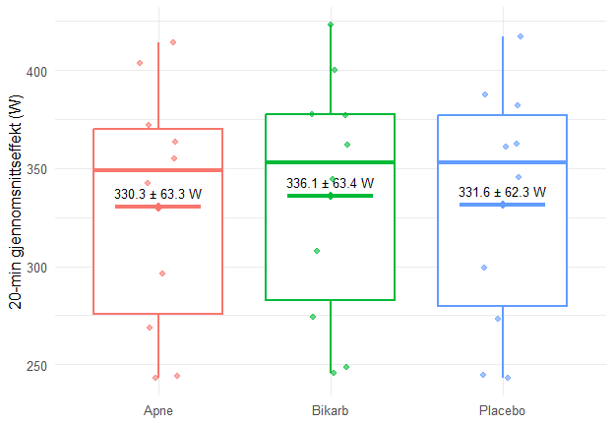
Figure 4.1: Boksdiagram av gjennomsnittswatt per deltaker. Boks = median/IQR. Diamant og tynn tverrstrek = gjennomsnitt. Tall angir gjennomsnitt ± SD.
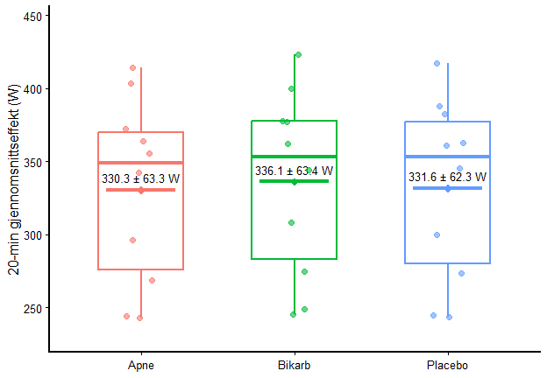
Figure 4.2: Boksdiagram av gjennomsnittswatt per deltaker. Boks = median/IQR. Diamant og tynn tverrstrek = gjennomsnitt. Tall angir gjennomsnitt ± SD.
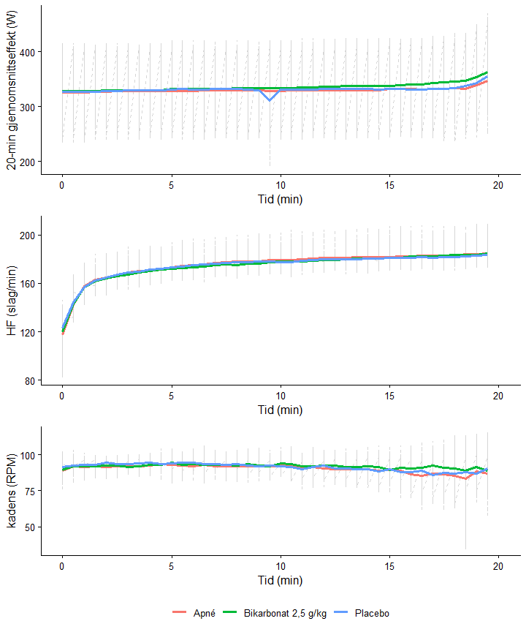
Figure 4.3: Figur 1. Individ-linjer (stiplet, grå) og gjennomsnitt (heltrukket) for (a) Watt, (b) Hjertefrekvens (HF) og (c) Kadens (RPM) i Apné, Bikarbonat 2,5 g/kg og Placebo over 20 minutter.
Watt:
repeatet measures ANOVA (watt)
Antall per protokoll:
Apne Bikarb Placebo
10 10 10
Antall unike deltakere (id): 10
Repeated-measures ANOVA:
Error: id
Df Sum Sq Mean Sq F value Pr(>F)
Residuals 9 106781 11865
Error: id:protocol
Df Sum Sq Mean Sq F value Pr(>F)
protocol 2 180.4 90.18 3.797 0.0421 *
Residuals 18 427.5 23.75
---
Signif. codes: 0 '***' 0.001 '**' 0.01 '*' 0.05 '.' 0.1 ' ' 1
Post-hoc (paired t-test, Holm-korreksjon):
Pairwise comparisons using paired t tests
data: watt_long$mean_watt and watt_long$protocol
Apne Bikarb
Bikarb 0.11 -
Placebo 0.59 0.11
P value adjustment method: holm
Med effect size:
Antall per protokoll:
Apne Bikarb Placebo
10 10 10
Antall unike deltakere (id): 10
Repeated-measures ANOVA:
Error: id
Df Sum Sq Mean Sq F value Pr(>F)
Residuals 9 106781 11865
Error: id:protocol
Df Sum Sq Mean Sq F value Pr(>F)
protocol 2 180.4 90.18 3.797 0.0421 *
Residuals 18 427.5 23.75
---
Signif. codes: 0 '***' 0.001 '**' 0.01 '*' 0.05 '.' 0.1 ' ' 1
ANOVA med effect size:
F(2, 18) = 3.797, p = 0.0421, partial eta squared (eta^2[p]) = 0.297
Post-hoc (paired t-test, Holm-korreksjon):
Pairwise comparisons using paired t tests
data: watt_long$mean_watt and watt_long$protocol
Apne Bikarb
Bikarb 0.11 -
Placebo 0.59 0.11
P value adjustment method: holm
Effect size for post-hoc sammenligninger (paired Cohen's d_z):
comparison d_z magnitude
1 Apne vs Bikarb -0.7701506 moderat
2 Apne vs Placebo -0.1774372 triviell
3 Bikarb vs Placebo 0.7254376 moderat
Leneær Mixed-model- test (watt)
Linear mixed model fit by maximum likelihood . t-tests use Satterthwaite's
method [lmerModLmerTest]
Formula: watt ~ protocol * time_min + (1 + time_min | id)
Data: watt_ts
AIC BIC logLik deviance df.resid
9016.7 9067.6 -4498.4 8996.7 1190
Scaled residuals:
Min 1Q Median 3Q Max
-20.9222 -0.3004 0.0122 0.2687 7.5958
Random effects:
Groups Name Variance Std.Dev. Corr
id (Intercept) 3484.4728 59.0294
time_min 0.1224 0.3499 0.02
Residual 96.9929 9.8485
Number of obs: 1200, groups: id, 10
Fixed effects:
Estimate Std. Error df t value Pr(>|t|)
(Intercept) 326.03780 18.69176 10.27625 17.443 5.72e-09 ***
protocolBikarb -0.50061 1.36707 1179.91947 -0.366 0.71429
protocolPlacebo 0.64817 1.36707 1179.91946 0.474 0.63549
time_min 0.44099 0.13972 17.69354 3.156 0.00555 **
protocolBikarb:time_min 0.63724 0.12066 1179.91947 5.281 1.52e-07 ***
protocolPlacebo:time_min 0.06173 0.12066 1179.91947 0.512 0.60904
---
Signif. codes: 0 '***' 0.001 '**' 0.01 '*' 0.05 '.' 0.1 ' ' 1
Correlation of Fixed Effects:
(Intr) prtclB prtclP tim_mn prtB:_
protoclBkrb -0.037
protoclPlcb -0.037 0.500
time_min -0.014 0.372 0.372
prtclBkrb:_ 0.031 -0.861 -0.430 -0.432
prtclPlcb:_ 0.031 -0.430 -0.861 -0.432 0.500
optimizer (nloptwrap) convergence code: 0 (OK)
Model failed to converge with max|grad| = 0.0501666 (tol = 0.002, component 1)
Type III Analysis of Variance Table with Satterthwaite's method
Sum Sq Mean Sq NumDF DenDF F value Pr(>F)
protocol 68.9 34.43 2 1179.9 0.355 0.7012401
time_min 3003.4 3003.44 1 10.0 30.966 0.0002392 ***
protocol:time_min 3291.7 1645.87 2 1179.9 16.969 5.426e-08 ***
---
Signif. codes: 0 '***' 0.001 '**' 0.01 '*' 0.05 '.' 0.1 ' ' 1
med effect size:
Linear mixed model fit by maximum likelihood . t-tests use Satterthwaite's
method [lmerModLmerTest]
Formula: watt ~ protocol * time_min + (1 + time_min | id)
Data: watt_ts
AIC BIC logLik deviance df.resid
9016.7 9067.6 -4498.4 8996.7 1190
Scaled residuals:
Min 1Q Median 3Q Max
-20.9222 -0.3004 0.0122 0.2687 7.5958
Random effects:
Groups Name Variance Std.Dev. Corr
id (Intercept) 3484.4728 59.0294
time_min 0.1224 0.3499 0.02
Residual 96.9929 9.8485
Number of obs: 1200, groups: id, 10
Fixed effects:
Estimate Std. Error df t value Pr(>|t|)
(Intercept) 326.03780 18.69176 10.27625 17.443 5.72e-09 ***
protocolBikarb -0.50061 1.36707 1179.91947 -0.366 0.71429
protocolPlacebo 0.64817 1.36707 1179.91946 0.474 0.63549
time_min 0.44099 0.13972 17.69354 3.156 0.00555 **
protocolBikarb:time_min 0.63724 0.12066 1179.91947 5.281 1.52e-07 ***
protocolPlacebo:time_min 0.06173 0.12066 1179.91947 0.512 0.60904
---
Signif. codes: 0 '***' 0.001 '**' 0.01 '*' 0.05 '.' 0.1 ' ' 1
Correlation of Fixed Effects:
(Intr) prtclB prtclP tim_mn prtB:_
protoclBkrb -0.037
protoclPlcb -0.037 0.500
time_min -0.014 0.372 0.372
prtclBkrb:_ 0.031 -0.861 -0.430 -0.432
prtclPlcb:_ 0.031 -0.430 -0.861 -0.432 0.500
optimizer (nloptwrap) convergence code: 0 (OK)
Model failed to converge with max|grad| = 0.0501666 (tol = 0.002, component 1)
Type III Analysis of Variance Table with Satterthwaite's method
Sum Sq Mean Sq NumDF DenDF F value Pr(>F)
protocol 68.9 34.43 2 1179.9 0.355 0.7012401
time_min 3003.4 3003.44 1 10.0 30.966 0.0002392 ***
protocol:time_min 3291.7 1645.87 2 1179.9 16.969 5.426e-08 ***
---
Signif. codes: 0 '***' 0.001 '**' 0.01 '*' 0.05 '.' 0.1 ' ' 1
# Effect Size for ANOVA (Type III)
Parameter | Eta2 (partial) | 95% CI
-------------------------------------------------
protocol | 6.01e-04 | [0.00, 1.00]
time_min | 0.76 | [0.45, 1.00]
protocol:time_min | 0.03 | [0.01, 1.00]
- One-sided CIs: upper bound fixed at [1.00].
# Standardization method: refit
Parameter | Std. Coef. | 95% CI
----------------------------------------------------------
(Intercept) | -0.04 | [-0.65, 0.57]
protocol [Bikarb] | 0.09 | [ 0.07, 0.12]
protocol [Placebo] | 0.02 | [ 0.00, 0.04]
time min | 0.04 | [ 0.02, 0.07]
protocol [Bikarb] × time min | 0.06 | [ 0.04, 0.08]
protocol [Placebo] × time min | 5.87e-03 | [-0.02, 0.03]
contrast estimate SE df t.ratio p.value
Apne - Bikarb -0.6372 0.121 1184 -5.273 <0.0001
Apne - Placebo -0.0617 0.121 1184 -0.511 0.6096
Bikarb - Placebo 0.5755 0.121 1184 4.762 <0.0001
Degrees-of-freedom method: kenward-roger
P value adjustment: holm method for 3 tests
contrast effect.size SE df lower.CL upper.CL
Apne - Bikarb -0.06470 0.0123 19.6 -0.0905 -0.0389
Apne - Placebo -0.00627 0.0123 19.6 -0.0319 0.0194
Bikarb - Placebo 0.05844 0.0123 19.6 0.0327 0.0842
sigma used for effect sizes: 9.848
Degrees-of-freedom method: inherited from kenward-roger when re-gridding
Confidence level used: 0.95
Hjertefrekvens:
Repeatet measures ANOVA (HF)
Antall per protokoll (HF):
Apne Bikarb Placebo
10 10 10
Antall unike deltakere (HF): 10
Repeated-measures ANOVA (HF):
Error: id
Df Sum Sq Mean Sq F value Pr(>F)
Residuals 9 1703 189.2
Error: id:protocol
Df Sum Sq Mean Sq F value Pr(>F)
protocol 2 5.61 2.804 0.447 0.646
Residuals 18 112.90 6.272
Post-hoc (paired t-test, Holm) (HF):
Pairwise comparisons using paired t tests
data: hf_long$mean_hf and hf_long$protocol
Apne Bikarb
Bikarb 1 -
Placebo 1 1
P value adjustment method: holm
Leneær Mixed-model- test (HF)
LMM (HF) – fixed effects:
Linear mixed model fit by maximum likelihood . t-tests use Satterthwaite's
method [lmerModLmerTest]
Formula: hf ~ protocol * time_min + (1 + time_min | id)
Data: hf_ts
AIC BIC logLik deviance df.resid
8580.8 8631.7 -4280.4 8560.8 1190
Scaled residuals:
Min 1Q Median 3Q Max
-8.7882 -0.3009 0.1994 0.5633 1.4944
Random effects:
Groups Name Variance Std.Dev. Corr
id (Intercept) 60.56622 7.7824
time_min 0.03013 0.1736 -0.25
Residual 70.07390 8.3710
Number of obs: 1200, groups: id, 10
Fixed effects:
Estimate Std. Error df t value Pr(>|t|)
(Intercept) 159.52902 2.59456 11.29014 61.486 1.28e-15 ***
protocolBikarb -1.17427 1.16198 1180.08734 -1.011 0.312
protocolPlacebo 0.71671 1.16198 1180.08734 0.617 0.537
time_min 1.58882 0.09095 29.81888 17.469 < 2e-16 ***
protocolBikarb:time_min 0.01223 0.10256 1180.08734 0.119 0.905
protocolPlacebo:time_min -0.13582 0.10256 1180.08734 -1.324 0.186
---
Signif. codes: 0 '***' 0.001 '**' 0.01 '*' 0.05 '.' 0.1 ' ' 1
Correlation of Fixed Effects:
(Intr) prtclB prtclP tim_mn prtB:_
protoclBkrb -0.224
protoclPlcb -0.224 0.500
time_min -0.362 0.485 0.485
prtclBkrb:_ 0.193 -0.861 -0.430 -0.564
prtclPlcb:_ 0.193 -0.430 -0.861 -0.564 0.500
optimizer (nloptwrap) convergence code: 0 (OK)
Model failed to converge with max|grad| = 0.0394948 (tol = 0.002, component 1)
Type III ANOVA (HF):
Type III Analysis of Variance Table with Satterthwaite's method
Sum Sq Mean Sq NumDF DenDF F value Pr(>F)
protocol 189 95 2 1180.09 1.350 0.2596
time_min 35215 35215 1 9.94 502.544 7.64e-10 ***
protocol:time_min 180 90 2 1180.09 1.284 0.2773
---
Signif. codes: 0 '***' 0.001 '**' 0.01 '*' 0.05 '.' 0.1 ' ' 1
med ES:
LMM (HF) – fixed effects:
Linear mixed model fit by maximum likelihood . t-tests use Satterthwaite's
method [lmerModLmerTest]
Formula: hf ~ protocol * time_min + (1 + time_min | id)
Data: hf_ts
AIC BIC logLik deviance df.resid
8580.8 8631.7 -4280.4 8560.8 1190
Scaled residuals:
Min 1Q Median 3Q Max
-8.7882 -0.3009 0.1994 0.5633 1.4944
Random effects:
Groups Name Variance Std.Dev. Corr
id (Intercept) 60.56622 7.7824
time_min 0.03013 0.1736 -0.25
Residual 70.07390 8.3710
Number of obs: 1200, groups: id, 10
Fixed effects:
Estimate Std. Error df t value Pr(>|t|)
(Intercept) 159.52902 2.59456 11.29014 61.486 1.28e-15 ***
protocolBikarb -1.17427 1.16198 1180.08734 -1.011 0.312
protocolPlacebo 0.71671 1.16198 1180.08734 0.617 0.537
time_min 1.58882 0.09095 29.81888 17.469 < 2e-16 ***
protocolBikarb:time_min 0.01223 0.10256 1180.08734 0.119 0.905
protocolPlacebo:time_min -0.13582 0.10256 1180.08734 -1.324 0.186
---
Signif. codes: 0 '***' 0.001 '**' 0.01 '*' 0.05 '.' 0.1 ' ' 1
Correlation of Fixed Effects:
(Intr) prtclB prtclP tim_mn prtB:_
protoclBkrb -0.224
protoclPlcb -0.224 0.500
time_min -0.362 0.485 0.485
prtclBkrb:_ 0.193 -0.861 -0.430 -0.564
prtclPlcb:_ 0.193 -0.430 -0.861 -0.564 0.500
optimizer (nloptwrap) convergence code: 0 (OK)
Model failed to converge with max|grad| = 0.0394948 (tol = 0.002, component 1)
Type III ANOVA (HF):
Type III Analysis of Variance Table with Satterthwaite's method
Sum Sq Mean Sq NumDF DenDF F value Pr(>F)
protocol 189 95 2 1180.09 1.350 0.2596
time_min 35215 35215 1 9.94 502.544 7.64e-10 ***
protocol:time_min 180 90 2 1180.09 1.284 0.2773
---
Signif. codes: 0 '***' 0.001 '**' 0.01 '*' 0.05 '.' 0.1 ' ' 1
Effect size – partial eta squared (HF):
# Effect Size for ANOVA (Type III)
Parameter | Eta2 (partial) | 95% CI
-------------------------------------------------
protocol | 2.28e-03 | [0.00, 1.00]
time_min | 0.98 | [0.95, 1.00]
protocol:time_min | 2.17e-03 | [0.00, 1.00]
- One-sided CIs: upper bound fixed at [1.00].
Standardiserte koeffisienter (HF):
# Standardization method: refit
Parameter | Std. Coef. | 95% CI
----------------------------------------------------------
(Intercept) | 0.04 | [-0.29, 0.37]
protocol [Bikarb] | -0.07 | [-0.15, 0.01]
protocol [Placebo] | -0.04 | [-0.12, 0.04]
time min | 0.64 | [ 0.57, 0.71]
protocol [Bikarb] × time min | 4.90e-03 | [-0.08, 0.09]
protocol [Placebo] × time min | -0.05 | [-0.14, 0.03]
Parvise forskjeller i utvikling over tid (HF):
contrast estimate SE df t.ratio p.value
Apne - Bikarb -0.0122 0.103 1184 -0.119 0.9052
Apne - Placebo 0.1358 0.103 1184 1.322 0.4495
Bikarb - Placebo 0.1480 0.103 1184 1.441 0.4495
Degrees-of-freedom method: kenward-roger
P value adjustment: holm method for 3 tests
Effect size for parvise slope-forskjeller (HF):
contrast effect.size SE df lower.CL upper.CL
Apne - Bikarb -0.00146 0.0123 33 -0.02643 0.0235
Apne - Placebo 0.01622 0.0123 33 -0.00875 0.0412
Bikarb - Placebo 0.01769 0.0123 33 -0.00729 0.0427
sigma used for effect sizes: 8.371
Degrees-of-freedom method: inherited from kenward-roger when re-gridding
Confidence level used: 0.95
Estimert startpuls (HF):
protocol emmean SE df lower.CL upper.CL
Apne 160 2.71 12.5 154 165
Bikarb 158 2.71 12.5 152 164
Placebo 160 2.71 12.5 154 166
Degrees-of-freedom method: kenward-roger
Confidence level used: 0.95
Parvise forskjeller i startpuls (HF):
contrast estimate SE df t.ratio p.value
Apne - Bikarb 1.174 1.16 1184 1.009 0.6266
Apne - Placebo -0.717 1.16 1184 -0.616 0.6266
Bikarb - Placebo -1.891 1.16 1184 -1.625 0.3136
Degrees-of-freedom method: kenward-roger
P value adjustment: holm method for 3 tests
Effect size for parvise forskjeller i startpuls (HF):
contrast effect.size SE df lower.CL upper.CL
Apne - Bikarb 0.1403 0.139 12.5 -0.162 0.442
Apne - Placebo -0.0856 0.139 12.5 -0.387 0.216
Bikarb - Placebo -0.2259 0.139 12.5 -0.528 0.076
sigma used for effect sizes: 8.371
Degrees-of-freedom method: inherited from kenward-roger when re-gridding
Confidence level used: 0.95
Startpuls:
Startpuls HF – gjennomsnitt og SD:
# A tibble: 3 × 4
protocol n mean sd
<fct> <int> <dbl> <dbl>
1 Apne 10 118. 16.8
2 Bikarb 10 120. 15.0
3 Placebo 10 123. 9.81
Repeated-measures ANOVA for startpuls HF:
Error: id
Df Sum Sq Mean Sq F value Pr(>F)
Residuals 9 3550 394.5
Error: id:protocol
Df Sum Sq Mean Sq F value Pr(>F)
protocol 2 148.2 74.1 0.71 0.505
Residuals 18 1879.8 104.4
Effect size for ANOVA – partial eta squared:
# Effect Size for ANOVA (Type I)
Group | Parameter | Eta2 (partial) | 95% CI
-------------------------------------------------------
id:protocol | protocol | 0.07 | [0.00, 1.00]
- One-sided CIs: upper bound fixed at [1.00].
Parvise sammenligninger med Holm-korrigering og Cohen's dz:
comparison p_raw p_holm dz
1 Apne - Bikarb 0.6185496 0.9987407 -0.1630516
2 Apne - Placebo 0.3894814 0.9987407 -0.2859140
3 Bikarb - Placebo 0.3329136 0.9987407 -0.3235743
Kadens:
Repeatet measures ANOVA (HF)
Antall per protokoll (RPM):
Apne Bikarb Placebo
10 10 10
Antall deltakere (RPM): 10
Repeated-measures ANOVA (RPM):
Error: id
Df Sum Sq Mean Sq F value Pr(>F)
Residuals 9 959 106.6
Error: id:protocol
Df Sum Sq Mean Sq F value Pr(>F)
protocol 2 12.59 6.296 0.979 0.395
Residuals 18 115.79 6.433
Post-hoc (paired t-test, Holm) (RPM):
Pairwise comparisons using paired t tests
data: rpm_long$mean_rpm and rpm_long$protocol
Apne Bikarb
Bikarb 0.89 -
Placebo 0.89 0.89
P value adjustment method: holm
Leneær Mixed-model- test (RPM)
LMM (RPM) – fixed effects:
Linear mixed model fit by maximum likelihood . t-tests use Satterthwaite's
method [lmerModLmerTest]
Formula: rpm ~ protocol * time_min + (1 + time_min | id)
Data: rpm_ts
AIC BIC logLik deviance df.resid
6912.4 6963.3 -3446.2 6892.4 1190
Scaled residuals:
Min 1Q Median 3Q Max
-10.3990 -0.4727 0.0578 0.5564 2.9511
Random effects:
Groups Name Variance Std.Dev. Corr
id (Intercept) 9.9573 3.1555
time_min 0.2552 0.5052 -0.08
Residual 17.0431 4.1283
Number of obs: 1200, groups: id, 10
Fixed effects:
Estimate Std. Error df t value Pr(>|t|)
(Intercept) 93.51817 1.07700 12.19194 86.832 < 2e-16 ***
protocolBikarb -0.61988 0.57305 1179.99984 -1.082 0.2796
protocolPlacebo 1.39524 0.57305 1179.99984 2.435 0.0150 *
time_min -0.32520 0.16371 10.66808 -1.986 0.0733 .
protocolBikarb:time_min 0.22409 0.05058 1179.99984 4.431 1.03e-05 ***
protocolPlacebo:time_min -0.03951 0.05058 1179.99984 -0.781 0.4348
---
Signif. codes: 0 '***' 0.001 '**' 0.01 '*' 0.05 '.' 0.1 ' ' 1
Correlation of Fixed Effects:
(Intr) prtclB prtclP tim_mn prtB:_
protoclBkrb -0.266
protoclPlcb -0.266 0.500
time_min -0.140 0.133 0.133
prtclBkrb:_ 0.229 -0.861 -0.430 -0.154
prtclPlcb:_ 0.229 -0.430 -0.861 -0.154 0.500
Type III ANOVA (RPM):
Type III Analysis of Variance Table with Satterthwaite's method
Sum Sq Mean Sq NumDF DenDF F value Pr(>F)
protocol 221.15 110.573 2 1180 6.4879 0.001577 **
time_min 45.66 45.663 1 10 2.6793 0.132703
protocol:time_min 538.61 269.306 2 1180 15.8015 1.69e-07 ***
---
Signif. codes: 0 '***' 0.001 '**' 0.01 '*' 0.05 '.' 0.1 ' ' 1
med ES:
LMM (RPM) – fixed effects:
Linear mixed model fit by maximum likelihood . t-tests use Satterthwaite's
method [lmerModLmerTest]
Formula: rpm ~ protocol * time_min + (1 + time_min | id)
Data: rpm_ts
AIC BIC logLik deviance df.resid
6912.4 6963.3 -3446.2 6892.4 1190
Scaled residuals:
Min 1Q Median 3Q Max
-10.3990 -0.4727 0.0578 0.5564 2.9511
Random effects:
Groups Name Variance Std.Dev. Corr
id (Intercept) 9.9573 3.1555
time_min 0.2552 0.5052 -0.08
Residual 17.0431 4.1283
Number of obs: 1200, groups: id, 10
Fixed effects:
Estimate Std. Error df t value Pr(>|t|)
(Intercept) 93.51817 1.07700 12.19194 86.832 < 2e-16 ***
protocolBikarb -0.61988 0.57305 1179.99984 -1.082 0.2796
protocolPlacebo 1.39524 0.57305 1179.99984 2.435 0.0150 *
time_min -0.32520 0.16371 10.66808 -1.986 0.0733 .
protocolBikarb:time_min 0.22409 0.05058 1179.99984 4.431 1.03e-05 ***
protocolPlacebo:time_min -0.03951 0.05058 1179.99984 -0.781 0.4348
---
Signif. codes: 0 '***' 0.001 '**' 0.01 '*' 0.05 '.' 0.1 ' ' 1
Correlation of Fixed Effects:
(Intr) prtclB prtclP tim_mn prtB:_
protoclBkrb -0.266
protoclPlcb -0.266 0.500
time_min -0.140 0.133 0.133
prtclBkrb:_ 0.229 -0.861 -0.430 -0.154
prtclPlcb:_ 0.229 -0.430 -0.861 -0.154 0.500
Type III ANOVA (RPM):
Type III Analysis of Variance Table with Satterthwaite's method
Sum Sq Mean Sq NumDF DenDF F value Pr(>F)
protocol 221.15 110.573 2 1180 6.4879 0.001577 **
time_min 45.66 45.663 1 10 2.6793 0.132703
protocol:time_min 538.61 269.306 2 1180 15.8015 1.69e-07 ***
---
Signif. codes: 0 '***' 0.001 '**' 0.01 '*' 0.05 '.' 0.1 ' ' 1
Effect size – partial eta squared (RPM):
# Effect Size for ANOVA (Type III)
Parameter | Eta2 (partial) | 95% CI
-------------------------------------------------
protocol | 0.01 | [0.00, 1.00]
time_min | 0.21 | [0.00, 1.00]
protocol:time_min | 0.03 | [0.01, 1.00]
- One-sided CIs: upper bound fixed at [1.00].
Standardiserte koeffisienter (RPM):
# Standardization method: refit
Parameter | Std. Coef. | 95% CI
-----------------------------------------------------------
(Intercept) | -0.11 | [-0.56, 0.34]
protocol [Bikarb] | 0.20 | [ 0.13, 0.27]
protocol [Placebo] | 0.13 | [ 0.06, 0.20]
time min | -0.24 | [-0.48, 0.00]
protocol [Bikarb] × time min | 0.17 | [ 0.09, 0.24]
protocol [Placebo] × time min | -0.03 | [-0.10, 0.04]
Parvise forskjeller i utvikling over tid / slope (RPM):
contrast estimate SE df t.ratio p.value
Apne - Bikarb -0.2241 0.0507 1184 -4.423 <0.0001
Apne - Placebo 0.0395 0.0507 1184 0.780 0.4356
Bikarb - Placebo 0.2636 0.0507 1184 5.203 <0.0001
Degrees-of-freedom method: kenward-roger
P value adjustment: holm method for 3 tests
Effect size for parvise slope-forskjeller (RPM):
contrast effect.size SE df lower.CL upper.CL
Apne - Bikarb -0.05428 0.0123 11.8 -0.0812 -0.0274
Apne - Placebo 0.00957 0.0123 11.8 -0.0172 0.0364
Bikarb - Placebo 0.06385 0.0123 11.8 0.0369 0.0908
sigma used for effect sizes: 4.128
Degrees-of-freedom method: inherited from kenward-roger when re-gridding
Confidence level used: 0.95

4.2 Blodanalyse

4.2.1 Laktat
Table 4.1: Laktatkonsentrasjon
Mål | Apné | Bikarbonat | Placebo
Laktat (mmol·L⁻¹) - X10.min | 6.79 (0.71) | 9.43 (1.67) | 7.70 (1.29)
Laktat (mmol·L⁻¹) - Post | 10.15 (1.85) | 14.52 (2.44) | 10.86 (1.83)
Verdier er oppgitt som gjennomsnitt (SD). Laktat i mmol·L⁻¹.
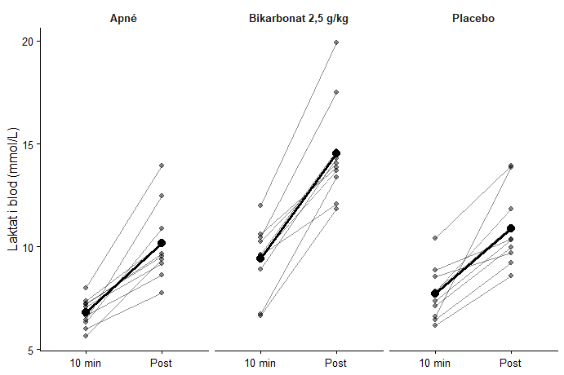
Figure 4.4: Slopegraph for laktat: individuelle målinger og gjennomsnitt ved 10 min og post for Apné, Bikarbonat 2,5 g/kg og Placebo (separate paneler).
Toveis r-m ANOVA
Antall observasjoner per protokoll × tid (laktat):
time
protocol 10min Post
Apne 10 10
Bikarb 10 10
Placebo 10 10
Antall deltakere: 10
Toveis repeated-measures ANOVA (Laktat):
Error: id
Df Sum Sq Mean Sq F value Pr(>F)
Residuals 9 108.3 12.04
Error: id:protocol
Df Sum Sq Mean Sq F value Pr(>F)
protocol 2 134.48 67.24 94.95 2.73e-10 ***
Residuals 18 12.75 0.71
---
Signif. codes: 0 '***' 0.001 '**' 0.01 '*' 0.05 '.' 0.1 ' ' 1
Error: id:time
Df Sum Sq Mean Sq F value Pr(>F)
time 1 224.92 224.92 66.3 1.92e-05 ***
Residuals 9 30.53 3.39
---
Signif. codes: 0 '***' 0.001 '**' 0.01 '*' 0.05 '.' 0.1 ' ' 1
Error: id:protocol:time
Df Sum Sq Mean Sq F value Pr(>F)
protocol:time 2 11.227 5.614 12.81 0.000347 ***
Residuals 18 7.889 0.438
---
Signif. codes: 0 '***' 0.001 '**' 0.01 '*' 0.05 '.' 0.1 ' ' 1
Post-hoc: protokollforskjeller ved 10min (paired t, Holm):
Pairwise comparisons using paired t tests
data: x10$value and x10$protocol
Apne Bikarb
Bikarb 0.0011 -
Placebo 0.0216 0.0011
P value adjustment method: holm
Post-hoc: protokollforskjeller ved Post (paired t, Holm):
Pairwise comparisons using paired t tests
data: xp$value and xp$protocol
Apne Bikarb
Bikarb 1.1e-07 -
Placebo 0.028 3.0e-06
P value adjustment method: holm
Post-hoc: endring 10min → Post innen hver protokoll (paired t, Holm):
Apne Bikarb Placebo
2.253195e-04 2.014444e-05 2.253195e-04
Med ES:
Toveis repeated-measures ANOVA (Laktat):
Error: id
Df Sum Sq Mean Sq F value Pr(>F)
Residuals 9 108.3 12.04
Error: id:protocol
Df Sum Sq Mean Sq F value Pr(>F)
protocol 2 134.48 67.24 94.95 2.73e-10 ***
Residuals 18 12.75 0.71
---
Signif. codes: 0 '***' 0.001 '**' 0.01 '*' 0.05 '.' 0.1 ' ' 1
Error: id:time
Df Sum Sq Mean Sq F value Pr(>F)
time 1 224.92 224.92 66.3 1.92e-05 ***
Residuals 9 30.53 3.39
---
Signif. codes: 0 '***' 0.001 '**' 0.01 '*' 0.05 '.' 0.1 ' ' 1
Error: id:protocol:time
Df Sum Sq Mean Sq F value Pr(>F)
protocol:time 2 11.227 5.614 12.81 0.000347 ***
Residuals 18 7.889 0.438
---
Signif. codes: 0 '***' 0.001 '**' 0.01 '*' 0.05 '.' 0.1 ' ' 1
Effect size – partial eta squared (Laktat):
# Effect Size for ANOVA (Type I)
Group | Parameter | Eta2 (partial) | 95% CI
----------------------------------------------------------------
id:protocol | protocol | 0.91 | [0.83, 1.00]
id:time | time | 0.88 | [0.69, 1.00]
id:protocol:time | protocol:time | 0.59 | [0.29, 1.00]
- One-sided CIs: upper bound fixed at [1.00].
Post-hoc 10min (Holm + dz):
Pairwise comparisons using paired t tests
data: x10$value and x10$protocol
Apne Bikarb
Bikarb 0.0011 -
Placebo 0.0216 0.0011
P value adjustment method: holm
comparison dz
1 Apne-Bikarb -1.7565706
2 Apne-Placebo -0.8772181
3 Bikarb-Placebo 1.6858869
Post-hoc Post (Holm + dz):
Pairwise comparisons using paired t tests
data: xp$value and xp$protocol
Apne Bikarb
Bikarb 1.1e-07 -
Placebo 0.028 3.0e-06
P value adjustment method: holm
comparison dz
1 Apne-Bikarb -5.3821710
2 Apne-Placebo -0.8300578
3 Bikarb-Placebo 3.5044918
Endring 10min → Post (Holm + dz):
protocol p dz p_holm
1 Apne 1.126598e-04 2.052548 2.253195e-04
2 Bikarb 6.714814e-06 2.930638 2.014444e-05
3 Placebo 2.182434e-04 1.878123 2.253195e-04

4.2.2 pH i blodet
Table 4.2: pH
Mål | Apné | Bikarbonat | Placebo
pH - Baseline | 7.402 (0.015) | 7.464 (0.031) | 7.404 (0.015)
pH - Pre | 7.389 (0.020) | 7.454 (0.025) | 7.381 (0.024)
pH - Post | 7.218 (0.076) | 7.232 (0.071) | 7.212 (0.066)
pH - NA | 7.311 (0.043) | 7.357 (0.042) | 7.302 (0.048)
Verdier er oppgitt som gjennomsnitt (SD).
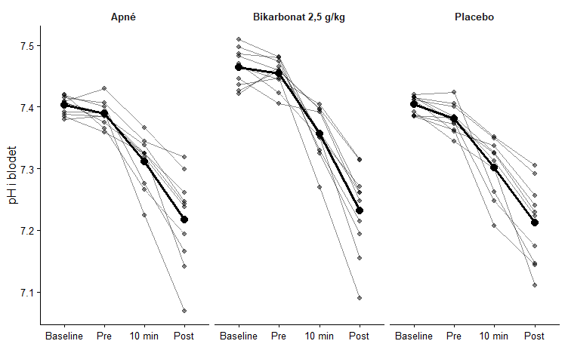
Figure 4.5: Slopegraph for pH: individuelle målinger og gjennomsnitt ved baseline, pre, 10 min og post for Apné, Bikarbonat 2,5 g/kg og Placebo (separate paneler).
ANOVA:
Toveis repeated-measures ANOVA (pH):
Error: id
Df Sum Sq Mean Sq F value Pr(>F)
Residuals 9 0.09575 0.01064
Error: id:protocol
Df Sum Sq Mean Sq F value Pr(>F)
protocol 2 0.0657 0.03285 93.86 3.01e-10 ***
Residuals 18 0.0063 0.00035
---
Signif. codes: 0 '***' 0.001 '**' 0.01 '*' 0.05 '.' 0.1 ' ' 1
Error: id:time
Df Sum Sq Mean Sq F value Pr(>F)
time 3 0.7815 0.26052 68.79 9.11e-13 ***
Residuals 27 0.1023 0.00379
---
Signif. codes: 0 '***' 0.001 '**' 0.01 '*' 0.05 '.' 0.1 ' ' 1
Error: id:protocol:time
Df Sum Sq Mean Sq F value Pr(>F)
protocol:time 6 0.01071 0.0017856 8.832 1.03e-06 ***
Residuals 54 0.01092 0.0002022
---
Signif. codes: 0 '***' 0.001 '**' 0.01 '*' 0.05 '.' 0.1 ' ' 1
Post-hoc: protokollforskjeller ved hvert tidspunkt (paired t-test, Holm):
Tidspunkt: Baseline
Pairwise comparisons using paired t tests
data: tmp$ph and tmp$protocol
Apne Bikarb
Bikarb 0.00019 -
Placebo 0.38031 0.00019
P value adjustment method: holm
Tidspunkt: Pre
Pairwise comparisons using paired t tests
data: tmp$ph and tmp$protocol
Apne Bikarb
Bikarb 5.5e-05 -
Placebo 0.14 4.6e-06
P value adjustment method: holm
Tidspunkt: 10min
Pairwise comparisons using paired t tests
data: tmp$ph and tmp$protocol
Apne Bikarb
Bikarb 1.0e-05 -
Placebo 0.055 4.3e-06
P value adjustment method: holm
Tidspunkt: Post
Pairwise comparisons using paired t tests
data: tmp$ph and tmp$protocol
Apne Bikarb
Bikarb 0.0095 -
Placebo 0.6166 0.1434
P value adjustment method: holm
Post-hoc: tidsforskjeller innen hver protokoll (paired t-test, Holm):
Protokoll: Apne
comparison p_raw p_holm
1 Baseline vs Pre 7.915897e-02 0.0791589699
2 Baseline vs 10min 1.493335e-04 0.0005092366
3 Baseline vs Post 2.474257e-05 0.0001484554
4 Pre vs 10min 1.863868e-04 0.0005092366
5 Pre vs Post 2.534458e-05 0.0001484554
6 10min vs Post 1.273091e-04 0.0005092366
Protokoll: Bikarb
comparison p_raw p_holm
1 Baseline vs Pre 3.288047e-01 3.288047e-01
2 Baseline vs 10min 1.548718e-04 4.646153e-04
3 Baseline vs Post 5.440097e-06 2.273986e-05
4 Pre vs 10min 3.217374e-04 6.434748e-04
5 Pre vs Post 3.920505e-06 2.273986e-05
6 10min vs Post 3.789977e-06 2.273986e-05
Protokoll: Placebo
comparison p_raw p_holm
1 Baseline vs Pre 3.828321e-03 3.828321e-03
2 Baseline vs 10min 7.136410e-05 2.394228e-04
3 Baseline vs Post 4.541709e-06 2.725025e-05
4 Pre vs 10min 7.053707e-04 1.410741e-03
5 Pre vs Post 1.053358e-05 5.266788e-05
6 10min vs Post 5.985570e-05 2.394228e-04
Planlagt post-hoc: Δ(Pre − Baseline) mellom protokoller (paired t-test, Holm):
Pairwise comparisons using paired t tests
data: delta_wide$delta_pre_minus_base and factor(delta_wide$protocol, levels = c("Apne", "Bikarb", "Placebo"))
Apne Bikarb
Bikarb 0.62 -
Placebo 0.28 0.28
P value adjustment method: holm
Med ES:
Toveis repeated-measures ANOVA (pH):
Error: id
Df Sum Sq Mean Sq F value Pr(>F)
Residuals 9 0.09575 0.01064
Error: id:protocol
Df Sum Sq Mean Sq F value Pr(>F)
protocol 2 0.0657 0.03285 93.86 3.01e-10 ***
Residuals 18 0.0063 0.00035
---
Signif. codes: 0 '***' 0.001 '**' 0.01 '*' 0.05 '.' 0.1 ' ' 1
Error: id:time
Df Sum Sq Mean Sq F value Pr(>F)
time 3 0.7815 0.26052 68.79 9.11e-13 ***
Residuals 27 0.1023 0.00379
---
Signif. codes: 0 '***' 0.001 '**' 0.01 '*' 0.05 '.' 0.1 ' ' 1
Error: id:protocol:time
Df Sum Sq Mean Sq F value Pr(>F)
protocol:time 6 0.01071 0.0017856 8.832 1.03e-06 ***
Residuals 54 0.01092 0.0002022
---
Signif. codes: 0 '***' 0.001 '**' 0.01 '*' 0.05 '.' 0.1 ' ' 1
Effect size – partial eta squared (pH):
# Effect Size for ANOVA (Type I)
Group | Parameter | Eta2 (partial) | 95% CI
----------------------------------------------------------------
id:protocol | protocol | 0.91 | [0.83, 1.00]
id:time | time | 0.88 | [0.81, 1.00]
id:protocol:time | protocol:time | 0.50 | [0.30, 1.00]
- One-sided CIs: upper bound fixed at [1.00].
Post-hoc: protokollforskjeller ved hvert tidspunkt (Holm + dz):
Tidspunkt: Baseline
comparison p_raw dz p_holm
1 Apne vs Bikarb 6.182729e-05 2.2201066 0.0001854819
2 Apne vs Placebo 3.803052e-01 0.2917383 0.3803051609
3 Bikarb vs Placebo 8.020646e-05 -2.1462907 0.0001854819
Tidspunkt: Pre
comparison p_raw dz p_holm
1 Apne vs Bikarb 2.731597e-05 2.4639003 5.463194e-05
2 Apne vs Placebo 1.365908e-01 -0.5168656 1.365908e-01
3 Bikarb vs Placebo 1.538006e-06 -3.4974031 4.614018e-06
Tidspunkt: 10min
comparison p_raw dz p_holm
1 Apne vs Bikarb 5.087147e-06 3.030974 1.017429e-05
2 Apne vs Placebo 5.520491e-02 -0.696177 5.520491e-02
3 Bikarb vs Placebo 1.424443e-06 -3.529321 4.273330e-06
Tidspunkt: Post
comparison p_raw dz p_holm
1 Apne vs Bikarb 0.003177039 1.2604725 0.009531116
2 Apne vs Placebo 0.616580862 -0.1639803 0.616580862
3 Bikarb vs Placebo 0.071678676 -0.6453403 0.143357352
Post-hoc: tidsforskjeller innen hver protokoll (Holm + dz):
Protokoll: Apne
comparison p_raw dz p_holm
1 Baseline vs Pre 7.915897e-02 -0.6258842 0.0791589699
2 Baseline vs 10min 1.493335e-04 -1.9769566 0.0005092366
3 Baseline vs Post 2.474257e-05 -2.4947462 0.0001484554
4 Pre vs 10min 1.863868e-04 -1.9188234 0.0005092366
5 Pre vs Post 2.534458e-05 -2.4872248 0.0001484554
6 10min vs Post 1.273091e-04 -2.0195222 0.0005092366
Protokoll: Bikarb
comparison p_raw dz p_holm
1 Baseline vs Pre 3.288047e-01 -0.3264906 3.288047e-01
2 Baseline vs 10min 1.548718e-04 -1.9673269 4.646153e-04
3 Baseline vs Post 5.440097e-06 -3.0064699 2.273986e-05
4 Pre vs 10min 3.217374e-04 -1.7803324 6.434748e-04
5 Pre vs Post 3.920505e-06 -3.1277336 2.273986e-05
6 10min vs Post 3.789977e-06 -3.1405004 2.273986e-05
Protokoll: Placebo
comparison p_raw dz p_holm
1 Baseline vs Pre 3.828321e-03 -1.221650 3.828321e-03
2 Baseline vs 10min 7.136410e-05 -2.179200 2.394228e-04
3 Baseline vs Post 4.541709e-06 -3.072786 2.725025e-05
4 Pre vs 10min 7.053707e-04 -1.591939 1.410741e-03
5 Pre vs Post 1.053358e-05 -2.773740 5.266788e-05
6 10min vs Post 5.985570e-05 -2.229424 2.394228e-04
Planlagt post-hoc: Δ(Pre − Baseline) mellom protokoller (Holm + dz):
comparison p_raw dz p_holm
1 Apne vs Bikarb 0.61788658 0.1633642 0.6178866
2 Apne vs Placebo 0.09484536 -0.5901990 0.2837266
3 Bikarb vs Placebo 0.09457554 -0.5907642 0.2837266

4.2.3 Hb-konsentrasjon
Table 4.3: Hb-konsentrasjon
Mål | Apné | Bikarbonat | Placebo
Hb - Baseline | 16.33 (0.80) | 15.81 (0.64) | 16.20 (0.81)
Hb - Pre | 16.39 (1.05) | 15.88 (0.93) | 16.11 (0.95)
Hb - Post | 17.05 (1.07) | 16.66 (0.95) | 16.81 (0.87)
Hb - NA | 16.68 (1.03) | 16.45 (0.97) | 16.74 (0.81)
Verdier er oppgitt som gjennomsnitt (SD).
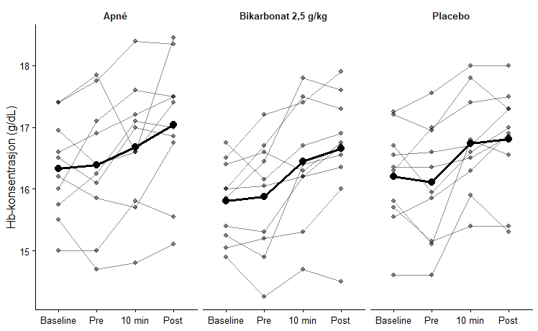
Figure 4.6: Slopegraph for Hb-konsentrasjon: individuelle målinger og gjennomsnitt ved baseline, pre, 10 min og post for Apné, Bikarbonat 2,5 g/kg og Placebo (separate paneler).
ANOVA:
Toveis repeated-measures ANOVA (Hb):
Error: id
Df Sum Sq Mean Sq F value Pr(>F)
Residuals 9 74.19 8.243
Error: id:protocol
Df Sum Sq Mean Sq F value Pr(>F)
protocol 2 3.499 1.7496 8.297 0.00279 **
Residuals 18 3.795 0.2109
---
Signif. codes: 0 '***' 0.001 '**' 0.01 '*' 0.05 '.' 0.1 ' ' 1
Error: id:time
Df Sum Sq Mean Sq F value Pr(>F)
time 3 11.85 3.949 14.67 7.34e-06 ***
Residuals 27 7.27 0.269
---
Signif. codes: 0 '***' 0.001 '**' 0.01 '*' 0.05 '.' 0.1 ' ' 1
Error: id:protocol:time
Df Sum Sq Mean Sq F value Pr(>F)
protocol:time 6 0.51 0.08501 0.898 0.503
Residuals 54 5.11 0.09464
Post-hoc: protokollforskjeller ved hvert tidspunkt (paired, Holm):
Tidspunkt: Baseline
Pairwise comparisons using paired t tests
data: tmp$hb and tmp$protocol
Apne Bikarb
Bikarb 0.12 -
Placebo 0.44 0.12
P value adjustment method: holm
Tidspunkt: Pre
Pairwise comparisons using paired t tests
data: tmp$hb and tmp$protocol
Apne Bikarb
Bikarb 0.019 -
Placebo 0.133 0.199
P value adjustment method: holm
Tidspunkt: 10min
Pairwise comparisons using paired t tests
data: tmp$hb and tmp$protocol
Apne Bikarb
Bikarb 0.399 -
Placebo 0.745 0.023
P value adjustment method: holm
Tidspunkt: Post
Pairwise comparisons using paired t tests
data: tmp$hb and tmp$protocol
Apne Bikarb
Bikarb 0.028 -
Placebo 0.204 0.353
P value adjustment method: holm
Post-hoc: tidsforskjeller innen hver protokoll (paired, Holm):
Protokoll: Apne
comparison p_raw p_holm
1 Baseline vs Pre 7.524745e-01 7.524745e-01
2 Baseline vs 10min 2.382809e-01 5.639510e-01
3 Baseline vs Post 2.298340e-03 1.149170e-02
4 Pre vs 10min 1.879837e-01 5.639510e-01
5 Pre vs Post 2.296909e-06 1.378146e-05
6 10min vs Post 1.222156e-01 4.888624e-01
Protokoll: Bikarb
comparison p_raw p_holm
1 Baseline vs Pre 0.6698486072 0.669848607
2 Baseline vs 10min 0.0225746040 0.067723812
3 Baseline vs Post 0.0027619879 0.013809939
4 Pre vs 10min 0.0116776630 0.046710652
5 Pre vs Post 0.0003188872 0.001913323
6 10min vs Post 0.0806907901 0.161381580
Protokoll: Placebo
comparison p_raw p_holm
1 Baseline vs Pre 0.5617862210 1.000000000
2 Baseline vs 10min 0.0113922827 0.034176848
3 Baseline vs Post 0.0034140067 0.017070034
4 Pre vs 10min 0.0039353941 0.017070034
5 Pre vs Post 0.0002344848 0.001406909
6 10min vs Post 0.6161520387 1.000000000
Planlagt post-hoc: Δ(Pre − Baseline) mellom protokoller (paired, Holm):
Pairwise comparisons using paired t tests
data: delta_wide$delta_pre_minus_base and factor(delta_wide$protocol, levels = c("Apne", "Bikarb", "Placebo"))
Apne Bikarb
Bikarb 0.95 -
Placebo 0.85 0.54
P value adjustment method: holm
Med ES:
Toveis repeated-measures ANOVA (Hb):
Error: id
Df Sum Sq Mean Sq F value Pr(>F)
Residuals 9 74.19 8.243
Error: id:protocol
Df Sum Sq Mean Sq F value Pr(>F)
protocol 2 3.499 1.7496 8.297 0.00279 **
Residuals 18 3.795 0.2109
---
Signif. codes: 0 '***' 0.001 '**' 0.01 '*' 0.05 '.' 0.1 ' ' 1
Error: id:time
Df Sum Sq Mean Sq F value Pr(>F)
time 3 11.85 3.949 14.67 7.34e-06 ***
Residuals 27 7.27 0.269
---
Signif. codes: 0 '***' 0.001 '**' 0.01 '*' 0.05 '.' 0.1 ' ' 1
Error: id:protocol:time
Df Sum Sq Mean Sq F value Pr(>F)
protocol:time 6 0.51 0.08501 0.898 0.503
Residuals 54 5.11 0.09464
Effect size – partial eta squared (Hb):
# Effect Size for ANOVA (Type I)
Group | Parameter | Eta2 (partial) | 95% CI
----------------------------------------------------------------
id:protocol | protocol | 0.48 | [0.16, 1.00]
id:time | time | 0.62 | [0.39, 1.00]
id:protocol:time | protocol:time | 0.09 | [0.00, 1.00]
- One-sided CIs: upper bound fixed at [1.00].
Post-hoc: protokollforskjeller ved hvert tidspunkt (Holm + dz):
Tidspunkt: Baseline
comparison p_raw dz p_holm
1 Apne vs Bikarb 0.05510177 -0.6965396 0.1154935
2 Apne vs Placebo 0.44286562 -0.2538146 0.4428656
3 Bikarb vs Placebo 0.03849782 0.7658354 0.1154935
Tidspunkt: Pre
comparison p_raw dz p_holm
1 Apne vs Bikarb 0.006417765 -1.1161641 0.01925329
2 Apne vs Placebo 0.066575935 -0.6597627 0.13315187
3 Bikarb vs Placebo 0.198923695 0.4385042 0.19892369
Tidspunkt: 10min
comparison p_raw dz p_holm
1 Apne vs Bikarb 0.19933610 -0.4380621 0.39867220
2 Apne vs Placebo 0.74517141 0.1059924 0.74517141
3 Bikarb vs Placebo 0.00768793 1.0799332 0.02306379
Tidspunkt: Post
comparison p_raw dz p_holm
1 Apne vs Bikarb 0.009268113 -1.0427327 0.02780434
2 Apne vs Placebo 0.102078887 -0.5755821 0.20415777
3 Bikarb vs Placebo 0.353287185 0.3095018 0.35328718
Post-hoc: tidsforskjeller innen hver protokoll (Holm + dz):
Protokoll: Apne
comparison p_raw dz p_holm
1 Baseline vs Pre 7.524745e-01 0.1028320 7.524745e-01
2 Baseline vs 10min 2.382809e-01 0.3994388 5.639510e-01
3 Baseline vs Post 2.298340e-03 1.3289315 1.149170e-02
4 Pre vs 10min 1.879837e-01 0.4505293 5.639510e-01
5 Pre vs Post 2.296909e-06 3.3345822 1.378146e-05
6 10min vs Post 1.222156e-01 0.5394514 4.888624e-01
Protokoll: Bikarb
comparison p_raw dz p_holm
1 Baseline vs Pre 0.6698486072 0.1393512 0.669848607
2 Baseline vs 10min 0.0225746040 0.8687872 0.067723812
3 Baseline vs Post 0.0027619879 1.2899051 0.013809939
4 Pre vs 10min 0.0116776630 0.9971227 0.046710652
5 Pre vs Post 0.0003188872 1.7825384 0.001913323
6 10min vs Post 0.0806907901 0.6221173 0.161381580
Protokoll: Placebo
comparison p_raw dz p_holm
1 Baseline vs Pre 0.5617862210 -0.1904907 1.000000000
2 Baseline vs 10min 0.0113922827 1.0019873 0.034176848
3 Baseline vs Post 0.0034140067 1.2454456 0.017070034
4 Pre vs 10min 0.0039353941 1.2159433 0.017070034
5 Pre vs Post 0.0002344848 1.8597913 0.001406909
6 10min vs Post 0.6161520387 0.1641828 1.000000000
Planlagt post-hoc: Δ(Pre − Baseline) mellom protokoller (Holm + dz):
comparison p_raw dz p_holm
1 Apne vs Bikarb 0.9476421 0.02135245 0.9476421
2 Apne vs Placebo 0.4272863 -0.26289281 0.8545727
3 Bikarb vs Placebo 0.1815640 -0.45787021 0.5446919
Apné tid vs Hb:
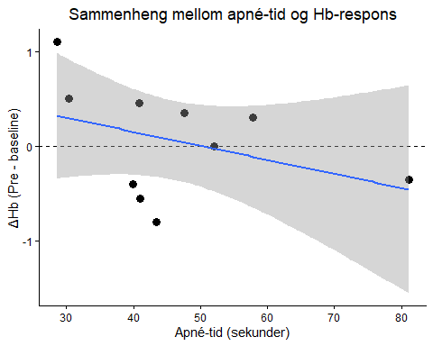
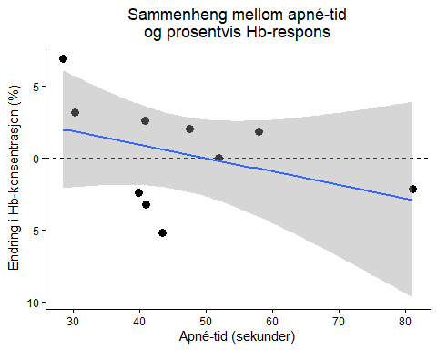

5. Diskusjon

6. Referanser

