**Assignment II (Parallelize Particle Simulation)**

Parallel Algorithms (Fall 2021)

Shiraz University

The purpose of this assignment is introduction to programming in shared memory models. Your goal is to parallelize a toy particle simulator (similar particle simulators are used in mechanics, biology, astronomy, etc.) that reproduces the behavior shown in the following Figure:

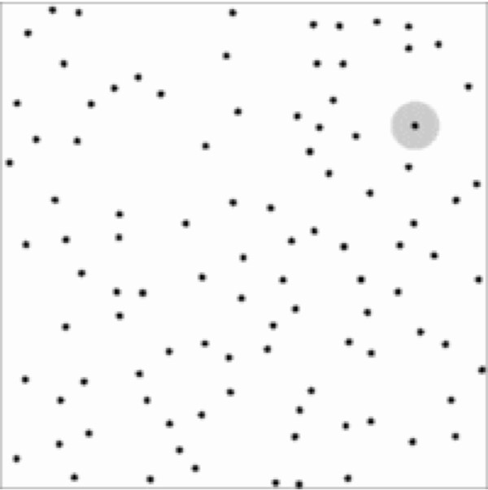

The range of interaction forces is limited as shown in grey for a selected particle. Density is set sufficiently low so that given *n* particles, only *O*(*n*) interactions are expected. Suppose we have a code that runs in time *T = O(n)* on a single processor. Then we'd hope to run in time *T/p* when using *p* processors. We'd like you to write parallel codes using pthreads that approach these expectations. The serial code will be provided through a zip file.

Deliverable

Here is the list of items you might show in your report:

* A description of the synchronization you used in the shared memory implementation.
* A description of the design choices that you tried and how did they affect the performance.
* Speedup plots that show how closely your parallel codes approach the idealized *p*times speedup and a discussion on whether it is possible to do better.
* Where does the time go? Consider breaking down the runtime into computation time, synchronization time and/or communication time. How do they scale with *p*?
* A discussion on using pthreads.