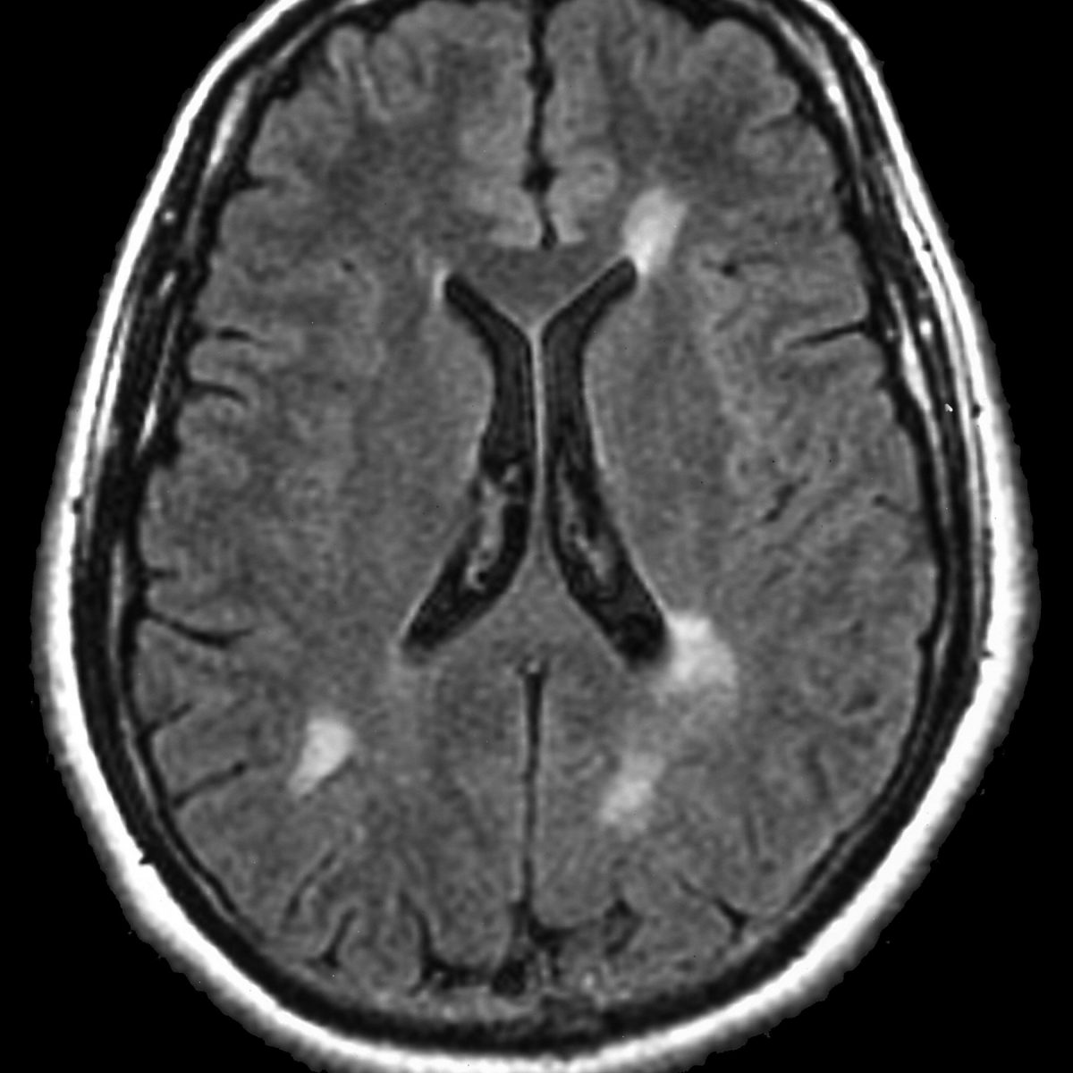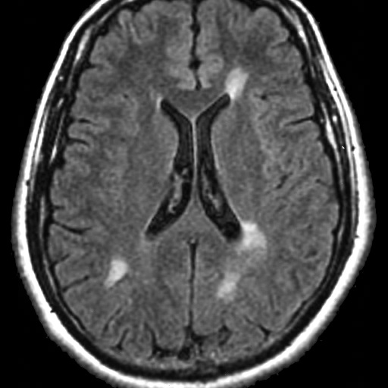

(a) (b) (c) (d)

Figure 1. (a) CT-Scan (Host Image); (b) Copyright (Watermark Image); (c) Watermarked Image;

(d) Extracted Watermark.

**Table 1.** Imperceptibility Analysis for Different Groups of Images by PSNR (dB) and SSIM.

|  |  |  |  |
| --- | --- | --- | --- |
| **Image Type** | **Image Name** | **PSNR (dB)** | **SSIM** |
| Aerials | Satelite Image | 48.131 | 1.000 |
| People | Girl | 46.624 | 0.999 |
| Woman | 48.193 | 0.997 |
| Miscellaneous | Pepper | 48.131 | 1.000 |
| House | 48.131 | 1.000 |
| Medical Image | Brain | 47.086 | 0.999 |
| CT-Scan | 46.367 | 0.999 |
| Texture | Foam | 47.532 | 1.000 |
| Straw | 48.131 | 1.000 |

**Table 2.** Robustness Analysis for Noise Attack with Different Groups of Images by NC.

|  |  |  |  |  |  |
| --- | --- | --- | --- | --- | --- |
| **Image Type** | **Image Name** | **GN** | **PN** | **SPN** | **SN** |
| Aerials | Satelite Image | 0.965 | 0.968 | 0.995 | 0.965 |
| People | Girl | 0.966 | 0.965 | 0.994 | 0.957 |
| Woman | 0.969 | 0.972 | 0.994 | 0.966 |
| Miscellaneous | Pepper | 0.955 | 0.960 | 0.993 | 0.954 |
| House | 0.955 | 0.959 | 0.991 | 0.953 |
| Medical Image | Brain | 0.991 | 0.992 | 0.998 | 0.990 |
| CT-Scan | 0.989 | 0.989 | 0.998 | 0.987 |
| Texture | Foam | 0.968 | 0.971 | 0.996 | 0.966 |
| Straw | 0.965 | 0.968 | 0.993 | 0.964 |

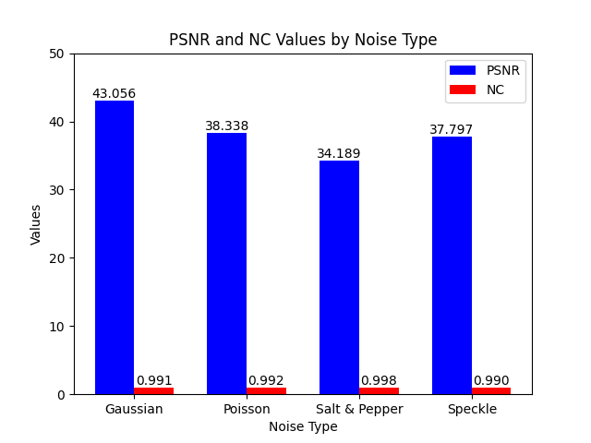

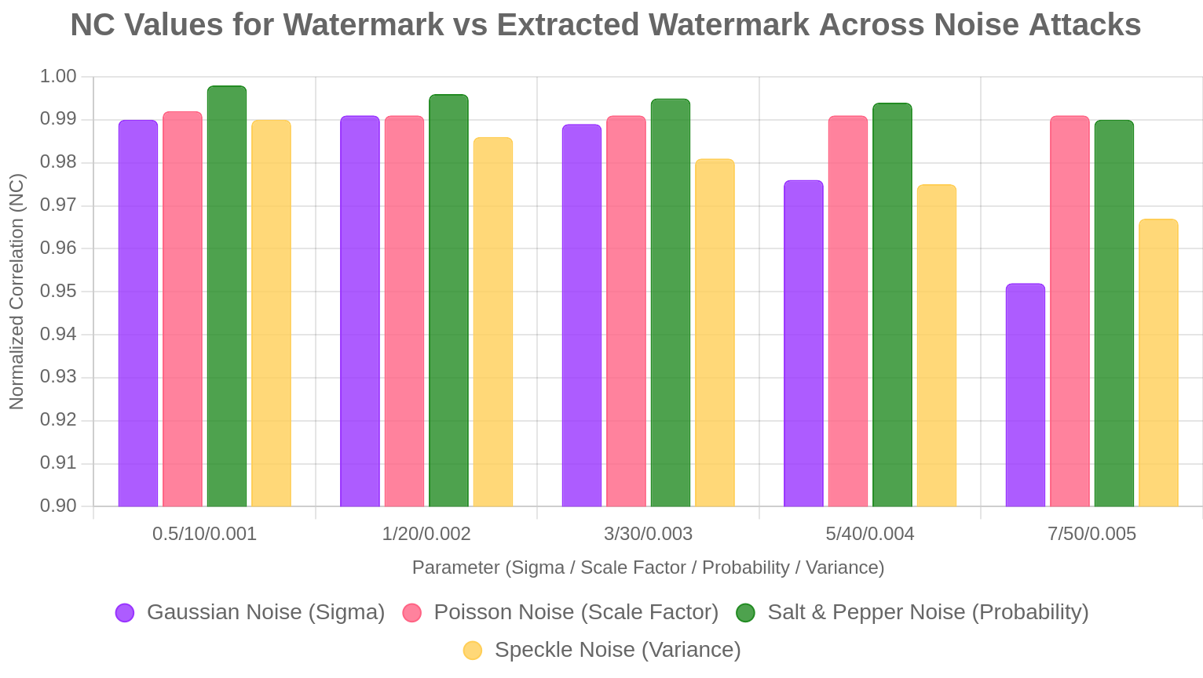

**Filter Attack:**

|  |  |  |
| --- | --- | --- |
| **Low Pass Gaussian Filter(3x3)**    PSNR: 47.085, NC: 0.999 | **Median Filter(3x3)**      PSNR: 41.752, NC: 0.998 | **Average Filter(3x3)**    PSNR: 37.488, NC: 0.958 |

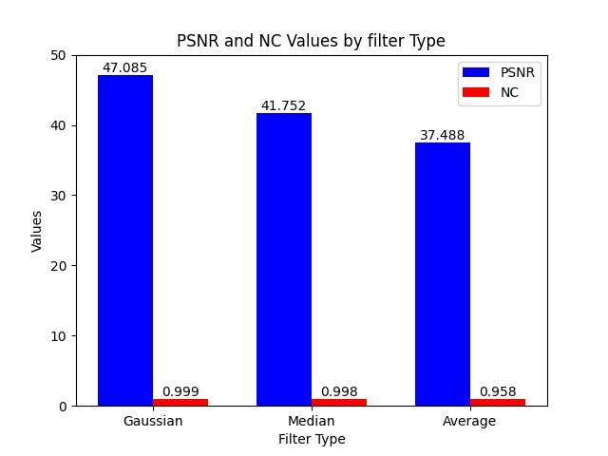

Robustness analysis for Filter Attack:

|  |  |  |  |  |
| --- | --- | --- | --- | --- |
| **Image Type** | **Image Name** | **Gaussian Filter** | **Median Filter** | **Average Filter** |
| Aerials | Satelite Image | 0.994 | 0.980 | 0.979 |
| People | Girl | 0.994 | 0.995 | 0.994 |
| Woman | 0.994 | 0.983 | 0.957 |
| Miscellaneous | Pepper | 0.992 | 0.991 | 0.989 |
| House | 0.992 | 0.995 | 0.996 |
| Medical Image | Brain | 0.999 | 0.998 | 0.958 |
| Ct Scan | 0.999 | 0.997 | 0.967 |
| Texture | Foam | 0.995 | 0.868 | 0.886 |
| Straw | 0.994 | 0.993 | 0.971 |

Robustness analysis for Geometric attack:

|  |  |  |  |  |
| --- | --- | --- | --- | --- |
| **Image Type** | **Image Name** | **Cropping** | **Rotation** | **Scaling** |
| Aerials | Satelite Image | 0.993 | 0.994 | 0.998 |
| People | Girl | 0.994 | 0.994 | 0.997 |
| Woman | 0.994 | 0.995 | 0.999 |
| Miscellaneous | Pepper | 0.995 | 0.993 | 0.998 |
| House | 0.999 | 0.992 | 0.998 |
| Medical Image | Brain | 0.998 | 0.999 | 0.998 |
| Ct Scan | 0.998 | 0.999 | 0.999 |
| Texture | Foam | 0.991 | 0.996 | 0.998 |
| Straw | 0.991 | 0.996 | 0.999 |

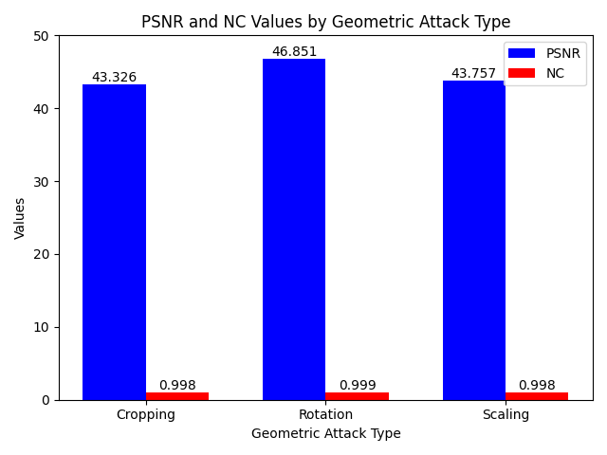

Robustness analysis for JPEG Compression attack

|  |  |  |  |
| --- | --- | --- | --- |
| **Image Type** | **Image Name** | **PSNR(dB)** | **NC** |
| Aerials | Satelite Image | 35.265 | 0.993 |
| People | Girl | 36.489 | 0.993 |
| Woman | 37.526 | 0.995 |
| Miscellaneous | Pepper | 36.482 | 0.992 |
| House | 44.562 | 0.992 |
| Medical Image | Brain | 42.099 | 0.998 |
| Ct Scan | 39.918 | 0.999 |
| Texture | Foam | 31.721 | 0.997 |
| Straw | 35.526 | 0.994 |

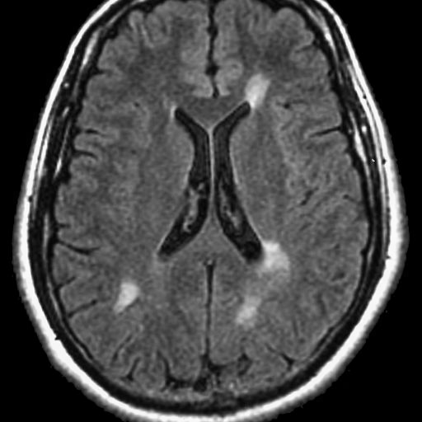

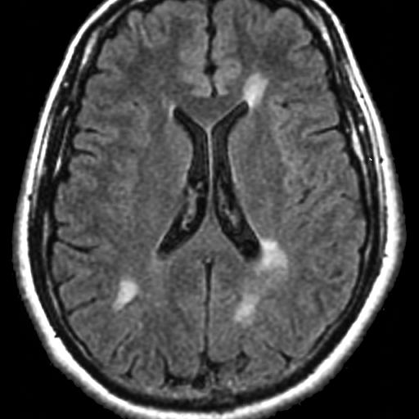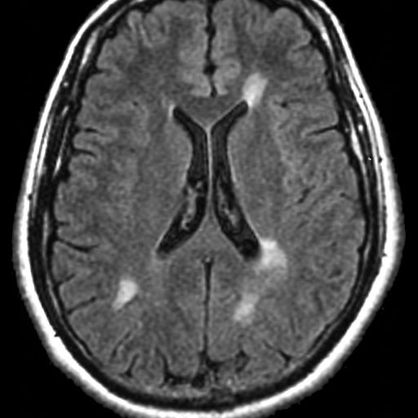

(a) (b) (c) (d)

Figure: Watermarked Image(a), Compressed(JPEG) Image(b), Reconstructed Host(c), Extracted Watermark(d).

**Robustness analysis for Hybrid attacks:**

|  |  |  |  |  |  |  |
| --- | --- | --- | --- | --- | --- | --- |
| **Image Type** | **Image Name** | **GN+JPEG** | **SPN+Rotate** | **SPN+GF** | **Crop+JPEG** | **SN+SPN** |
| Aerials | Satelite Image | 0.965 | 0.995 | 0.995 | 0.992 | 0.968 |
| People | Girl | 0.965 | 0.995 | 0.998 | 0.993 | 0.959 |
| Woman | 0.985 | 0.995 | 0.998 | 0.995 | 0.966 |
| Miscellaneous | Pepper | 0.959 | 0.994 | 0.998 | 0.995 | 0.962 |
| House | 0.961 | 0.991 | 0.998 | 0.999 | 0.951 |
| Medical Image | Brain | 0.991 | 0.996 | 0.995 | 0.997 | 0.989 |
| Ct Scan | 0.989 | 0.998 | 0.997 | 0.998 | 0.986 |
| Texture | Foam | 0.986 | 0.996 | 0.995 | 0.994 | 0.976 |
| Straw | 0.965 | 0.993 | 0.993 | 0.991 | 0.961 |

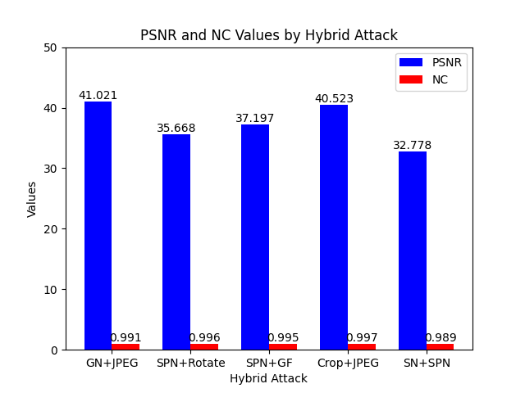

|  |  |  |
| --- | --- | --- |
| **GN + JPEG**    PSNR: 41.021, NC: 0.991 | **SPN + Rotation (-0.1)**    PSNR: 35.668, NC: 0.995 | **SPN + GF (3x3)**      PSNR: 37.197, NC: 0.995 |
| **Crop + JPEG**      PSNR: 40.523, NC: 0.997 | **SN + SPN**      PSNR: 32.778, NC: 0.989 |  |

**Security Analysis:**

|  |  |  |  |
| --- | --- | --- | --- |
| |  |  | | --- | --- | | (a) | (b) | |  |

Figure: Extracted watermark; (a) with right key 10; (b) with wrong key 5

**Encryption effect:**

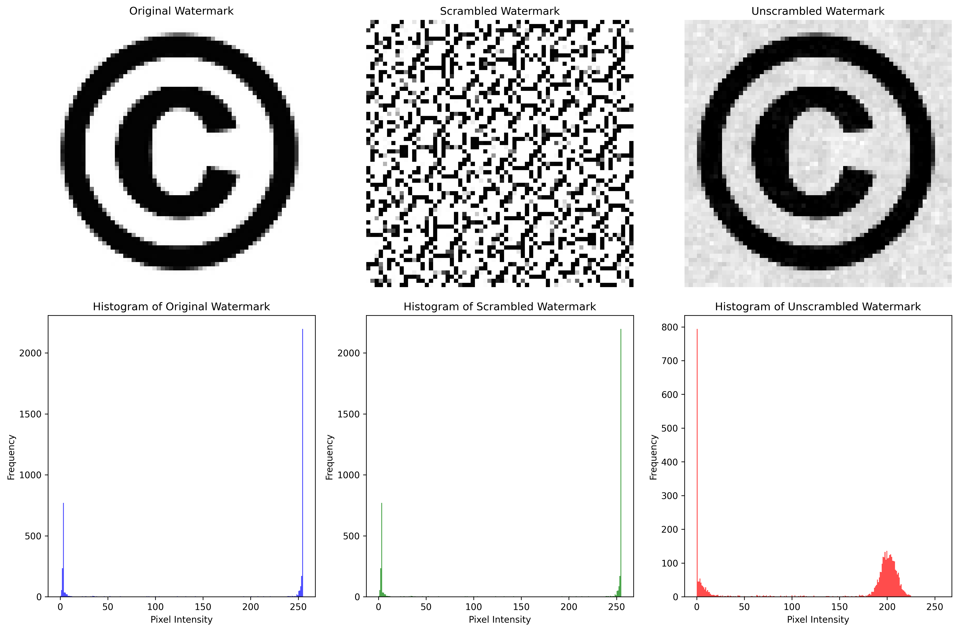

**Table:** Comparison of Characteristics of the Proposed Method with Recent Methods.

|  |  |  |  |  |  |  |
| --- | --- | --- | --- | --- | --- | --- |
| **Parameter** | **Scientific Reports, "An adaptive robust watermarking scheme based on chaotic mapping," 2024** | **ScienceDirect, "A comprehensive review on optimization-based image watermarking," 2024** | **ScienceDirect, "Robust watermarking against print and scan attack," 2023** | **ScienceDirect, "Robust and reliable image copyright protection," 2023** | **PMC, "Encryption-based image watermarking in 2DWT-DCT domains," 2023** | **Proposed Method** |
| **Method** | DWT, Heisenberg decomposition, SVD | Varies (DWT, DCT, SVD, optimization-based) | DWT-DCT composite, SVD modification | Two-level SVD, block DCT, integer wavelet transform | 2DWT-DCT, zig-zag operation | DWT+  SVD |
| **Cover Image Type** | Baboon, Goldhill, Lake, Peppers | Satellite image, Lena | Character image | Lena | Baboon, Lake | Satellite Image, Brain, Woman |
| **Cover Image Size and Color** | 512 × 512,  color images in YcbCr space | 512 × 512,  color and greyscale | 512 × 512,  grayscale | 512 × 512,  color | 512 × 512,  grayscale | 512 × 512,  grayscale |
| **Watermark Image**  **Type** | Man and Woman in a room | Logo, Signature | Logo | Logo of Math works company | Baboon | Copyright |
| **Watermark Image**  **Size and Color** | 64 × 64,  color images in YcbCr space | 64 × 64,  binary or grreyscale | 32 × 32,  grayscale | 128 × 128,  grayscale | 64 × 64,  grayscale | 64 × 64,  grayscale |
| **PSNR (dB)** | 45.34 | 40-50 | 43.8 | 44.5 | 45.2 | Satellite Image(48.131), Brain(47.086), Woman(48.193) |
| **SSIM** | 0.9987 | 0.98-0.999 | 0.997 | 0.998 | 0.998 | Satellite Image(1.000), Brain(0.999), Woman(0.997) |
| **NC** | >0.95 | >0.9 | >0.92 | >0.97 | >0.95 | Satellite Image(0.994), Brain(0.999), Woman(0.994) |
| **Security Technique** | Logistic chaotic mapping encryption | Visual cryptography, chaotic maps | ABC optimization | Guided dynamic PSO | Random bit sequence encryption | Arnold  transform |
| **Applications** | Copyright protection, information hiding | Multimedia security, Copyright protection | Security documents, ID cards | Digital media protection | Secure image transmission | Copyright  protection |

**Imperceptibility Comparison:**

|  |  |
| --- | --- |
| (a) | (b) |

Figure. (a) PSNR values of various methods; (b) SSIM values of various methods.