國 立 交 通 大 學

財 務 金 融 研 究 所

碩 士 論 文

以Hull-White短利模型評價雪球型債券
Pricing Snowball Notes with Hull-White Model

研 究 生：戴 慈
指導教授：王克陸 博士
戴天時 博士

中 華 民 國 九 十 六 年 六 月

以Hull-White短利模型評價雪球型債券
Pricing Snowball Notes with Hull-White Model

研 究 生: 戴 慈 Student: Tzu Tai
指導教授: 王克陸博士 Advisor: Dr. Keh-Luh Wang
戴天時博士 Dr. Tian-Shyr Dai

國立交通大學
財務金融研究所碩士班
碩士論文
A Thesis
Submitted to Graduate Institute of Finance
National Chiao Tung University
in partial Fulfillment of the Requirements
for the Degree of
Master of Science
in
Finance

June 2007

Hsinchu, Taiwan, Republic of China

中華民國九十六年六月
以Hull-White短利模型評價雪球型債券
學生：戴慈 指導教授：王克陸 博士
戴天時 博士

國立交通大學財務金融研究所碩士班
2007年6月

摘 要
本研究將以Hull-White短利模型為基礎，提出創新的演算法評價雪球型利率連動商品。雪球型債券為利率衍生性商品，此債券之特色在於其票面利率具有路徑相關之特性，並且付息利率不可小於零，在加上可以提早贖回債券之條款，因此複雜不易評價，也無封閉解存在，因此我們將以三元樹之數值方法估算其價值。雖然蒙地卡羅法也可以評價商品，並利用最小評方法處理提前贖回之條款，但其演算方法複雜不易處理。若 LIBOR 市場模型 (BGM利率模型) 作為評價債券的利率期限結構，其 non-Markov 性質以及參數太多，不適用於樹狀結構以及複雜的債券付息，因此我們採用簡單的利率模型，Hull-White 短期利率期限結構。之後，我們將根據永豐銀行所發行的雪球型債券作敏感度分析，探討Hull-White 模型的參數、利差定價、以及市場利率對其債券價格之影響。

關鍵字：雪球型利率連動商品、Hull-White 模型、三元樹。

Pricing Snowball Notes with Hull-White Model

Student: Tzu Tai Advisors: Dr. Keh-Luh Wang
Dr. Tian-Shyr Dai

Institute of Finance
National Chiao Tung University
June 2007

ABSTRACT

In this paper, a novel polynomial-time pricing algorithm based on Hull-White term structure model is introduced for pricing snowball notes. Snowball notes are sophisticated inversing floating rate bonds with path-dependent coupons, freeze at zero and redemption articles. Because of no proper closed form of Snowball notes, we must use numerical approach by trinomial tree structure to price these bonds. Although there is another way to solve complex derivatives via Monte Carlo method, it is hard for pricing bonds with both path-dependent coupons and redemption articles. Compare with the advanced interest rate model, LIBOR market model (BGM model), its defect is hard to calculate the complex coupon of interest rate derivatives. Thus, we take simple interest mode, Hull-White short rate term structure, to be the base for pricing sophisticated Snowball notes. Furthermore, numerical experiments and sensitivity analysis are given to show the behaviors of relationship between price and parameters (spreads, zero curves and parameters of Hull-White term structure model) according to the contract issued by Bank SinoPac.

Keywords: Snowball Notes; Hull-White Model; Trinomial Tree.

誌 謝

首先，謝謝王克陸老師與戴天時老師的栽培。謝謝王克陸老師給我擔任助教，讓我從中學習到很多的經驗，也幫助我釐清一些課本的知識，除此之外，也是我在信用風險這塊領域的啟蒙老師，在老師身邊學習到很多事情，真的很謝謝老師兩年來的關照。謝謝戴天時老師不僅是在論文研究方面給予很多中肯的建議，更在英文寫作上面給我很多的指導，讓我學習到很多東西，真的很謝謝老師這麼有耐心和細心的教導。在交大財金所中，也要謝謝殺手、維峻、twenty、君婷、一起研究信用風險的夥伴們、可愛的好咖團成員、以及其他同學們，讓我在這兩年中過的充實又快樂。

最後，僅此以這篇論文獻給我最親愛的父母，因為你們的支持和體諒，才能讓我無後顧之憂的專心完成這篇論文。

戴 慈 謹致於

交通大學財務金融所

民國九十六年六月
Contents
1. Introduction 1
1.1 Setting the Ground 1
1.2 Structures of the Thesis 2
2. Fundamental Concepts 3
2.1 Reviews of Interest Rate Models 3
2.1.1 Standard Market Models 3
2.1.2 Equilibrium Models 3
2.1.3 No-arbitrage Models 5
2.1.4 Forward Rate Models 7
2.2 Derivatives Basics 7
2.2.1 Bond Basics 7
2.2.2 Interest Rate Derivatives Basics 8
2.2.3 Complex Interest Rate Swaps 10
2.3 Pricing Methods 11
2.3.1 A General Tree Building Procedure for Hull-White Model 11
2.3.2 Calibration 16
3. Combine of Pricing Tree with State Variables of Snowball Notes 17
3.1 Discuss State Variables of Snowball Price and Coupons 17
3.1.1 Forward-Tracking Method on Snowball Notes 17
3.1.2 Backward-Tracking Method 19
3.2 Numerical Approach of Snowball Notes 20
3.2.1 Determinate States of Snowball Price and Coupon Variables 20
3.2.2 Creating Proper Recursive Steps for Pricing Snowball Based on Hull-White Trinomial Tree 31
4. Numerical Experience of Pricing Snowball Notes 33
4.1 An Example of Snowball Contract 33
4.2 Simulation and Analysis of Pricing 34
4.2.1 Sensitivity of mean reversion of Hull-White model 34
4.2.2 Sensitivity of volatility of short rate 36
4.2.3 Sensitivity of spread of snowball contract 38
4.2.4 Sensitivity of interest rates of zero curves 41
4.3 Estimation of parameters 43
4.3.1 Zero rate function 43
4.3.2 Calibration of mean reversion and volatility 45
5. Conclusions and Future Work 50
References 52
Appendix A 54
Appendix B 55

List of Figures
Figure 2.1 Mean Reversion 4
Figure 2.2 An Example of Coupon Bond 8
Figure 2.3 Alternative Branching for Hull-White Tree 12
Figure 2.4 A Simple Trinomial Tree for the Hull-White Model 14
Figure 2.5 Calibration with Today’s Term Structure for the Hull-White Tree 16
Figure 3.1 Snowball Notes 17
Figure 3.2 States of Rate Variables in Hull-White Preliminary Tree 18
Figure 3.3 An Example of the Maximum and Minimum Summation of Each
Node 22
Figure 3.4 Adjust the Maximum and Minimum Summation of Each Node in the First Step of Second Stage 24
Figure 3.5 Adjust the Maximum and Minimum Summation of Each Node in the Second Step of Second Stage 26
Figure 3.6 Maximum and Minimum Summation of Each Node in Forward-Tracking Method 27
Figure 3.7 Two Examples for Discounted Process 29
Figure 3.8 The Example of Interpolation Process from Figure 3.7(b) 31
Figure 4.1 Snowball Price vs. Mean Reversion 35
Figure 4.2 Snowball Price vs. Volatility of Short Rate 36
Figure 4.3 Snowball Price without Redemptive Article 37
Figure 4.4 Snowball Price with Redemption Article 38
Figure 4.5 (a) Snowball Price with Redemptive Article vs. Spreads 39
Figure 4.5 (b) Snowball Price without Redemption Article vs. Spreads 39
Figure 4.6 Snowball Price with Half Spreads vs. Mean Reversion 40
Figure 4.7 Zero Curves 41
Figure 4.8 Snowball Prices vs. Different Zero Rates 42
Figure 4.9 Snowball Prices with High Zero Rates vs. Volatility of Short Rate 42
Figure 4.10 A Curve Fitting of Zero Rate Function 44
Figure 4.11 Consequence of Calibration for Parameters of Hull-White Model 49

List of Tables

Table 4.1 Coupons of Ten Years Snowball Bond 34
Table 4.2 An Example of Zero Rates 44
Table 4.3 Market caplet volatilities 46
Table 4.4 (a) Caplet Price from 2006/6/1 to 2009/11/27 47
Table 4.4 (b) Cap Price of maturities 1,2,3,4 years 47
Table 4.5 Cap Prices of maturities 1,2,3,4 years from Hull-White Model 48

1. Introduction
  - Setting the Ground
Snowball notes are such complicated interest rate swaps, not only for the property of path-dependent, but also for the property of redeemable style bond. About models of evaluating bond prices, there are many kinds of interest rate models which could be classified as equilibrium models of short rate models, no-arbitrage models of short rate models, and forward rate models. These would be explained in the next chapter.
This thesis purpose is using uncomplicated interest rate model, Hull-White model, constructing a general method, modeling and pricing complicated Snowball notes. Compare with LIBOR market model (BGM model), it can price interest rate derivatives by observation of market forward rates, and use Least-Square approach provided by Longstaff and Schwartz to solve American style options. Nevertheless, the weakness of BGM model is hard to calculate the complex coupon of interest rate derivatives and the shortcoming of Least-Square approach is need for many regression variables. Thus, we take simple interest short rate model to solve complex swaps.
Because of no proper closed form of Snowball notes, this study uses numerical approach by tree models combined with state variables. Although there is another way to solve complex derivatives via Monte Carlo method, it is hard for pricing options with both path-depend and American style options. A systematic approach is constructing data structures and algorithms for pricing; the idea would be showed by illustrations; the parameters of Hull-White model would be calibrated by observable market value of interest rate caps. Moreover, the thesis would demonstrate efficient of pricing date.

  - Structures of the Thesis
This study divides from five segments: To begin with chapter one, it is introduction of this thesis. In the second place, it introduces common financial knowledge about derivatives and reviews some interest rate models; description of Snowball notes is also among the interest rate swaps of this chapter. Then, we will talk about how to implement a computer program for pricing Snowball notes and next chapter will put into practice, simulation and analysis. Finally, we will discuss results, make conclusion and suggest what can extend in the future.

2. Fundamental Concepts
This chapter introduces common financial knowledge about derivatives and review of some interest rate models, especially focusing on interest rate derivatives and models and Snowball is also described among them.

2.1 Reviews of Interest Rate Models
This segment is introduction of interest rate models which class as standard market models, equilibrium models of short rate models, no-arbitrage models of short rate models, and forward rate models.

2.1.1 Standard Market Models
The significant assumption is that the underlying such as interest rate derivatives are following log-normal, for examples, Black’s model assumes that the underlying bond price is log-normal at the option’s maturity in the case of a European bond option. Therefore we can use Black’s model to evaluate commodities such as caps or floors introduced in section 2.2.2.

2.1.2 Equilibrium Models
Equilibrium models with assumptions about economic variables derive a process for the short rate r which follows like geometric Brownian motion but has the character of mean reversion. That is to say, interest rates appear to be pulled back to some long-run average level and this phenomenon is known as mean reversion. This segment will introduce subsection of these kind models.
Interest
rate
HIGH interest rate has negative trend
Low interest rate has positive trend
Reversion
Level
Time
Figure 2.1: Mean Reversion.
When interest rate r is high, mean reversion tends to cause it have negative trend down to reversion level; When r is low, mean reversion tends to cause it have positive trend up to reversion level.
Vasicek Model
In Vasicek’s model, interest rate r is supposed to follow
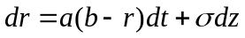 (2.1)
where mean reversion, reversion level, and volatilityare constants. But its weakness is that interest rate could be negative. In this model, Vasicek shows that the general pricing form of zero-coupon bond which pays $1 at time T can be shown:
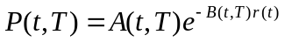 (2.2)
where
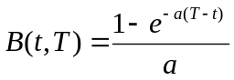 (2.3)
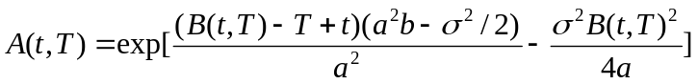 (2.4)
CIR Model
To improve Vasicek’s model, Cox, Ingersoll, and Ross have proposed CIR model where r is always non-negative. This model is
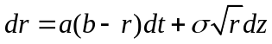 (2.5)
and it has the same general form of bond prices in Vasicek’s model. But its A(t, T) and B(t, T) are different:
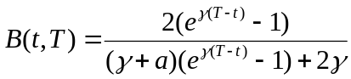 (2.6)
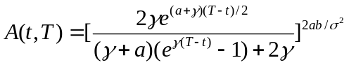 (2.7)
where 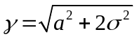.

2.1.3 No-arbitrage Models
Although equilibrium models have mean-reverting properties, their disadvantage is that they can not fit today’s term structure of interest rate. Thus, no-arbitrage models come into being. No-arbitrage models not only contain the property of equilibrium models but also can be consistent with today’s observation of market interest rate because of today’s term structure as an input.
Ho-Lee Model
The first model of no-arbitrage models is Ho-Lee model which is shown
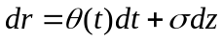 (2.8)
where 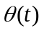is a function of time chosen to ensure that the model fits the initial term structure and it is relative to the instantaneous forward rate. The relevance to instantaneous forward rate is
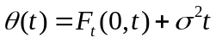 (2.9)
where 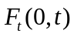 is the instantaneous forward rate for maturity t as seen at time zero and subscript t denotes a partial derivative with respect to t.
Moreover, the price of zero-coupon bond at time t can be expressed as
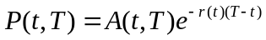 (2.10)
where
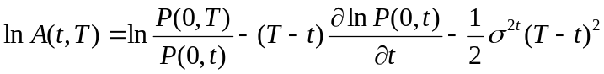 (2.11)
Hull-White Model
The other no-arbitrage model is Hull-White model which is extension of the Vasicek model that provide an exact fit to the initial term structure. The model is following
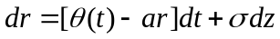 (2.12)
or
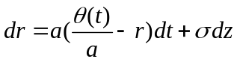
where a and are constants and the function of can be calculated from the initial term structure:
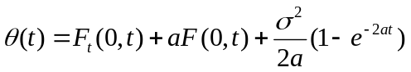 (2.13)
Moreover, it has the same general form of bond prices in Vasicek’s model, but it’s B(t,T) is different:
(2.14)
where
(2.15)
and
(2.16)
Furthermore, at time zero, the price of a call option that matures at time T on a zero-coupon bond maturing at time s can be expressed as
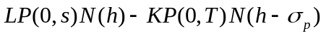 (2.17)
where L is the principal of the bond, K is its strike price,
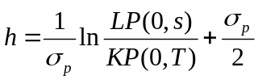 (2.18)
and
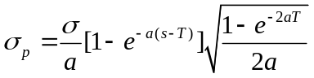 (2.19)
The price of a put option on the bond is
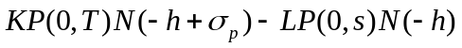 (2.20)
This thesis would take the Hull-White model as the basis of pricing structure because of its adaption of today’s term structure of interest rate and more flexible than the Ho-Lee model. The volatility structure in the Hull-White model is determined by both and , so it represents a wider range of volatility structure than Ho-Lee model. The volatility at time t of the price of a zero-coupon bond maturing at time T is
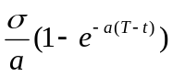
and the instantaneous standard deviation at time t of the zero-coupon interest rate maturing at time T is
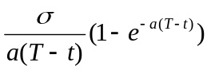
and the instantaneous standard deviation of the T-maturity instantaneous forward rate is 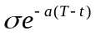.

2.1.4 Forward Rate Models
There are two typical forward rate models: one is HJM model which develops in terms of instantaneous forward rates; the other one is BGM model or LIBOR market model which expresses in terms of the forward rates. Both of them have the properties of variable volatility and non-Markov processes, therefore they cannot presented as recombining tree but be implemented by Monte Carlo simulation.

2.2 Derivatives Basics
There are some popular financial derivatives and the detailed description of Snowball notes within this segment. In this section, it includes payoff of bond option and interest rate derivatives, closed form of some popular commodities and expression of some complex interest rate swaps.

2.2.1 Bond Basics
Most bonds provide coupons periodically and at maturity the owner receives the principal or face value of the bond. The theoretical price of a bond can be calculated at the present value of all cash flows using zero rates as discount rates. The zero rate (zero-coupon rate) at year n means that the rate of interest earned on an investment that start today and lasts for n years. Thus, the expression of present value of the zero-coupon bond for maturity t years is
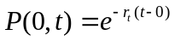
where means the zero rate at t years.
Therefore, considering the bond which has coupon 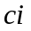 at time 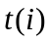 in Figure 2.2 is following:
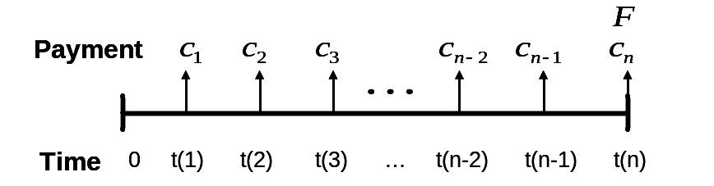
Figure 2.2 An Example of Coupon Bond.
The coupon bond is that paying coupon at time and notional principal  at maturity.

And the bond value is expressing
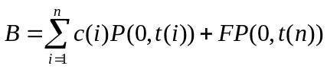 (2.21)

2.2.2 Interest Rate Derivatives Basics
In this section, only focus on valuation of popular interest rate derivatives which we need in this thesis and explain to their properties.
An interest rate cap or floor is a floating-rate note where the interest rate reset periodically equal to LIBOR; the time between resets is known as the tenor; the payoff does not occur on the reset date but occurs at the days of tenor later, for instance, if the life of cap or floor is one year, the reset dates are at times 0.25, 0.50, 0.75 years and payment dates are at times 0.50, 0.75, 1.00 years. In other words, they have the property of delayed payoff. Cap and floor are designed to provide insurance against the rate of interest on the floating-rate note; cap is insurance for note rising above a certain level and floor is insurance for note falling down a certain level. Define:
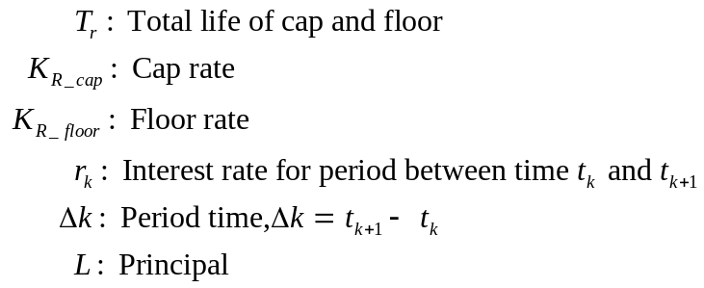
The payoff of caplet at time 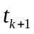 is
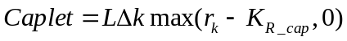
and the payoff of floorlet at time is
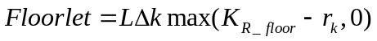
In one hand, both of them can be assumed as a portfolio of interest rate options. Therefore, each payoff of caplets or floorlet can be priced by Black’s formulas form. The value of caplet is given as
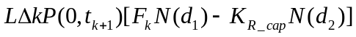 (2.22)
where 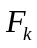 is the forward rate for the period 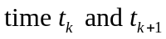, and
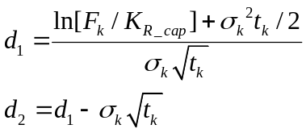
The value of the corresponding floorlet is
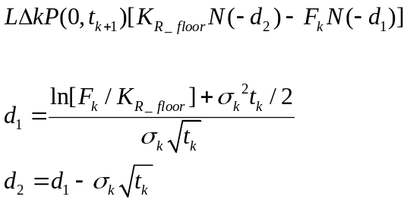 (2.23)
In the other hand, both of them can be assumed as a portfolio of bond options. Caplet is a put option of zero-coupon bond which the strike price is 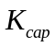and the underlying value is S as following:
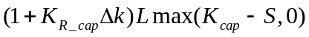 (2.24)
And floorlet is a call option of zero-coupon bond which the strike price is 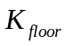and the underlying value is S as following:
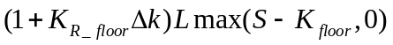 (2.25)
where
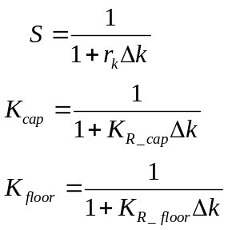
and the derivation of equations (2.24) and (2.25) would be provided in Appendix.

2.2.3 Complex Interest Rate Swaps
Some interest rate swaps containing embedded options cause difficult pricing of these complex derivatives, so it is hard to find closed forms of them. In this issue, we consider some commonly encountered these kinds of swaps.
Quanto IRS
Quanto IRS is an interest rate swap which two different interest rates are involved on the same notional principal, ex. fixed rate vs. floating rate, floating rate vs. floating rate or change of two different maturity LIBOR rates. At maturity, the parties of Quanto IRS would pay the value of the appointed coupon rate multiplied by the principal to each other and do not involve in notional principal. This Swap has the character that currency of coupon rates can differ from currency of principal.
Redeemable Range Accrual Notes
Redeemable range accrual note is a swap that’s the property of American style option which issuer can call back the notes; its interest on one side accrues only when the floating reference rate is within a certain range. Sometimes the range remains fixed during the entire life of the contract; sometimes it is reset periodically. At maturity date, the payoff is that the proportion of accumulated days to range life of contract multiplies the reference rate and principal. Thus, the more times of interest rate dropping in the range, the more profit.
Snowball Notes
Snowball is a kind of inverse floating rate bond which the present payment of coupon rate is relevant of last coupon rate. Usually, it has constant coupon rate in first year; begin to the second year, the current coupon is given by the previous coupon plus a spread minus a reference index, floored at 0%. So Snowball notes have the character of path-dependent payment of coupon such as Asian style option; the lower reference indexes, the more coupons over time, just like snowball rolls more and bigger. Oppositely, if the higher reference indexes, the fewer coupons over time, the Snowball will “melt away”. This thesis’ purpose is to solve this problem and the example of Snowball contract will be given at chapter four.

2.3 Pricing Methods

2.3.1 A General Tree Building Procedure for Hull-White Model
This tree structure is a good approach for constructing no-arbitrage short rate models of Hull-White model. This approach, making use of the trinomial tree, is appropriate for models where there is some function of the short rate that follows mean-reverting arithmetic process. The key element of this process is that it produces a tree that is symmetrical about the expected value of . There are three types of sub-trees, illustrated at Figure 2.3, for the tree building procedure.
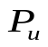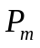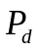
(b)
(a)
(c)
Figure 2.3: Alternative Branching for Hull-White Tree.
Assume the length for each time step is  and the variance for each time step is . We can set the size of the interest rate step, , at spacing between interest rates on the tree, 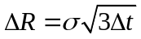. Then the tree can be built by the following two steps.

First stage: building a preliminary tree
Setting in (2.13) and the initial value of r at zero suggest the following equation:
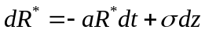 (2.26)
Building an interest rate tree for (2.26) is the goal for first stage. This can be illustrated an example. Define (i, j) as the node where 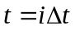 and 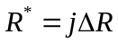; denote probabilities of three branches as 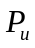, 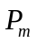 and 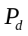 which must be positive and less than one; summation of them is one. The calculated probabilities depend on types of sub-trees.
Figure 2.3(a)
The probabilities must satisfy the following equations: first is expected value equation; second is about variance equation; finally, it is a basic equation of probability.
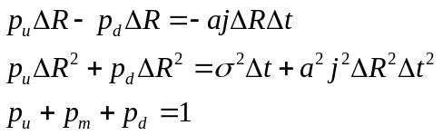
Therefore, solution to these equations is
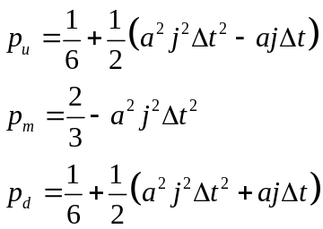
By the same way, the probabilities of type-(b) and type-(c) could be calculated.
Figure 2.3(b)
Three equations of type-(b) are
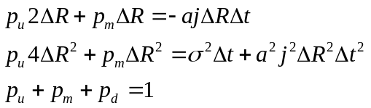
and the solution of these equations is
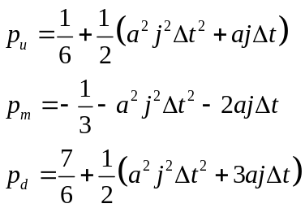
Figure 2.3(c)
Three equations of type-(c) are
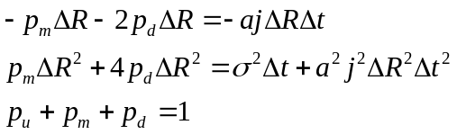
and the solution of these equations is
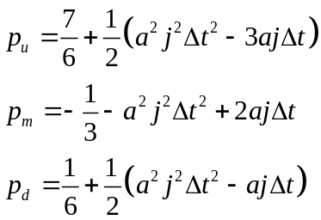
To make sure that probabilities are always positive, the restrain of must satisfies:
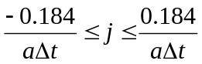
A sample tree constructed by this step is illustrated in Figure 2.4.

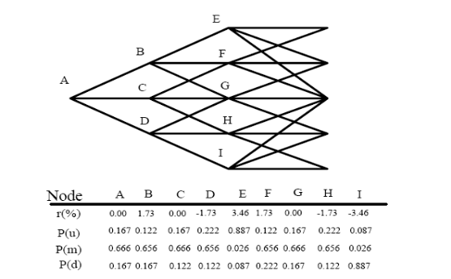
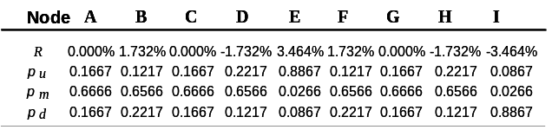
Figure 2.4: A Simple Trinomial Tree for the Hull-White Model.
Parameters set as follows,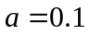, 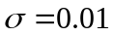and =one year.

Second stage: calibration with the real term structure
Fitting today's term structure is the main goal of this stage. The exact method for this problem can be provided by Hull and White. Assume the term structure function today is
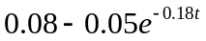 (2.27)
and the interest rate tree being calibrated is illustrated in Figure 2.3. Obviously, the average interest rate for the first period can be obtained by taking in equation (2.27). Denote 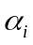 is a moving up adjustment of period at time 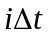; 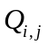 means that the value of paying $1 at node (i, j), and otherwise paying nothing; the price of a zero-coupon bond maturing at time us given by 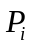 known by today’s term structure function (2.27) and bond basic in chapter 2.2.1. Thus, can be calculated by recursive formulas:
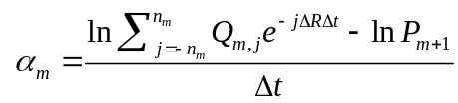
Because of
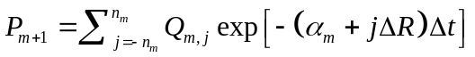

where 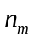 is the number of nodes on each side of the central node at time 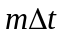. And then could be determined as
where 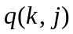 is the probability of moving from node (m, k) to node (m+1, j) and the summation is taken over all values of for which this is nonzero. After two stages, the complete Hull-White tree model is built as Figure 2.5.

A
B
C
G
H
I
D
F
E
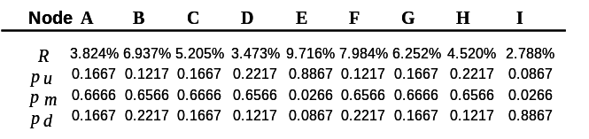
Figure 2.5: Calibration with Today’s Term Structure for the Hull-White Tree.
The basic tree structure is not changed; the node in the same period would push up the same increment, but the increments of each period are different.

2.3.2 Calibration
Up to know, the mean reversion and volatility in Hull-White model are constants. The goal of this section is described how to estimate the parameters of this model. This is known as calibrating the model.
As we know, interest rate cap could be characterized as a portfolio of put options on zero-coupon bond from equation (2.24), so it can be priced by Hull-White (2.20). Moreover, cap can be assumed as a portfolio of interest rate options from equation (2.22). Thus, we can compare the cap value of the market observation data and formula (2.22) with the estimated value by Hull-White model, to find the suitable mean reversion and volatility. A popular goodness-of-fit measure is
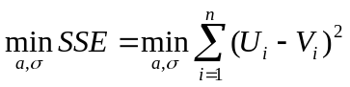
where 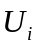 is the market price and 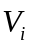 is the price given by the Hull-White model.

3. Combine of Pricing Tree with State Variables of Snowball Notes
In this chapter, a novel polynomial-time pricing algorithm based on the Hull-White term structure model is introduced for pricing snowball notes. First, we will describe snowball price and coupons variables, and then analysis these variables at different nodes in Hull-White trinomial tree. Next, we construct the state variables for non-negative coupons, and furthermore the redeemable snowball is then priced by a numerical approach and linear interpolation method for freeze on zero coupons article. Finally, we would introduce a proper recursive steps for pricing snowball notes.

3.1 Discuss State Variables of Snowball Price and Coupons

3.1.1 Forward-Tracking Method on Snowball Notes
Consider a snowball contract illustrated in figure 3.1. The coupon of i-th period paid in next period is following:
At maturity, issuers would pay the coupon fixed in last period and notional principal F. Significantly, consider the freeze on zero coupons article; the coupon rate must be non-negative.
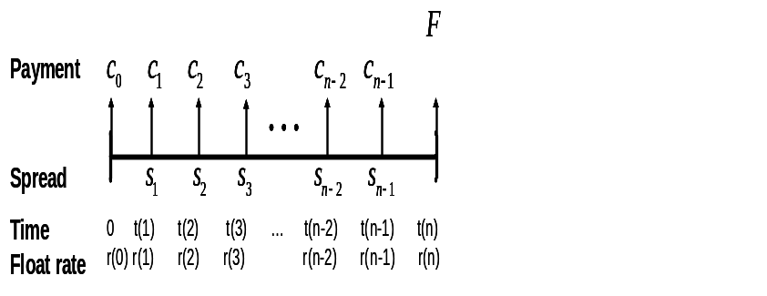
Figure 3.1 Snowball Notes.
The spread rate at time t(i) is S_{i,} and the coupon Ci determined at time t(i) is paid at t(i+1); the floating interest rate from time t(i) to time t(i+1)is denoted r(i), and the face value is paid at maturity date t(n).

The coupons of snowball notes can be showed by the following recursive formula:
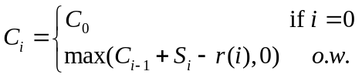
Consider floating rate r(i) as short rate based on Hull-White tree in figures 2.4 and 2.5 ,and then r(i) can be divided into the rate of node (i, j) of the preliminary tree in figure 3.2 and the moving up adjustment of the i-th period 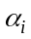, both of them defined in chapter 2.3.

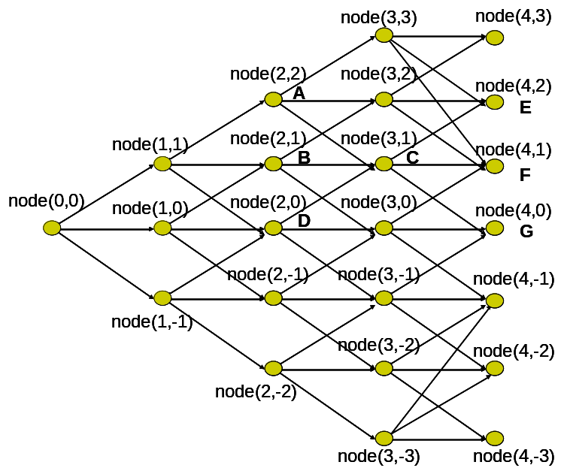
Figure 3.2 States of Rate Variables in Hull-White Preliminary Tree.
The node (i, j) is the state of rate variables in Hull-White preliminary tree from figure 2.4. The node (i, j) means that at time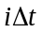 , the rate is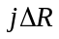, where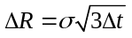.

Define the node is child of node (i, j) if it connects to node (i, j) in i+1 period and the node is parent of node (i, j) if it join to node (i, j) in i-1 period. For example, in figure 3.2, nodes A、B、D are the parents of node C and nodes E、F、G are children of node C. Therefore, the recursive formula for coupon rates at node (i, j) in figure 3.2 can be expressed as
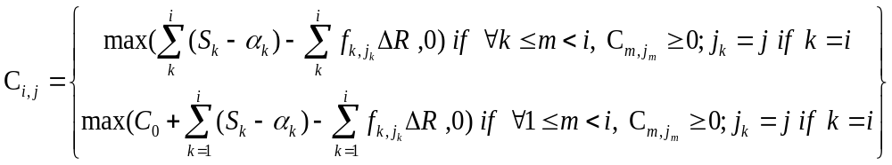(3.1)
where 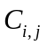 is all kinds of coupon rates at node (i, j) and 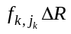 is the rate at node (k, j_{k}) which is the child of node (k-1, j_{k-1}) and the parent of node (k+1, j_{k+1}).
Example 3.1 Given a path { node (0, 0)-> node (1, 1) -> node (2, 0) -> node (3, 1)} which is a kind of coupon sequence in C_{3,1} and suppose in the path, the coupons of C_{1,1} and C_{2,0} are non-negative, then the coupon at node (3, 1) in this case is
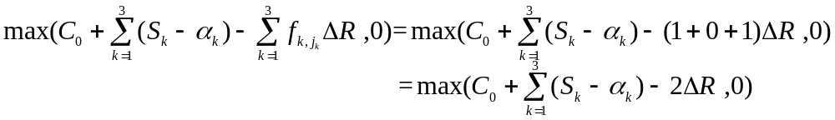

3.1.2 Backward-Tracking Method
Combine bond basic from equation (2.21) and figure 2.2 with Hull-White tree, we can get the snowball price at node (i, j) following:
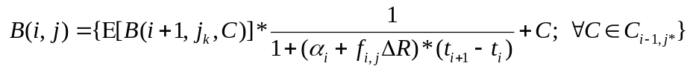 (3.2)
where C_{i-1,j*} is the set of coupon in node (i-1, j*) which is the parent of node (i, j), B (i+1, j_{k}, C) is the set of snowball price at node (i+1, j_{k}) which is the child of node (i, j) with coupon C in i-1 period and coupon 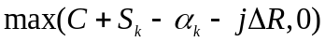 in i period. Because of lattices method to price Snowball, so we take discrete time method of discount factor, for instance, in equation (3.2), the discount factor from time i to time i+1 at node (i, j) is:
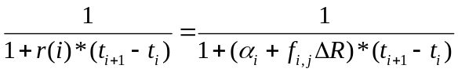 (3.3)
Example 3.2 Following the path in example 3.1, the bond value at node C with its children nodes E、F、G is
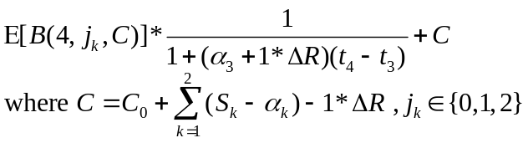
where C is the coupon at node (2, 0) in this path and the coupon at node (3, 1) is
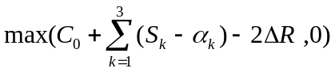
In order to solve redemption article of snowball notes, assume redemptive cost is constant in the contract, redeem Snowball notes if the following condition is satisfied:
(3.4)
where 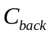 is the cost of redeeming Snowball bond and B is the Snowball value at node (i, j) with coupon C in i-1 period and C_{i-1,j*} denoted in equation (3.2).
Usually, for holders, the early exercise time to call back is when the bond value is less than callable value. However, redeemable bond is that issuer can buy back the bond. Thus, in an issuer position, the early redemption time with coupon payment delayed is when bond value is more than the value of redemptive cost plus coupon fixed in i-1 period.

3.2 Numerical Approach to Snowball Notes
Here we will discuss a numerical approach to Snowball notes, provide an algorithm of forward and backward-tracking method, and create proper recursive general steps to pricing Snowball notes in the cause of the implement in next chapter. We simply suppose C₀ equals zero in examples of this section.

3.2.1 Construct States Variables of Snowball Price and Coupon
In this segment, there are three stages to construct the state variables of coupon rates in each node (i, j). To start with, in order to evaluate coupons from equation (3.1), we compute negative summation of number of spacing between interest rate without freeze at zero article,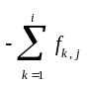, in the Hull-White preliminary tree. Next, consider the freeze at zero coupon article, the negative coupons should be eliminated and adjust the states of coupon variables with previous zero coupons. Lastly, for articles of redemptive and freeze on zero coupon, we introduced back-ward tracking and linear interpolation method to price snowball notes.
First stage: building the maximum and minimum of negative summation of number of spacing rate in the Hull-White preliminary tree without freeze at zero article
Sum (i, j) is denoted as the negative summation of number of spacing rate which final rate is the rate at node (i, j) without the article of freeze at zero in the Hull-White preliminary tree:
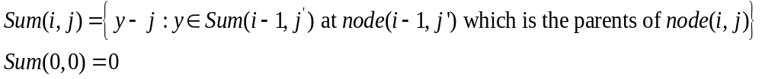(3.5)
and equation (3.5) satisfies the following formulas:
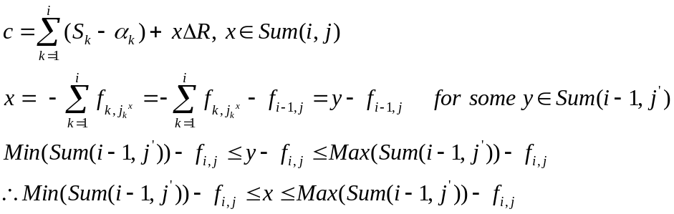 (3.6)
where c is one case of coupons at node (i, j) without the article of freeze at zero and node (i, j) is the child of node (i, j’).
Therefore, focus on the maximum and minimum of negative summation of number of spacing rate at each node, the all possible negative summation of number of spacing rate at node could be known. Nevertheless, determinate maximum and minimum of Sum (i, j) at node (i, j) is considered the previous nodes by different types of branches.
Example 3.3 In figure 3.2, Sum (i, j) of nodes A、B、D are:
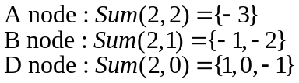
Node C is the child of these nodes, so Sum (3, 1) calculated by equation (3.6) is following:
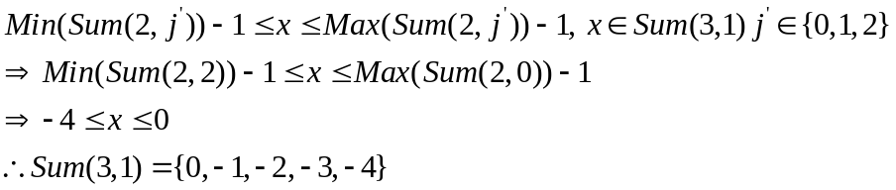
Follow equation (3.6), we can get the Max(Sum(i, j)) and Min(Sum(i, j)) at each node from figure 3.3:

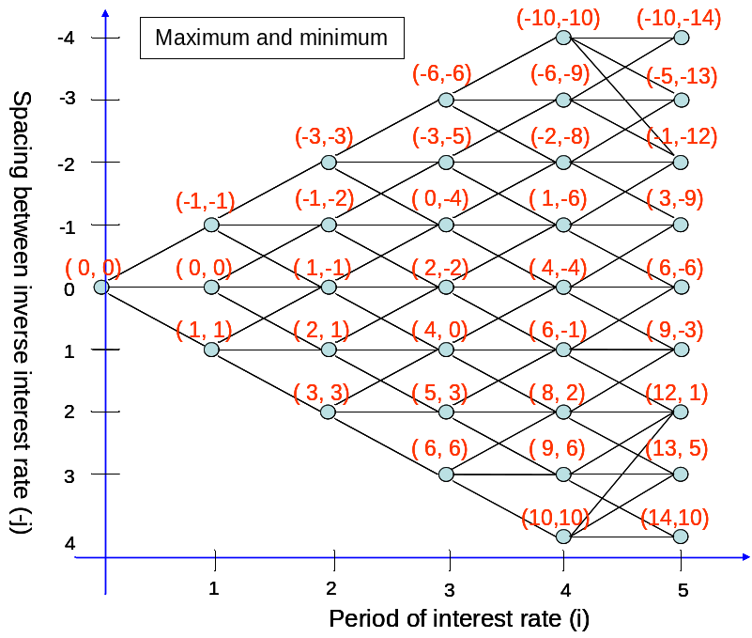
Figure 3.3 An Example of the Maximum and Minimum Summation of Each Node. The unit of x-axis is period time and unit of y-axis is the spacing between interest rate on the preliminary tree; ( M, m ) represents that M is the maximum and m is the minimum summation number of spacing rate.
When the maximum and minimum summation of each node is determinated, the number of possible path in each node is also known. For instance, ( M, m ) at node (3, 2) where at time 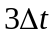and inverse rate 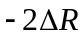 is (-3,-5) which means that the node (3, 2) has three kinds of negative summation of number of spacing rate. It is following:
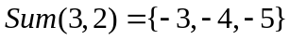
Consequently, as the summations of node, Sum (i, j), and adjustments of Hull-White tree calculated, the coupons without the article of freeze at zero in each node could be given and the next stage will solve the problem of non-negative coupons.
Second stage: Check that the coupons at each node are non-negatives
Continuously, the problem of non-negative coupons would be solved by the following two steps. There are two situations we must adjust the states of coupons. One phenomenon is that the previous coupon is positive but present coupon becomes negative. Therefore, the first step is to eliminate the states with negative coupons for the article of freeze on zero coupons. The other phenomenon is how to find the maximum and minimum of Sum (i, j) at present nodes when the precious coupons are reset to zero coupons. The second step would be introduced to solve this circumstance.
The First Step: Eliminate the states with negative coupons.
We define the lower bond of integers of each period such that the maximum and minimum summations which are larger than those integers would enable positive coupons of each node. The mathematical description is
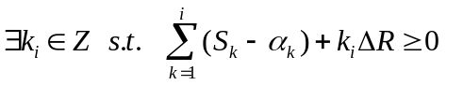
Then solution of the lower bond of integers in each period is
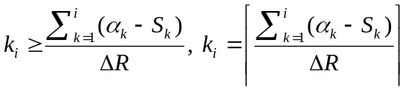 (3.7)
where k_{i} is to eliminate the states with negative coupons in i-th period. If the elements in Sum (i, j) less than or equal to that integer in the period, it means that resetting coupon rate to zero is in node (i, j).
Take the example from figure 3.3 with the condition for non-negative coupons, if the node has a situation of resetting coupon rate to zero, there is a symbol of 0* in (M, m) of that node. Supposing the node is (0*,0*), it means that the maximum summation is less the lower bond. That is to say, there is only one case of coupon rate in that node and the coupon rate is zero.
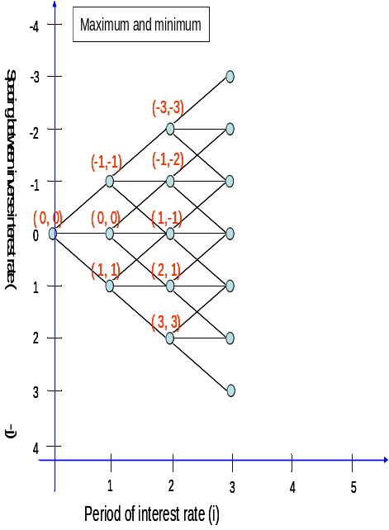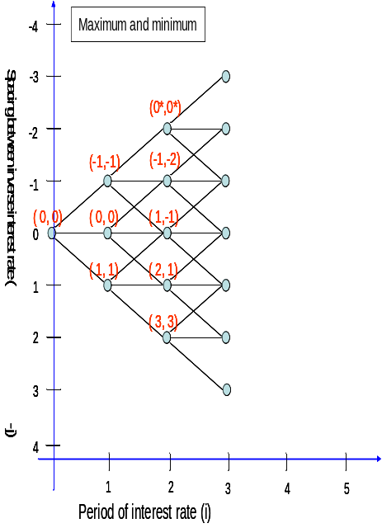
(a)
(b)
Figure 3.4 Adjust the Maximum and Minimum Summation of Each Node in the First Step of Second Stage.
Assume the estimation of 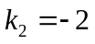 from equation (3.7), the maximum and minimum summations of node (2, 2) is (-3,-3) where touch the lower bond of integer, so as (-1,-2) at node (2, 1). Thus, (-3,-3) changes to N(0*,0*) where 0* is a symbol of a reset coupon rate in that node.
From figure 3.4, the coupons of node (2, 2) and node (2, 1) are
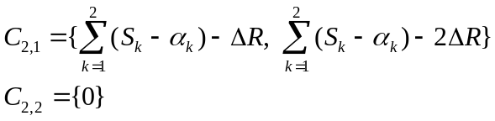
where is the set of all kinds of coupon rates at node (i, j). Moreover, there are M-m+1 kinds of coupon rates in (M, m) and M-m+2 kinds of coupon rates in (M, m, 0*) which can be seen in figure 3.4 and figure 3.6.
The Second Step: Adjust the sates with previous zero coupons
We define the reset integers of each period,δ_{i,j}, such that change the present coupon value to the form of maximum and minimum summations at this time where the previous coupon is reset to zero. The mathematical description is
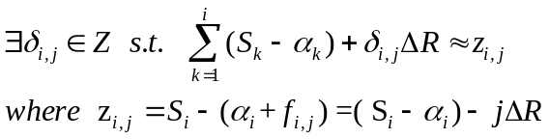
where 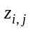 is the coupon at node (i, j) before freeze at zero article and its previous coupon is zero. Then solution of the reset integers of each node is
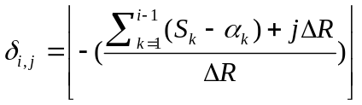 (3.8)
Take the same example from figure 3.4 and do the first stage method to create the maximum and minimum of negative summation of number of spacing rate in the Hull-White preliminary tree in i=3 period. After that, change present coupon which the previous coupon is reset to zero to the form of maximum and minimum of summation in figure 3.5 by the equation (3.8).
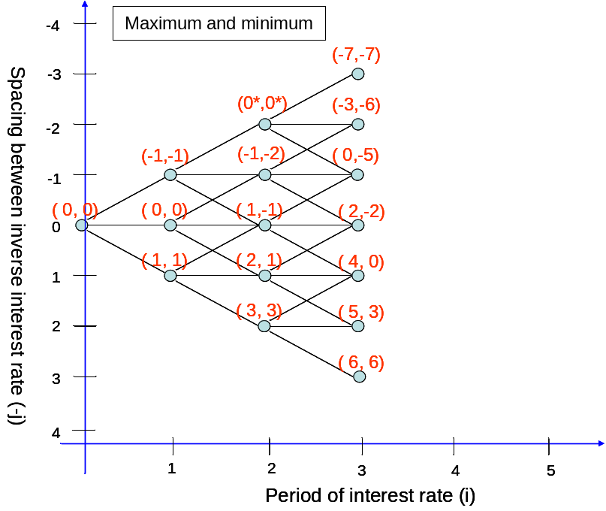
Figure 3.5 Adjust the Maximum and Minimum Summation of Each Node in the Second Step of Second Stage.
From equation (3.7), assume the estimations of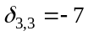, 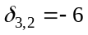,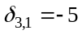. The maximum and minimum summations of node (3, 3) is calculated by type-(A) in first stage, so it has only reset coupon in the node and change summation into (-7,-7). About node (3, 2) calculated by type-(B), the maximum summation is from the maximum one of node (2, 1) and the minimum summation is from the minimum one of node (2, 2) which has zero coupon rate, in this case, its minimum at node (3, 2) is 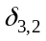. Hence we can analogize the all node in third period.

After the first and second stages are completed, the determination of Sum (i, j) is built in figure 3.6 and the formula for coupons at node (i, j) is following:
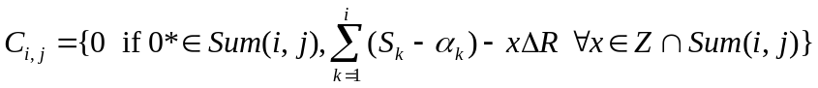
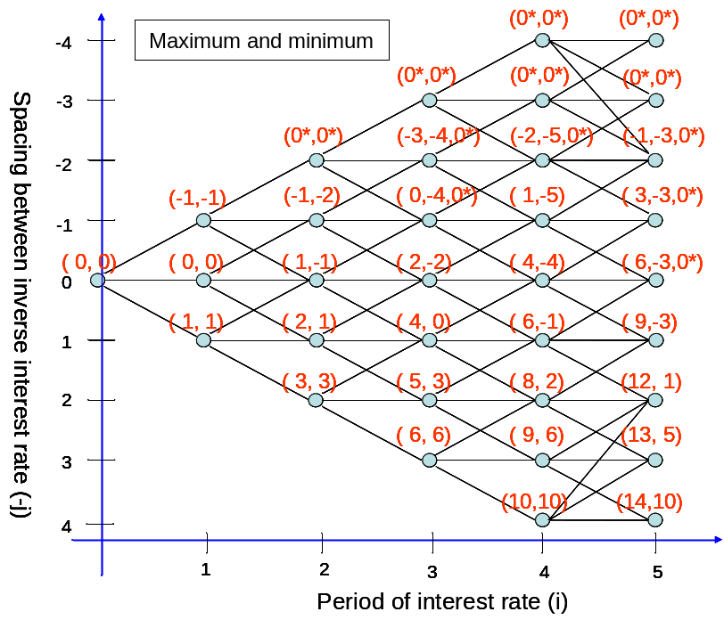
Figure 3.6 Maximum and Minimum Summation of Each Node in Forward-Tracking Method.
The maturity is i=5, the example is the same from figure 3.3 to figure 3.5. Assume the value of principal and the cost of redeeming snowball notes are $1. The numbers of coupon rates is -2-(-5) +2=5 according to (-2, -5, 0*) at node (4, 2) and the set of coupon rates at node (4, 2) is following:
Furthermore, the next stage is to evaluate the Snowball bonds from formula (3.2) and early redemptive time is considered in equation (3.4).
Third stage: Pricing the value by backward-tracking method
In this segment, the third stage is divided from two parts. One is how to discount the bond value with redemptive article; the other one is to use linear interpolation method when the discounted node has the situation of resetting zero coupons.
The First Step: Price the bond value of snowball notes
Suppose coupons at node (i, j) are built in figure 3.6, the equation (3.2) and (3.4) for pricing snowball value can be rewritten as:
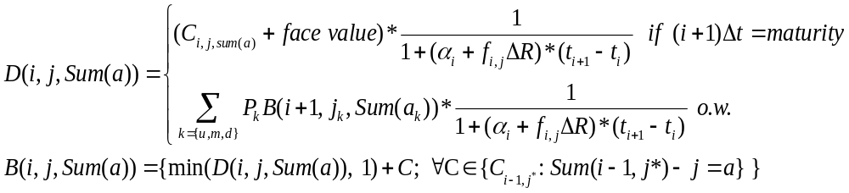(3.9)
where 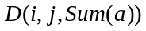 is the discounted snowball note value and C_{i,j,sum(a)} is the coupon fixed at node (i, j) and its summation situation is a times spacing between interest rate in Hull-White tree; 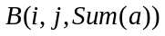 is the snowball value at node (i, j) with redemptive article and 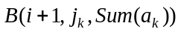is the snowball value at node (i+1, j_{k}) which is the child of node (i, j) ; C is the coupon paid at node(i, j) and fixed at node(i-1, j*) which is the parent of node(i, j) with Sum(i-1,j*)-j equal to a.
Choice of the following probability 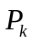 and discounted nodes of up, median and down are according to the styles of branch in figure 2.3 and its following:
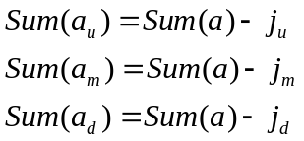
However, there is a problem when discounted bond value with its summation situation 0* in pricing snowball process. Thus, we will give examples to price snowball note value by equation (3.9) and linear interpolation method in next step.
The Second Step: Interpolation of coupons in discounted process
In corroding to simplify algorithm, we take the integer value to approach the reset coupon in second stage, thus we use linear interpolation method to find actual the discounted coupons. Given two examples from figure 3.6 which one must use interpolation method in figure 3.7(b) and the other one is without this character in figure 3.7(a).

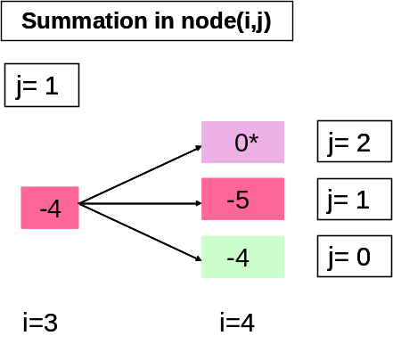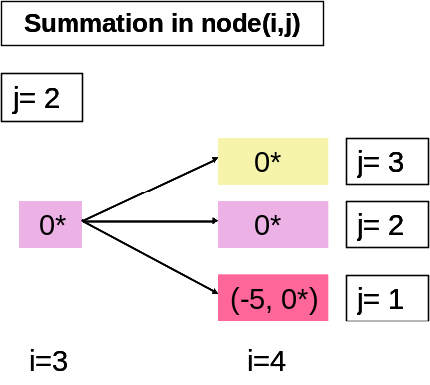
(a)
(b)
Figure 3.7 Two Examples for Discounted Process.
One case is the discounted process of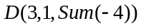 and the other case is the discounted process of 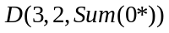 which the coupon rate is reset to zero at node (3, 2). Moreover, assume the lower bond of integers is 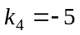 by equation 3.7 and the reset integers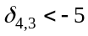,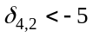,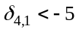 by equation 3.8.

On one hand, in the case of at node (3, 1), its tree is a type-(a) in figure 2.3. Hence its according discounted nodes are from node (4, 2), node (4, 1), and node (4, 0), and corresponding summations are
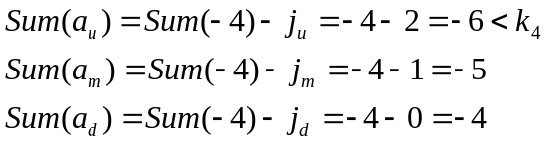
the solution is rewritten by
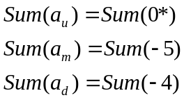
From equation (3.9), the bond value of at node (3, 1) which its parents are node (2, 0), node (2, 1), and node (2, 2) is following:
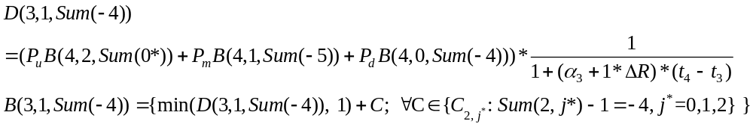 and the solution of probabilities is type-(a) solution in Hull-White tree.
On the other hand, in the case of at node (3, 2), its tree is also type-(a) in figure 2.3. Hence the children of node (3, 2) are node (4, 3), node (4, 2), and node (4, 1). Because of its zero coupons in node (3, 2), the coupons of these discounted nodes are following the equation (3.1):
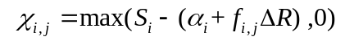 (3.10)
where χ_{i,j} is actual coupon at node (i, j) with the previous coupon reset to zero.
Hence, we must check the actual coupons in these nodes for formula (3.10). Assume at node (4, 3) and node (4, 2), the actual coupons are also reset to zero with previous coupon reset to zero; nevertheless, the actual coupon at node (4, 1) is positive. We must use interpolation method to find the actual discounted value in node (4, 1) because its actual coupon is positive. It is following
The solution of actual discounted value is
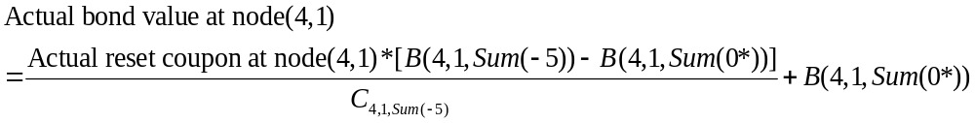(3.11)
where 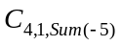 is the coupon rate of Sum (-5) at node (4, 1), and the illustration to explain this method is in figure 3.8.
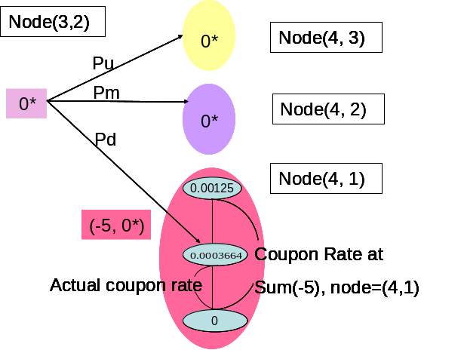
Figure 3.8 The Example of Interpolation Process from Figure 3.7 (b).
Assume actual coupon rate is 0.0003664, the coupon rate at Sum (-5) is 0.00125, and as we known 0* means that coupon rate is 0. Therefore, the actual discounted value from node (4, 1) could be calculated by equation (3.11).From equation (3.9), the discounted value of is following:

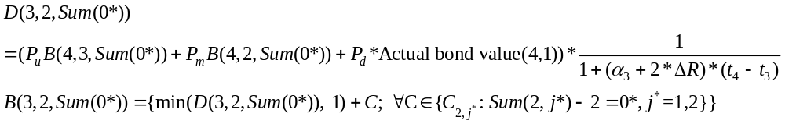and the solution of probabilities is type-(a) solution in Hull-White tree.

We can use this linear interpolation method to find the actual bond value at the reset node (4, 1), and so on. After the procedure of third stage, the determination of variables in backward-tracking is built and snowball value at all nodes are known.

3.2.2 Creating Proper Recursive Steps for Pricing Snowball Based on Hull-White Trinomial Tree
General programs will be introduced in this segment and the proper recursive steps would be provided for pricing snowball based on Hull-White trinomial tree.
- Determine the nodes of Hull-White tree described in chapter 2.3.1, and then the preliminary tree is build and becomes the foundation stone of constructing Snowball state variables.
- Determine the states of coupon variable in Snowball contract by first and second stages in chapter 3.2.1. The technological process is that do the first stage for a start and then do first way of second stage in the first period of the tree; in the second period, do the first stage again, continuously do second way of second stage, and final do first way of second stage to check the variables in this period; moreover, the nodes in forward period, do recursive steps like the second period and so on.
- Determine the states of bond value variable by third stage in chapter 3.2.1. Pricing the discounted bonds usually use the method in first part of third stage, and using second part of third stage only when the node has reset coupon.
- Implement the programming of three steps above.
- Evaluating snowball notes on i-th period could be reduced to original general programs.

4. Numerical Experience of Pricing Snowball Notes

The algorithm for pricing snowball notes is discussed in last chapter. Firstly, give the example of snowball contract from Bank SinoPac. Moreover, following this contract, the results in simulation and sensitivity analysis of pricing would be explained the associations between parameters in Hull-White term structure model and price, and influence of redemptive article, tendency of zero rate curves and spreads designed on snowball price. Finally, we will estimate parameters about mean reversion, volatility of Hull-White model, and coefficients of zero rates function from equation (2.24) to price snowball contract which Bank SinoPac issues.

4.1 An Example of Snowball Contract
Given a contract of snowball note issued by Bank SinoPac which par value equals $ 10,000,000, and the contract could be redeemed with par value after the third year. The coupon is paid quarterly and the general form for i-th quarter coupon is
where the floating rate in this contract is fixing rate of 90 days CP and each coupon rate is illustrated in table 4.1.
Table 4.1 Coupons of Ten Years Snowball Bond.
Cn, i means that coupon rate at i quarter of n year. Notes that the floating interest rate (FR) is the fixing rate of 90 days CP; if i-1=0, Cn, i-1= Cn-1, 4 for n=1…10, i=1..4.
Year | Coupon rate (Cn,i )
1 | C1,i=3%, i=1,2,3,4
2 | C2,i=C2,i-1+1.40%-FR2,i
3 | C3,i=C3,i-1+1.65%-FR3,i
4 | C4,i=C4,i-1+1.90%-FR4,i
5 | C5,i=C5,i-1+2.15%-FR5,i
6 | C6,i=C6,i-1+2.40%-FR6,i
7 | C7,i=C7,i-1+2.65%-FR7,i
8 | C8,i=C8,i-1+2.90%-FR8,i
9 | C9,i=C9,i-1+3.15%-FR9,i
10 | C10,i=C10,i-1+3.40%-FR10,i

4.2 Simulation and Analysis of Pricing
We will continuously analysis influence of the parameters of Hull-White model, spreads designed and zero rates on snowball price with contract in section 4.1. There are many figures in this section to particularly explain the associations between sensitivity of parameters and snowball price.

4.2.1 Sensitivity to mean reversion of Hull-White model
We will discuss how mean reversion parameter influence snowball price. In Figure 4.1, we can observe that if mean reversion increases, the price of snowball notes decreases as volatility equals 0.006, especially with non-redeemable contract.
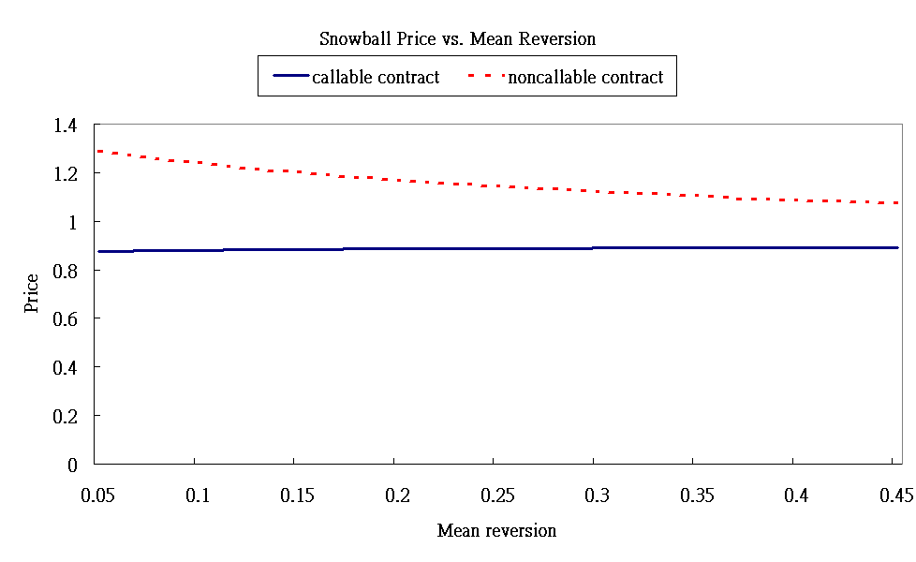
Figure 4.1 Snowball Price vs. Mean Reversion.
The volatility is 0.006, par value is $1 and zero rate function is rate (t) =0.02363-0.007314*exp (-1.316*t). There is negative association of price and mean reversion. Because issuers of snowball notes with non-redeemable contract can not call back the bond to hedge loss when its price move up, the price with non-redeemable contract is more than with redeemable contract.

There is negative relationship between mean reversion and price in figure 4.1. At low mean reversion, that is to say, the higher and the lower interest rates would not quickly back to long-run average level, so it is possible to maintain low interest rates at low market short rates and get more profit because of inverse rate property on the coupons of snowball contract. Moreover, the discounted factor also rises at low interest rate, so the bond value would increase. Although it is possible to maintain high interest rates at low mean reversion, non-negative coupon contract would protect against price of snowball failing down violently. Only decrement of bond price results from low discounted factor at high interest rate. Hence, there is a negative association between mean reversion and price.

4.2.2 Sensitivity to volatility of short rate
Next, we discuss relationship between volatility of short rate and snowball price. In figure 4.2, we can observe that if volatility increases as mean reversion equals 0.005, the price of snowball notes increases, especially with non-redeemable contract.
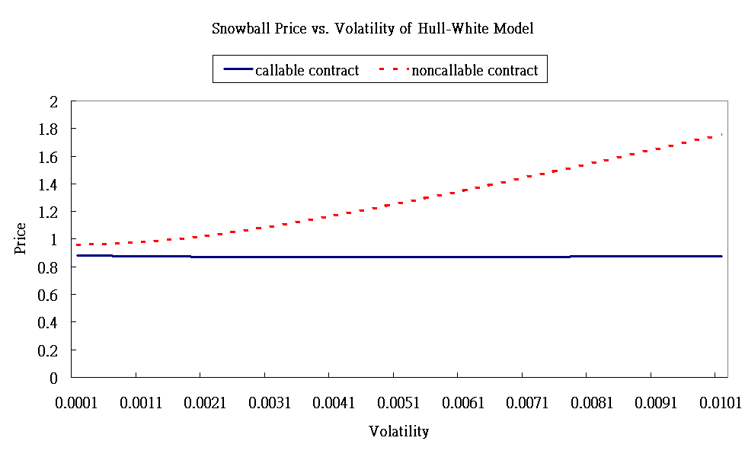
Figure 4.2 Snowball Price vs. Volatility of Short Rate.
The mean reversion is 0.005, par value is $1 and zero rate function is rate (t) =0.02363-0.007314*exp (-1.316*t). There is positive association of price and volatility. Because issuers of snowball notes with non-redeemable contract can not call back the bond to hedge loss when its price move up, the price with non-redeemable contract is more than with redeemable contract.

There is positive relationship between volatilty and price in figure 4.2.At high volatility of Hull-White model, that is to say, the change of interest rate is violent, so it is possible to become high interest rates at low market short rates or low interest rates at high market short rates. Thus, non-negative coupon contract would protect against price of snowball failing down violently at previous high market rates and get profit of coupons at present low market rates because of high volatility. Figure 4.3 shows this phenomenon and could explain the detail clearly.
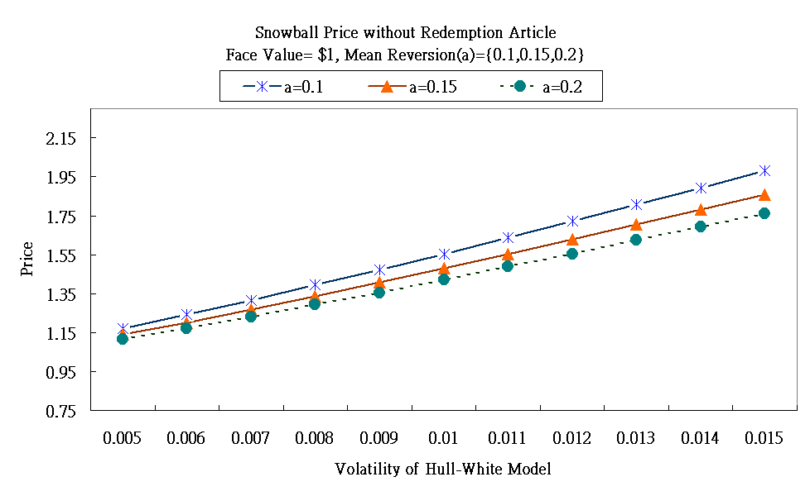
Figure 4.3 Snowball Price without Redemption Article.
The par value is $1 and zero rate function is rate (t) =0.02363-0.007314*exp (-1.316*t). In all different lines, they could obviously display the positive association between price and volatility. Resulting from the negative relation between price and mean reversion, the line with bigger mean reversion moves up slowly, oppositely, the line with smaller mean reversion moves up rapidly.

Combine the influence of mean reversion and volatility of short rate on non-redeemable snowball price in figure 4.3, the relation between these parameters and price consists with results in figure 4.1 and 4.2. With regard to price with redeemable snowball contract, most profit of coupons bond holder get is in the first three year because of issuer redeeming contract to protect the loss from more coupon payments on low market rates. Therefore, the price of redeemable Snowball notes would not move up rapidly than non-redeemable snowball price even volatility increasing and this phenomenon is showed in Figure 4.4.
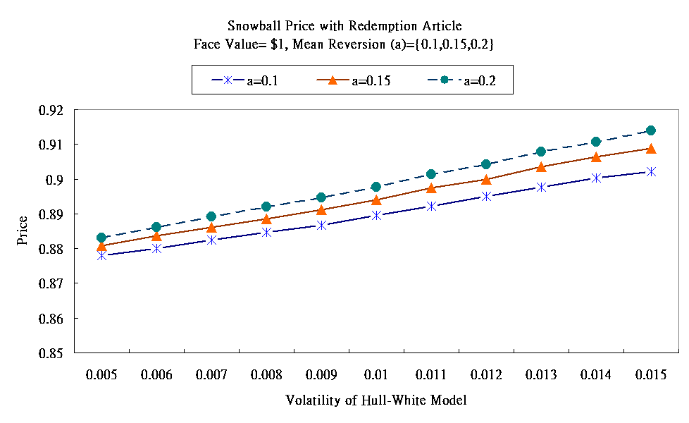
Figure 4.4 Snowball Price with Redemption Article.
The par value is $1 and zero rate function is rate (t) =0.02363-0.007314*exp (-1.316*t). Tendencies of all different lines are the same as Figure 4.3. If the price too higher, the issuer would redeem the contract and this snowball note would be concealed. Therefore, price dose not reach $1 or more.

Hence, there is a positive association between volatility and price without redemptive article but not obvious in redeemable snowball contract. Furthermore, in non-redeemable condition, if mean reversion is big enough, the negative association of mean reversion and price would eliminate some positive association of volatility and price.

4.2.3 Sensitivity to spread of snowball contract
Moreover, we would discuss how spreads influence snowball price in Figure 4.5.

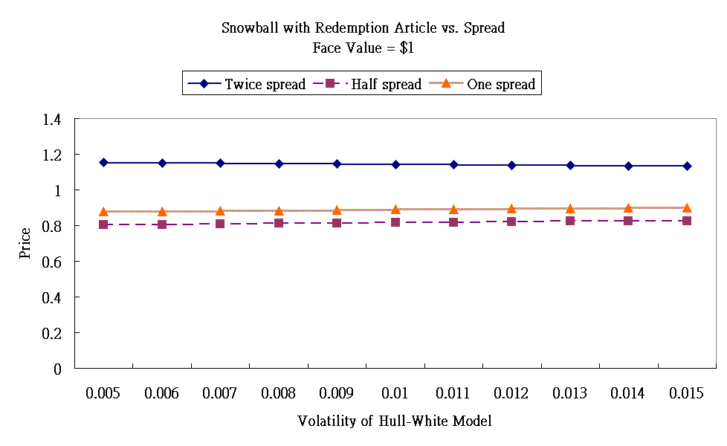
Figure 4.5(a) Snowball Price with Redemptive Article vs. Spreads.
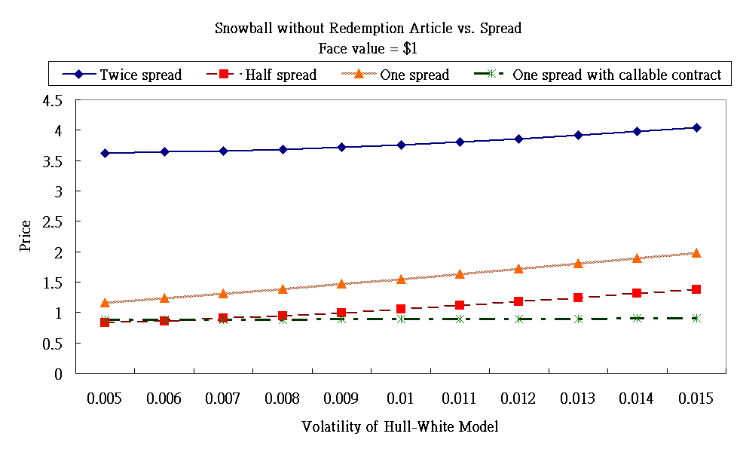
Figure 4.5(b) Snowball Price without Redemption Article vs. Spreads.
The par value is $1 and zero rate function is rate (t) =0.02363-0.007314*exp (-1.316*t). In graph (a), the price with twice spreads of snowball contract issued by Bank SinoPac in chapter 4.1 is larger than with one and half. However, it is not very distinct than graph (b) because redemptive article could make issuers to hedge loss. Moreover, in graph (b), even the price of non-redeemable snowball contract with half spreads is more than the price of redeemable snowball contract with origin spreads (shot dotted line).

Issuers may lose a lot for higher spreads of snowball contracts. However, the change of price in figure 4.5(a) is not more conspicuous than figure 4.5(b) even the price of non-redeemable snowball contract with half spreads of snowball contract from section 4.1 is more than the price of redemptive article with origin spreads. That is to say, the effective way to hedge snowball price is redemptive article, not how to contract spreads.
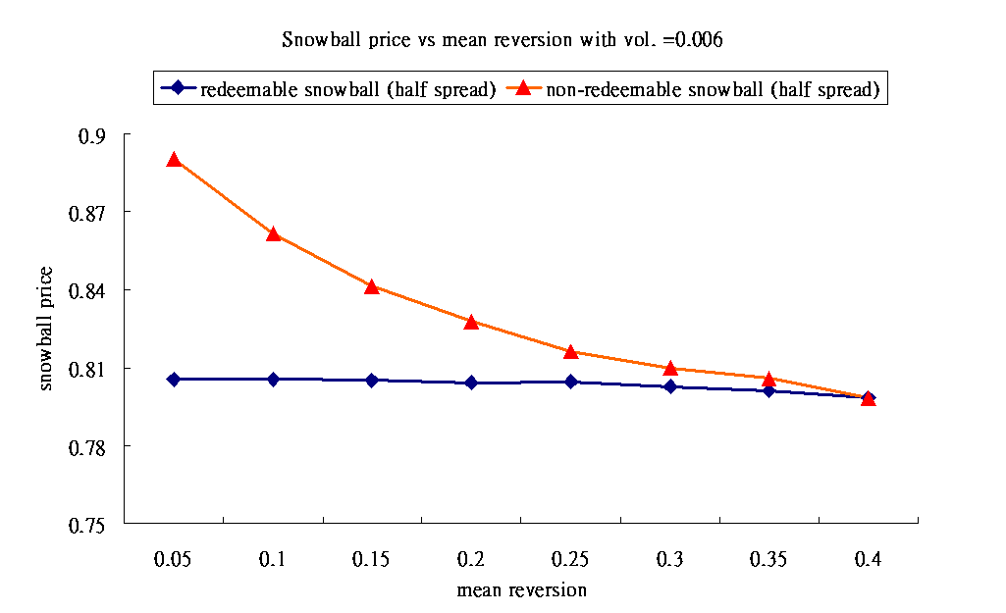
Figure 4.6 Snowball Price with Half Spreads vs. Mean Reversion.
The par value is $1 and zero rate function is rate (t) =0.02363-0.007314*exp (-1.316*t). With half spreads of snowball contract issued by Bank SinoPac, the redeemable price in situation of high mean reversion is low enough for not redeeming the contract, thus non-redeemable price would converges to redeemable price when mean reversion increases.

In figure 4.6, the negative relationship between price and mean reversion would influence on redeeming contract. In high mean reversion, the snowball price with redemption article may be low enough for not redeeming the contract. Thus, non-redeemable price would converges to redeemable price when mean reversion increases. If mean reversion is large enough, the snowball price with redemption article maybe equal to non-redeemable price.

4.2.4 Sensitivity to interest rates of zero curves
In this section, we will compare the snowball contract in chapter 4.1 in situations of different zero rates. Figure 4.7 is showed the high zero rate and the low zero rate which we take different parameters in equation (2.27).
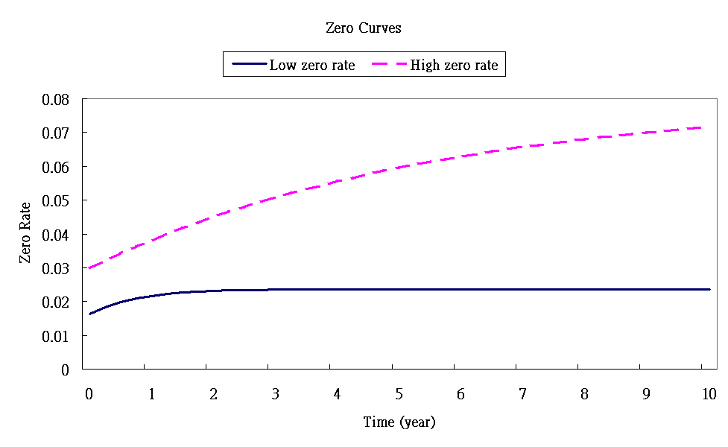
Figure 4.7 Zero Curves.
The two lines come from the same equation (2.27) which is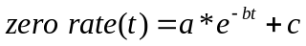. The parameters of high rate curve (dotted line) is a=-0.05, b=0.18, c=0.08 and low rate curve (real line) is a=-0.007314, b=1.316, c=0.02363.

As we known, the interest rates would take great effect on coupons because of inverse interest rate property of snowball notes. Figure 4.8 explains that under the same spreads, non-redeemable snowball price at low market rates is more than at high market rates. Moreover, even without redemptive article, price at high market rates is less than with redeemable contract at low rates.
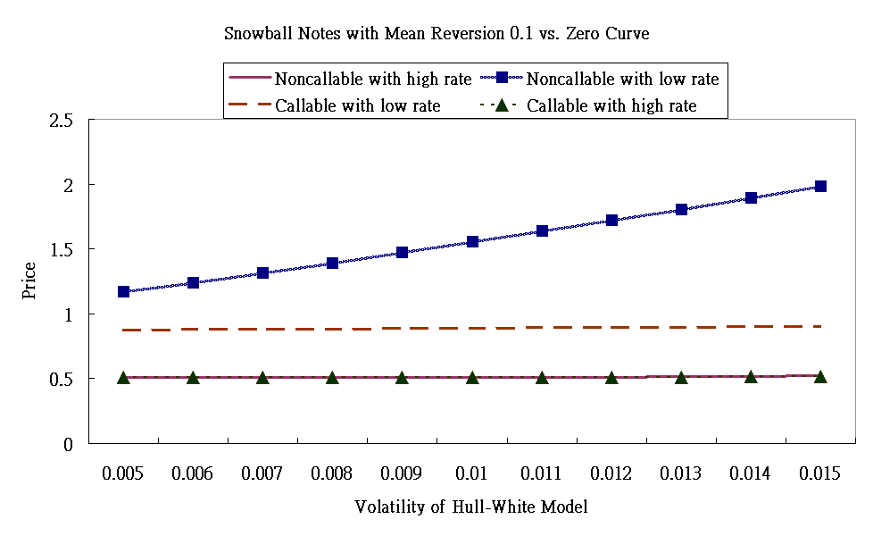
Figure 4.8 Snowball Prices vs. Different Zero Rates.
The prices with different zero rate curves are according to the figure 4.7. Real lines are the price with non-redeemable snowball contract and dotted line is with redeemable snowball contract.
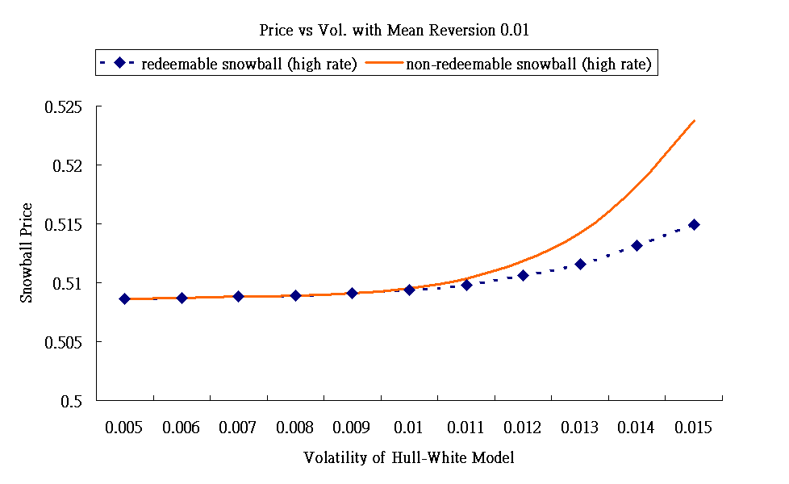
Figure 4.9 Snowball Prices with High Zero Rates vs. Volatility of Short Rate.
The prices in both lines are very low because in high zero rates, most coupons may be reset to zero and decrement of discounted factor makes bond value diminish. The prices don’t increase unless volatility of Hull-White model is big enough.

In Figure 4.9, because in high zero rates, most coupons may be reset to zero and decrement of discounted factor make bond value diminish, the redeemable and non-redeemable snowball price are very low and the price would increase unless volatility is big enough. To conclusion, if the issuers forecast the wrong tendency of interest rate and contract unsuitable spreads, they may be subjected to loss.

4.3 Estimation of parameters
There are two steps for estimating parameters: one is to find the coefficients of zero rate function; the other is to calibrate the mean reversion and volatility in Hull-White model.

4.3.1 Zero rate function
We take Hull-White zero rate equation (2.27) and use curve fitting tool of Matlab toolbox to find the coefficients of term structure function
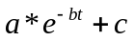
where t means time of year. The observation of zero rates today is in table 4.2 and illustration figure 4.10 shows fitting coefficients.
Table 4.2 An Example of Zero Rates.
The zero rates for ten years from 2006/3/1 could be observed.
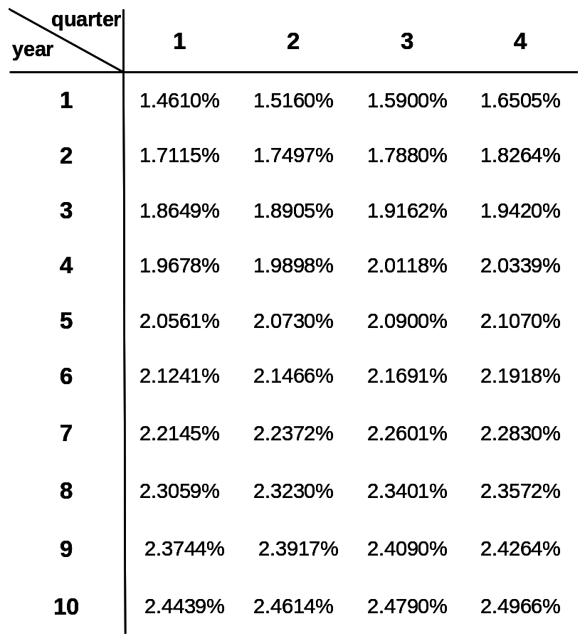
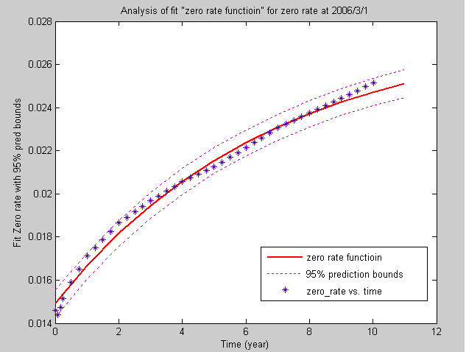
Figure 4.10 A Curve Fitting of Zero Rate Function.
The fitting coefficients are a=-0.01269, b=0.1475, c=0.02761 with 95% confidence bounds where SSE= 3.418e-006, R-square=0.9916.
In order to decrease errors, we use directly the observable zero rate from Table 4.2 to calibrate parameters of Hull-White model in section 4.3.2.

4.3.2 Calibration of mean reversion and volatility
In the first place, as zero rates known in Table 4.2, the forward rate could be calculated by
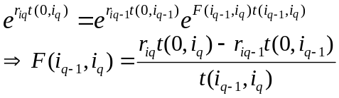
where 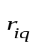 is q-th quarter zero rate of i-th year, 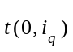 is time from present to q-th quarter of i-th year, and 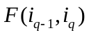 is forward rate from q-1 to q quarter of i-th year.
In the second place, with variable volatilities of caplet on different strike rate observed in the market like table 4.3, we can compute each cap price in table 4.4 by Black’s formulas (2.22)
Table 4.3 Market caplet volatilities.
Each value is percentage of volatilities with different strike rates from 2006/3/1 to 2009/11/27.
Strike rate | 1.5% | 2.5% | 3.5% | 4.5%
2006/6/1 | 8 | 8 | 8 | 8
2006/8/31 | 8 | 8 | 8 | 8
2006/11/29 | 8 | 8 | 8 | 8
2007/3/5 | 8.538594 | 8.360483 | 8.321068 | 8.314355
2007/6/1 | 9.065219 | 8.712955 | 8.635001 | 8.621724
2007/8/30 | 9.603813 | 9.073438 | 8.956069 | 8.936078
2007/11/29 | 10.14839 | 9.437926 | 9.280704 | 9.253926
2008/3/4 | 11.1357 | 10.14639 | 9.837004 | 9.778085
2008/6/2 | 12.12301 | 10.85486 | 10.3933 | 10.30224
2008/8/29 | 13.08838 | 11.54759 | 10.93724 | 10.81475
2008/11/27 | 14.07569 | 12.25605 | 11.49354 | 11.33891
2009/3/4 | 14.81617 | 12.97623 | 12.06952 | 11.85515
2009/6/2 | 15.55665 | 13.69641 | 12.6455 | 12.37139
2009/8/31 | 16.29713 | 14.41659 | 13.22149 | 12.88762
2009/11/27 | 17.02116 | 15.12076 | 13.78467 | 13.39239

Table 4.4 (a) Caplet Price from 2006/6/1 to 2009/11/27.
The caplet price from Black’s formula is shown below.
Strike rate | 1.5% | 2.5% | 3.5% | 4.5%
2006/6/1 | 0.000416 | 0 | 0 | 0
2006/8/31 | 0.000683 | 3.58E-14 | 0 | 0
2006/11/29 | 0.000989 | 3.41E-09 | 0 | 0
2007/3/5 | 0.000993 | 6.95E-08 | 9.18E-18 | 0
2007/6/1 | 0.001176 | 1.53E-06 | 1.97E-13 | 0
2007/8/30 | 0.001364 | 1.04E-05 | 9.90E-11 | 5.62E-17
2007/11/29 | 0.001545 | 3.58E-05 | 5.69E-09 | 9.22E-14
2008/3/4 | 0.001441 | 4.27E-05 | 2.61E-08 | 3.05E-12
2008/6/2 | 0.00156 | 8.68E-05 | 2.53E-07 | 1.99E-10
2008/8/29 | 0.001687 | 0.000149 | 1.34E-06 | 4.30E-09
2008/11/27 | 0.001814 | 0.000228 | 4.78E-06 | 4.38E-08
2009/3/4 | 0.001802 | 0.000265 | 8.96E-06 | 1.55E-07
2009/6/2 | 0.001904 | 0.00035 | 1.96E-05 | 6.28E-07
2009/8/31 | 0.002014 | 0.000446 | 3.73E-05 | 1.97E-06
2009/11/27 | 0.002124 | 0.000549 | 6.33E-05 | 4.96E-06
Table 4.4 (b) Cap Price of maturities 1,2,3,4 years.
The cap price could be calculated by table 4.4(a); for example, the one year cap of strike rate 1.5% is summation of caplets from 2006/6/1 to 2006/11/29, namely, one year cap of strike rate 1.5%={0.000416+0.000683+0.000989}=0.0020879. All caps are computed by the same way.
Strike rate | 1.5% | 2.5% | 3.5% | 4.5%
1 year | 0.0020879 | 3.41E-09 | 0 | 0
2 year | 0.00716633 | 4.79E-05 | 5.79E-09 | 9.23E-14
3 year | 0.0136686 | 0.000555042 | 6.41E-06 | 4.83E-08
4 year | 0.0215128 | 0.00216609 | 0.000135513 | 7.76E-06
Nevertheless, we can sum up cap price of different maturity and compare with cap price which pricing caplet as a put option on a zero coupon bond (2.24) by Hull-White equation (2.20).
In order to find adapted mean reversion and volatility of Hull-White model, we Use summation of square error (SSE) method to find the coefficient
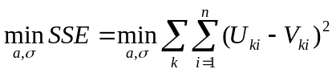
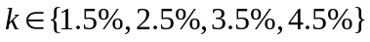
where k is strike rate, n is maturity date, 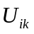 is the market cap price from Black’s formula and 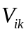 is the price of cap given by the Hull-White model.
The optimal parameters of mean reversion and volatility are 0.014485 and 0.004596. The cap price from Hull-White model with optimal parameters is showed in table 4.5.
Table 4.5 Cap Prices of maturities 1,2,3,4 years from Hull-White Model.
The caplet is calculated by Hull-White equation and the way to compute cap price is the same as table 4.4(b).
Strike rate | 1.5% | 2.5% | 3.5% | 4.5%
1 year | 0.002331 | 3.20E-05 | 6.50E-09 | 4.96E-15
2 year | 0.007852 | 0.000599 | 8.94E-06 | 1.79E-08
3 year | 0.01489 | 0.002012 | 9.27E-05 | 1.24E-06
4 year | 0.023215 | 0.00435 | 0.000373 | 1.32E-05
Moreover, the total fitting consequence of cap price is in figure 4.11. There are caps of 1, 2,3,4,5,7,10 years’ maturities and four kinds of strike rates.
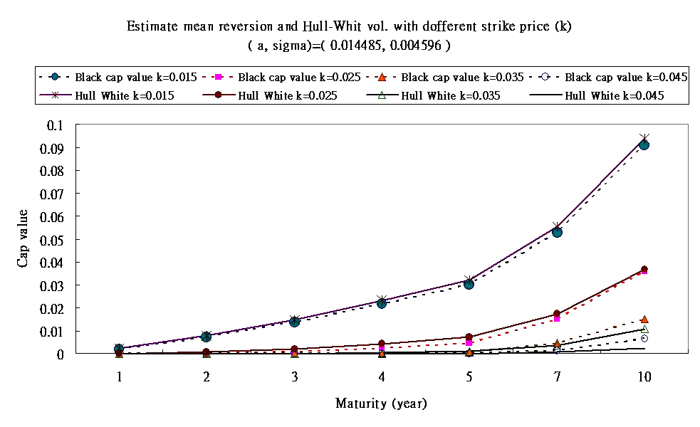
Figure 4.11 Consequence of Calibration for Parameters of Hull-White Model.
The optimal estimated parameters are that mean reversion equals 0.014485 and volatility of Hull-White model equals 0.004596. The minimum summation of square error (SSE) is 7.80133e-005. The dotted lines above are cap price of different strike rates calculated by Hull-White model with optimal parameters and real lines are calculated by Black formula.

5. Conclusions and Future Work
We provide a numerical approach method to price sophisticated snowball notes. Firstly, take Hull-White short rate model as a basic of term structure combined with trinomial tree. Secondly, construct the state variables of coupons and price in snowball notes. Finally, snowball price can be calculated by backward induction and linear interpolation method.
In the sensitivity analysis, we find that the parameters of Hull-White model have significant influence on snowball price. On the one hand, there is negative association between price and mean reversion of Hull-White model, and on the other hand, price and volatility of Hull-White model have positive relation. It is also important about contracting spreads of Snowball notes because of its positive relation to Snowball price. Moreover, the effective way to hedge snowball price is redemptive article which could protect issuers from losing a lot by using lower price to redeem contracts.
In the future, we maybe use different interest rate models to pricing snowball notes and compare with Hull-White tree model in this thesis. Moreover, we also could extend the algorithm of this thesis to price other sophisticated interest rate derivatives by the same term structure.

References
Bender, C., A. Kolodko, and J. Schoenmakers, 2005, “Iterating Snowballs and related path dependent callables in a multi-factor Libor model.” Working Paper
Black, F., 1976, “The Pricing of Commodity Contracts.” Journal of Financial Economics, 3, 167-179
Black, F., and P. Karasinski, 1991, “Bond and Option Pricing When Short Rates Are Lognormal.” Financial Analysts Journal, 52-59
Brace, A., D. Gatarek, and M. Musiela, 1997, “The Market Model of Interest Rate Dynamics.” Mathematical Finance, 7, no. 2, 127-155
Brennan, M. J., and E. S. Schwartz, 1982, “An Equilibrium Model of Bond Pricing and a Test of Market Efficiency.” Journal of Financial and Quantitative Analysis, 17, no. 3, 301-329
Cox, J. C., J. E. Ingersoll, and S. A. Ross, 1982, “A Theory of the Term Structure of Interest Rates.” Econometrica, 53, 385-407
Health, D., R. Jarrow, and A. Morton, 1990, “Bond Pricing and the Term Structure of Interest Rates: A Discrete Time Approximation.” Journal of Financial and Quantitative Analysis, 25, no. 4, 419-440
Health, D., R. Jarrow, and A. Morton, 1990, “Bond Pricing and the Term Structure of Interest Rates: A New Methodology.” Econometrica, 60, no. 1, 77-105
Ho, T. S. Y., and S.-B. Lee, 1986, “Term Structure Movements and Pricing Interest Rate Contingent Claims.” Journal of Finance, 41, 1011-1029
Hull, J. and A. White, 1990, “Pricing Interest Rate Derivative Securities.” Review of Financial Studies, 3, no. 4, 573-592
Hull, J. and A. White, 1993, “Bond Option Pricing Based on a Model for the Evolution of Bond Prices.” Advances in Futures and Options Research, 6, 1-13
Hull, J. and A. White, 1993, “The Pricing of Options on Interest Rate Caps and Floors Using the Hull-White Model.” Journal of Financial Engineering, 2, no. 3, 287-296
Hull, J. and A. White, 1994, “Numerical Procedures for Implementing Term Structure Model I：Single Factor Models.” Journal of Derivatives, 2, 7-16
Hull, J. and A. White, 1996, “Using Hull-White Interest Rate Trees.” Journal of Derivatives, 26-36
Hull, J. and A. White, 2000, “Forward Rate Volatilities, Swap Rate Volatilities, and the Implementation of the LIBOR Market Model.” Journal of Fixed Income, 10, no. 2, 46-62
Jamshidian, F., 1977, “LIBOR and Swap Market Models and Measures.” Finance and Stochastics, 1, 293-330
Kijima, M. and I. Nagayama, 1994, “Efficient Numerical Procedures for the Hull-White Extended Vasicek Model.” Journal of Financial Engineering, 3, 275-292
Miltersen, K., K. Sandmann, and D. Sondermann, 1997, “Closed Form Solutions for Term Structure Derivatives with Lognormal Interest Rates.” Journal of Finance, 52, no. 1, 409-430
Vasicek, O. A., 1977, “An Equilibrium Characterization of the Term Structure.” Journal of Financial Economics, 5, 177-188

Appendix A
Derive caplet as a put option of zero-coupon bond
At time, Caplet value which is paid at time is following:
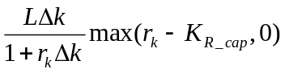
where
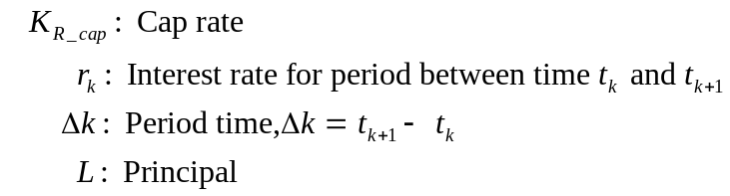
Because 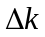and 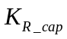 are constants, we can change the formula of caplet into following equation:
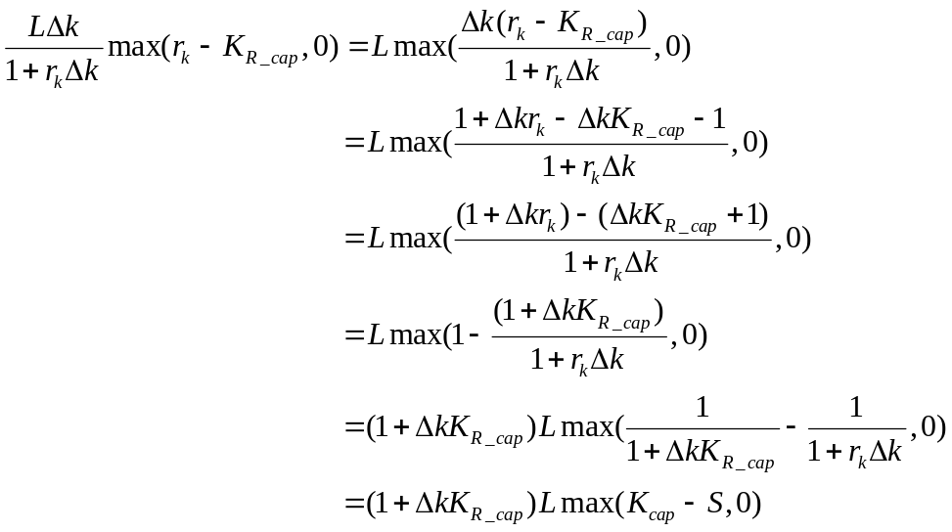
where
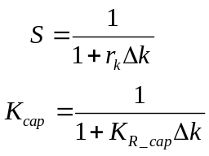
Consider S is the underlying value at time and is a strike price of a put option where the underlying is a zero-coupon bond which maturity is .

Appendix B
Derive floorlet as a call option of zero-coupon bond
At time, floorlet value which is paid at time is following:
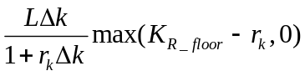
where
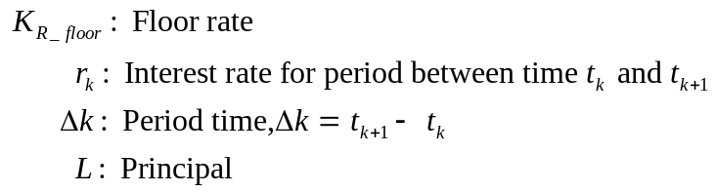
Because and 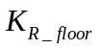 are constants, we can change the formula of floorlet into following equation:
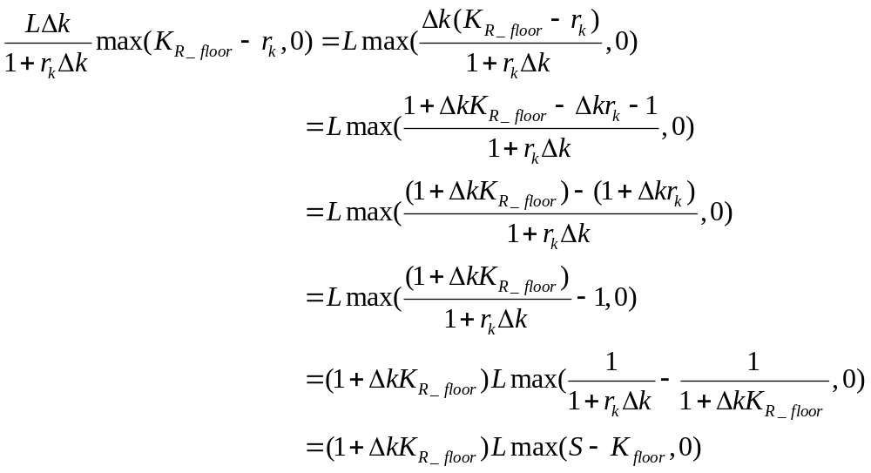
where
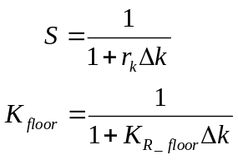
Consider S is the underlying value at time and is a strike price of a call option where the underlying is a zero-coupon bond which maturity is .

