利率期末報告

How Does Creditor’s Liquidation Decision Affect Debt and Equity Values with Stochastic Interest Rate?

學生：交大財金碩二 9639506 施嘉紋
9639507 王薇婷

介紹
目前有許多公司債與股東價值的研究，本篇論文主要是在分析破產後(grace period;寬限期)股東與債權人的行為，且股東會進行策略性債務清償時的公司價值的變動。但本篇股東債權人可以分析主要源於假設債權人與債務人彼此知道彼此的行為。
由於清算成本使債權人即使公司在寬限期後仍處於破產狀態或是沒有重整的情況下會想延後清算，此時也提供了股東有策略性債務清償的機會。我們引進了隨機利率模型，假設利率服從CIR model，在這樣的條件下檢視策略性債務清償與利率變動對公司資產變化造成的效果。而此模型的破產門檻為債權人與股東經過賽局決策而決定，換句話說可視為內生給定的。

文獻回顧與探討
- Merton, R. C., (1974),
On the Pricing of Corporate Debt: The Risk Structure of Interest Rates, Journal of Finance, 29:449-470
Metron模型是將股東權益看成買權，利用Black and Scholes的選擇權公式套用到信用風險這個領域，推導出債券PDE及訂價，看到期日公司資產是否會低於該付的債款，也就是在到期日用一固定破產門檻檢視是否破產，但無法檢視到期日之前公司發生破產的狀況。
- Black , F., and Cox, J.,(1976),
Valuing Corporate Securities: Some Effects of Bond Indenture Provisions, Journal of Finance, 31:351-367
Black and Cox改進Merton模型，提出與時間相關的破產門檻，公司資產在第一次碰到破產門檻後就視為破產(即First passage model)，改進了Merton model只在到期日檢視的缺點。
- Brennan, M.J., and Schwartz, E.S.,(1978),
Corporate Income Taxes , Valuation, and the Problem of Optimal Capital Structure, Journal of Business, 51:103-114
Leland, H. (1994),
Corporate Debt Value, Bond Covenants, and Optimal Capital Structure, Journal of Finance,49:1213-1252
通常公司破產不見得會馬上被清算掉，但這幾篇論文是將破產與清算視為同一件事，也就是說，公司破產就會被清算掉。
- Fan, H., and Sundaresan, S., (2000),
Debt Valuation, Renegotiation, and Optimal Dividend Policy, Review of Finance Studies, 13:1057-1099
此篇論文顯示股東可能會停止支付票面利率或該付的債款並進行策略性債務清償的動作，並把債務人與債權人之間的協商過程視為Nash bargaining的賽局。
以下幾篇論文是將破產與清算視為不同的事件
在回顧下列幾篇論文前先提出美國破產法的第十一章，簡單來說，有財務危機的公司當無力償還債款時，可根據美國破產法的第十一章中的grace period(下列我們翻成寬限期)暫時先不用償還，也暫時免於清算的危機，在寬限期中擬定重整或其他計畫。
- Francois, P., and Morellec, E., (2004; henceafter FM),
Capital Structure and Asset Prices: Some Effects of Bankruptcy Procedures, Journal of Business, 77:387-441
此篇假設當公司停留在破產的狀況超過寬限期時才會發生清算。
- Broadie, M., Chernov, M. and Sundaresan, S., (2005; henceafter BCS),
Optimal Debt and Equity Values in the Presence of Chapter 7 and Chapter 11, Working Paper, Columbia University.
此篇論文主要在研究股東與債權人除了清算以外，因為重整而造成的衝突，並發現債務人與債權人之間的不斷協商其實並沒有增進社會福利。
- Galai, D., Raviv, A., and Wiener, Z., (2003),
Liquidation Triggers and the Valuation of Equity and Debt, Working Paper, Herbrew University of Jerusalem.
Moraux , F., (2002),
Valuing Corporate Liabilities When the Default Threshold is not an Absorbing Barrier, Working Paper, University Rennes I.
Paseka, A., (2003)
Debt Valuation with Endogenous Default and Chapter 11 Reorganization, Working Paper, University of Arizona.
這幾篇都是與此篇議題相關的論文

研究方法與模型
- 研究方法:
三維度之有限差分法(Explicit Finite Difference)模擬
- Model: 推導如下
假設:
- 設公司資產過程V(t)為動態，隨時間經過可以以下面的SDE來描述公司資產變動過程，在風險中立測度下的SDE:
其中 r(t) : stochastic interest rate
δ : the continuous dividend rate
σ₁ : the asset volatility
σ₂ : the interest rate volatility
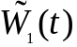: a standard Brownian motion under the filtered probability space
(Ω,ℑ,P*)
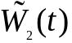: a standard Brownian motion under the filtered probability space
(Ω,ℑ,P*)
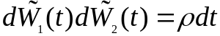
- 隨機利率服從CIR(Cox-Ingersoll-Ross) model
- The risk-neutral dynamics of the process V are given
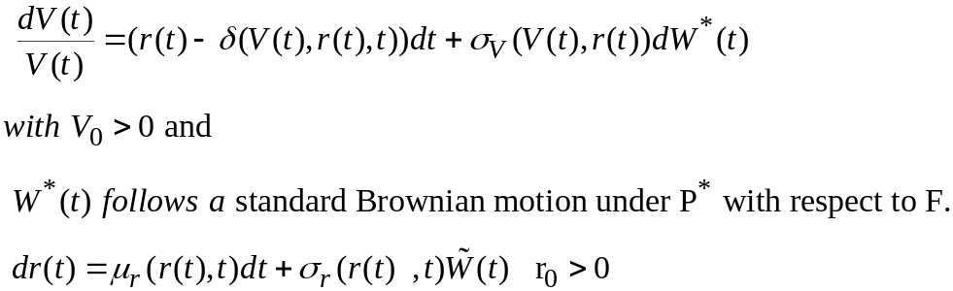
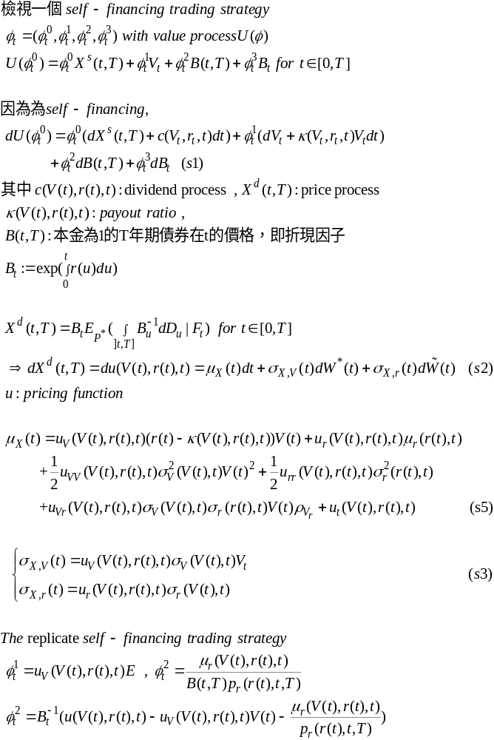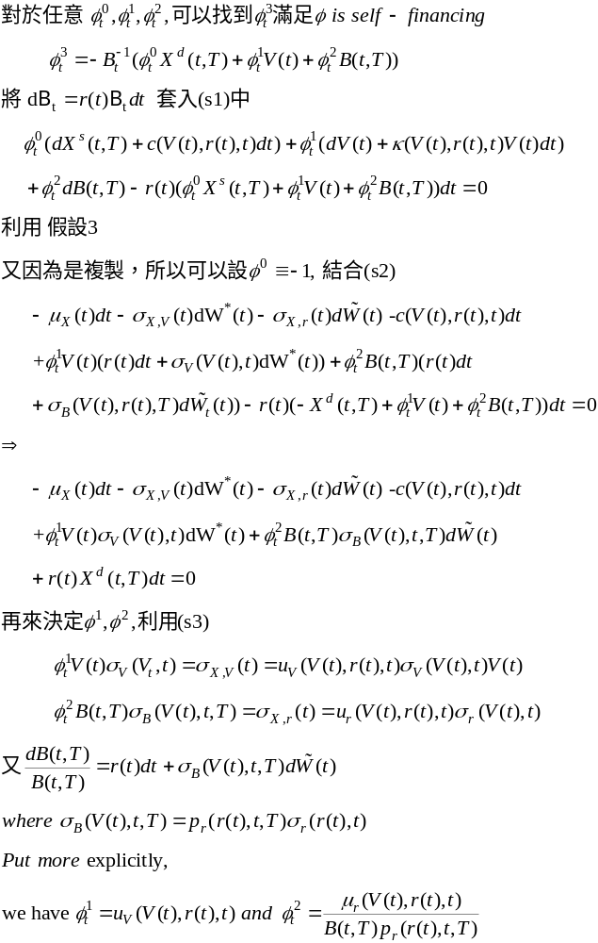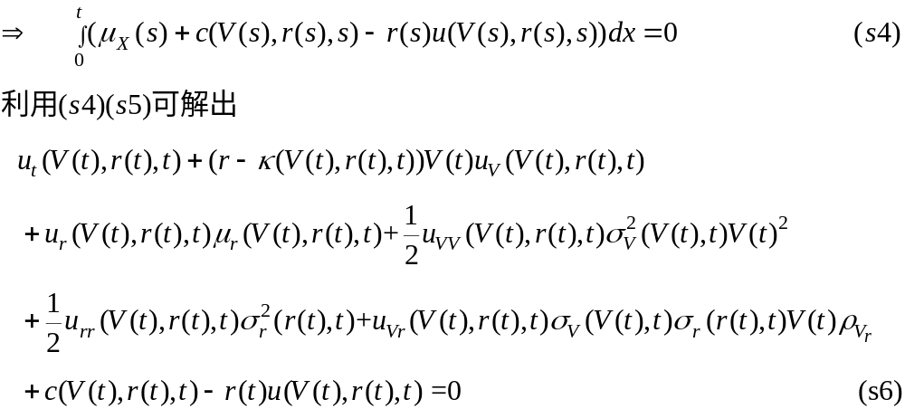得證。

我們接著利用上面證明的結果去推導我們引進隨機利率模型的PDE：
Equity: 在liquid state PDE
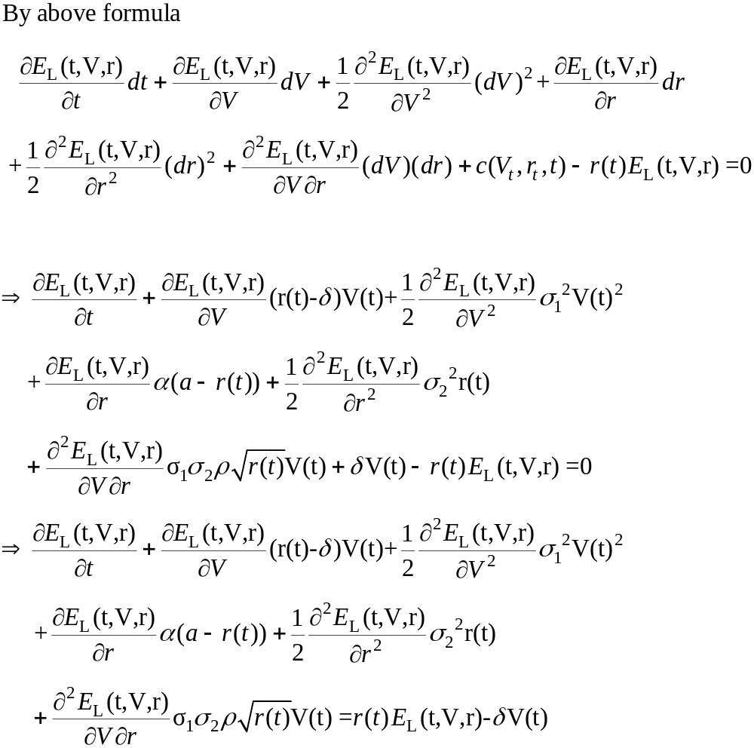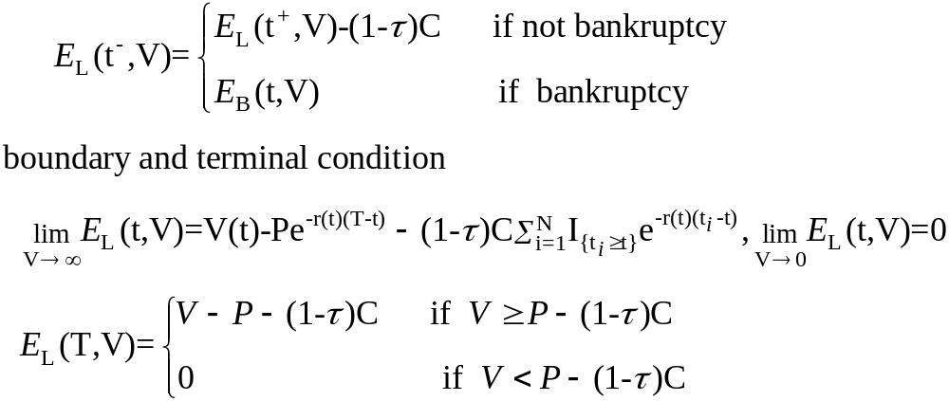同理可證;
debt: 在liquid state PDE 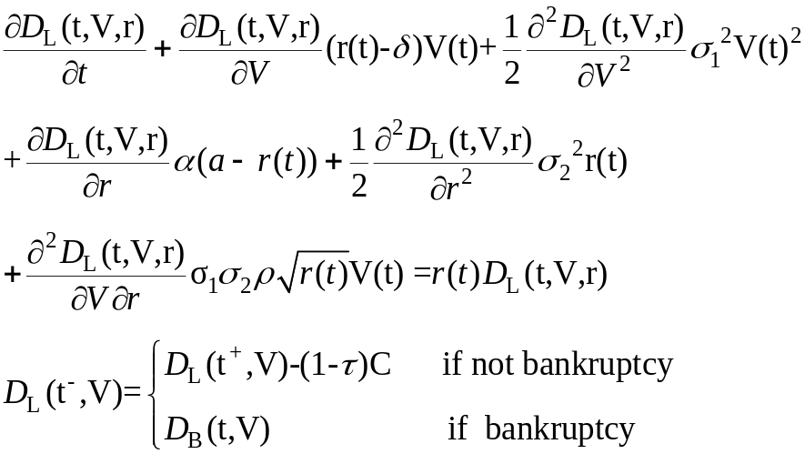
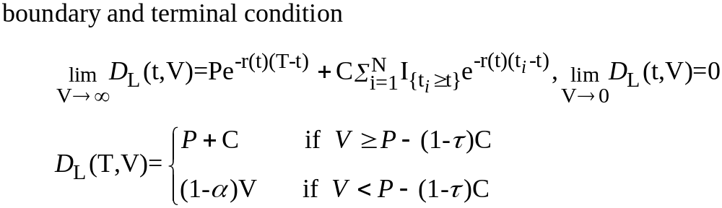
Equity: 在bankruptcy state PDE
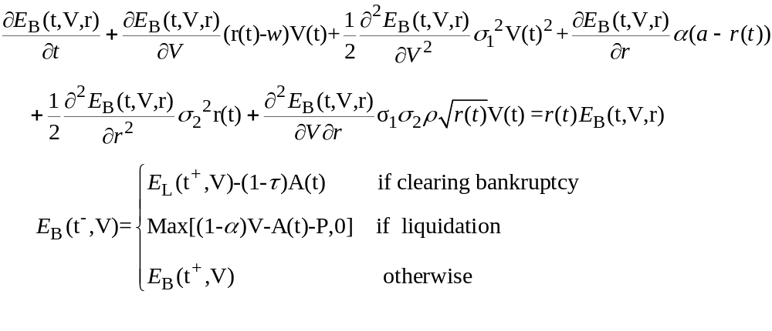
debt: 在bankrupcy state PDE
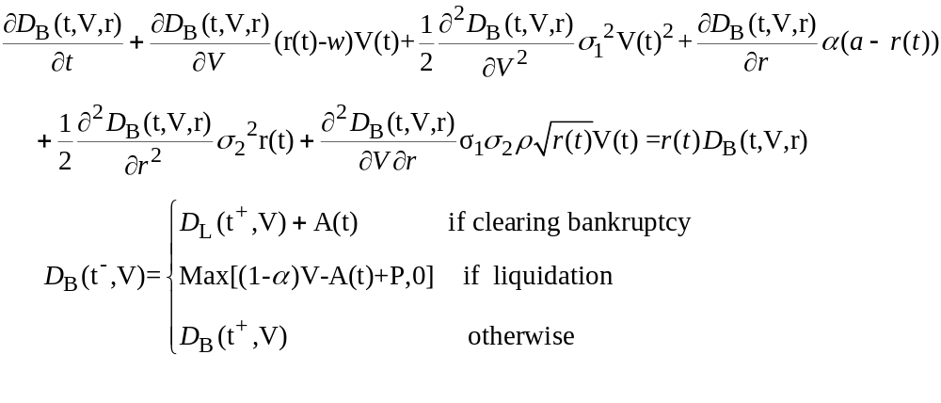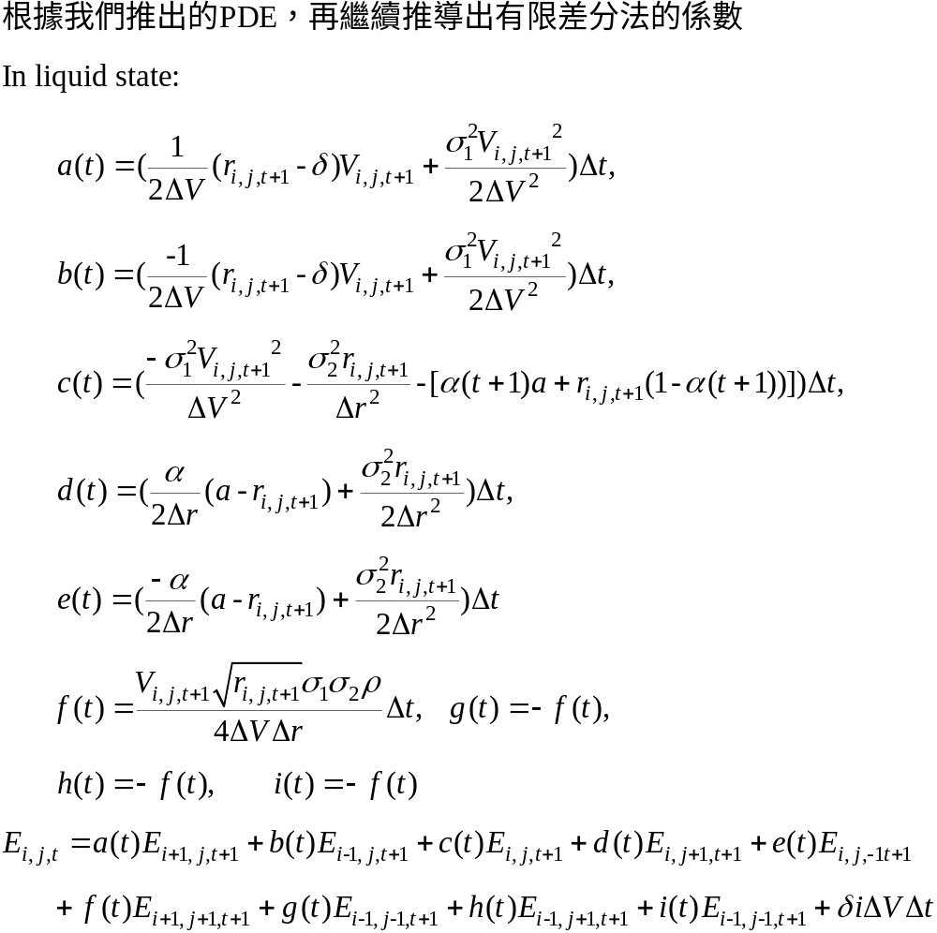
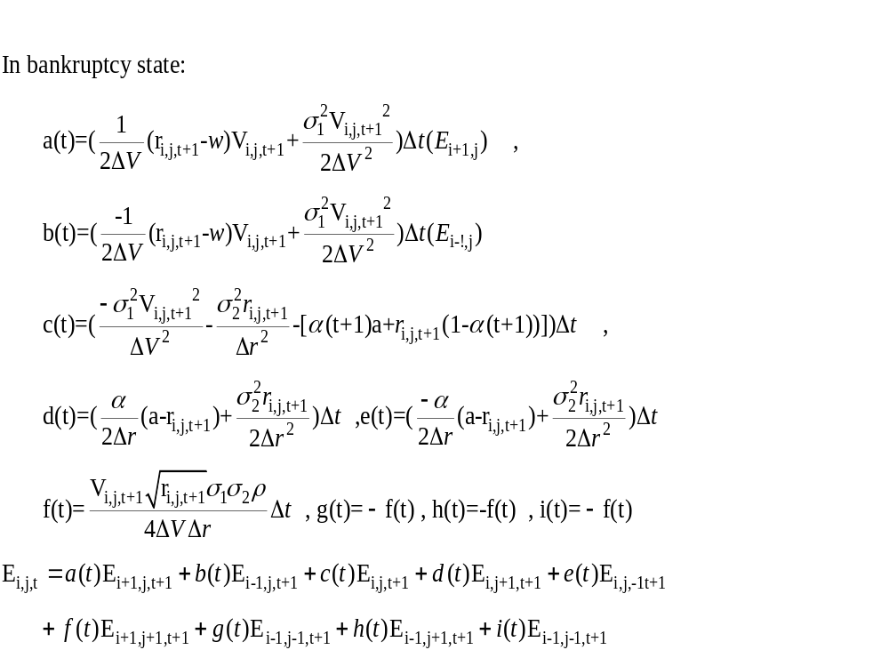
根據原始paper的假設，我們放寬無風險利率為常數的假設條件，採用隨機利率模型CIR model。在每個時點去檢視股東要宣稱破產或是清算進行選擇，相當於設定一個與時間相關的破產門檻，用這樣的數值方法解決了與時間相關的門檻設定的問題。如果公司處於破產狀態，股東可以選擇支付累積的逾期債款與利息然後讓公司正常回到正常營運狀態，或是繼續處於破產的狀態。公司如果被清算時，清算成本會跟公司資產成正比，也就是αV(t)，會使債權人收到部分剩下 (1-α)V(t) .

預期結果
藉由引進CIR利率模型，可以增加影響公司資產變化的因子，考慮更多樣化，加上實際市場上的利率確實是浮動，隨時間改變的，所以加入利率在評價公司資產、股東權益及債權人價值應會比固定利率去求算的結果來的更符合真實值。此外可以檢視在不同的利率水準之下對公司價值的影響並透過使用外生的有限差分法來做模擬，分析利率高低時公司資產的敏感度。預期在利率比較高時，可能使債券價值下降，在利率比較低時，債券價值應該會升高，再繼續分析利率高低是否會侵蝕公司獲利率、資產價值的變動是否有不同趨勢等。

實證
我們舉一個三期的例子，以三維度有限差分法模擬在各個狀態下的股東價值與債權價值。公司價值V設定範圍為0~450，利率水準(r)由0.01~0.19，債券P=100，債息C=2，稅收35%。
在公司正常狀態下求出的股東價值：
E1(:,:,1) =
% 時間點t=1 縱軸往上表公司價值(V)越高情形下股東價值也越高
% 橫軸往右表利率水準(r)越高，股東價值下降
Columns 1 through 5
352.2859 354.7089 357.0712 359.3745 361.6202
302.2859 296.0067 294.5399 291.6379 287.1271
252.2859 231.1889 218.7263 207.1747 196.0315
202.2859 184.8859 174.4192 164.6553 155.2414
152.2859 138.5830 130.1122 122.1360 114.4514
102.2859 92.3814 85.9215 79.7620 73.8389
52.2859 47.4824 43.2746 39.3546 35.6679
2.2859 9.8716 8.0652 6.8145 5.6968
-47.7141 -4.5148 1.9648 1.9213 1.8965
0 0 0 0 0
Columns 6 through 10
363.8099 365.9448 368.0265 370.0562 372.0353
281.0381 273.4076 264.2728 341.4014 322.0353
185.3003 174.9833 165.0818 209.6428 272.0353
146.1808 137.4751 129.1256 169.5475 222.0353
107.0613 99.9670 93.1694 129.4523 172.0353
68.1543 62.7094 57.5051 89.6232 122.0353
32.2169 29.0028 26.0266 53.1703 72.0353
4.7138 3.8661 3.1545 16.3053 22.0353
1.8906 1.9038 1.9362 -13.8226 -27.9647
0 0 0 0 0
E1(:,:,2) = % 時間點t=2
Columns 1 through 5
349.3960 353.2150 356.8179 360.2207 363.4378
299.3960 287.7650 279.7650 271.7650 263.7650
249.3960 239.7650 232.7650 225.7650 218.7650
199.3960 191.7650 185.7650 179.7650 173.7650
149.3960 143.7650 138.7650 133.7650 128.7650
99.3960 95.7650 91.7650 87.7650 83.7650
49.3960 48.0185 45.0575 42.0965 39.1355
-0.6040 5.4090 4.4350 3.4610 2.4870
-50.6040 1.0000 1.0000 1.0000 1.0000
0 0 0 0 0
Columns 6 through 10
366.4826 369.3672 372.1026 374.6990 377.1655
255.7650 247.7650 239.7650 231.7650 327.1655
211.7650 204.7650 197.7650 190.7650 277.1655
167.7650 161.7650 155.7650 149.7650 227.1655
123.7650 118.7650 113.7650 108.7650 177.1655
79.7650 75.7650 71.7650 67.7650 127.1655
36.1745 33.2135 30.2525 27.2915 77.1655
1.5130 0.5390 -0.4350 -1.4090 27.1655
1.0000 1.0000 1.0000 1.0000 -22.8345
0 0 0 0 0
E1(:,:,3) = % 時間點t=3
Columns 1 through 5
348.7000 348.7000 348.7000 348.7000 348.7000
298.7000 298.7000 298.7000 298.7000 298.7000
248.7000 248.7000 248.7000 248.7000 248.7000
198.7000 198.7000 198.7000 198.7000 198.7000
148.7000 148.7000 148.7000 148.7000 148.7000
98.7000 98.7000 98.7000 98.7000 98.7000
48.7000 48.7000 48.7000 48.7000 48.7000
0 0 0 0 0
0 0 0 0 0
0 0 0 0 0
Columns 6 through 10
348.7000 348.7000 348.7000 348.7000 348.7000
298.7000 298.7000 298.7000 298.7000 298.7000
248.7000 248.7000 248.7000 248.7000 248.7000
198.7000 198.7000 198.7000 198.7000 198.7000
148.7000 148.7000 148.7000 148.7000 148.7000
98.7000 98.7000 98.7000 98.7000 98.7000
48.7000 48.7000 48.7000 48.7000 48.7000
0 0 0 0 0
0 0 0 0 0
0 0 0 0 0
在公司正常狀態下求出的債權人價值：
D1(:,:,1) = % 時間點t=1
Columns 1 through 5
99.0734 96.6205 94.2291 91.8976 89.6244
99.0734 95.4515 90.2371 85.8701 82.2033
99.0734 93.6603 92.0550 91.0860 90.1170
99.0734 93.6603 92.0550 91.0860 90.1170
99.0734 93.6603 92.0550 91.0860 90.1170
99.0734 89.6047 87.3997 85.2692 83.0190
99.0734 76.5758 73.8483 70.9639 68.0221
99.0734 51.3592 44.2676 42.0201 39.8441
99.0734 32.5619 21.2184 20.3321 19.4852
0 0 0 0 0
Columns 6 through 10
87.4082 85.2475 83.1408 81.0868 79.0841
79.1907 76.7872 74.9498 53.6860 79.0841
89.1480 88.1790 87.2100 71.9465 79.0841
89.1480 88.1790 87.2100 71.9465 79.0841
89.1480 88.1790 87.2100 71.9465 79.0841
80.6476 78.1539 75.5375 61.3013 79.0841
65.0218 61.9622 58.8429 61.1033 79.0841
37.7401 35.7084 33.7492 58.6623 79.0841
18.6784 17.9116 17.1852 49.4214 79.0841
0 0 0 0 0
D1(:,:,2) = % 時間點t=2
Columns 1 through 5
101.9902 98.1448 94.5170 91.0908 87.8514
101.9902 96.9000 96.9000 96.9000 96.9000
101.9902 96.9000 96.9000 96.9000 96.9000
101.9902 96.9000 96.9000 96.9000 96.9000
101.9902 96.9000 96.9000 96.9000 96.9000
101.9902 96.9000 96.9000 96.9000 96.9000
101.9902 86.7600 85.2000 83.6400 82.0800
101.9902 48.8900 47.3500 45.8100 44.2700
101.9902 23.5000 23.0000 22.5000 22.0000
0 0 0 0 0
Columns 6 through 10
84.7855 81.8810 79.1267 76.5124 74.0288
96.9000 96.9000 96.9000 96.9000 74.0288
96.9000 96.9000 96.9000 96.9000 74.0288
96.9000 96.9000 96.9000 96.9000 74.0288
96.9000 96.9000 96.9000 96.9000 74.0288
96.9000 96.9000 96.9000 96.9000 74.0288
80.5200 78.9600 77.4000 75.8400 74.0288
42.7300 41.1900 39.6500 38.1100 74.0288
21.5000 21.0000 20.5000 20.0000 74.0288
0 0 0 0 0
D1(:,:,3) = % 時間點t=3
Columns 1 through 10
102 102 102 102 102 102 102 102 102 102
102 102 102 102 102 102 102 102 102 102
102 102 102 102 102 102 102 102 102 102
102 102 102 102 102 102 102 102 102 102
102 102 102 102 102 102 102 102 102 102
102 102 102 102 102 102 102 102 102 102
102 102 102 102 102 102 102 102 102 102
50 50 50 50 50 50 50 50 50 50
25 25 25 25 25 25 25 25 25 25
0 0 0 0 0 0 0 0 0 0
在公司破產狀態下求出的股東價值：
Eb(:,:,1) =
Columns 1 through 5
352.1975 354.5387 356.8210 359.0459 361.2148
302.1975 307.8898 309.7539 309.3768 307.3819
252.1975 268.0256 257.7487 245.3639 233.3877
202.1975 216.2670 207.6489 197.1730 187.0473
152.1975 164.5076 157.5483 148.9813 140.7062
102.1975 112.8978 107.6272 101.0241 94.6613
52.1975 62.3291 58.9411 54.6325 50.5582
2.1975 17.8907 16.5456 15.0494 13.6837
-47.8025 -1.6810 4.9820 4.8657 4.7674
0 0 0 0 0
Columns 6 through 10
363.3291 365.3902 367.3994 369.3580 371.2672
303.8010 298.6718 292.0327 351.9668 321.2672
221.8239 210.6745 199.9409 232.2352 271.2672
177.2751 167.8582 158.7976 188.7807 221.2672
132.7257 125.0412 117.6537 145.3260 171.2672
88.5409 82.6643 77.0321 102.3419 121.2672
46.7206 43.1212 39.7608 61.5446 71.2672
12.4502 11.3497 10.3828 20.3363 21.2672
4.6875 4.6260 4.5830 - 12.5206 -28.7328
0 0 0 0 0
Eb(:,:,2) =
Columns 1 through 5
346.7303 350.5145 354.0817 357.4478 360.6274
296.7303 285.0645 277.0288 268.9921 260.9546
246.7303 237.0645 230.0288 222.9921 215.9546
196.7303 189.0645 183.0288 176.9921 170.9546
146.7303 141.0645 136.0288 130.9921 125.9546
99.3047 106.2963 102.2932 98.2901 94.2869
49.3047 55.6975 52.7830 49.8685 46.9539
- 0.6953 9.7112 8.7689 7.8267 6.8845
- 50.6953 2.5000 2.5000 2.5000 2.5000
0 0 0 0 0
Columns 6 through 10
363.6337 366.4788 369.1737 371.7285 374.1524
252.9161 244.8765 236.8360 228.7945 324.1524
208.9161 201.8765 194.8360 187.7945 274.1524
164.9161 158.8765 152.8360 146.7945 224.1524
120.9161 115.8765 110.8360 105.7945 174.1524
90.2838 86.2807 82.2776 78.2745 124.1524
44.0394 41.1249 38.2103 35.2958 76.3704
5.9422 0 0 0 26.3704
0 0 0 0 -23.6296
0 0 0 0 0
Eb(:,:,3) =
Columns 1 through 5
346.0870 346.0610 346.0350 346.0090 345.9830
296.0870 296.0610 296.0350 296.0090 295.9830
246.0870 246.0610 246.0350 246.0090 245.9830
196.0870 196.0610 196.0350 196.0090 195.9830
146.0870 146.0610 146.0350 146.0090 145.9830
97.1511 97.1511 97.1511 97.1511 97.1511
47.1115 47.1115 47.1115 47.1115 47.1115
0 0 0 0 0
0 0 0 0 0
0 0 0 0 0
Columns 6 through 10
345.9570 345.9310 345.9050 345.8790 345.8530
295.9570 295.9310 295.9050 295.8790 295.8530
245.9570 245.9310 245.9050 245.8790 245.8530
195.9570 195.9310 195.9050 195.8790 195.8530
145.9570 145.9310 145.9050 145.8790 145.8530
97.1511 97.1511 97.1511 97.1511 97.1511
47.1115 47.1115 47.1115 47.1115 47.1115
0 0 0 0 0
0 0 0 0 0
0 0 0 0 0
在公司破產狀態下求出的債權人價值：
Db(:,:,1) =
Columns 1 through 5
99.2095 96.8823 94.6140 92.4031 90.2482
99.2095 103.4074 99.9378 96.5998 93.9665
99.2095 127.4338 128.1750 126.6711 125.1668
99.2095 122.8613 123.3000 121.8711 120.4418
99.2095 118.2887 118.4250 117.0711 115.7168
99.2095 110.9332 110.2060 107.9056 105.4775
99.2095 95.2103 93.9008 90.8210 87.6821
99.2095 64.4660 58.2304 55.6965 53.2374
99.2095 38.5269 27.5372 26.5203 25.5438
0 0 0 0 0
Columns 6 through 10
88.1479 86.1008 84.1056 82.1610 80.2658
91.9910 90.6272 89.8313 51.8630 0
123.6619 122.1566 120.6509 94.3373 0
119.0119 117.5816 116.1509 91.3202 0
114.3619 113.0066 111.6509 88.3031 0
102.9192 100.2294 97.4068 76.5042 0
84.4828 81.2226 77.9009 74.2765 0
50.8541 48.5472 46.3173 67.7486 0
24.6081 23.7136 22.8604 53.8872 0
0 0 0 0 0
Db(:,:,2) =
Columns 1 through 5
102.1307 98.4142 94.9126 91.6098 88.4917
102.1307 118.9746 119.0000 119.0254 119.0507
102.1307 116.4746 116.5000 116.5254 116.5507
102.1307 113.9746 114.0000 114.0254 114.0507
102.1307 111.4746 111.5000 111.5254 111.5507
102.1307 108.9746 109.0000 109.0254 109.0507
102.1307 98.3471 96.7367 95.1227 93.5051
102.1307 56.4126 54.8330 53.2514 51.6677
102.1307 26.7500 26.2500 25.7500 25.2500
0 0 0 0 0
Columns 6 through 10
85.5452 82.7584 80.1205 77.6214 75.2520
119.0759 119.1010 119.1260 119.1508 75.2520
116.5759 116.6010 116.6260 116.6508 75.2520
114.0759 114.1010 114.1260 114.1508 75.2520
111.5759 111.6010 111.6260 111.6508 75.2520
109.0759 109.1010 109.1260 109.1508 75.2520
91.8835 90.2579 88.6280 86.9936 75.2520
50.0817 48.4933 46.9025 45.3092 75.2520
24.7500 24.2500 23.7500 23.2500 75.2520
0 0 0 0 0
Db(:,:,3) =
Columns 1 through 5
104.1011 104.1547 104.2096 104.2660 104.3237
104.1011 104.1547 104.2096 104.2660 104.3237
104.1011 104.1547 104.2096 104.2660 104.3237
104.1011 104.1547 104.2096 104.2660 104.3237
104.1011 104.1547 104.2096 104.2660 104.3237
104.1011 104.1547 104.2096 104.2660 104.3237
104.1011 104.1547 104.2096 104.2660 104.3237
50.0000 50.0000 50.0000 50.0000 50.0000
25.0000 25.0000 25.0000 25.0000 25.0000
0 0 0 0 0
Columns 6 through 10
104.3830 104.4438 104.5061 104.5700 104.6355
104.3830 104.4438 104.5061 104.5700 104.6355
104.3830 104.4438 104.5061 104.5700 104.6355
104.3830 104.4438 104.5061 104.5700 104.6355
104.3830 104.4438 104.5061 104.5700 104.6355
104.3830 104.4438 104.5061 104.5700 104.6355
104.3830 104.4438 104.5061 104.5700 104.6355
50.0000 50.0000 50.0000 50.0000 50.0000
25.0000 25.0000 25.0000 25.0000 25.0000
0 0 0 0 0
公司在各種條件下所處的狀態：
1：正常營運 0：破產狀態 -1：被清償狀態
% 縱軸：公司價值(往上，價值高) 橫軸：利率水準(往右，利率高)
state(:,:,1) =
% 在時間點一，由此可知在任何情況下公司皆會選擇繼續經營
Columns 1 through 10
1 1 1 1 1 1 1 1 1 1
1 1 1 1 1 1 1 1 1 1
1 1 1 1 1 1 1 1 1 1
1 1 1 1 1 1 1 1 1 1
1 1 1 1 1 1 1 1 1 1
1 1 1 1 1 1 1 1 1 1
1 1 1 1 1 1 1 1 1 1
1 1 1 1 1 1 1 1 1 1
1 1 1 1 1 1 1 1 1 1
1 1 1 1 1 1 1 1 1 1
state(:,:,2) =
% 在時間點二，當公司價值下降，會選擇宣告破產，但是當利率水準較高時，會傾向清算
Columns 1 through 10
1 1 1 1 1 1 1 1 1 1
1 1 1 1 1 1 1 1 1 1
1 1 1 1 1 1 1 1 1 1
1 1 1 1 1 1 1 1 1 1
1 1 1 1 1 1 1 1 1 1
0 0 0 0 0 0 0 0 0 1
0 0 0 0 0 0 0 0 0 0
0 0 0 0 0 0 -1 -1 -1 0
0 0 0 0 0 -1 -1 -1 - 1 0
0 0 0 0 0 0 0 0 0 0
state(:,:,3) =
% 在時間點三，當公司價值下降，大部份會選擇宣告破產
Columns 1 through 10
1 1 1 1 1 1 1 1 1 1
1 1 1 1 1 1 1 1 1 1
1 1 1 1 1 1 1 1 1 1
1 1 1 1 1 1 1 1 1 1
1 1 1 1 1 1 1 1 1 1
0 0 0 0 0 0 0 0 0 0
0 0 0 0 0 0 0 0 0 0
0 0 0 0 0 0 0 0 0 0
0 0 0 0 0 0 0 0 0 0
0 0 0 0 0 0 0 0 0 0

這部分的結果符合我們對公司破產宣告的預期，我們會在結論部分做更深入的說明。

貢獻
藉由加入隨機利率模型，將r r(t)，分別在推出在正常營運狀態與破產狀態的股東權益與債權人價值，繼而推出加入利率隨機時，有限差分法的股東與債權人分別吻合的updating equation，利用程式跑模擬，造出複雜的三維度的樹並進行利率對資產以及策略性債務清償對公司資產與清算或破產與否的決策的影響。

參考書目
Stochastic Calculus For Finance II Continuous-Time Models Steven E. Shreve
Credit Risk: Modeling, Valuation and Hedging Tomasz R. Bielecki , Marek Ruykowski
Interest Rate Models : An Introduction Andrew J.G. Cains

結論
這篇原始論文造樹比較複雜的部份是在計算破產狀態時，累積的逾期欠款的計算，必須考慮每一個可能的破產點，當期數增加時，折現的影響越大，所以我們引入隨機利率模型藉加以探討。雖加入利率隨機項到此模型中，直覺上應該比較符合真實市場的狀況，但數學的推導過程比兩維度來的繁複，造樹模擬過程也複雜許多，再加上當期數越多時，不僅時間、資產與利率影響，每次檢視點考慮的預期債款計算也是一項浩大的工程。我們利用外生有限差分法對我們所提出的模型修改與方程式進行模擬實證，實證結果可以發現當期數為三期時，在一開始公司資產開始往下降時，債權人或股東幾乎都傾向於讓公司處於正常營運的狀態；一段時間後當公司資產下降時，在利率比較低的時候，股東會宣稱破產，在利率比較高時，債權人會清算公司；在到期日時，公司資產太低驅使股東宣稱破產。換句話說，一開始的時間即便公司資產開始下滑，但是距離到期日還有一大段時間，債權人與股東心裡應該預期有足夠反應的時間可以使公司資產回復到正常水準下，所以大都不採取清算或破產的動作，但時間慢慢過去時，公司資產若仍處於比較低的狀態，股東與債權人會紛紛採取行動，當利率偏高時，會侵蝕掉債權人原本的價值，此時債權人則會傾向清算掉公司比較有利，若利率偏低時，債權人清算的意願會比較低，而股東則會考慮是否要維持正常營運狀態。我們的例子中，在這樣的情形之下，股東多半傾向宣稱破產。在到期日如果公司資產價值仍太低，公司只有宣稱破產的動作了，所以引進利率模型不僅與市場情形一致，還可以進一歩分析股東與債權人會隨公司資產變動時，在不同利率水準下分別會採取什麼樣的策略。

程式碼
%function [ output_args ] = firm_value( input_args )
%FIRM_VALUE Summary of this function goes here
% Detailed explanation goes here
V=450:-50:0;dV=50;n=10;
r=0.01:0.02:0.19;dr=0.02;
did=0.02;s1=0.2;s2=0.1;ro=0.3;alpha=0.5;a=0.05;
P=100;tou=0.35;C=2;
PV=zeros(3,n);
%% liquid state
% equity
E1=zeros(n,n,3);
E1(:,:,3)=max( V'-P-(1-tou)*C,0)*ones(1,n);
G=sqrt(alpha^2+2*s2^2);
PV(3,:)=1./(1+r);
PV(2,:)=(1./(1+r)).^2;
T=2;
for j=1:n
t=0;
A(t+1)=(2*G*exp((alpha+G)*(T-t)/2)/((G+alpha)*(exp(G*(T-t))-1)+2*G))^(2*alpha*a/(s2*s2));
B(t+1)=(2*(exp(G*(T-t))-1)/((G+alpha)*(exp(G*(T-t))-1)+2*G));
PV(t+1,j)=A(t+1)*exp(-B(t+1)*r(j));
E1(1,j,2)=V(1)-P*PV(2,j)-(1-tou)*C*(1+PV(2,j));
E1(n,j,2)=0;
for i=2:n-1
E1(i,n,2)=V(i)-P*PV(2,n)-(1-tou)*C*(1+PV(2,n));
E1(i,1,2)=V(i)-P*PV(2,1)-(1-tou)*C*(1+PV(2,1));
end
t=0;
E1(1,j,t+1)=V(1)-P*PV(t+1,j)-(1-tou)*C*(PV(3,j)+PV(t+1,j));
E1(n,j,t+1)=0;
for i=2:n-1
E1(i,n,t+1)=V(i)-P*PV(t+1,n)-(1-tou)*C*(PV(3,n)+PV(t+1,n));
E1(i,1,t+1)=V(i)-P*PV(t+1,1)-(1-tou)*C*(PV(3,1)+PV(t+1,1));
end
end
for t=1:-1:0
for i=2:n-1
for j=2:n-1
at=((r(j)-did)*V(i)/dV+(s1*V(i)/dV)^2)/2;
bt=(-(r(j)-did)*V(i)/dV+(s1*V(i)/dV)^2)/2;
ct=1-(s1*V(i)/dV)^2-(s2/dr)^2*r(j)-alpha*(t+1)*a-r(j)*(1-alpha*(t+1));
dt=(alpha/dr*(a-r(j))+(s2/dr)^2*r(j))/2;
et=(-alpha/dr*(a-r(j))+(s2/dr)^2*r(j))/2;
ft=V(i)*sqrt(r(j))*s1*s2*ro/(4*dV*dr);
E1(i,j,t+1)=at*E1(i+1,j,t+2)+bt*E1(i-1,j,t+2)+ct*E1(i,j,t+2)+dt*E1(i,j+1,t+2)+et*E1(i,j-1,t+2)+ft*E1(i+1,j+1,t+2)-ft*E1(i+1,j-1,t+2)-ft*E1(i-1,j+1,t+2)+ft*E1(i-1,j-1,t+2)+did*V(i);
end
end
end
% debt
D1=zeros(n,n,3);
for i=1:n
if V(i)>=P+(1-tou)*C;
D1(i,:,3)=(P+C)*ones(1,n);
else
D1(i,:,3)=(1-alpha)*V(i)*ones(1,n);
end
end
T=2;
for j=1:n
D1(1,j,2)=P*PV(2,j)+C*(1+PV(2,j));
D1(n,j,2)=0;
for i=2:n-1
D1(i,n,2)=P*PV(2,n)+C*(1+PV(2,n));
D1(i,1,2)=P*PV(2,1)+C*(1+PV(2,1));
end
t=0;
D1(1,j,t+1)=P*PV(t+1,j)+C*(PV(3,j)+PV(t+1,j));
D1(n,j,t+1)=0;
for i=2:n-1
D1(i,n,t+1)=P*PV(t+1,n)+C*(PV(3,n)+PV(t+1,n));
D1(i,1,t+1)=P*PV(t+1,1)+C*(PV(3,1)+PV(t+1,1));
end
end
for t=1:-1:0
for i=2:n-1
for j=2:n-1
at=((r(j)-did)*V(i)/dV+(s1*V(i)/dV)^2)/2;
bt=(-(r(j)-did)*V(i)/dV+(s1*V(i)/dV)^2)/2;
ct=1-(s1*V(i)/dV)^2-(s2/dr)^2*r(j)-alpha*(t+1)*a-r(j)*(1-alpha*(t+1));
dt=(alpha/dr*(a-r(j))+(s2/dr)^2*r(j))/2;
et=(-alpha/dr*(a-r(j))+(s2/dr)^2*r(j))/2;
ft=V(i)*sqrt(r(j))*s1*s2*ro/(4*dV*dr);
D1(i,j,t+1)=at*D1(i+1,j,t+2)+bt*D1(i-1,j,t+2)+ct*D1(i,j,t+2)+dt*D1(i,j+1,t+2)+et*D1(i,j-1,t+2)+ft*D1(i+1,j+1,t+2)-ft*D1(i+1,j-1,t+2)-ft*D1(i-1,j+1,t+2)+ft*D1(i-1,j-1,t+2);
end
end
end
%% bankruptcy
w=0.05;
% equity
Eb=zeros(n,n,3);
Eb(:,:,3)=max( V'-P-(1-tou)*C*(1+1./PV(1,:))',0)*ones(1,n);
for j=1:n
Eb(1,j,2)=V(1)-P*PV(2,j)-(1-tou)*C*(1+1/PV(1,j));
Eb(n,j,2)=0;
for i=2:n-1
Eb(i,n,2)=V(i)-P*PV(2,n)-(1-tou)*C*(1+1/PV(1,n));
Eb(i,1,2)=V(i)-P*PV(2,1)-(1-tou)*C*(1+1/PV(1,1));
end
t=0;
Eb(1,j,t+1)=V(1)-P*PV(t+1,j)-(1-tou)*C*(1/PV(3,j)+1);
Eb(n,j,t+1)=0;
for i=2:n-1
Eb(i,n,t+1)=V(i)-P*PV(t+1,n)-(1-tou)*C*(1/PV(3,n)+1);
Eb(i,1,t+1)=V(i)-P*PV(t+1,1)-(1-tou)*C*(1/PV(3,1)+1);
end
end
for t=1:-1:0
for i=2:n-1
for j=2:n-1
at=((r(j)-w)*V(i)/dV+(s1*V(i)/dV)^2)/2;
bt=(-(r(j)-w)*V(i)/dV+(s1*V(i)/dV)^2)/2;
ct=1-(s1*V(i)/dV)^2-(s2/dr)^2*r(j)-alpha*(t+1)*a-r(j)*(1-alpha*(t+1));
dt=(alpha/dr*(a-r(j))+(s2/dr)^2*r(j))/2;
et=(-alpha/dr*(a-r(j))+(s2/dr)^2*r(j))/2;
ft=V(i)*sqrt(r(j))*s1*s2*ro/(4*dV*dr);
Eb(i,j,t+1)=at*Eb(i+1,j,t+2)+bt*Eb(i-1,j,t+2)+ct*Eb(i,j,t+2)+dt*Eb(i,j+1,t+2)+et*Eb(i,j-1,t+2)+ft*Eb(i+1,j+1,t+2)-ft*Eb(i+1,j-1,t+2)-ft*Eb(i-1,j+1,t+2)+ft*Eb(i-1,j-1,t+2)+w*V(i);
end
end
end
% debt
Db=zeros(n,n,3);
for j=1:n
for i=1:n
if V(i)>= (P+(1-tou)*C*(1+1/PV(1,j)));
Db(i,j,3)=(P+C*(1+1/PV(1,j))');
else
Db(i,j,3)=(1-alpha)*V(i);
end
end
end
T=2;
for j=1:n
Db(1,j,2)=P*PV(2,j)+C*(1+1./PV(1,j));
Db(n,j,2)=0;
for i=2:n-1
Db(i,n,2)=P*PV(2,n)+C*(1+1./PV(1,n));
Db(i,1,2)=P*PV(2,1)+C*(1+1./PV(1,1));
end
t=0;
Db(1,j,t+1)=P*PV(t+1,j)+C*(1./PV(3,j)+1);
Db(n,j,t+1)=0;
for i=2:n-1
Db(i,5,t+1)=P*PV(t+1,5)+C*(1./PV(3,5)+1);
Db(i,1,t+1)=P*PV(t+1,1)+C*(1./PV(3,1)+1);
end
end
for t=1:-1:0
for i=2:n-1
for j=2:n-1
at=((r(j)-w)*V(i)/dV+(s1*V(i)/dV)^2)/2;
bt=(-(r(j)-w)*V(i)/dV+(s1*V(i)/dV)^2)/2;
ct=1-(s1*V(i)/dV)^2-(s2/dr)^2*r(j)-alpha*(t+1)*a-r(j)*(1-alpha*(t+1));
dt=(alpha/dr*(a-r(j))+(s2/dr)^2*r(j))/2;
et=(-alpha/dr*(a-r(j))+(s2/dr)^2*r(j))/2;
ft=V(i)*sqrt(r(j))*s1*s2*ro/(4*dV*dr);
Db(i,j,t+1)=at*Db(i+1,j,t+2)+bt*Db(i-1,j,t+2)+ct*Db(i,j,t+2)+dt*Db(i,j+1,t+2)+et*Db(i,j-1,t+2)+ft*Db(i+1,j+1,t+2)-ft*Db(i+1,j-1,t+2)-ft*Db(i-1,j+1,t+2)+ft*Db(i-1,j-1,t+2)+w*V(i);
end
end
end
%% default
state=ones(n,n,3); % 1:正常 0:破產 -1:清算
for j=1:n
At(:,j)=C*[(1+1/PV(1,j)); 1/PV(3,j)+1];
end
for t=3:-1:2
for i=1:n
for j=1:n
if ( E1(i,j,t)- (1-tou)*At(t-1,j)>=Eb(i,j,t) || (Db(i,j,t)<(1-alpha)*V(i) && E1(i,j,t)-(1-tou)*At(t-1,j)>=max((1-alpha)*V(i)-At(t-1)-P,0)) )
Eb(i,j,t)=E1(i,j,t)-(1-tou)*At(t-1,j);
state(i,j,t)=1;
elseif Db(i,j,t)<(1-alpha)*V(i)
Eb(i,j,t)=max((1-alpha)*V(i)-At(t-1)-P,0);
state(i,j,t)=-1;
else
state(i,j,t)=0;
end
end
end
end

