

**Project**

**Call Of Duty Website**

**Teacher**: **Student**:

Nataliia Strukalo Nyengeterayi Mawire w66964

**Class: Field of study**:

Web Technologies Computer Science

***EXPLANATION***

*The website that I uploaded is an informative site for a game called Call Of Duty. On the informative website the website shows updates on the game that are to come and give players a sneak pic of what to expect in the next update of the game. To learn a new technology at the same time of the creation of this project , I decided to challenge myself and implement the website in React.js .*

***TECHNOLOGY USED IN THE PROJECT***

1. *S3 bucket – it is one of many services to be implemented and available for use in the AWS system. It is used to upload any website/data/app over the internet. I used the S3 bucket because of it security and reliability. This will protect my site from any unauthorized users if needed and as well protect my data from any online attacks such as DDOS. Its cheap pricing. Even though I am not paying now. If I were it would have been a cheap payout to upload such a small website. Reduced latency : even though my site is not big on data and has a heavy load in processing of tasks, I still wat it to be of top efficiency and that is achieved by the S3 bucket. The simplicity in interface allows me to create and upload the buckets in quick succession with the only delay coming from file uploading process. It also helps me to manage policies and authorizations, adjusts them and configure in a very quick and simple manner which is good for me as a beginner.*

***HOW DID I CREATE THE SITE***

*I used a S3 bucket on the AWS cloud services to upload my website.*

*Step 1 : Since the website is created in React and it used jsx code instead of regular html. I first had to bundle up my code so that it can create a local html file to upload to my site. To do this I had to run the (npm run bundle) command on my terminal to get those results.*

*Step 2: In AWS I created an S3 bucket and set the bucket name to call-of-duty-site.*

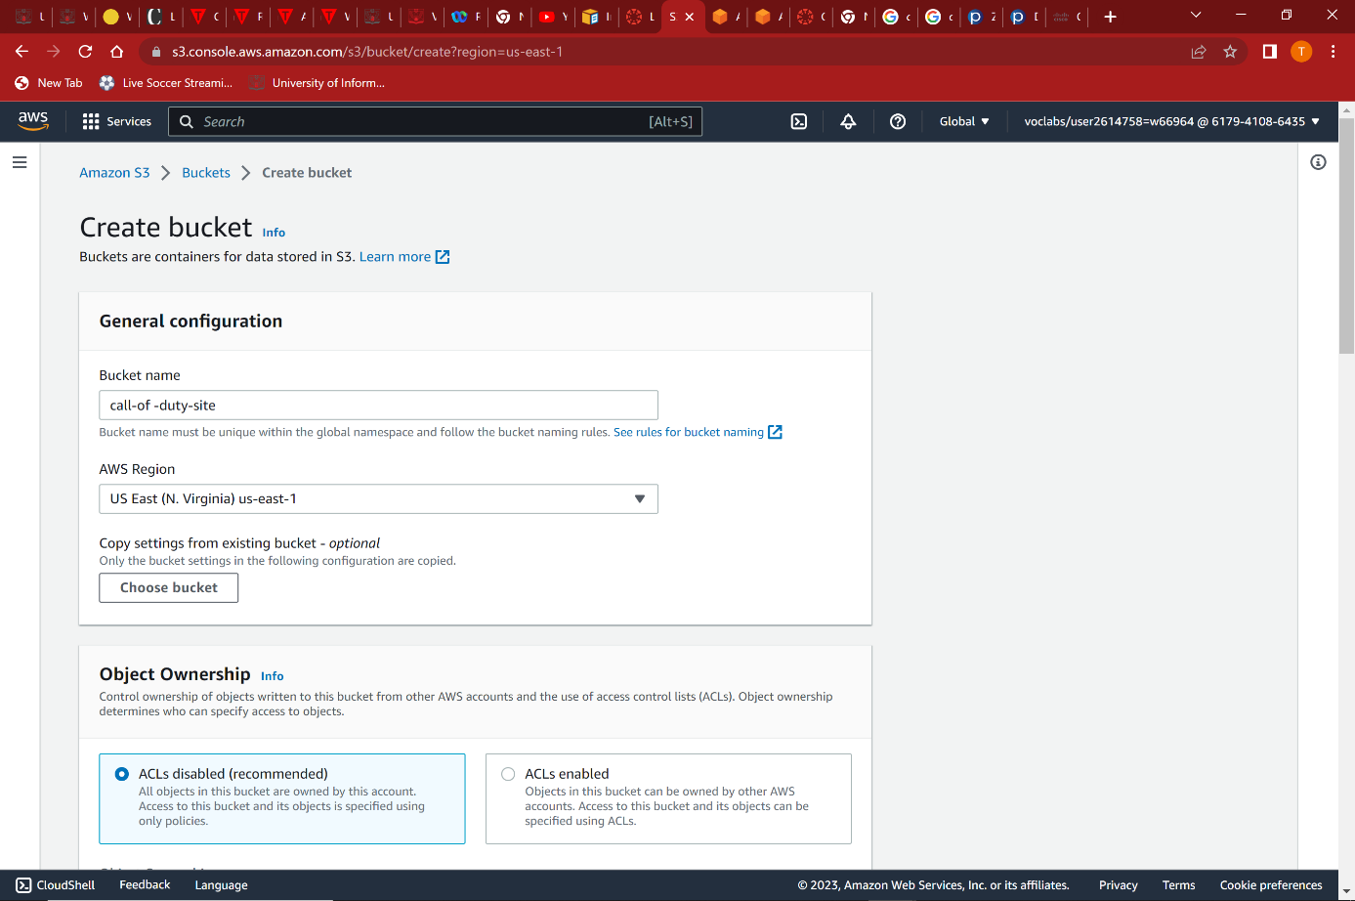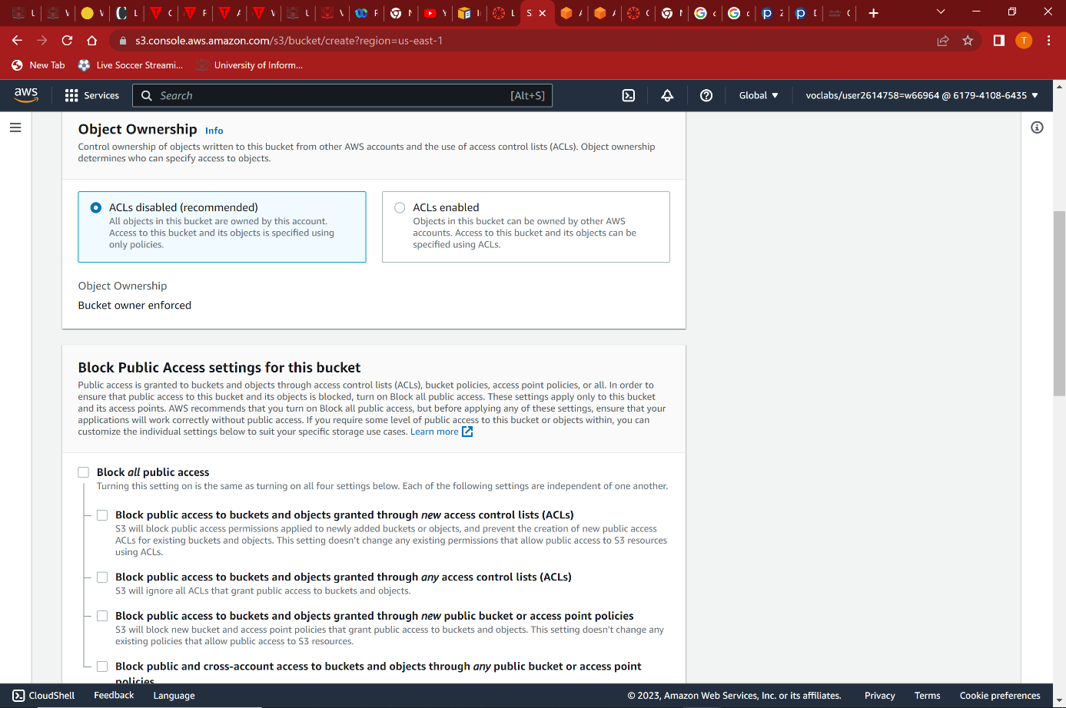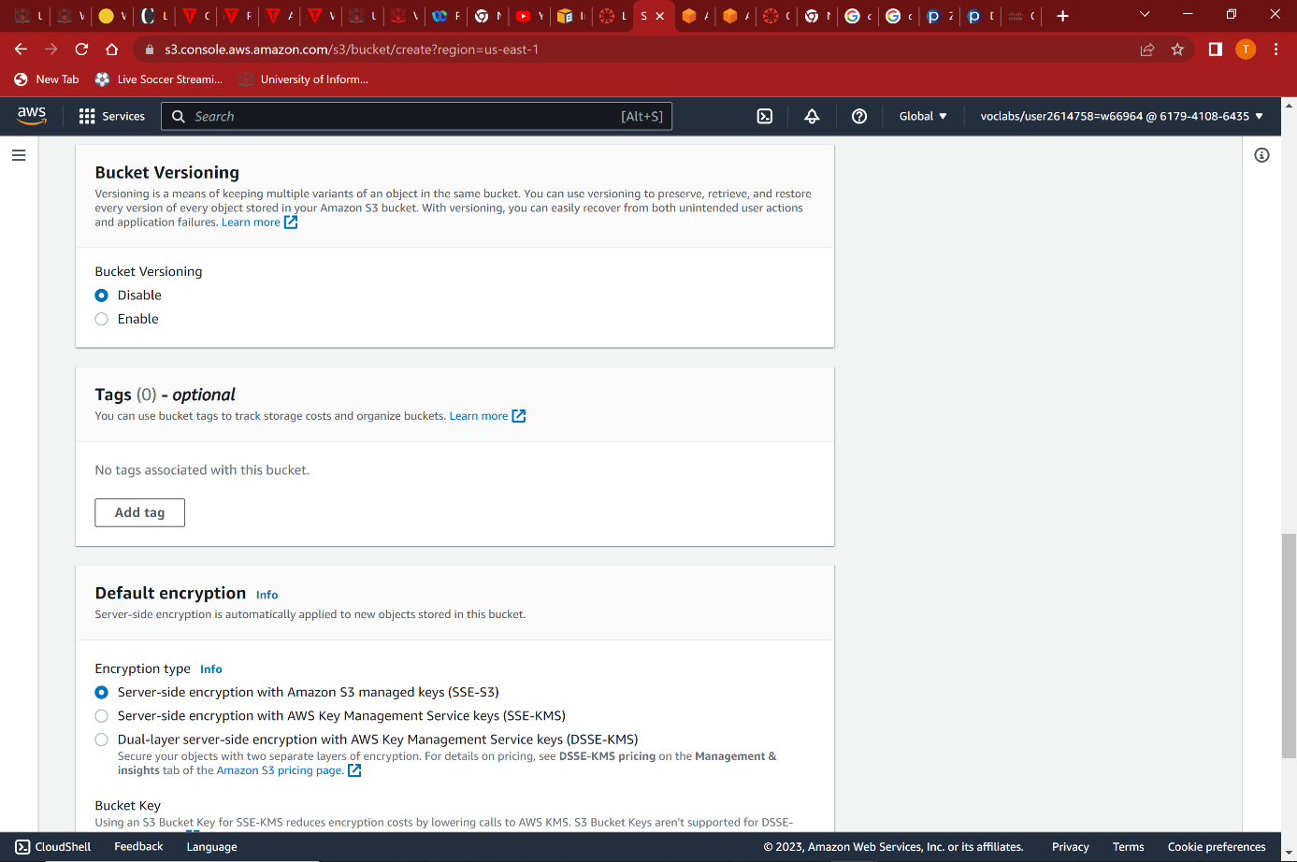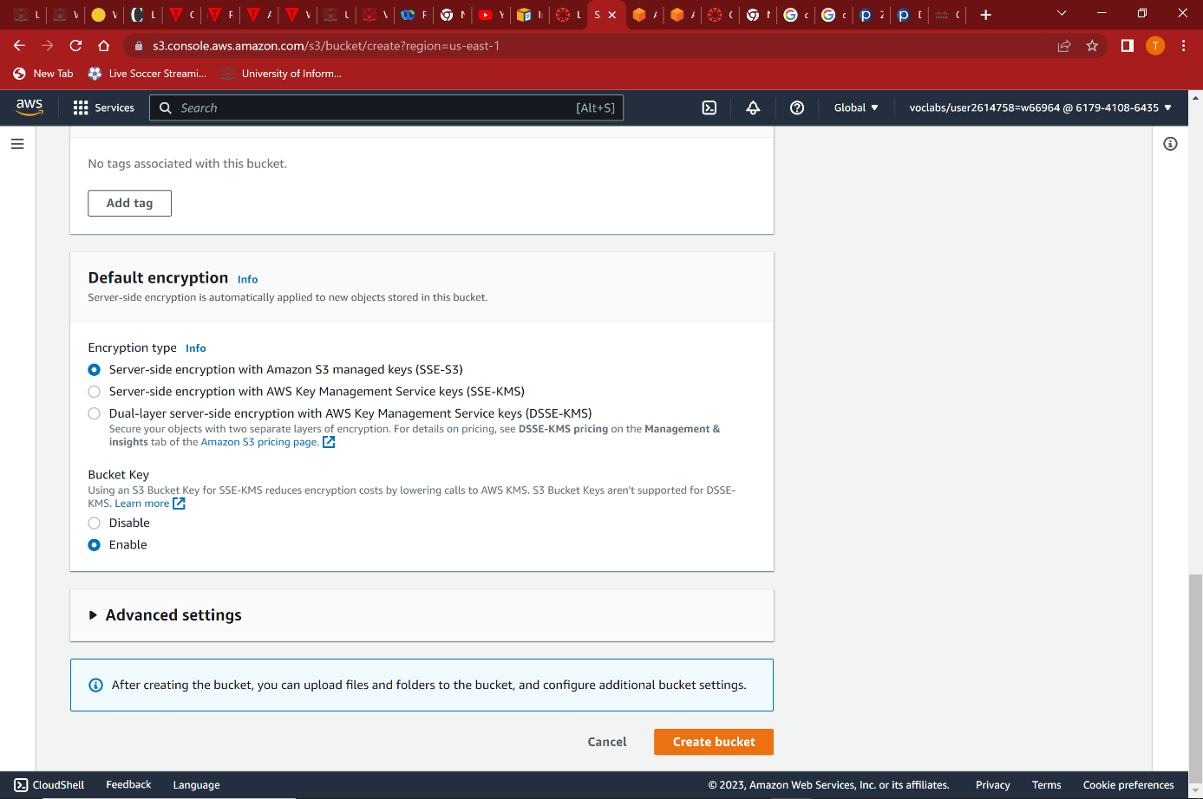

*Step 2: The s3 bucket is created. Now inside the bucket I upload the files for the website. However, in my case I am not uploading my React source file, instead I am uploading my build file to the bucket which contains the index.html file. After I upload that I then click the link to the website however an error is generated. This is because I have not yet set up the permissions for the bucket yet.*

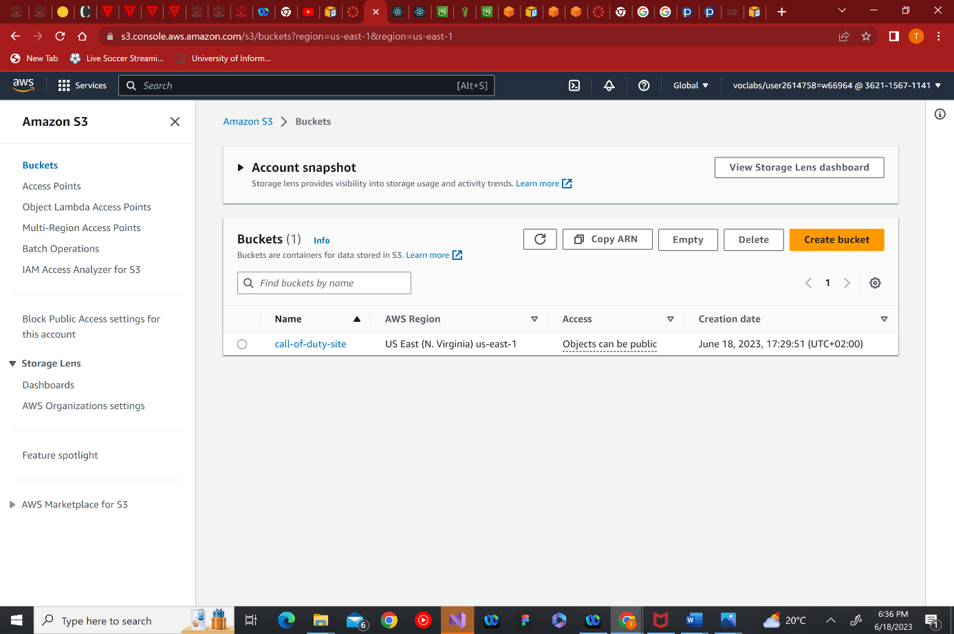 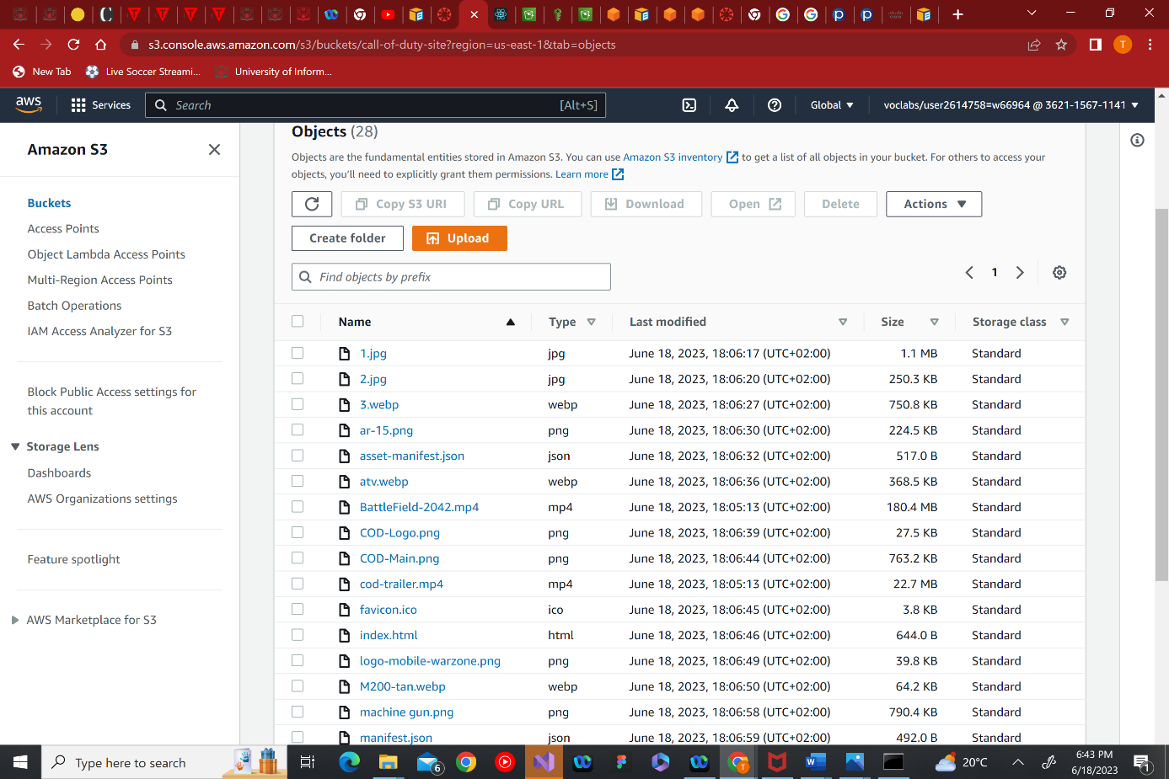

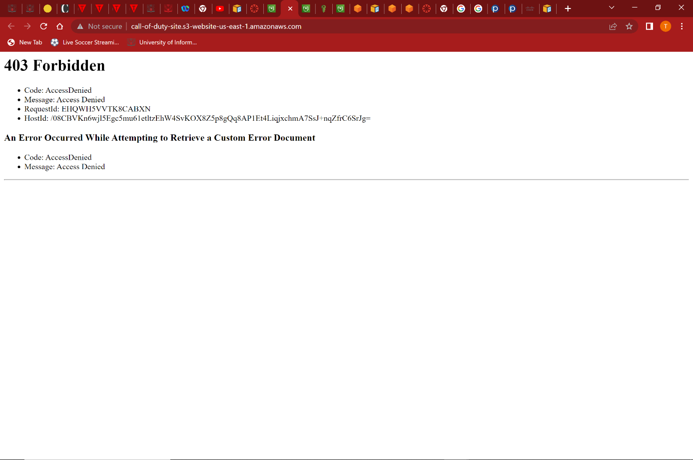

Step 3 : After creating the bucket I then went on to create the permissions for the bucket. In the permissions I added a getObject s3 permission, as in the future I would like to upload some data/files to the websites in order for users to access and obtain. On the permissions in the s3 bucket I set the “Principal” permission to a “*”, this means that all users/public users over the internet can access the objects.

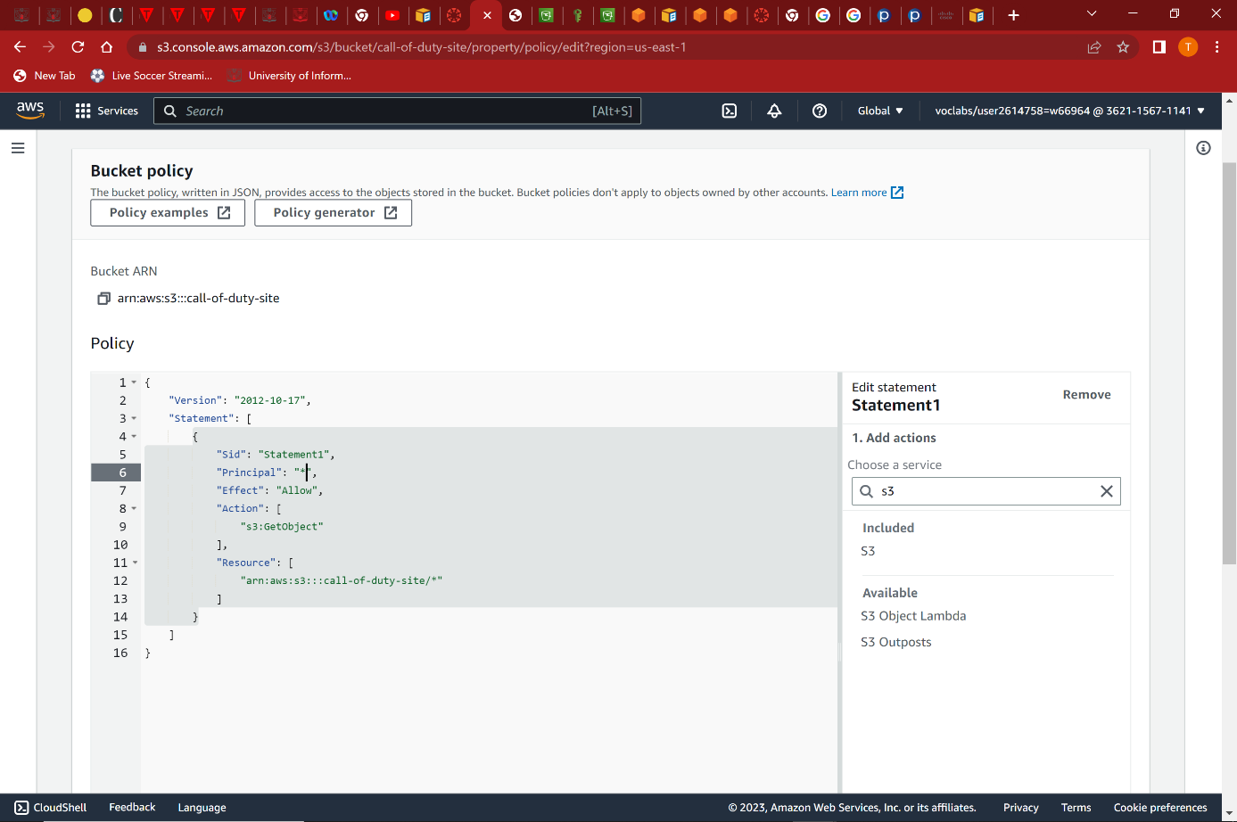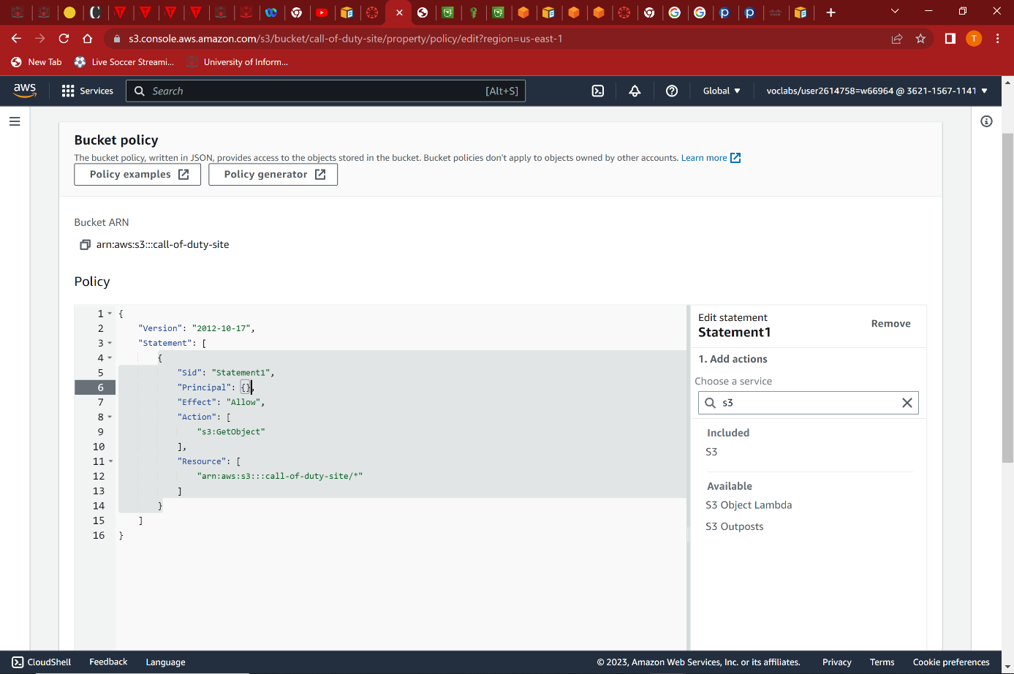

Result : After creating my permission my website is up and running

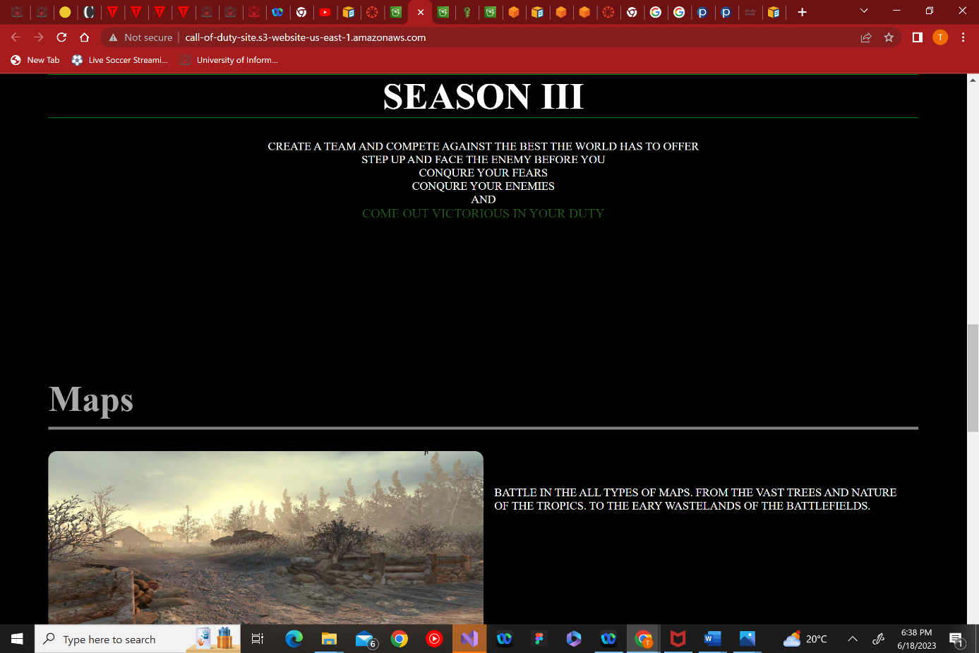

***LINK TO THE SITE***

http://call-of-duty-site.s3-website.eu-north-1.amazonaws.com

***LINK TO GITHUB FOR CODE OF SITE***

https://github.com/Nyengeterayi-Mawire/Hospital-project