Cybersecurity 1st year
Team: 3

Name of the application:
“Mester”

Addressed problem or challenge
How can the average person find a tradesman easily, if he needs one? But how about the tradesmen, how can they find customers that need their skills and expertise?

Technical solution / framework
A full stack web application using .NET C# as a backend and React TypeScript as a frontend.

Application description
An online marketplace type web application serving both tradesmen that want to market their skills and expertise and regular users who want to pay for the services of tradesmen.

Main functionalities
The first functionality of the app that we need to highlight is the account system. As is to be expected from such an application, users can register accounts and update certain aspects of them. In our case, they can set an avatar and can decide whether they would like their account to be a tradesman one or a normal one.

The second functionality that we want to highlight is everything related to the main page, where tradesmen can show off their profiles.

The third functionality and the backbone of the app constitutes the ability for normal user to make requests to a specific or all tradesmen, chat with the tradesmen and negotiate a deal.

Images related to the first functionality:
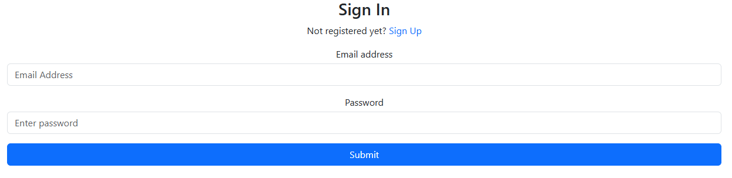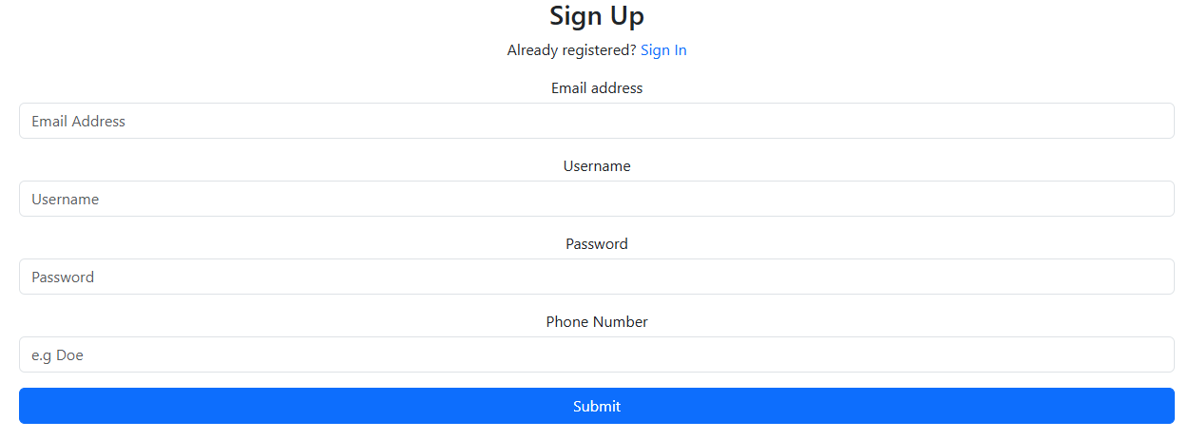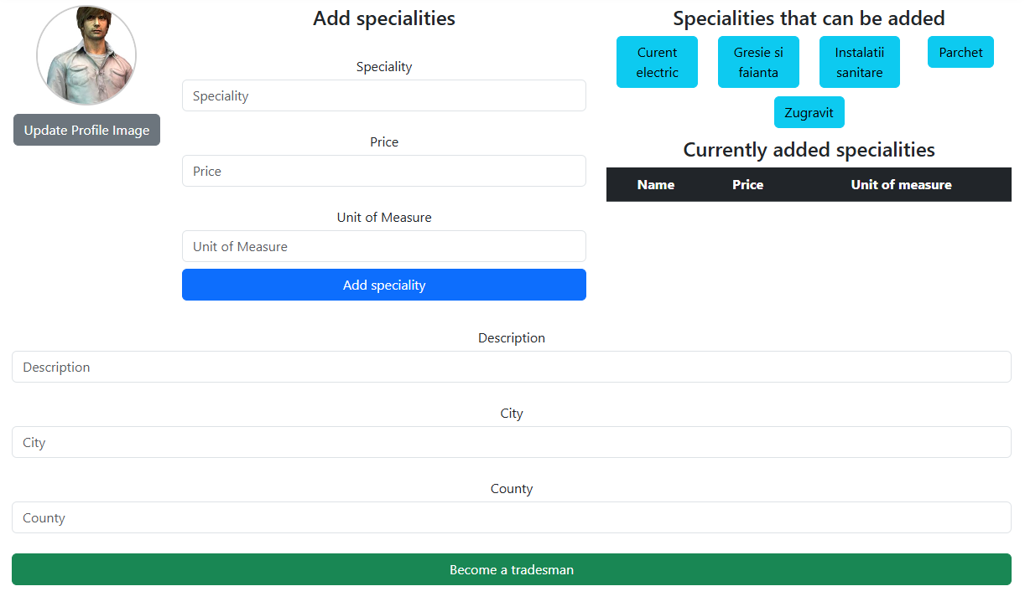
Images related to the second functionality:
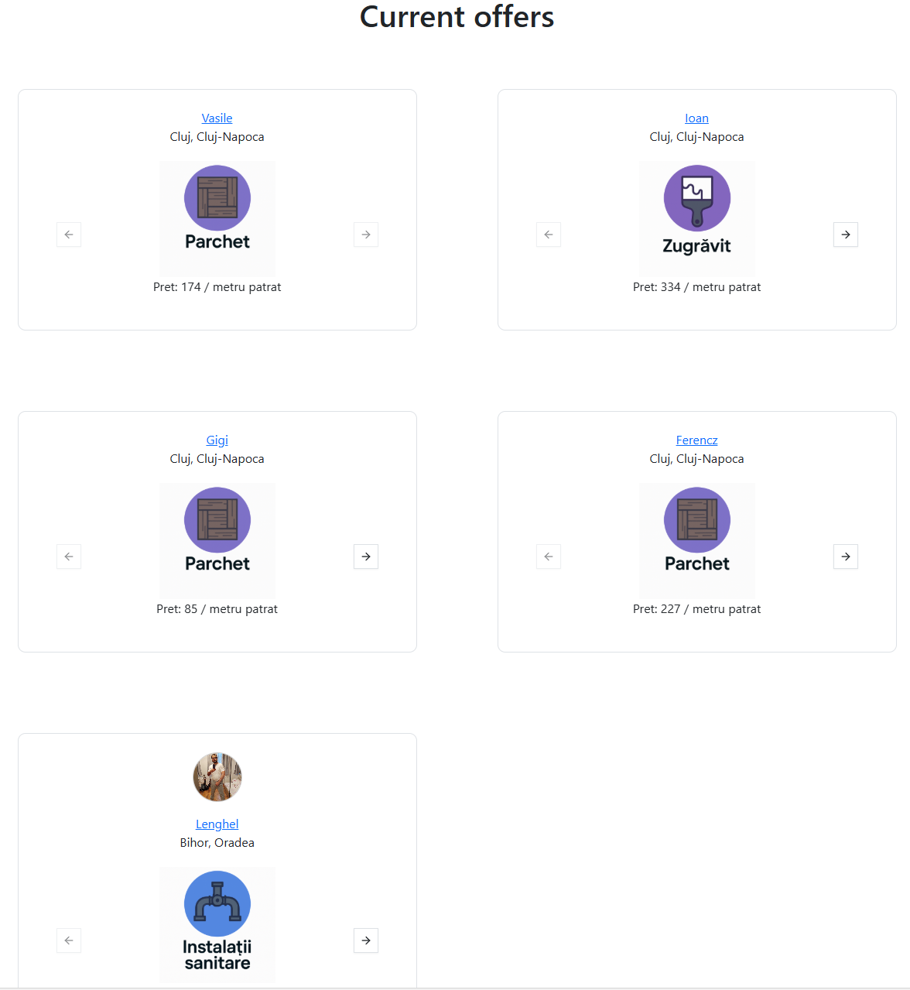
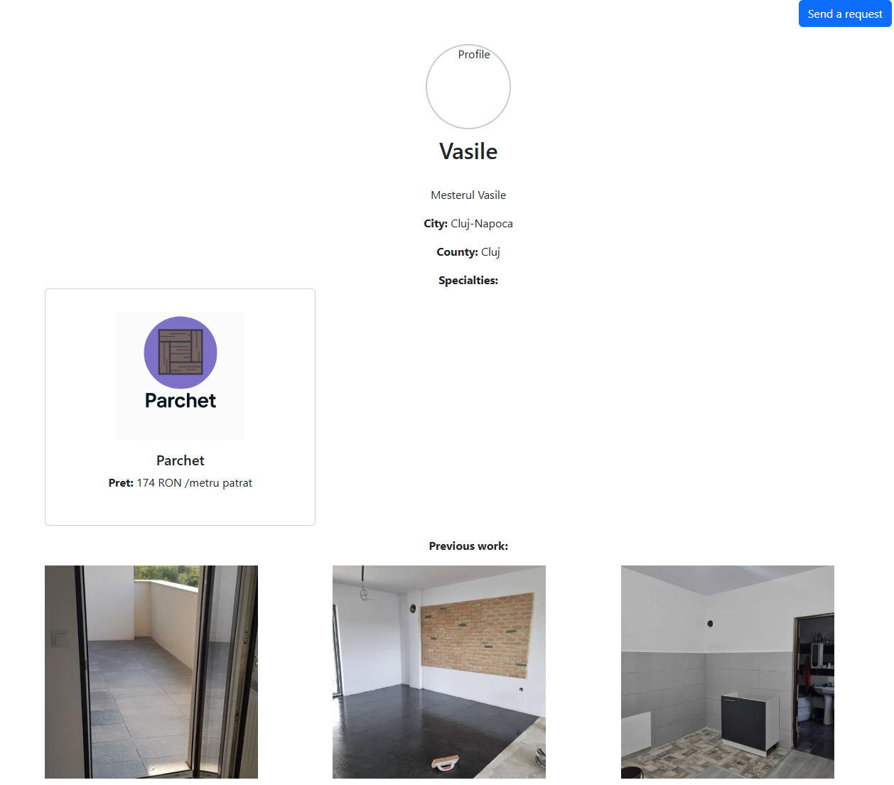

Images related to the third functionality:

Requests:
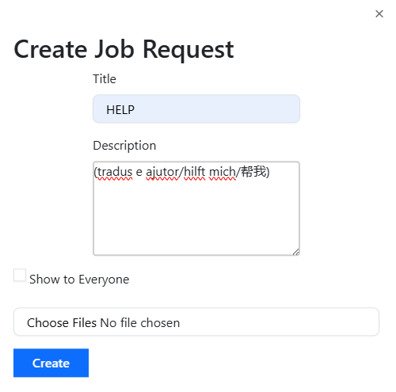
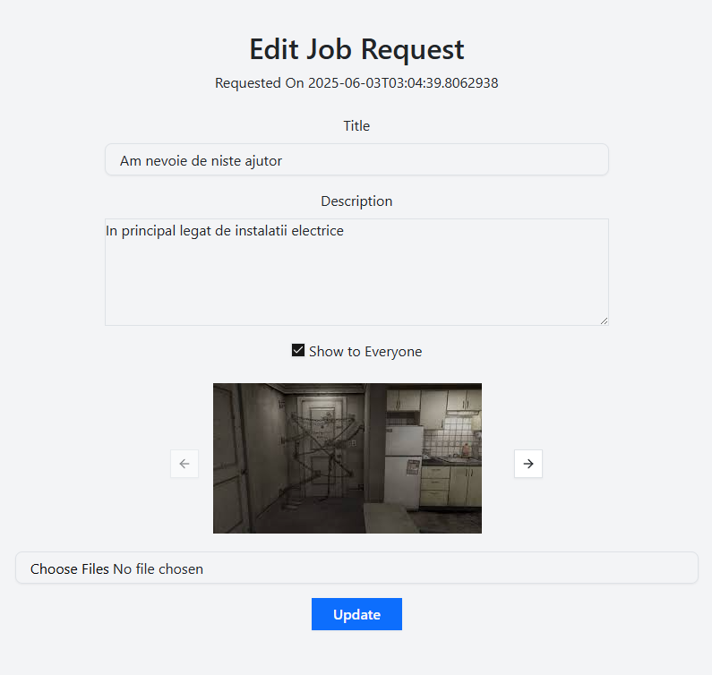

Chat: 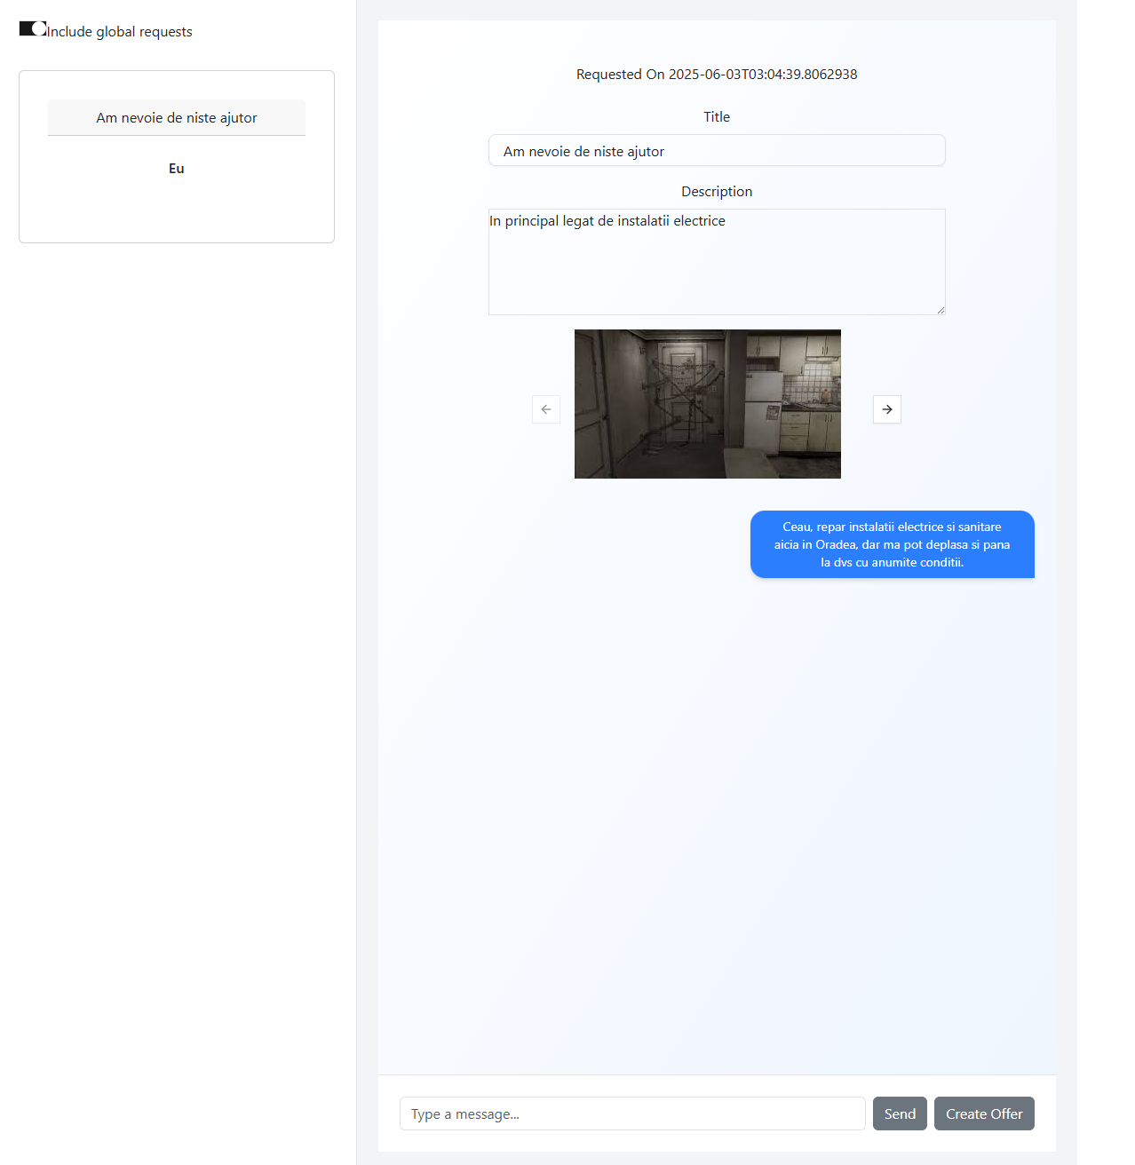
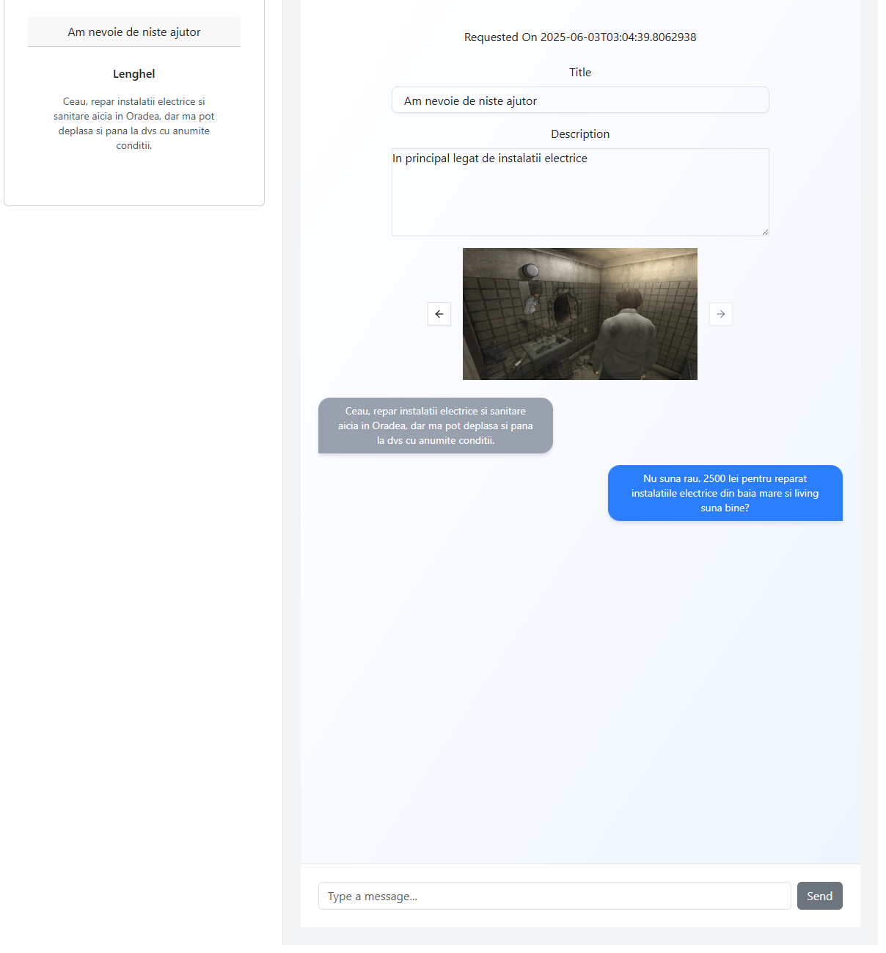

Offers and payment:
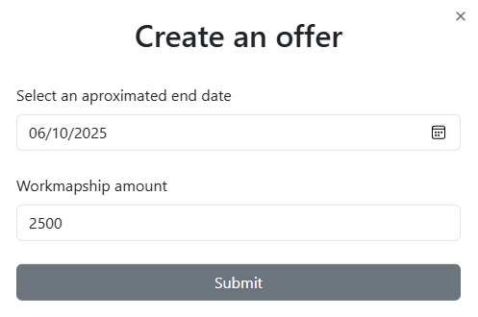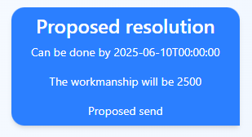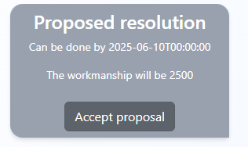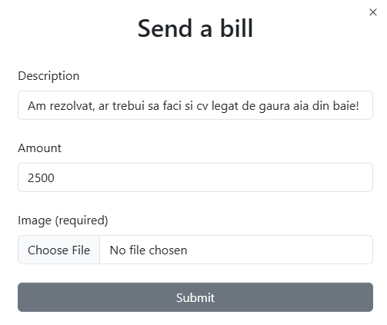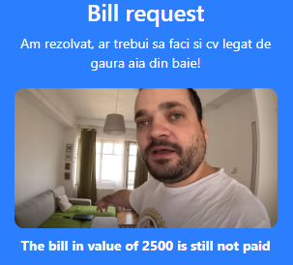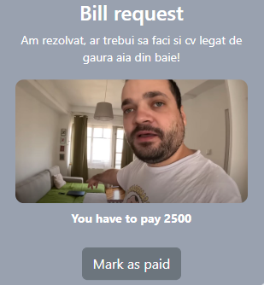

Application validation and next steps
To validate the application, we would need to test even more edge cases and network related issues besides the ones we have already dealt with during development. The next steps which we would need to take to be able to have a fully working commercial website are sprucing up the UI to make it even more appealing to the average user, implementing a payment processor (ex. Stripe) and bolstering the server’s security.

