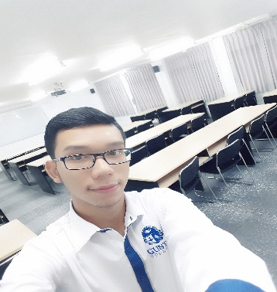 **Nyi Nyi**

No. 32, 134th Street, Maugone, Tamwe Township, Yangon.

Phone: 09 455205805, 09693592601

Email: [nyinyideveloper1@gmail.com](mailto:nyinyideveloper1@gmail.com)

**Career Objective**

My prior experience knowledge and skills, self-confidence, team spirit a challenging and responsible position that can effectively apply self-motivation and technical skills can be effectively applied as a team in web development.

**Personal Particulars**

Date of Birth : 31/1/2001

Gender : Male

Marital Status : Single

Nationality : Myanmar

NRC : 12/TMN (Naing) 129204

Availability : Immediately

Position Finding : **Web Developer**

Address : No. 32, 134th Street, Maugone, Tamwe Township, Yangon.

Email : nyinyi@gusto.edu.mm

**Education**

**Diploma**

Major **: HND (Higher National Diploma (UK))**

Institute/University **: GUSTO UNIVERSITY**

Graduation Date **: 2021**

**Certificate**

* PHP Web Developer Bootcamp (Myanmar IT Consulting)
* Foundation Course for HND in computing (UK)
* Competence (KMD)

**Technical Skills**

* C#
* HTML
* CSS
* JavaScript
* jQuery
* Bootstrap4
* Vue
* Php
* MySQL
* Laravel

**Communication Skills**

English: **Fair**

**Project Experiences**

1. Unique Furniture (HTML, CSS, FoundationProject, GUSTO UNIVERSITY)
2. C9 cafe & bakery (Bootstrap, Year 1 Semester 2 Project, GUSTO UNIVERSITY)
3. IoT-Smart eggs hatching devices(Arduino, Year 2 Semester 1 Project, GUSTO UNIVERSITY)
4. Especially the phone frequency affects our heart (Research paper, Year 2 Semester (1,2) Project, GUSTO UNIVERSITY)
5. Shopules OnlineShopping (PHP, Test Project, Myanmar IT Consulting)
6. LearningSchool (Laravel, Final Project, Myanmar IT Consulting)

**Personality**

Quick learning and self-motivation, teamwork and leadership, general knowledge of databases, soft-skills and hard skills, hardware and networking, work in a progressive organization, offering a conductive & challenging work environment for learning and growth, reasonably good communication skills, presentation skills, Hardworking, honesty and dedication, creativity, ability to cope with work pressure.

**Salary**

Nego