**Pulju Ab**

1.

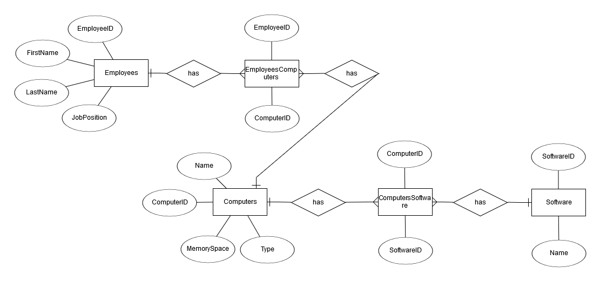

2.

Ein Bild, das Screenshot enthält.

3. Introduction to the class.

4.

create table Employees (

EmployeeID int NOT NULL,

FirstName varchar(255),

LastName varchar(255),

JobPosition varchar(255),

PRIMARY KEY (EmployeeID)

);

create table Computers (

ComputerID int NOT NULL,

Name varchar(255),

MemorySpace varchar(255),

Type varchar(255),

PRIMARY KEY (ComputerID)

);

create table Software (

SoftwareID int NOT NULL,

Name varchar(255),

PRIMARY KEY (SoftwareID)

);

create table EmployeesComputers (

EmployeeID int NOT NULL,

ComputerID int NOT NULL,

FOREIGN KEY (EmployeeID) REFERENCES Employees(EmployeeID),

FOREIGN KEY (ComputerID) REFERENCES Computers(ComputerID)

);

create table ComputersSoftware (

ComputerID int NOT NULL,

SoftwareID int NOT NULL,

FOREIGN KEY (ComputerID) REFERENCES Computers(ComputerID),

FOREIGN KEY (SoftwareID) REFERENCES Software(SoftwareID)

);

5. Tee tietokantaan seuraavat kyselyt ja kopioi toimivat kyselyt dokumenttiisi.

5.1. Mitä koneita Teemu Työntekijä käyttää ja mitä ohjelmia niihin on asennettu?

5.2. Keiden koneilla on käyttöjärjestelmänä Windows 10?

5.3. Mitä ohjelmia johdon assistentilla on käytössä (Huom.! Tietokannassa pitää siis olla tieto henkilön asemasta/työtehtävistä).

5.4. Kenen pöytäkoneessa on eniten muistia? Vinkki: tässä saatat tarvita alikyselyä.

|  |  |  |  |  |  |
| --- | --- | --- | --- | --- | --- |
| Testattava asia | SQL-lause | Mitä pitäisi tapahtua | Mitä tapahtui | Milloin testattu | Milloin korjattu |
| 5.1. | SELECT Employees.FirstName, Computers.Name, Software.Name  FROM Employees  INNER JOIN EmployeesComputers ON Employees.EmployeeID = EmployeesComputers.EmployeeID  INNER JOIN Computers ON EmployeesComputers.ComputerID = Computers.ComputerID  INNER JOIN ComputersSoftware ON Computers.ComputerID = ComputersSoftware.ComputerID  INNER JOIN Software ON ComputersSoftware.SoftwareID = Software.SoftwareID  WHERE Employees.FirstName = 'Teemu'; | Shows the name of the employee Teemu, the machines that he uses and the software that is installed on those machines | Shows the name of the employee Teemu, the machines that he uses and the software that is installed on those machines | 24.08.19 |  |
| 5.2. | SELECT employees.FirstName, employees.LastName FROM employees  INNER JOIN employeescomputers ON employees.EmployeeID = employeescomputers.EmployeeID  INNER JOIN computers ON employeescomputers.ComputerID = computers.ComputerID  INNER JOIN computerssoftware ON computers.ComputerID = computerssoftware.ComputerID  INNER JOIN software ON computerssoftware.SoftwareID = software.SoftwareID  WHERE software.Name = 'Windows10'; | Shows the first and last name of the employees that use Windows 10 | Shows the first and last name of the employees that use Windows 10 | 24.08.19 |  |
| 5.3. | SELECT Software.*  FROM Employees  INNER JOIN EmployeesComputers ON Employees.EmployeeID = EmployeesComputers.EmployeeID  INNER JOIN Computers ON EmployeesComputers.ComputerID = Computers.ComputerID  INNER JOIN ComputersSoftware ON Computers.ComputerID = ComputersSoftware.ComputerID  INNER JOIN Software ON ComputersSoftware.SoftwareID = Software.SoftwareID  WHERE Employees.JobPosition = 'Management Assistant'; | Shows all the software that the management assistant uses | Shows all the software that the management assistant uses | 24.08.19 |  |
| 5.4. | SELECT TOP 1 MemorySpace FROM computers; | Shows the computer with the most memory space | Error, because, when I created the table, I used the wrong field type | 24.08.19 | 25.08.19 |