**Hobby – Games**

Playing games has been my hobby for my whole life and I like to play various games of various different styles.

The idea behind the database is that we have all games listed and linked with the developer of the game, which genre the game has and the reviews of the game. For example, this could be used in a blog or website, where multiple people review multiple games and have a rating for each one.

**ER Diagram**

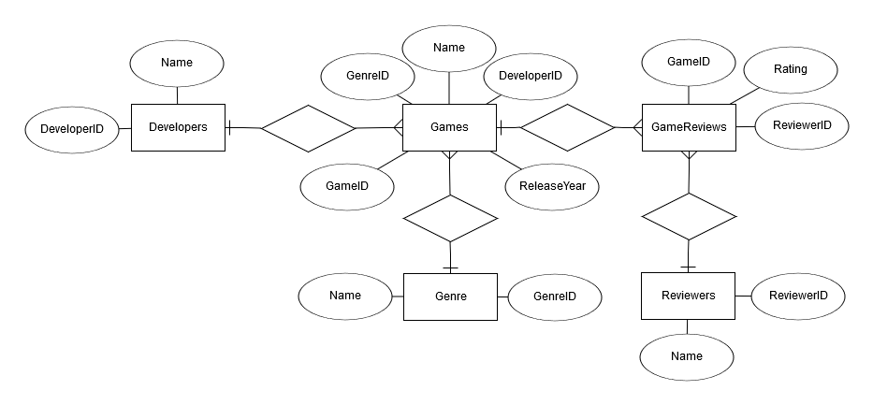

**Database Structure**

Ein Bild, das Screenshot enthält.

**SQL CREATE Sentences**

CREATE TABLE Developers (

DeveloperID int NOT NULL,

Name varchar(255),

PRIMARY KEY (DeveloperID)

);

CREATE TABLE Genre (

GenreID int NOT NULL,

Name varchar(255),

PRIMARY KEY (GenreID)

);

CREATE TABLE Games (

GameID int NOT NULL,

GenreID int NOT NULL,

DeveloperID int NOT NULL,

Name varchar(255),

ReleaseYear int NOT NULL,

PRIMARY KEY (GameID),

FOREIGN KEY (GenreID) REFERENCES Genre(GenreID),

FOREIGN KEY (DeveloperID) REFERENCES Developers(DeveloperID)

);

CREATE TABLE Reviewers (

ReviewerID int NOT NULL,

Name varchar(255),

PRIMARY KEY (ReviewerID)

);

CREATE TABLE GameReviews (

GameID int NOT NULL,

ReviewerID int NOT NULL,

Rating int NOT NULL,

FOREIGN KEY (GameID) REFERENCES Games(GameID),

FOREIGN KEY (ReviewerID) REFERENCES Reviewers(ReviewerID)

);

**Queries**

1. Find all games, sorted by developers.

**SELECT developers.Name, games.Name FROM developers**

**INNER JOIN games ON developers.DeveloperID = games.DeveloperID**

**ORDER BY developers.Name ASC;**

1. Find all games with ratings that are higher than 8.

**SELECT games.* FROM games**

**INNER JOIN gamereviews ON games.GameID = gamereviews.GameID**

**WHERE gamereviews.Rating > '8';**

1. Find all games from the RPG genre, sorted by the release year.

**SELECT games.*, genre.Name FROM games**

**INNER JOIN genre ON games.GenreID = genre.GenreID**

**WHERE genre.Name = 'RPG'**

**ORDER BY games.ReleaseYear ASC;**

1. Find which genre the reviewers have made reviews of.

**SELECT reviewers.Name, genre.Name FROM reviewers**

**INNER JOIN gamereviews ON reviewers.ReviewerID = gamereviews.ReviewerID**

**INNER JOIN games ON gamereviews.GameID = games.GameID**

**INNER JOIN genre ON games.GenreID = genre.GenreID**

**ORDER BY reviewers.ReviewerID ASC;**

1. Find all reviews with the name of the game and the reviewer and the rating.

**SELECT games.Name, reviewers.Name, gamereviews.Rating FROM games**

**INNER JOIN gamereviews ON games.GameID = gamereviews.GameID**

**INNER JOIN reviewers ON gamereviews.ReviewerID = reviewers.ReviewerID**

**ORDER BY games.Name ASC, gamereviews.Rating ASC;**

1. Find which genre the games of the developer BioWare are of.

**SELECT developers.Name, genre.Name FROM developers**

**INNER JOIN games ON developers.DeveloperID = games.DeveloperID**

**INNER JOIN genre ON games.GenreID = genre.GenreID**

**ORDER BY developers.DeveloperID ASC;**