**Osa 1: Navigation and Usability**

As a good example of user interface, I have chosen the site <https://www.hometogo.com/>.

The website is one of the biggest, when it comes to vacation rental and one of the reasons for that is definitely the user interface. As soon as you visit the page, you are greeted by a search bar that gives you the most essential options that you need for when looking for a good place for your vacation.

Ein Bild, das Screenshot enthält.

So, right at the start, you have a good navigation option, which helps the user to find what they are looking for, but that’s not the only thing that is well done on this frontpage.

Right underneath the search bar, hometogo provides you with popular traveling options in the USA and all other parts of the world, accompanied by good pictures and lists. They have multiple different lists of travel destinations, which are all sorted by either which country you want to travel to, or what kind of vacation experience you want to have, for example a big city vacation, or beach vacation and so on.

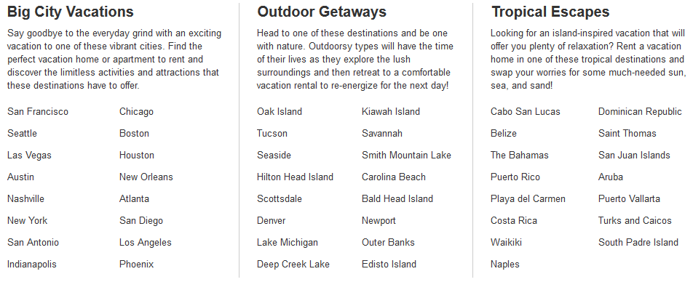

Again, these navigation options make the frontpage very user-friendly and it leads to the user having a good time, while browsing through the website.

The layout of the frontpage is very good too, because everything is ordered accordingly and you don’t get overwhelmed by too many options, but it doesn’t look empty either. It’s pretty much a perfect balance.

When you click on a country, for example Finland, you get directed to a page that shows you the best vacation home deals in Finland, followed by some recommendations and then by a few specific options like vacation rentals with saunas. You get an amazing overview of some options in Finland, just by heading to the Finland specific page with one click.

Ein Bild, das Screenshot, Himmel, Baum enthält.

The usability is increased a lot by the fast loading times, you barely have to wait a second before the page shows up.

**Osa 1: Visual Appearance**

The website hometogo doesn’t use many different kinds of colors, mainly just blue and green here and there for the different kinds of buttons, but that’s not a bad thing at all. In fact, I think it’s good that the website is mostly blank, it makes it easier for the user to read every text on the page.

Still, the website uses a ton of images, to display how the destinations look, which is to be expected. It’s definitely very simple in terms of visual design, but that’s a good thing for a vacation rental page. For every entry, you get multiple images of the vacation place.

Ein Bild, das Objekt enthält.
Ein Bild, das Gebäude, Schild, draußen enthält.

**Osa 1: Nielsen Principles**

In terms of Nielsen Principles, the website does quite a good job. It provides only understandable and simple dialogue, which make it very clear what you are supposed to do, to find your desired vacation destination.

It only requires a few clicks to find some results that could be interesting for you, because it gives you a ton of shortcuts. Lists, pictures, and so on do a great job to provide you with shortcuts and make the navigation very fast. Also, you always can click on the logo of the page to get back to the homepage.

The loading of the page is very quick, which adds to the usability, as well as having a perfect layout for smartphones as well. The only thing that stands out as a little negative might be the color choice. Bright blue, bright green and bright red make it very clear what it says, but the colors don’t match too well and might look a bit out of place. Except for that, the interface is consistent and very user-friendly.

**Osa 2: Navigation and Usability**

At first, when you enter <https://www.friendlyrentals.com/en/>, you might think it’s the same as hometogo, because it features a similar search bar, but as soon as you scroll down, you will see that the frontpage is very small and doesn’t give you many options. Basically, there is a list with a few European cities, and some have images accompanying them.

Above the search bear there is a video playing, which should be nice, but thanks to that video the website takes a while to load, which might be a bother to some people, who want to look for a vacation.

The usability of the frontpage is not that bad, because it is quite simple, but, as I said, it doesn’t give you many navigation options and as soon as you start searching for a vacation destination, you are running into problems with the usability.

Let’s say you are looking for a place in Barcelona and click on Barcelona, then this comes up:

Ein Bild, das Screenshot enthält.

You could easily get overwhelmed by this at first, because you have so many things to look at and so many different options. Compared to hometogo, where you still had a lot of options, which were displayed in a simple look, this site just seems full of stuff and it could get confusing.

You might be able to navigate well here after a while, but a user-friendly page should give you good navigation options together with a simple layout that makes it easy for you to search what you want.

**Osa 2: Visual Appearance**

Now, the visual appearance in terms of colors and buttons seems alright, the green and blue shades fit well together, different than with hometogo, but that is pretty much the only thing that this website does better.

The images are also well placed, and they have multiple images for each product.

As with the rest of the website, the visual design is also a bit overloaded, but it’s not too bad.

**Osa 2: Nielsen Principles**

In terms of the Nielsen Principles the website is not that bad, but it’s clearly not the best website for vacation rentals.

The biggest problem of the website is that it features way too little shortcuts, recommendation and navigation options. Also, the layout can be quite overloaded, which affects the user-friendliness in a negative way.

A big problem is also that it takes a little until the website loads, because it has a video on the frontpage.