**Use Case Description Login – Sign In**

Description The user registers or logs in

and is authorized as either

a customer or landlord.

Starting process The user registers and the email

and password are saved into

the database.

Normal course The user enters his

of events email and password.

The system authorizes and logs

in the user with their role.

Alternative course The user enters a wrong

of events email and/or password.

A login error is displayed.

End Condition The user is successfully logged in

as a landlord or customer.

Users Administrators, landlords and customers

Display Diagram

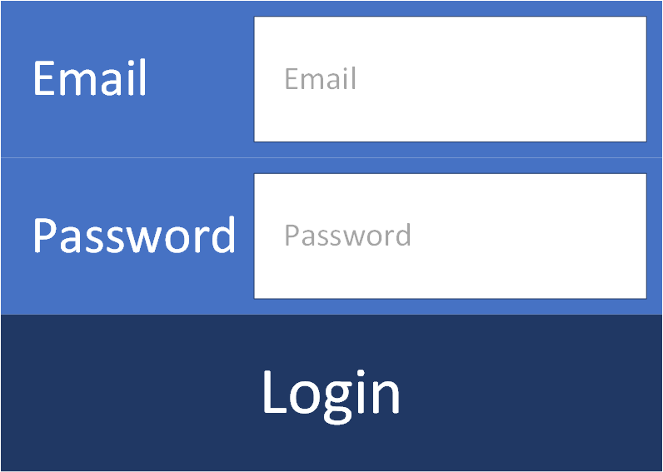

Sequence Diagram

