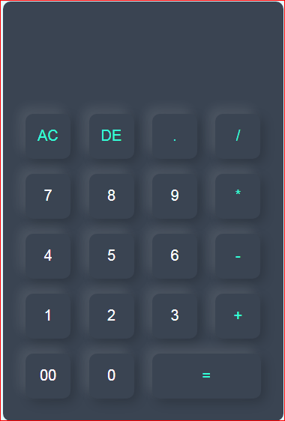

Submitted by: Project Work:

NAAILAH FIRDOUS Basic Calculator

Internship Program:

Full Stack Web Development

Batch: 15th May,2024

TABLE OF CONTENTS:

1. Introduction …………………………………………..3
2. Basic Functions ………………………………………..4
3. Proposed System ………………………………………..6
   * 1. Description
     2. System Requirements

4. Applications ……………………………………………7

5. Future Scope of the Project …………………………….8

6. Testing …………………………………………………8

7. References ……………………………………………..9

INTRODUCTION

*History:*

A calculator is a device used to perform calculations, ranging from basic arithmetic to complex mathematics.

The Renaissance saw the invention of the mechanical calculator by Wilhelm Schickard in 1623 and later by Blaise Pascal in 1642. A device that was over-promoted as being able to perform all four arithmetic operations with minimal human intervention.

*Online Scientific Calculator:*

The online calculator was designed by Rolf Howarth in early 1996.It includes trig functions and logarithms, factorials, 12 levels of parentheses, logs to base 2, bitwise logical operators, hex, octal, binary and ASCII display. The calculator was written in JavaScript.

*Basic Calculator:*

A basic calculator is a simple electronic device designed to perform basic arithmetic operations. These operations include addition, subtraction, multiplication and division.

It includes a keypad with digits 0-9, a decimal point key, and the basic operation keys. A small screen, displays the input numbers and the results of the calculation.

These are user-friendly and do not include advanced functions found in scientific or graphing calculators such as trigonometric, logarithmic or statistical calculations. They are ideal for quick, everyday mathematical tasks.

The calculator used here has a keypad consisting of 19 buttons. The buttons used are:

* **Digits**: the keypad has buttons numbered 0 to 9; these buttons serve as operands for arithmetic operation.
* **Signs**: the keypad has buttons with various signs, that is:

“+” for addition, “-” for subtraction, “*” for multiplication and “/” for division. There is also a button with “.” to display and calculate the result of decimal numbers.

* **Equality**: there is an additional button with “=” sign which is used for displaying the result of the operation on the screen.
* **All** **Clear**: this button is used for erasing/deleting the entire data present on the screen. It is denoted by “**AC**” on the calculator.
* **Delete**: it is denoted by “**DE**” and is used for deleting one value at a time.

BASIC FUNCTIONS

Addition:

The addition (sum function) is used by clicking on the “+” button on the keypad.

The function results in “a + b”.

For example, let’s take a=34 and b=19. The result (i.e. a + b = 53) is displayed in the result box.

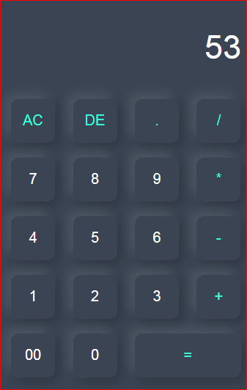

Subtraction:

The subtraction (minus function) is used by clicking on the “-” button on the keypad. The function results in “a – b”.

For example, let’s take a=34 and b=19. The difference (i.e. a – b= 15) is displayed on the screen in the result box.

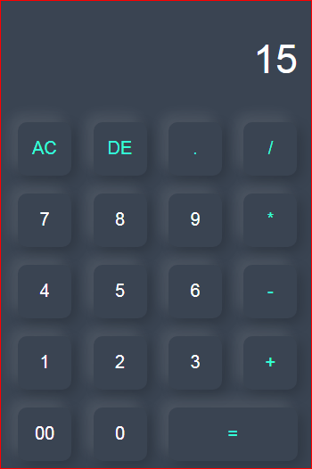

Multiplication:

The multiplication (times function) is used by clicking on the “*” button on the keypad. The function results in “a * b”.

For example, let’s take a=34 and b=19. The product (i.e. a * b= 646) is displayed on the screen in the result box.

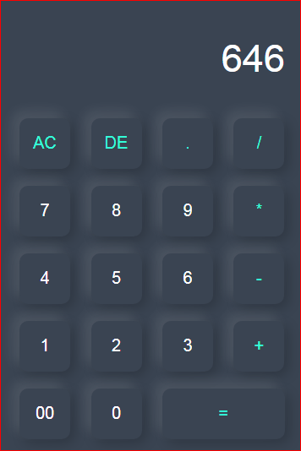

Division:

The division (divide function) is used by clicking on the “/” button on the keypad. The function results in “a / b”.

For example, let’s take a=34 and b=19. The quotient (i.e. a / b= 1.7894) is displayed on the screen in the result box.

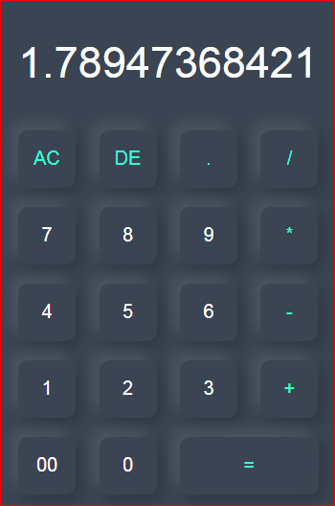

PROPOSED SYSTEM

The following is a project titled the “Basic Calculator”. It is a summary of the drawbacks of the old system and how the new proposed system overcomes these shortcomings. The new system takes into account the various factors while designing the new system. It keeps into account the ‘Economical bandwidth’ available for the new system. The foremost thing that is taken care of is the Need and Requirements of the User.

**DESCRIPTION**:

Before developing software we keep following things in mind that we can develop powerful and quality software.

**PROBLEM STATEMENT**

1. Problem statement was to design a module:
2. That’s user-friendly
3. That has a layout which includes a display for input and results.
4. Add special buttons for “Clear” and “Equals”.
5. It should be capable of performing basic arithmetic operations.
6. That is able to implement error handling to handle cases of mathematical errors.

**FUNCTIONS TO BE PROVIDED:**

* The system will be efficient and fast in response.
* The system will be customized according to needs.

**SYTEM REQUIREMENTS:**

Operating system: Windows10, 11

Language: HTML, CSS, JS

APPLICATIONS

In most countries, students use calculators for schoolwork. There was some initial resistance to the idea out of fear that basic arithmetic skills would suffer. There remains disagreement about the importance of the ability to perform calculations “in the head” with some curricula restricting calculator use until a certain level of proficiency has been obtained, while others concentrate more on teaching estimation techniques and problem-solving. Research suggests that inadequate guidance in the use of calculating tools can restrict the kind of mathematical thinking that students engage in. Others have argued that calculator use can even cause core mathematical skills atrophy, or that such use can prevent understanding of advanced algebraic concepts.

Online calculators are readily available on the internet and can range from simple to complex. You can find built-in calculators even on your smart devices. They are useful for different purposes like education, financial planning, and everyday problem-solving.

There are other concerns – for example, that a pupil could use the calculator in the wrong fashion but believe the answer because that was the result given. Teachers try to combat this by encouraging the student to make an estimate of the result manually and ensuring it roughly agrees with the calculated result. Also, it is possibly for a child to type in -1x-1 and obtain the correct answer ‘1’ without realizing the principle involved. In this sense, the calculator becomes a crutch rather than a learning tool, and it can slow down students in exam conditions as they check even the most trivial result on a calculator.

FUTURE SCOPE OF THE PROJECT

Our project can be implemented now but we wish to add a few more features to the calculator in the future and make it more versatile for operations such as square root, cube root, trigonometric functions, logarithmic functions, binomial series and integration.

On a little higher level, to make it such that by pressing keyboard buttons of the device; we are able to enter the values.

TESTING

Testing is the major control measure used during software development. Its basic function is to detect errors in the software. During requirement analysis and design, the output is a document that is usually textual and not executable. After the coding phase, codes are available that can be executed for testing purpose. This implies that testing not only, has to uncover errors introduced during coding, but also errors introduced during previous phase. Thus, the goal of testing is to uncover the requirements, design and coding errors in the programs. The source code for the Basic Calculator has been tested and has been found that the code provided is okay and correct.

REFERENCES

I referred a few websites for the implementation of code in HTML, styling in CSS and functionality in JavaScript.These are:

* Geeksforgeeks
* Javatpoint
* freeCodeCamp
* wikiHow