Smart AI Doorbell
Nyle Farhan Ul Haq and Shivank Chhaya
Problem Statement:
Develop a Raspberry Pi smart doorbell that records visitors, displays a live camera feed, recognizes registered residents, plays a doorbell chime, and demonstrates automatic opening with a servo-driven cardboard door.
Materials: Raspberry Pi 3 Model B+, push button, breadboard, jumper wires, OV5647 camera module, servo motor, cardboard prototype, Bluetooth AirPods, power supply, computer (keypad optional).
Documentation (use single-cell tables)
Set up the wiring and components like this:
Connect button between GPIO17 (physical pin 11) and GND. Connect servo signal to GPIO18 (physical pin 12); use suitable servo power and a shared ground. Attach the camera ribbon cable to the Pi camera port. [Insert wiring photograph/diagram here.]
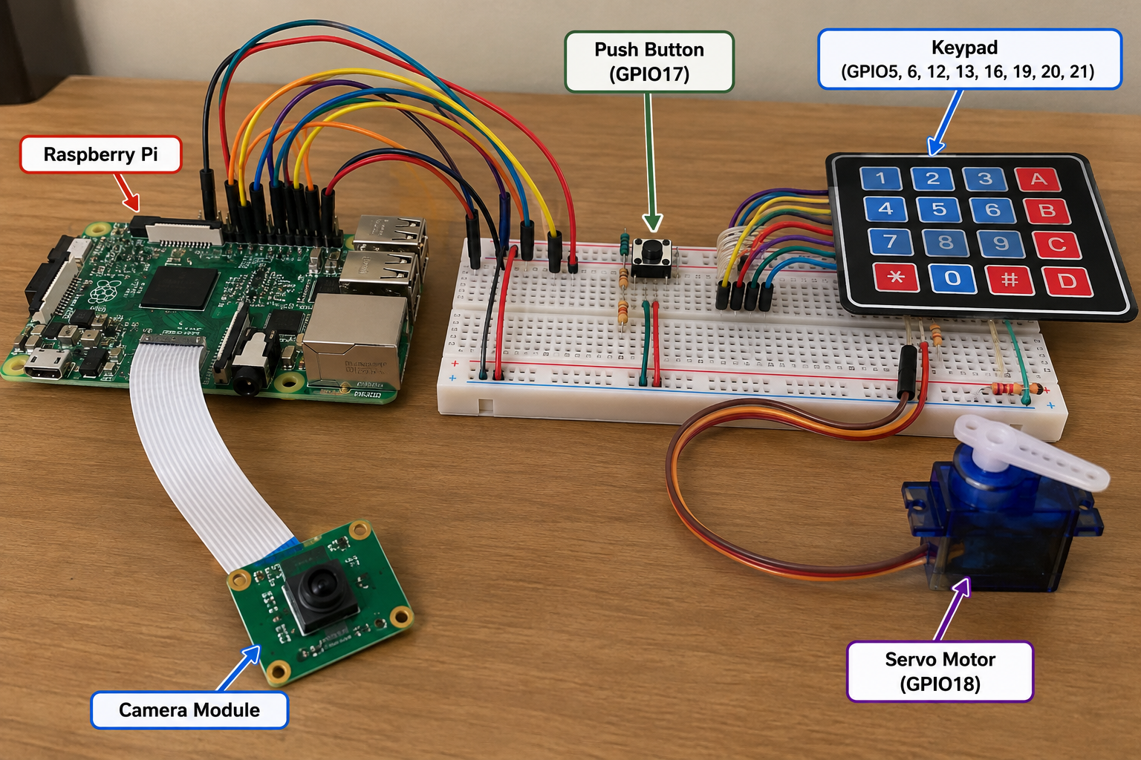
Repository source code: https://github.com/Nyle1/Smart-AI-Doorbell
Illustrative wiring photograph (not a pin-accurate schematic). The keypad shown is not connected in the current program; verify all connections against the written GPIO instructions before wiring.
Terminal editing tip: When a command opens nano, copy the source code from its GitHub link and paste it into nano (usually Ctrl+Shift+V in an SSH terminal, or right-click Paste). Press Ctrl+O, then Enter to save; press Ctrl+X to exit. Ctrl+S is not the standard save shortcut in nano. Run Python scripts using python3 filename.py, and press Ctrl+C to stop a running script.
1. Install necessary packages:
Update package lists and install software for the camera, web server, face recognition, and GPIO.
$ sudo apt update
$ sudo apt upgrade -y
$ sudo apt install python3-flask python3-opencv opencv-data python3-picamera2 python3-gpiozero -y

2. Create the proper directory and environment:
Organize all scripts and photos in one project folder.
$ mkdir -p ~/smart-doorbell
$ cd ~/smart-doorbell
$ nano doorbell.py

Copy and paste the source code from GitHub into the file:
View doorbell.py on GitHub
After pasting the code in nano: press Ctrl+O, then Enter to save the file; press Ctrl+X to exit nano and return to the terminal.

3. Test the push button:
Run the initial GPIO17 doorbell script.
$ cd ~/smart-doorbell
$ python3 doorbell.py
Expected Output (example):
Doorbell pressed!
Expected behavior: Pressing the GPIO17 button triggers the event. Result to verify: The button input is detected.

4. Check the camera:
Confirm that the Pi detects the OV5647 module and can take a photograph.
$ rpicam-hello --list-cameras
$ rpicam-still -o test.jpg --timeout 1000
Expected Output (example):
Available cameras:
0 : ov5647 [...]
$ ls -lh test.jpg
-rw-r--r-- 1 pi pi 245K ... test.jpg
Expected behavior: The camera is detected and a test image is saved. Result to verify: The OV5647 camera successfully captures test.jpg.

5. Make a visitor photo folder:
Store visitor snapshots separately from source code.
$ cd ~/smart-doorbell
$ mkdir -p photos
$ ls

6. Create the first Flask dashboard:
Build and start a simple local web server.
$ cd ~/smart-doorbell
$ nano app.py
$ python3 app.py
Expected Output (example):
* Running on http://127.0.0.1:5000
* Running on http://<Pi-IP>:5000
Expected behavior: The Flask development server starts on port 5000. Result to verify: The dashboard is reachable from a browser on the same network.

Copy and paste the source code from GitHub into the file:
View app.py on GitHub
After pasting the code in nano: press Ctrl+O, then Enter to save the file; press Ctrl+X to exit nano and return to the terminal.

7. Test face detection:
Use the Haar Cascade classifier to find faces in the camera feed.
$ cd ~/smart-doorbell
$ nano face_test.py
$ python3 face_test.py
Expected Output (example):
Faces detected: 1
Faces detected: 1
Faces detected: 0
Expected behavior: The script reports the number of faces detected in the camera frames. Result to verify: Face detection responds when a person enters or leaves the camera view.

Copy and paste the source code from GitHub into the file:
View face_test.py on GitHub
After pasting the code in nano: press Ctrl+O, then Enter to save the file; press Ctrl+X to exit nano and return to the terminal.

8. Verify OpenCV recognition support:
Confirm that the installed OpenCV build supports LBPH.
$ python3 -c "import cv2; print(cv2.__version__)"
$ python3 -c "import cv2; print(cv2.face.LBPHFaceRecognizer_create())"
Expected Output (example):
4.x.x
< cv2.face.LBPHFaceRecognizer ... >
Expected behavior: OpenCV reports its version and the LBPH recognizer object. Result to verify: The cv2.face LBPH module is available.

9. Collect resident training photos:
Create two resident folders and run the image collection program. Eventually we collected 100 images per resident.
$ cd ~/smart-doorbell
$ mkdir -p faces/resident1 faces/resident2
$ nano collect_faces.py
$ python3 collect_faces.py resident1
$ python3 collect_faces.py resident2
$ ls faces/resident1 | wc -l
$ ls faces/resident2 | wc -l
Expected Output (example):
resident1: 1/100
resident1: 2/100
...
resident1: 100/100
Expected behavior: Image files appear in each resident folder. Result to verify: The resident training images are saved locally.

Copy and paste the source code from GitHub into the file:
View collect_faces.py on GitHub
After pasting the code in nano: press Ctrl+O, then Enter to save the file; press Ctrl+X to exit nano and return to the terminal.

10. Train the face model:
Train an LBPH model and save it as face_model.yml.
$ cd ~/smart-doorbell
$ nano train_faces.py
$ python3 train_faces.py
Expected Output (example):
Saved /home/pi/smart-doorbell/face_model.yml using 200 images
Expected behavior: Training completes and creates face_model.yml. Result to verify: The LBPH model is available for recognition.

Copy and paste the source code from GitHub into the file:
View train_faces.py on GitHub
After pasting the code in nano: press Ctrl+O, then Enter to save the file; press Ctrl+X to exit nano and return to the terminal.

11. Test resident recognition:
Check whether the camera distinguishes residents from unknown visitors. We used a recognition distance threshold of 55.
$ cd ~/smart-doorbell
$ nano recognize_test.py
$ python3 recognize_test.py
Expected Output (example):
RESIDENT 1 | LBPH distance: 43.2
UNKNOWN | LBPH distance: 68.4
Expected behavior: The console displays a recognized resident or UNKNOWN and an LBPH distance. Result to verify: The model distinguishes registered and unregistered faces in the test.

Copy and paste the source code from GitHub into the file:
View recognize_test.py on GitHub
After pasting the code in nano: press Ctrl+O, then Enter to save the file; press Ctrl+X to exit nano and return to the terminal.

12. Back up and retrain:
Save the old model before rebuilding it with additional photos.
$ cd ~/smart-doorbell
$ cp face_model.yml face_model_OLD.yml
$ python3 train_faces.py

13. Test the servo motor:
Verify servo rotation for the cardboard door demonstration.
$ cd ~/smart-doorbell
$ nano servo_test.py
$ python3 servo_test.py
Expected Output (example):
Opening cardboard door prototype
Closing
Expected behavior: The servo rotates and returns to its starting position. Result to verify: The cardboard prototype door can open and close.

Copy and paste the source code from GitHub into the file:
View servo_test.py on GitHub
After pasting the code in nano: press Ctrl+O, then Enter to save the file; press Ctrl+X to exit nano and return to the terminal.

14. Combine recognition and servo:
Test automatic movement after recognizing an authorized resident. The final system uses five consecutive matching frames.
$ cd ~/smart-doorbell
$ nano recognize_servo_WORKING.py
$ python3 recognize_servo_WORKING.py
Expected Output (example):
Dashboard: Detected = RESIDENT 1
Confirmation = 5/5
Door = OPEN → CLOSED
Expected behavior: After repeated authorized matches, the cardboard door servo activates. Result to verify: The recognition and servo components work together.

Copy and paste the source code from GitHub into the file:
View recognize_servo_WORKING.py on GitHub
After pasting the code in nano: press Ctrl+O, then Enter to save the file; press Ctrl+X to exit nano and return to the terminal.

15. Install Flask-SocketIO:
Enable instant visitor updates without refreshing every existing photo.
$ sudo apt update
$ sudo apt install python3-flask-socketio -y
$ python3 -c "import flask_socketio; print('Flask-SocketIO ready')"
Expected Output (example):
Flask-SocketIO ready
Expected behavior: The Socket.IO Python package imports without an error. Result to verify: The real-time update library is installed.

16. Create the integrated application:
Combine camera, recognition, button, servo, saved photographs, and dashboard.
$ cd ~/smart-doorbell
$ nano smart_system.py
$ python3 smart_system.py
Expected Output (example):
* Running on http://127.0.0.1:5000
* Running on http://<Pi-IP>:5000
Expected behavior: The combined application starts the camera and web server. Result to verify: The integrated dashboard can be opened on port 5000.

Copy and paste the source code from GitHub into the file:
View smart_system.py on GitHub
After pasting the code in nano: press Ctrl+O, then Enter to save the file; press Ctrl+X to exit nano and return to the terminal.

17. Test the dashboard endpoints:
In a separate SSH session, check that the server and visitor history respond.
$ ssh pi@raspberrypi.local
$ curl -I http://localhost:5000/
$ curl http://localhost:5000/visitor_history
Expected Output (example):
[{"filename":"visitor_...jpg","timestamp":"2026-10-11 22:30:00"}]
HTTP/1.1 200 OK
Expected behavior: The visitor endpoint returns JSON and the home page responds successfully. Result to verify: The server responds to status and visitor-history requests.

18. Connect real-time visitor updates:
The dashboard loads existing history once, then adds new photos when it receives the Socket.IO new_visitor event.
$ cd ~/smart-doorbell
$ python3 smart_system.py
Expected Output (example):
Socket.IO event: new_visitor
Visitor history: new photo added at top
Expected behavior: A new visitor photo appears without refreshing older cards. Result to verify: Real-time dashboard updates work when the button is pressed.

19. Configure Bluetooth audio:
Set the connected AirPods as the audio output and play a test sound.
$ wpctl status
$ wpctl set-default bluez_output.EC_46_54_27_C4_B1.1
$ pw-play /usr/share/sounds/freedesktop/stereo/complete.oga
Expected Output (example):
pw-play completes without an error; audio is heard.
Expected behavior: The test sound plays through the selected AirPods. Result to verify: Bluetooth audio playback works.

20. Transfer and test a custom chime:
Copy the custom ding-dong WAV from Windows PowerShell, then test it on the Pi.
$ scp "$env:USERPROFILE\Downloads\doorbell.wav" pi@raspberrypi.local:/home/pi/smart-doorbell/
$ cd ~/smart-doorbell
$ ls -l doorbell.wav
$ pw-play doorbell.wav
Expected Output (example):
-rw-r--r-- 1 pi pi ... doorbell.wav
$ pw-play doorbell.wav
Expected behavior: The transferred WAV file exists and plays a two-note ding-dong. Result to verify: The custom chime plays successfully.

21. Update the chime file in the main program:
Point DOORBELL_SOUND to ~/smart-doorbell/doorbell.wav. Restart the integrated application.
$ cd ~/smart-doorbell
$ nano smart_system.py
$ python3 smart_system.py
Expected Output (example):
Saved visitor: visitor_2026-10-11_22-30-00-123456.jpg
Expected behavior: Pressing the physical button plays the custom chime and saves a visitor image. Result to verify: Audio and photography are triggered by the doorbell button.

22. Troubleshoot a busy camera:
Stop duplicate programs if the camera reports that it is already in use.
$ ps aux | grep -E "smart_system|app_WORKING|python|rpicam|libcamera" | grep -v grep
$ pkill -f smart_system.py
$ pkill -f app_WORKING_BACKUP.py
$ rpicam-still -o ~/camera_test.jpg --timeout 1000
$ cd ~/smart-doorbell
$ python3 smart_system.py
Expected Output (example):
Still capture image received
Expected behavior: After stopping the old process, the camera test completes without a resource-busy error. Result to verify: The camera is available to the main application.

23. Monitor Raspberry Pi performance:
Check memory, CPU usage, and throttling when the camera stream becomes slow.
$ free -h
$ top
$ vcgencmd get_throttled
Expected Output (example):
Mem: 905Mi total ...
throttled=0x0
Expected behavior: The commands report memory, CPU load, and throttling status. Result to verify: The Pi is not reporting active power throttling.

Final result: Pressing the button plays a ding-dong and saves a visitor photo. Socket.IO updates the visitor history in the browser. The camera displays live video and recognizes registered residents; the servo demonstrates opening the cardboard door after five consecutive matches.
Note: Commands and example outputs are reconstructed for instructional purposes. The source-code links in this document point to our GitHub repository. The GitHub code was reconstructed while the original Raspberry Pi was unavailable and should be verified on the device.

GitHub Repository and Source Code Access
Our project files are organized in the public GitHub repository linked below. It contains Python source code, the HTML dashboard in templates/, the doorbell audio file, a README, and documentation in docs/.
Repository: https://github.com/Nyle1/Smart-AI-Doorbell

24. Access the Project on GitHub
Open the repository to browse source files. Click smart_system.py for the integrated application, templates/index.html for the dashboard, or docs/ for the project documentation. The README provides an overview and setup requirements.

25. Access the Project Through SSH
Using an SSH terminal connected to the Raspberry Pi, install Git and clone the repository using the commands below:
$ sudo apt update
$ sudo apt install git -y
$ cd ~
$ git clone https://github.com/Nyle1/Smart-AI-Doorbell.git
$ cd Smart-AI-Doorbell
$ ls

The clone command creates a new Smart-AI-Doorbell folder containing the tracked repository files. If the folder already exists, open it instead of cloning into the same location.

26. Retrieve Updated Files
When the repository is updated on GitHub, retrieve the newest version from inside the cloned repository:
$ cd ~/Smart-AI-Doorbell
$ git pull origin main

Do not run git pull over uncommitted local edits without reviewing the changes first.

27. Run the Project on the Raspberry Pi
After connecting to the Raspberry Pi through SSH and obtaining the repository, install the required Raspberry Pi packages listed in README.md. Collect local resident images and train face_model.yml before testing recognition, then launch the integrated application:
$ cd ~/Smart-AI-Doorbell
$ python3 smart_system.py
Expected Output (example):
* Running on http://<Pi-IP>:5000
Expected behavior: The main application starts and the dashboard becomes accessible. Result to verify: The project can be launched after dependencies and local face data are configured.

Important: The public GitHub repository excludes resident face images, visitor photographs, and the trained face_model.yml for privacy. These must remain on the Raspberry Pi. The repository code was reconstructed and must be checked against the original working version.
Documentation note: The terminal outputs above are illustrative examples, not verbatim screenshots or captured logs. Actual output varies with OS version, device configuration, timing, and training data.

Updating This Documentation in the GitHub Repository
To publish this updated document, open the GitHub repository, enter the docs/ folder, select Add file → Upload files, and upload this .docx document. Commit the change. If replacing an older documentation file, remove the outdated copy to avoid confusion. This is a documentation publishing step; the Raspberry Pi setup and code editing instructions above remain SSH-based.

