Smart AI Doorbell
Nyle Farhan Ul Haq and Shivank Chhaya
Problem Statement:
Develop a Raspberry Pi smart doorbell that records visitors, displays a live camera feed, recognizes registered residents, plays a doorbell chime, and demonstrates automatic opening with a servo-driven cardboard door.
Materials: Raspberry Pi 3 Model B+, push button, breadboard, jumper wires, OV5647 camera module, servo motor, cardboard prototype, Bluetooth AirPods, power supply, computer (keypad optional).
Documentation (use single-cell tables)
Set up the wiring and components like this:
Connect button between GPIO17 (physical pin 11) and GND. Connect servo signal to GPIO18 (physical pin 12); use suitable servo power and a shared ground. Attach the camera ribbon cable to the Pi camera port. [Insert wiring photograph/diagram here.]
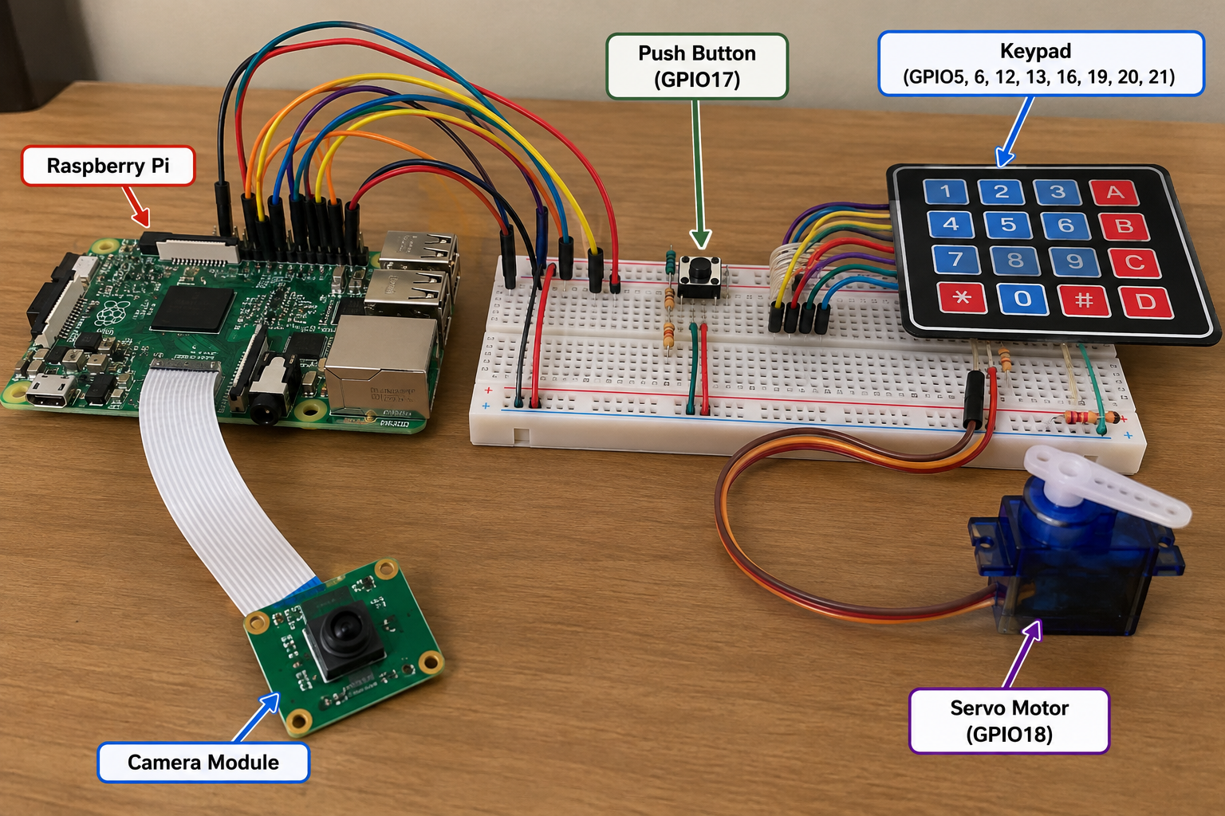
Illustrative wiring photograph (not a pin-accurate schematic). The keypad shown is not connected in the current program; verify all connections against the written GPIO instructions before wiring.
1. Install necessary packages:
Update package lists and install software for the camera, web server, face recognition, and GPIO.
$ sudo apt update
$ sudo apt upgrade -y
$ sudo apt install python3-flask python3-opencv opencv-data python3-picamera2 python3-gpiozero -y

2. Create the proper directory and environment:
Organize all scripts and photos in one project folder.
$ mkdir -p ~/smart-doorbell
$ cd ~/smart-doorbell
$ nano doorbell.py

Paste this code in:
$ [Link to doorbell.py Python file — add later]

3. Test the push button:
Run the initial GPIO17 doorbell script.
$ cd ~/smart-doorbell
$ python3 doorbell.py

4. Check the camera:
Confirm that the Pi detects the OV5647 module and can take a photograph.
$ rpicam-hello --list-cameras
$ rpicam-still -o test.jpg --timeout 1000

5. Make a visitor photo folder:
Store visitor snapshots separately from source code.
$ cd ~/smart-doorbell
$ mkdir -p photos
$ ls

6. Create the first Flask dashboard:
Build and start a simple local web server.
$ cd ~/smart-doorbell
$ nano app.py
$ python3 app.py

Paste this code in:
$ [Link to app.py Python file — add later]

7. Test face detection:
Use the Haar Cascade classifier to find faces in the camera feed.
$ cd ~/smart-doorbell
$ nano face_test.py
$ python3 face_test.py

Paste this code in:
$ [Link to face_test.py Python file — add later]

8. Verify OpenCV recognition support:
Confirm that the installed OpenCV build supports LBPH.
$ python3 -c "import cv2; print(cv2.__version__)"
$ python3 -c "import cv2; print(cv2.face.LBPHFaceRecognizer_create())"

9. Collect resident training photos:
Create two resident folders and run the image collection program. Eventually we collected 100 images per resident.
$ cd ~/smart-doorbell
$ mkdir -p faces/resident1 faces/resident2
$ nano collect_faces.py
$ python3 collect_faces.py resident1
$ python3 collect_faces.py resident2
$ ls faces/resident1 | wc -l
$ ls faces/resident2 | wc -l

Paste this code in:
$ [Link to collect_faces.py Python file — add later]

10. Train the face model:
Train an LBPH model and save it as face_model.yml.
$ cd ~/smart-doorbell
$ nano train_faces.py
$ python3 train_faces.py

Paste this code in:
$ [Link to train_faces.py Python file — add later]

11. Test resident recognition:
Check whether the camera distinguishes residents from unknown visitors. We used a recognition distance threshold of 55.
$ cd ~/smart-doorbell
$ nano recognize_test.py
$ python3 recognize_test.py

Paste this code in:
$ [Link to recognize_test.py Python file — add later]

12. Back up and retrain:
Save the old model before rebuilding it with additional photos.
$ cd ~/smart-doorbell
$ cp face_model.yml face_model_OLD.yml
$ python3 train_faces.py

13. Test the servo motor:
Verify servo rotation for the cardboard door demonstration.
$ cd ~/smart-doorbell
$ nano servo_test.py
$ python3 servo_test.py

Paste this code in:
$ [Link to servo_test.py Python file — add later]

14. Combine recognition and servo:
Test automatic movement after recognizing an authorized resident. The final system uses five consecutive matching frames.
$ cd ~/smart-doorbell
$ nano recognize_servo_WORKING.py
$ python3 recognize_servo_WORKING.py

Paste this code in:
$ [Link to recognize_servo_WORKING.py Python file — add later]

15. Install Flask-SocketIO:
Enable instant visitor updates without refreshing every existing photo.
$ sudo apt update
$ sudo apt install python3-flask-socketio -y
$ python3 -c "import flask_socketio; print('Flask-SocketIO ready')"

16. Create the integrated application:
Combine camera, recognition, button, servo, saved photographs, and dashboard.
$ cd ~/smart-doorbell
$ nano smart_system.py
$ python3 smart_system.py

Paste this code in:
$ [Link to smart_system.py Python file — add later]

17. Test the dashboard endpoints:
In a separate SSH session, check that the server and visitor history respond.
$ ssh pi@raspberrypi.local
$ curl -I http://localhost:5000/
$ curl http://localhost:5000/visitor_history

18. Connect real-time visitor updates:
The dashboard loads existing history once, then adds new photos when it receives the Socket.IO new_visitor event.
$ cd ~/smart-doorbell
$ python3 smart_system.py

19. Configure Bluetooth audio:
Set the connected AirPods as the audio output and play a test sound.
$ wpctl status
$ wpctl set-default bluez_output.EC_46_54_27_C4_B1.1
$ pw-play /usr/share/sounds/freedesktop/stereo/complete.oga

20. Transfer and test a custom chime:
Copy the custom ding-dong WAV from Windows PowerShell, then test it on the Pi.
$ scp "$env:USERPROFILE\Downloads\doorbell.wav" pi@raspberrypi.local:/home/pi/smart-doorbell/
$ cd ~/smart-doorbell
$ ls -l doorbell.wav
$ pw-play doorbell.wav

21. Update the chime file in the main program:
Point DOORBELL_SOUND to ~/smart-doorbell/doorbell.wav. Restart the integrated application.
$ cd ~/smart-doorbell
$ nano smart_system.py
$ python3 smart_system.py

22. Troubleshoot a busy camera:
Stop duplicate programs if the camera reports that it is already in use.
$ ps aux | grep -E "smart_system|app_WORKING|python|rpicam|libcamera" | grep -v grep
$ pkill -f smart_system.py
$ pkill -f app_WORKING_BACKUP.py
$ rpicam-still -o ~/camera_test.jpg --timeout 1000
$ cd ~/smart-doorbell
$ python3 smart_system.py

23. Monitor Raspberry Pi performance:
Check memory, CPU usage, and throttling when the camera stream becomes slow.
$ free -h
$ top
$ vcgencmd get_throttled

Final result: Pressing the button plays a ding-dong and saves a visitor photo. Socket.IO updates the visitor history in the browser. The camera displays live video and recognizes registered residents; the servo demonstrates opening the cardboard door after five consecutive matches.
Note: Commands are reconstructed from our development work and organized for readability. Some installation commands are consolidated. Add links to the actual Python files and wiring photos before submission.

