Guide to set up the project solution
This project is running on Window OS.
Dependencies
- Docker Desktop
- Kubernetes
- Kubectl
- Minikube
- Kubernetes metrics
- Python
- PyCharm Community Verion

Installation Guide
1. Docker Desktop
- Go to https://docs.docker.com/desktop/setup/install/windows-install/
- Download Docker Desktop For Window
- Run the Docker Desktop Installer.exe
- Open Docker Desktop
2. Kubernetes
- Go to setting, enable “Kubernetes”.
- Under Cluster settings, select “kind” for creating a cluster containing one or more nodes with kind
- The configuration must be as shown in the figure below.
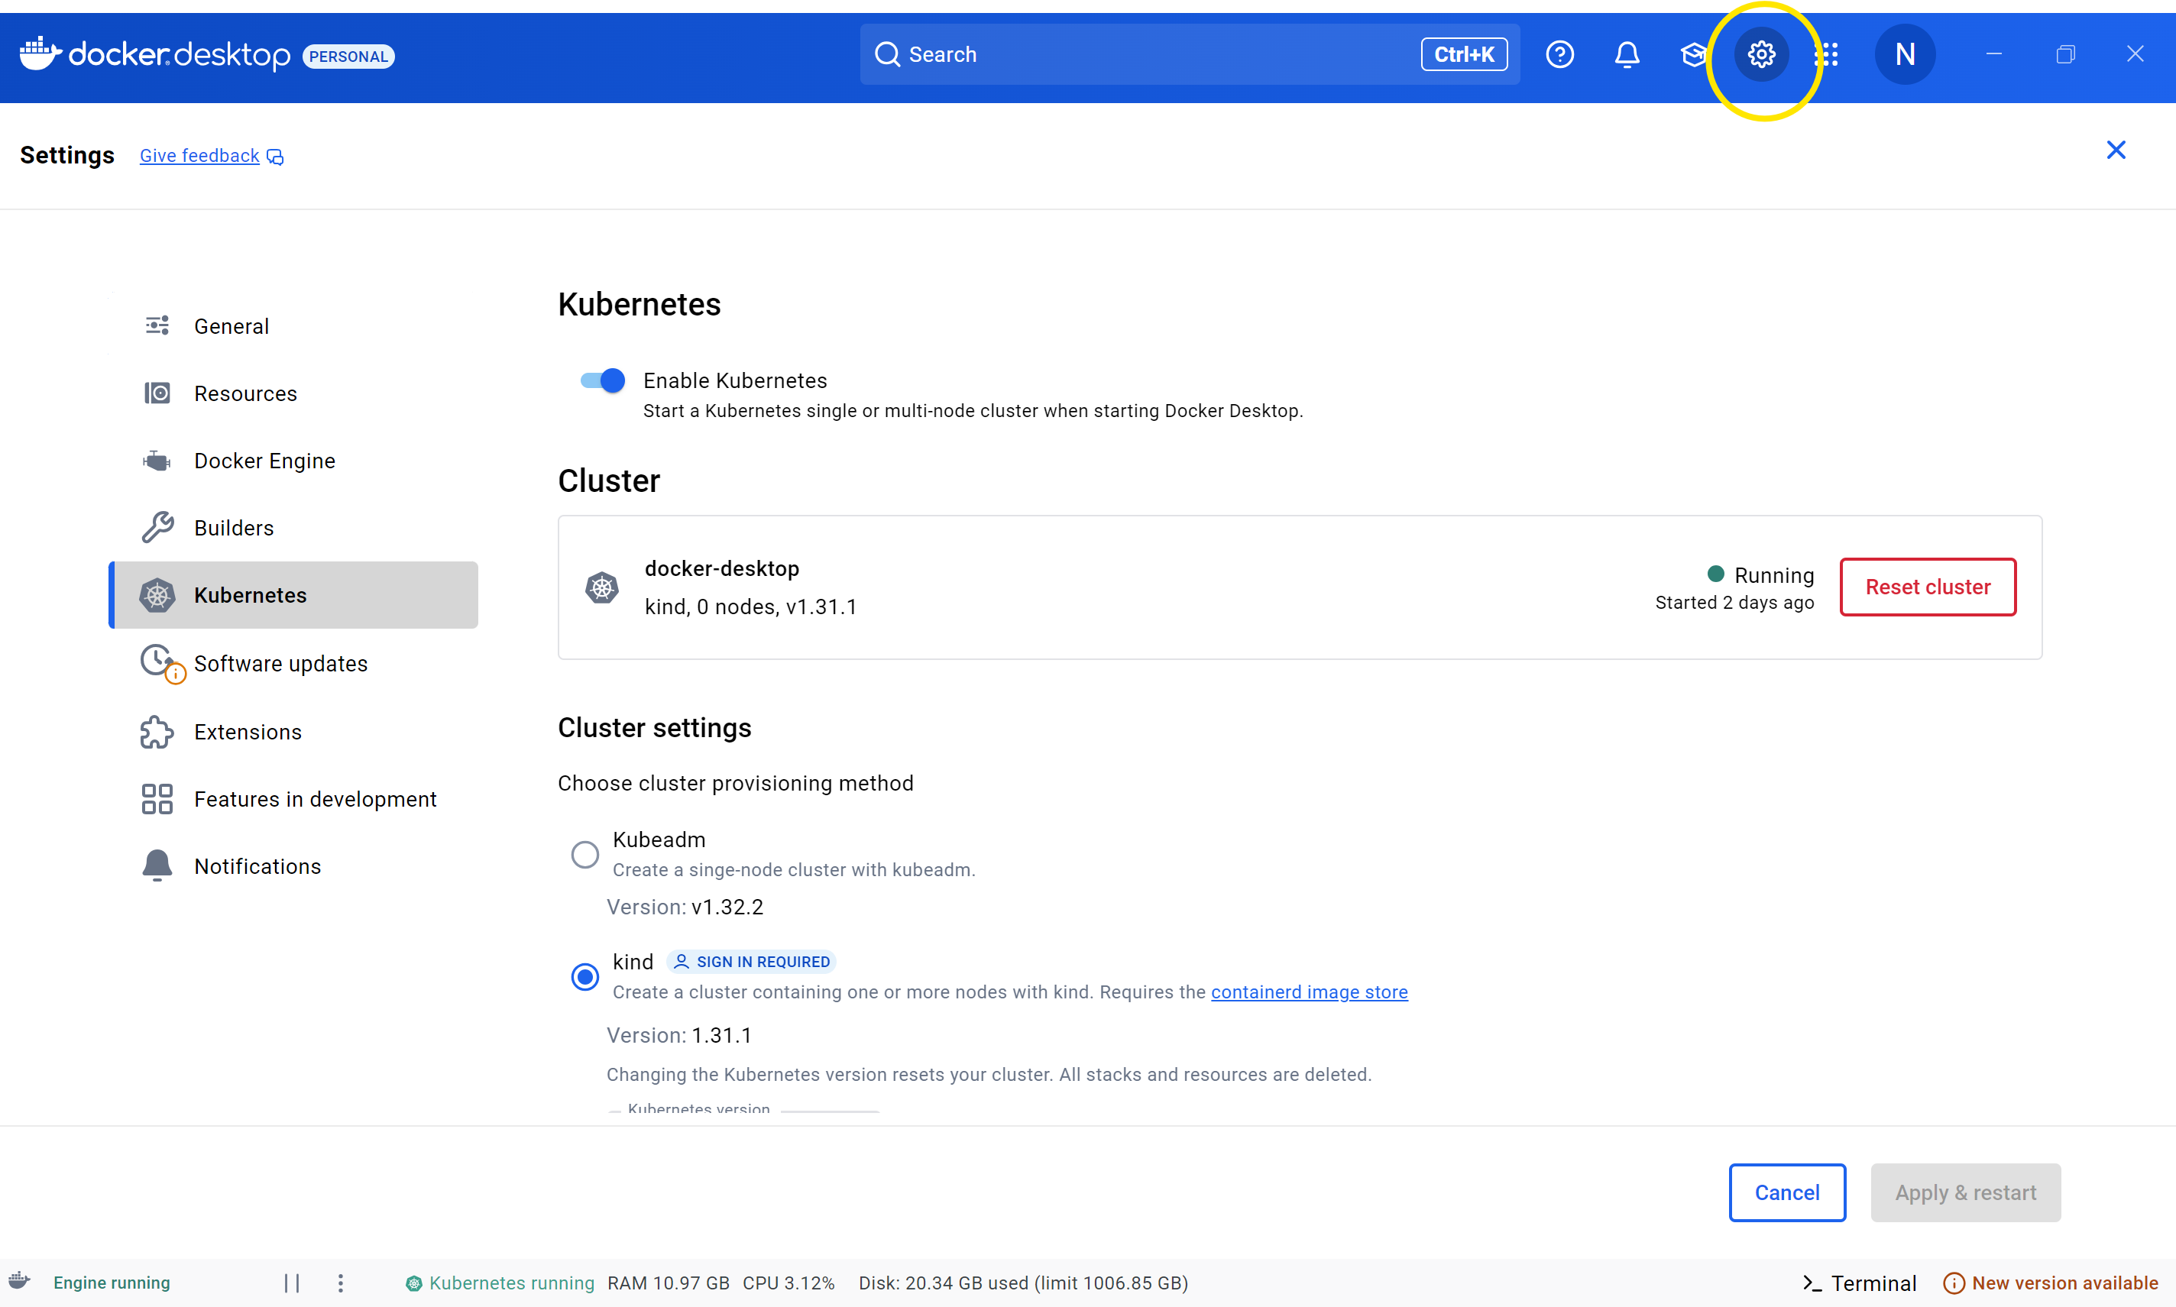
- Then check the Kubernetes version if it’s correctly installed using PowerShell command below.
>> kubectl version
Output >> Client Version: v1.32.2
Kustomize Version: v5.5.0
Server Version: v1.32.0
3. Kubectl
- Check if “Kubectl” is included in Docker Desktop installation
- Other install it with this PowerShell command.
>> curl.exe -LO https://dl.k8s.io/release/v1.33.0/bin/windows/amd64/kubectl.exe
- Move kubectl.exe to Docker Desktop installed path (eg. C:\Program Files\Docker\Docker\resources\bin)

4. Minikube
- Download Minikube from https://minikube.sigs.k8s.io/docs/start/?arch=%2Fwindows%2Fx86-64%2Fstable%2F.exe+download
- Select Window, .exe installer. Then click on the latest release link to download installer
- Run minikube-installer.exe
- After installation, add the minikube application path to the “Environment Variables”
- Open PowerShell, check if minikube if installed correctly using below command.
>> minikube version
Output >> minikube version: v1.35.0

- Create two clusters to simulate AWS and GCP in local Kubernetes
PowerShell commands
>> minikube start
>> kubectl config set-context aws-cluster --cluster=aws-cluster --user=aws-cluster
>> kubectl config set-context gcp-cluster --cluster=gcp-cluster --user=gcp-cluster

- Start both clusters
>> minikube start –profile aws-cluster
>> minikube start –profile gcp-cluster

- Check if both clusters were created
>> minikube profile list

- Check Kubernetes cluster and should see as below. “*” indicates that currently using that cluster
>> kubectl config get-contexts
Output >>
CURRENT NAME CLUSTER AUTHINFO NAMESPACE
* aws-cluster aws-cluster aws-cluster default
docker-desktop docker-desktop docker-desktop
gcp-cluster gcp-cluster gcp-cluster default
minikube minikube minikube default
5. Kubernetes metrics
- This should be installed for both aws-cluster and gcp-cluster
- Switch to aws clusters and continue installation steps. After that, switch to gcp-cluster and do the same.
- For switching to gcp-cluster
>> kubectl config use-context gcp-cluster
Output >> Switched to context "gcp-cluster"
- For switching to aws-cluster
>> kubectl config use-context aws-cluster
Output >> Switched to context "aws-cluster"

- Install using below PowerShell command
>> kubectl apply -f https://github.com/kubernetes-sigs/metrics-server/releases/latest/download/components.yaml
- Patch Metrics Server for Local Clusters
>> kubectl patch deployment metrics-server -n kube-system --type='json' -p='[{"op": "add", "path": "/spec/template/spec/containers/0/args/-", "value": "--kubelet-insecure-tls"}]'
- Verify Installation
>> kubectl get pods -n kube-system | Select-String "metrics-server"
Output >>
metrics-server-744bb9fbcf-wxqdt 1/1 Running 3 (40h ago) 45h
>> kubectl top nodes
Output >>
NAME CPU(cores) CPU(%) MEMORY(bytes) MEMORY(%)
aws-cluster 182m 0% 1721Mi 10%

6. Python
- Go to https://www.python.org/downloads/release/python-3126/
- Download and run the python installer
- Add python path to “Environment Variables”
7. PyCharm Community Verion
- Go to https://www.jetbrains.com/pycharm/download/?section=windows
- Download community version
- run the installer

Compilation and running the program
- Place the project solution folder to local drive.
- Open PyCharm code editor
- File => Open, select project folder path
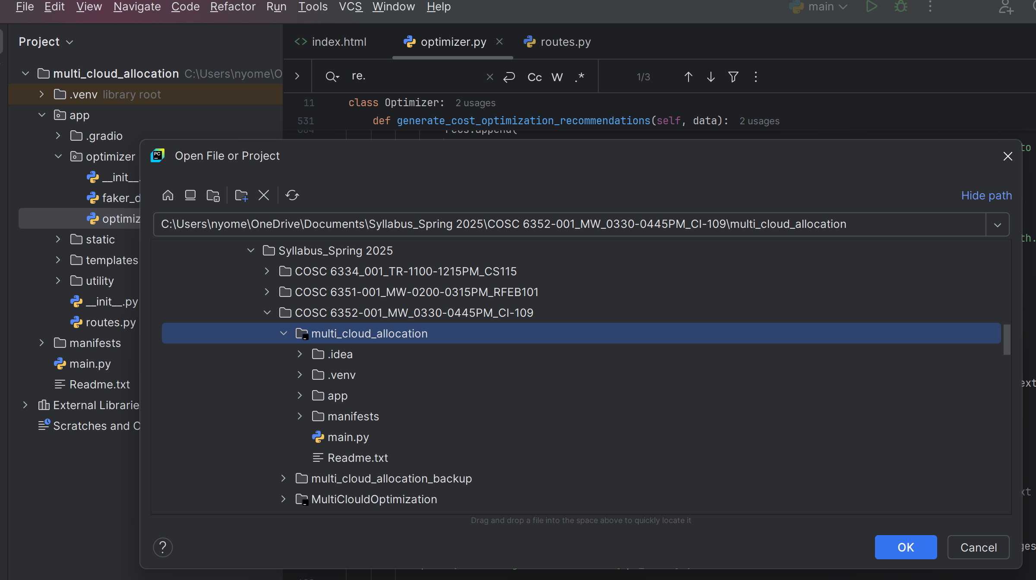
- Select python version
- File => Settings => Project name => Python Interpreter
- Select Python interpreter as shown below.
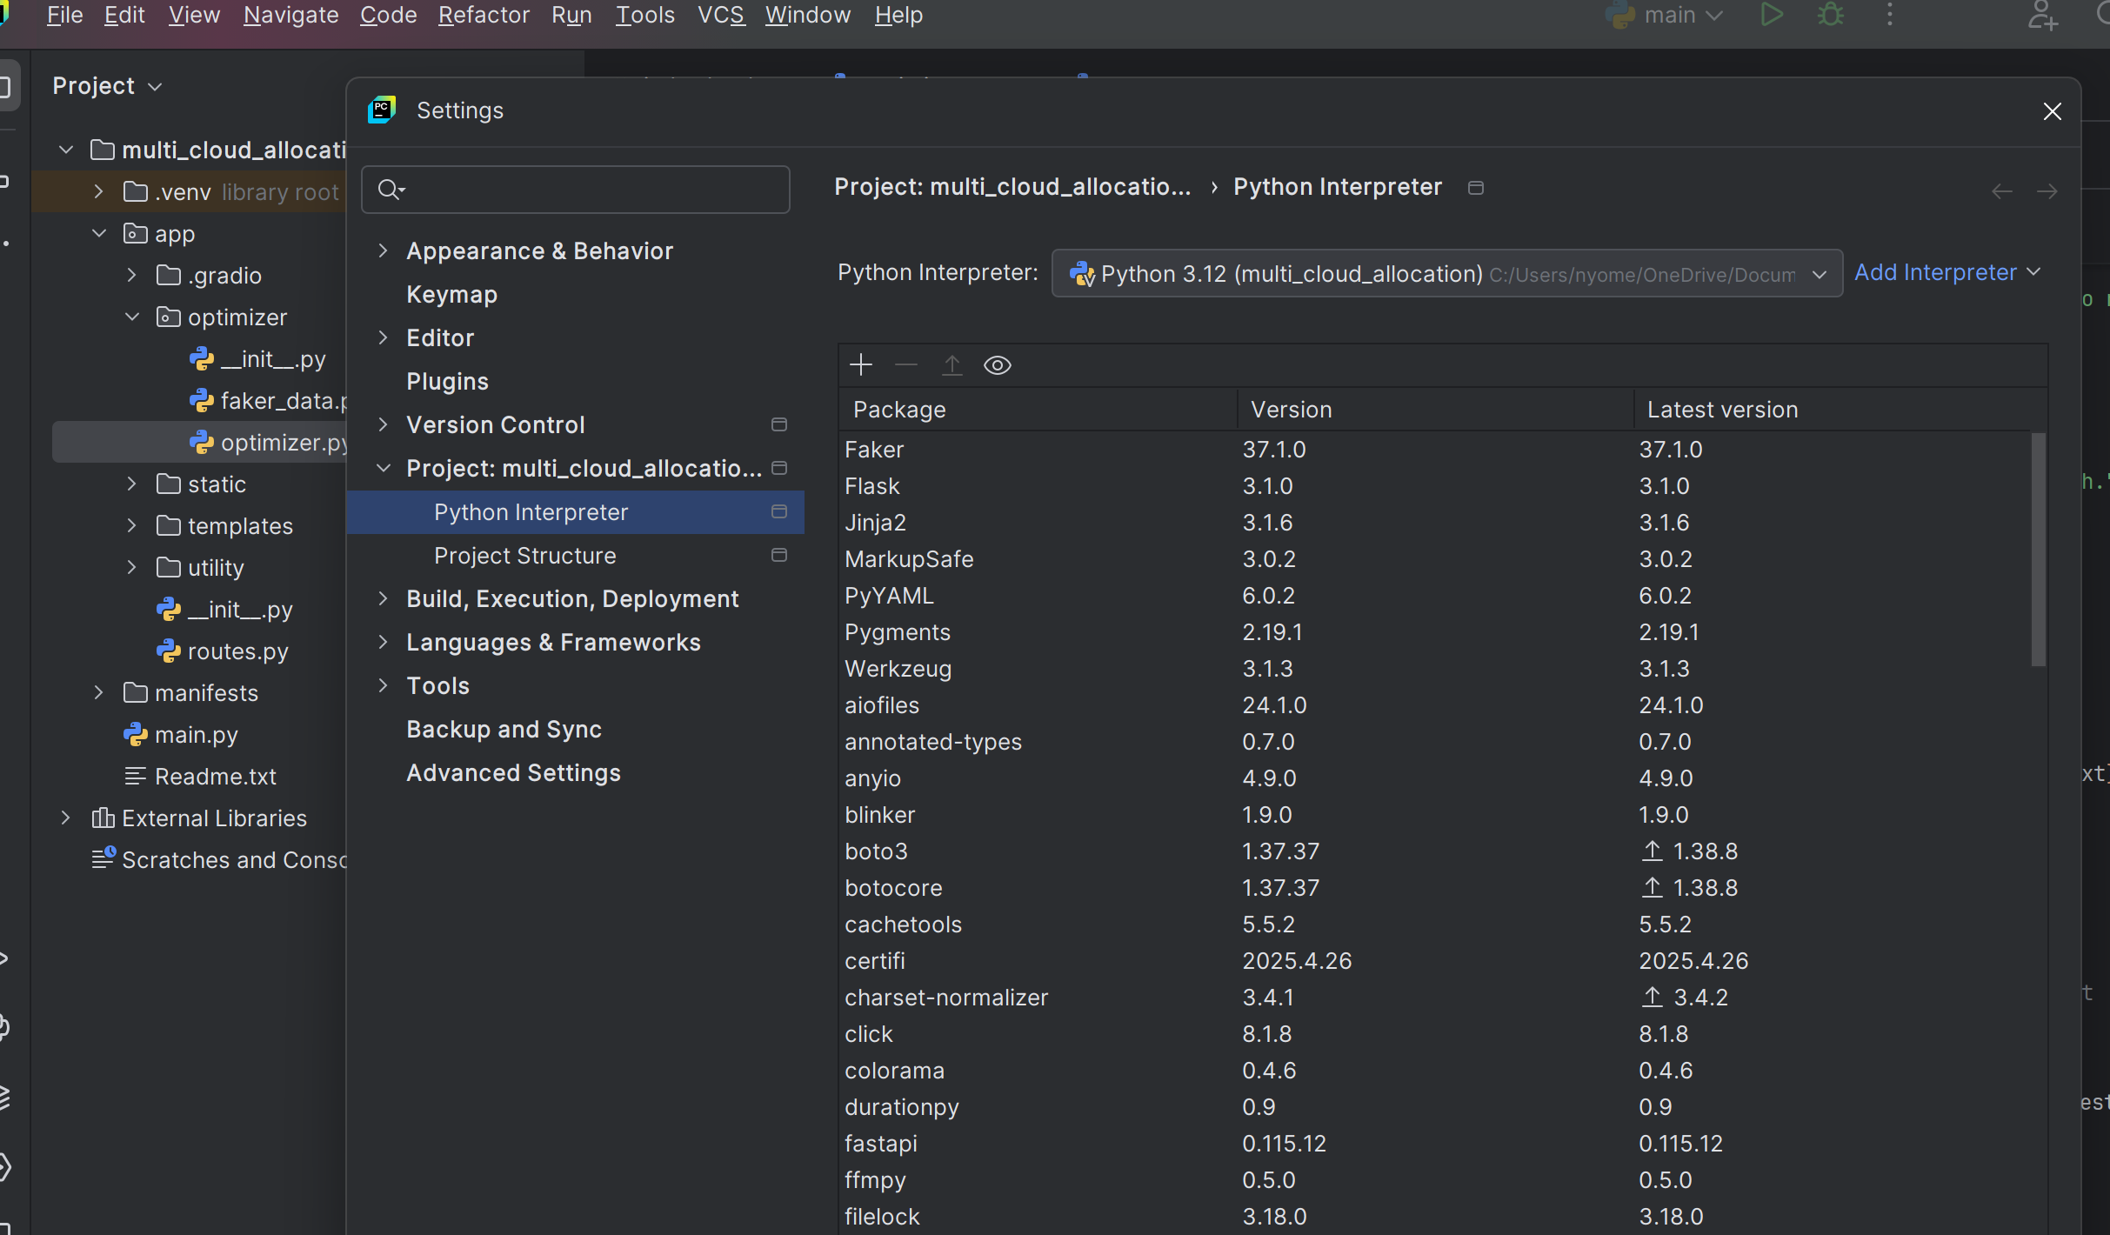
- If there are red lines highlighting the import libraries, just click on the red bulb shown in the editor and install missing libraries, those are in-built python libraries.

