**KABARAK  UNIVERSITY**

**SCHOOL OF SCIENCE, ENGINEERING AND TECHNOLOGY**

**INTE 424: IT PROJECT 2**

**DRIVING SCHOOL SCHEDULING SYSTEM USING RECOMMENDER (DSSS)**

**PRESENTED BY;**

**KAMANDE AGNES NYOKABI: INTE/MG/3065/09/19**

**A PROJECT SUBMITTED TO THE DEPARTMET OF COMPUTER SCIENCE AND INFORMATION TECHNOLOGY (UNDER THE SCHOOL OF SCIENCE ENGINEERING AND TECHNOLOGY) IN PARTIAL FULFILMENT OF DEGREE IN INFORMATION TECHNOLOGY.**

**NOVEMBER 2022**

**DECLARATION**

We hereby declare that this project DRIVING SCHOOL SCHEDULING SYSTEM USING RECOMMENDER is based on own work carried out during the course of our study. I assert that the statements made and conclusions drawn are outcomes of our own research. I further certify that the work contained in the report is original and has not been submitted in any other institution for any other degree/diploma/certificate or any other university in Kenya. Whenever I have used materials from other sources I will have given due credit to the text of the reporting and giving their details in the reference section.

NAME: KAMANDE AGNES NYOKABI

DATE: …………...

SIGNATURE: …………..

SUPERVISED BY: Mr. SIMON RUORO

DATE: …………...

SIGNATURE: …………..

**ACKNOWLEGEMENT**

We would like to thank the almighty God for bringing me this far. I would also like to thank Mr. Simon Ruoro for his continued support and guidance through this entire journey.

I also thank my fellow classmates for the support they have showed me when i needed to consult them. I would also like to express my gratitude to my friends and family for the encouragement and support they have shown.

Last but not the least I also show gratitude to all the lecturers for providing me with the technical skills and knowledge that i will implement in my day to day challenges.

**DEDICATION**

This project is dedicated to all driving schools in general but most especially Rocky Driving School since this is the institution I took my driving classes and exam.

# ABSTRACT

With the rapid development in technology, there is a need to develop a scheduling system for drive-schools enterprise. Driving-training school’s efficiency will be managed and the will be a reduced waste of human power and information resources. This will help make scheduling for classes for students very convenient as it is as per their own routine and at the time they are available. The System will grow for the most part of the driving school to deal with the activity increasingly productive as there will be more students registering for classes due to convenience.

This will involve the institution assigning a class and a student as per the availability of the student, the teacher, the instructor for the manual driving lessons and when a vehicle is available. It will also recommend what time is perfect for a certain student to go for a certain examination at the time scheduled on the time table and their own routine as well.

This framework will be overseen by the staff of driving school. The Driving School system will help keep up with all the assigned classes to the various available teachers, instructors or even the vehicle to be used during training. All this information will be on the instructor’s scheduler. Besides all that, driving school scheduling system will keep track of all the operation information securely and orderly and even with back up option. It is also supposed to make scheduling easier here one can search and retrieve data about students’ already scheduled classes, and make changes to all the stored record as per the requested changes by the students or the instructor at the driving institution.

The software will be implemented using HTML, CSS and PHP development technology. Phases that are included are the requirements, system analysis, system design, implementation, system testing and maintenance. At the end of this project, it is by hope that Driving School Scheduling System (DSSS) can contribute to driving school operations to make it better and to cater best service to both the institution and the students

Table of Contents

ABSTRACT 5

List of Tables 8

CHAPTER ONE 9

1.1 INTRODUCTION 9

1.2 BACKGROUND OF STUDY 10

1.2.1 CURRENT SYSTEM 10

1.2.2 PROPOSED SYSTEM 11

1.3 PROBLEM STATEMENT 11

1.4 OBJECTIVES 12

1.4.1 GENERAL OBJECTIVE 12

1.4.2 SPECIFIC OBJECTIVES 12

1.5 PURPOSE OF THE STUDY 13

1.6 FEASIBILITY STUDY 13

1.6.1 TECHNICAL FEASIBILITY 13

1.6.2 ECONOMIC FEASIBILITY 13

1.6.3 OPERATIONAL FEASIBILITY 13

1.6.4 PHYSICAL FEASIBILITY 13

1.7 SCOPE OF THE STUDY 14

1.8 LIMITATION OF THE STUDY 14

CHAPTER TWO: LITERATURE REVIEW 15

2.1 INTRODUCTION 15

2.2 GENERAL OVERVIEW OF THE LITERATURE RELATED TO THE MAIN CONCEPTS 15

2.3 REVIEW LITERATURE BASED ON OBJECTIVE ONE 15

2.4 REVIEW LITERATURE BASED ON OBJECTIVE TWO 16

2.5 REVIEW LITERATURE BASED ON OBJECTIVE THREE 16

2.6 REVIEW LITERATURE BASED ON OBJECTIIVE FOUR 17

2.7 SUMMARY 17

2.8 DESIGN FRAMEWORK 18

2.8.1 CHOSEN METHODOLOGY 18

CHAPTER THREE 20

3.1 INTRODUCTION 20

3.2 LOCATION OF THE STUDY 20

3.3 POPULATION OF THE STUDY 20

3.4 SAMPLING PROCEDURE AND SAMPLE SIZE 20

3.4.1 SAMPLING PROCEDURE 20

3.4 2 SAMPLING SIZE 21

3.5 DATA COLLECTION METHODS 21

3.5.1 OBSERVATION 21

3.5.2 INTERVIEWS 21

3.6 RESEARCH ETHICS 22

3.7 SYSTEM ANALYSIS AND DESIGN 23

3.7.1 CONTEXT DIAGRAM 23

3.7.2 DATA FLOW DIAGRAM 25

3.7.3 ENTITY-RELATIONSHIP DIAGRAM 26

3.7.4 USE-CASE DIAGRAM FOR ADMIN MODULE 27

3.7.5 USE CASE DIAGRAM FOR USER MODULE 28

3.7.6 CLASS DIAGRAM 29

CHAPTER 4: SYSTEM DESIGN AND IMPLEMENTATION 30

4.0 INTRODUCTION 30

4.1 SYSTEM DESCRIPTION 30

4.1.1 FRONT END DEPLOYMENT 30

4.1.2 USER INTERFACE DESIGN 30

4.1.3 INTERFACE DESIGN FOR LOGIN 31

4.2 BACK-END DEVELOPMENT 33

4.2.1 DATABASE DESIGN MODELS 33

4.2.2 BACK-END CODES 34

4.3 REFERENCES 36

4.4 PROPOSED TESTING TECHNIQUE 36

BLACK BOX TESTING 36

4.5 CONCLUSION 36

4.7 APPENDICES 37

List of Figures

Figure 1: Phased Development Methodology 18

Figure 2: Context Diagram 24

Figure 3: Data Flow Diagram 25

Figure 4: E-R Diagram 26

Figure 5: ADMIN Module 27

Figure 6: USER Module 28

Figure 7: Class Diagram 29

Figure 8: Homepage of the system 30

Figure 9: Sample details of the school 31

Figure 10: Login page Admin Module 31

Figure 11: Admin Module 32

Figure 12: School Module 32

Figure 13: Teachers registration details 33

Figure 14: Semester details 34

Figure 15: PHP code for Home page 34

Figure 16: PHP code to Generate timetable 35

# List of Tables

Table 1: Budget Estimate 31

Table 2: Gantt chart 32

**LIST OF ACRONYMNS**

DSSS – Driving School Scheduling System

RAD - Rapid Application Development

SDLC – System Development Life Cycle

DBMS - database management system

PHP - Hypertext Pre-processor

SQL - **Structured Query Language**

MySQL – **My Structured Query Language**

# CHAPTER ONE

## 1.1 INTRODUCTION

So many collaborative factors are used to filter out the available time for class scheduling for example, the availability of an instructor, the availability of the vehicle to be used or even the daily routine of the student. Driving-training school’s effective scheduling can reduce the waste of human power and wealth very much by each student and instructor being certain of the exact time each or both of them is supposed to avail themselves for classes. Present scheduling method involves the school setting a timetable for both the student, class time and the instructor without consulting if they are all available at tat specified time. This leads to most students missing classes because the classes have been set at inconvenient times when they are either unavailable or even caught up somewhere at another even more urgent activity. In this way, resource cannot be assigned reasonably and used effectively, which is clumsy human usage, unclear of administrative responsibility to ensure the comfort ability of all the members. This application will be managed by the staff of the driving school. The staff is responsible to the instructor and students schedules. The major problems of driving schools are that as students’ population increases, it is not systematic anymore to keep all the students in classes and instructors available. As example there are students assigned to morning classes strictly that randomly choose to attend either the afternoon or evening classes, displacing others who have already set their minds to either of the two hijacked classes. It is very impossible for the driving school center to start thinking of enlarging it building just to add room to cater for all these students at their institution. This method of scheduling for classes is very hectic and in most cases leads to some of the students missing a chance to attend classes or assessment tests that are conducted throughout their period at the driving school. Although new driving schools consult the student first about their routine, they still end up assigning the classes strictly during morning, afternoon or evening hours. Normally the staff of the driving school, who is the instructor or the teacher, will contact their students to pass information about class, examination or other related activities to driving lessons. This manual method of inconsideratingly scheduling students driving lessons is not practical anymore today because it is will involve a lot of time wasted. The scheduling system will not only save a great deal of manpower and resources of driving school, but also to improve and prettify driving school timetabling as it will be as per their students’ wishes hence will be easier and more effective.

## 1.2 BACKGROUND OF STUDY

The main problem being addressed in this study of the problem of class scheduling which is either unscheduled classes, cancelling of already scheduled classes due to an error in the routine of the student or the instructor or no attendance of these already scheduled classes due to various inconveniences.

Globally, most driving schools still use the traditional manual way of assigning students classes as per the timetable they are given at the driving institution. This also involves using a lot of resources financially and physically as the student may show up for a certain given class and never get to attend it, or the instructor may not be available hence a waste of their financial means of coming all the way to school and their energy as well. This may lead to demotivation and the student may never attend another class. This leads to them spending so long at the driving institution between the time they were supposed to complete their session there and the actual time they do.

In our country Kenya, the situation is the same as globally. There is no comfortable way of recommending classes to students in their own comfort and as per their routine. This is hindered by the school providing a timetable to the student, then request the student to avail themselves for classes which may be very inconvenient for both the student and the instructor. None of the parties may be comfortable with the time table provided as each may be held back by other activities in their own routine.

### 1.2.1 CURRENT SYSTEM

Currently, the major problem facing driving schools is the scheduling of classes to fit everyone likes. This involves fitting time classes using a recommender. This issue comes with not completely signing up for classes till one is free, or being forced not to attend lessons because they have been fixed at an unfavorable time or being truant in that one attends some and misses some. I will review the current system using a case study of Rocky Driving School, Nakuru County, Kenya. Rocky which has a maximum of five instructors and a majority of about seventy students to be scheduled each for class at either the morning, afternoon or evening hours. Many are the times when the instructors available in a day are only three. They only attend the morning and afternoon classes and tend to cancel the evening one because they are either very tired of have other pending activities in their individual schedules. This leads to major inconveniencing to those students whole classes are scheduled for the evening as they do not get a chance to attend a class hence waste so much financial and physical resources showing up physically without prior knowledge. Soon, this turns into a routine in that, most of them do not attend classes in fear of it getting cancelled while some misplace those scheduled for morning or afternoon classes inconveniencing others.

### 1.2.2 PROPOSED SYSTEM

The system I aim to develop is supposed to fit the above stated problems. This includes coming up with a system that correctly and conveniently recommends class schedule for students as per their own schedules as well. The system for be developed will prove very helpful and convenient for both instructors and the students. Each of them will provide their daily routine and each of them is recommended a class as per their own wanting and availability. This will avoid the confusion that comes with cancelling classes for either of them due to an additional activity in their schedule or a not updated schedule for driving classes and assessments. This will involve the instructor giving a specific time when they are available and get assigned classes. At the same time, the student will give their own daily routine that will help them to get recommended for a class at their own wanting and get scheduled for a class where the instructor is also available. This will help to fix the issue of not signing up for driving classes, missing them completely of even being truant. This will also help avoid confusion or them getting cancelled without notice.

## 1.3 PROBLEM STATEMENT

It is time and resources consuming. A lot of time is wasted filing in the time for class only for the students to be inconvenienced or even the instructors when students refuse to show up for classes not comfortable for them. This also involves resources such as laborers for example secretaries who use so much energy taking the details of every student manually and listing down in specific files for each to avoid confusion.

The current placement system that is, the manual one has proven to be very hectic in that the named parties, the students and instructors, have to individually go to the institution to book for classes or examination timings. This has proven very tiring and inconvenient most especially for those at other institutions part time as they have to fix this into their very already tight schedules. There also exists the problem of not providing the actual routine for the student and still end up missing classes and having a prolonged session at the driving school instead of the intended set time

.

## 1.4 OBJECTIVES

### 1.4.1 GENERAL OBJECTIVE

The principle aim of this project is to develop and implement a driving school scheduling system that will be useful to our driving schools institutions, using recommender.

### 1.4.2 SPECIFIC OBJECTIVES

1. To design and implement a system which saves on time for people with busy schedules.
2. To make a system that ensures convenience and flexibility of class attendance time for students.
3. To design a system that enforces maximum utilization of driving school instructors’ time.
4. To implement a web based system that makes driving sessions more cost effective for the student.

## 1.5 PURPOSE OF THE STUDY

The current system right now has proven very disadvantageous in many ways. An improvement will significantly yield better results. This involves;

This will allow faster allocation as this system does not consume as much time as the current one. This will help save on the cost for the student and the institutions as a whole as not much in spent during class and examinations scheduling as is the system currently respectively. The schedule of each student will be easily accessible from the system and their schedule hence no surprises as there is in the current system. The system will prove useful to majority of the people as it can just be easily used and is favorable to all students.

## FEASIBILITY STUDY

### 1.6.1 TECHNICAL FEASIBILITY

The technical feasibility requires that the following skills are required for the proposed system. One has to have knowledge in coding in HTML and PHP in the development of the web based system.

### ECONOMIC FEASIBILITY

In the development of the proposed system some funds were required in order to ensure the full working of the system.

### OPERATIONAL FEASIBILITY

This analysis involves how it will work when it is deployed and the assessment of the environment in which it is implemented. People are usually resistant to change and a web based system is a major twist or transformation when it comes to solving challenges that the education ministry is facing. The proposed system is efficient, convenient, simple and flexible for the users who are going to access these services of this system and thus many users will probably accept the system because of the many features and functionalities that it has.

### PHYSICAL FEASIBILITY

It involves study to establish the time responses of the new system being created. Take for example the amount of time it is going to take for the system to be accepted into use by the driving schools of Kenya. It should be clearly establishing that the new system requirements where its accuracy would be precise.

## SCOPE OF THE STUDY

The main aim of this study is to make scheduling for classes and examinations easier, convenient and more affordable for both students and the institutions. This is targeted to help the driving institutions of Kenya, the driving school students and instructors. This will ensure that each institution which has an account is placed for a specific class according to the time convenient for each student. This will guarantee of efficiency and effectiveness in this particular field.

## 1.8 LIMITATION OF THE STUDY

This system comes with some limitations. These may include;

There may be a financial hindrance to the success of this system as the budget may not be fully funded due to uncertainty of the continuation of this project. Institutions may over sell themselves in their bio to have more students applying there which may be misleading and not satisfying customers’ requirements or demands as per their own routine. Those who do not meet the standard time for any available classes may not be scheduled for any lesson thus going back to the current and hectic way of applying for classes manually. The system may only be limited to those who have a less tight schedule and may absolutely not favor those whose routines are a bit difficult to tamper with. If a malfunction occurs, some of the students may not be invited to the various classes or examinations hence the old method may be preferred. Some may not understand how the system works, while others may be stack in the old ways, hence education to the public may be needed.

# CHAPTER TWO: LITERATURE REVIEW

## 2.1 INTRODUCTION

This part entails details of other researchers on the topic of a driving school scheduling system. This basically involves coming up with a new method of scheduling students in driving school as per their own routine, for both classes and examinations. This involves coming up with a system where the driving institution can comfortably recommend time for class for each student as per the availability of the teacher/ instructor and the student. This way, the new system will prove more effective and efficient.

## 2.2 GENERAL OVERVIEW OF THE LITERATURE RELATED TO THE MAIN CONCEPTS

According to the research from [(PDF) Class Schedule System (researchgate.net)](https://www.researchgate.net/publication/335685036_Class_Schedule_System), class Scheduling System is software that improves these processes that the system has features can provide a database for storing records and information. It allows the end-user to add, edit, delete, save and update records or information if some changes occur. It can generate reports for example class schedule, class list, instructors list, hall list, department list and school year with different semesters. This can also be applicable in that, the scheduler could predict the time when the instructor is available, and hence recommending a time for the learner to attend classes as per their own routine as well. In the reference material as well, class Schedule System is a Class management system for a university for handling the course studying in which semester, managing user-profiles and allowing authority for users to let them retrieve and export information of course details. It is a better solution with many flexible and convenient features, allowing class administrators and instructors to maximize efficiency while reducing time wastage. It takes a few minutes to come up with a complete high-quality solution for assigning a significant improvement over of manual work. The most effective point for this system that has flexibility and scalability which is very important for the future you can do more development on it. Class Schedule System needs some future work and correlations.

## REVIEW LITERATURE BASED ON OBJECTIVE ONE

From the research displayed on the site [www.tech-lens.net/benefits-of-scheduling-saving-you-time-money](http://www.tech-lens.net/benefits-of-scheduling-saving-you-time-money), scheduling system is design in such a way that it will help you to keep all the tasks of the day organized. Rather than wasting some of the valuable time by writing or following up on ones activities, take the help of a scheduler. This helps you to keep track of everything. Task management software will show you what the tasks you have to perform each day and at what time. In our case, the scheduler helps recommend what class is available at each time of the day and which one is convenient as per ones schedule or routine. You can also reassign any project or task to a different day easily. In this project, one can easily change a recommended time by thee scheduler as per another more important activity that may come up during the day or week, hence helps to save time for people with busy schedules

## REVIEW LITERATURE BASED ON OBJECTIVE TWO

In the paper by Joy McGregor, Senior Lecturer and Course Coordinator of Master of Education (Teacher Librarianship), School of Information Studies, Charles Sturt University, Wagga Wagga, NSW, Australia, we see how library hours were shared amongst students at a specified time when the library was available and at the same time the students were. During the morning hours, the students who have a less tight schedule were allowed to access the library books while in the afternoon, another group was invited to the library for the same purpose as the others. This showed flexibility and convenience in that both groups did not have to leave an activity they were involved in just to access the library services. They waited till the time they were available to go to the library. In this case, in his research, we see how students in driving schools will have a chance to change their schedules or recommended time for class as per the time they are free in their routines hence not missing other important activities or even the driving classes themselves. Therefore, this system will help to ensure convenience and flexibility of class attendance for students and their instructors.

## REVIEW LITERATURE BASED ON OBJECTIVE THREE

In the research based on the [ERIC - ED012703 - UTILIZATION OF TEACHER TIME, A SURVEY., 1965](https://eric.ed.gov/?id=ED012703), to determine professional activities other than teaching, questionnaires were sent to 1,200 teachers in the gamma epsilon (Indiana) area. analysis of 630 returns (311 elementary, 166 junior high school, 153 high school) showed that teachers spent 25-30 hours a week in nonteaching activities, as follows; about 3 hours a week in building assignments (such as lunchroom supervision), from 100 to 300 hours a year in paid activities (coaching and yearbook sponsor), 17-18 hours a week in class preparation, marking papers, keeping records, student and parent conferences, and student supervision, 2-4 hours a week attending faculty, PTA, and committee meetings, and sponsoring student activities (not involving extra pay), and 25-50 hours a year in unpaid extra assignments (such as chaperoning and ticket taking). Teachers have an average of 4 1/2 hours a week free time. About 20 percent of them devote an average of 3 hours a week to graduate study. To enforce maximum utilization of driving school’s instructors’ time in this case involves assigning every instructor a class as per their own routine to ensure that their skills are not wasted by students not coming for classes or completely not being given a chance to showcase their work at the school. Every instructor deserves a chance to fully give to the students

## REVIEW LITERATURE BASED ON OBJECTIIVE FOUR

In the Article [Scheduling Software a Cost-Effective, Proven Solution For Small Businesses (ezinearticles.com)](https://ezinearticles.com/?Scheduling-Software-A-Cost-Effective,-Proven-Solution-For-Small-Businesses&id=3877988), appointment scheduling is what is commonly known as a Software As A Service (SaaS) program, where a business provides an application to customers for use as a service on demand. Like most SaaS programs, scheduling services are typically housed on a secure server, eliminating the need for the small business owner to purchase costly hardware components for his or her network. To add, some scheduler services also offer the conveniences of accessibility, which does not require the business operator to install the program on their computer. In this case, driving school becomes more cost effective for the student because they do not waste time going physically for a class they are unsure of and end up spending financially only for them not to attend the class or be misplaced due to confusion. This also helps avoid the inconvenient brought by offering the institutions’ resources such as the instructors or the vehicles used for assessment and end up not being used because students did not either show up for classes or were not assigned at that specified time. Hence, an improvement in the system will prove to make driving sessions are more cost effective for the student and the institution as well.

## SUMMARY

In conclusion according to the research reviewed and referenced in this study, a class scheduler using recommender will come in very handy at almost all driving institutions or even other classes in general. The scheduler will help save on time as it is very direct. It will also help save on resources and fully maximize the driving instructors’ potential in helping students learn driving. It also proves more cost effective for students as they do not have to spend money physically reporting to the school only for the class to be postponed or rescheduled. An upgrade in the system will ensure efficiency as the process is very fast and has a highly recommendable accuracy. And finally, the biggest improvement in the system will be the favorability of this scheduling to the students themselves. This will help solve on the issue of class attendance and availability of the required resources at that time. A recommender will efficiently fit these issues.

## 2.8 DESIGN FRAMEWORK

## 2.8.1 CHOSEN METHODOLOGY

There are a lot of software methodologies in the world and each methodology has their own advantage and disadvantage. Nowadays, the most suitable system development methodology is rapid application development design (RAD). RAD is chosen by most of the people because of fast implementation. It can deliver a high quality and faster way results of build up a system compared with other methodologies.

For this project, I would like to choose the phased development methodology as my development methodology to develop my own system. It is because the phased development methodology is one of the RAD and it fulfills the requirement of short time schedule.

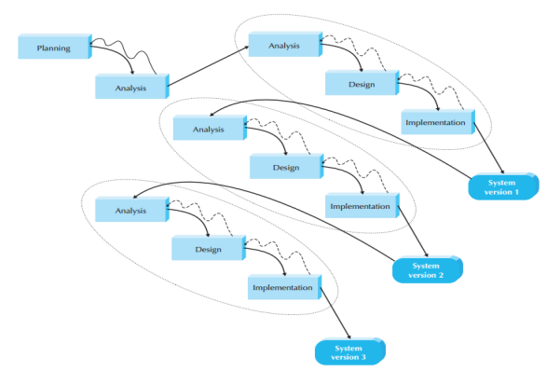

Figure 1: Phased Development Methodology

This figure shows that a phased development methodology way. Basically there are 4 general phases involving in System Development Life Cycle (SDLC) which is planning, analysis, design and implementation. In phased development-based methodology, it breaks an overall system into a series of versions, which are developed sequentially. It takes short time on the planning phase which identifies the project plan, state the objectives and scope and develop the work plan. After that, the analysis phase identifies the overall system concept and then categorizes the requirements into series of versions. The most important and fundamental requirements are bundled into the first version of the system, followed by design and implementation and a system version 1 will be implemented. This system version can let the users test and get their feedback. Additional analysis is required after version 1 and combined with new requirements and issues that given by the users. Version 2 will be designed and implemented based on version 1 and this process will be continuing until the system is complete or no longer use.

The advantage of phased development-based methodology is users can get the useful system in the hand very soon although it is not a complete developed system. After that, users can generate some new ideas based on the system version and improve in the next version till the end of the project.

Based on the project I aim to develop, first I will focus on the school registration into the scheduling system and queue list module as the first system version. Then next is making sure every student’s details about their routine are captured in order to help with filtering the best time to schedule for their classes. After that, admin module will be implemented into the second system version. Lastly, recommend perfect time to schedule for classes, for both the instructors and the students. That will be implemented into the third system version. After this, a system that I wish to develop will fully be implemented and presented. During the process for developing, I will seek advice from my supervisor as well as my friends in order to generate new ideas and get some feedbacks from them to improve on every next system version. By doing this, the mistakes and failures that I made will be reduced.

# CHAPTER THREE

## 3.1 INTRODUCTION

On this chapter, I review on the research methods to be used during the research, the various data collection methods to be applied to this project. Also, I look into the design diagrams that is the context diagram, the level 1 DFD of the project and the use case diagram that will assist in the better understanding of the steps I took to make this project a success. We are also going to review the research ethics that we observed throughout the study of the entire project for example the anonymity, or the confidentiality of the parties involved for the success of the research.

## 3.2 LOCATION OF THE STUDY

My study took place in Nakuru County, near driving institutions. I did my research in this county by interviewing some of the students at various driving institution for example Rocky driving school and AA driving school. The reason I chose to do my research in county is because it was the most accessible place for me since i was a student at one of the stated institutions.

## 3**.3 POPULATION OF THE STUDY**

The major population of my study was principals of different driving schools and driving school levers. I also visited those who did not get a chance to enroll themselves into driving schools and had a talk with them about the struggle they went through while being admitted to the driving school due to the crashing schedules.

## 3.4 SAMPLING PROCEDURE AND SAMPLE SIZE

### 3.4.1 SAMPLING PROCEDURE

In this project, I aim use the convenient/accidental sampling technique. I took the sample from the population of the current students to graduate from the various driving schools in our county and some of my friends. I used this method because some principals and driving school levers were readily available. i however chose them at random.

### 3.4 2 SAMPLING SIZE

My sample size was taken from our county. Out of the sample population of fifty students and ten principals, I performed my experiment on twenty five of the students and four principals. I was selecting them randomly and then writing them down in a book so that I could not do the experiment twice on the same person. I performed it twice on some people just to see whether there could be changes in the first results.

## 3.5 DATA COLLECTION METHODS

I used both:

1. Observations
2. Interviews

### 3.5.1 OBSERVATION

Observation includes going to the location of the study and gathering information by watching. This is very convenient as it saves on resources and time too. This process may however prove disadvantageous as it may come off a bit biased as one cannot be sure if what is observed is the accurate occurrence of such events.

I did observation on what was happening in our country and on my own experience as well. I observed how the current driving school system is hectic in all the above mentioned ways, for example having to use resources and time wasted as one travels to the school location to book the perfect time for classes as per their own schedule or even for tests and examination. I also checked how elder people of our generation taking driving classes and working simultaneously had a difficult time attending classes consistently while this confusion also lead to some of them delaying their time to almost four months instead of the intended seven weeks.

### 3.5.2 INTERVIEWS

Interviews are about imposing questions to the involved groups through a face to face interaction. This ensures right hand information from the stated individuals involved in the study. This involves asking questions to them and while answering, one can not only get the response but also the emotion on their face about the matter.

I interviewed 5 principals from different institutions. They explained to me how they had great challenge in getting people to sign up for driving classes even after spending so much in advertising their institution. I also interviewed driving school leavers on challenges they had faced in their previous institutions. I too was a victim of the same as stated about initially.

## 3.6 RESEARCH ETHICS

1. **Maintaining Expertise**

This was achieved by making sure I conducted myself professionally and respectfully during the various interviews with the respective school principals and the students questioned as well. I used appropriate language and body movement and made sure not to come off impolite at any point.

1. **Boundaries of Competence**

This was achieved through ensuring every interviewed member who wanted their identity not revealed was keep as per the agreed policies, same to the members whom I observed. The details about them were to be kept confidential at every point and assure of their safety even when I was done with my research project. I also made various rules about my conduct during the research and made sure to keep each one of them.

1. **Responsibility**

I conducted this research completely and with due concern for the dignity and welfare of all the participants involved. I ensured to keep the limits to which I was given along the way by the participants and not cross any professional boundaries, or those I was not trained for. All the steps taken were with confidence and for the unsure ones; I did not take at all.

1. **Compliance with Law and Standard**

This research was planned and conducted in a manner consistent with the union and state prevailing stature and the regulations as well as professional standards governing the conduct of research and particularly those that involve research with human beings. No single law was broken throughout the course of this research project.

1. **Research Responsibilities**

At each point of interaction with the various parties involved, I made sure to inform each what my research entailed and what they were getting involved in if they agreed to participate. I made sure that the nature of this research was crucially understood and that I did not mislead or manipulate any party into participation.

1. **Institutional Approval**

This is to acknowledge that I had approval from the necessary institution delegates. This includes approval from the school, and my research supervisor to conduct the activities I did to ensure the success of this research project. There was permission at every step of this research.

1. **Planning Research**

I designed, conducted and reported my research in accordance with the recognized standard of scientific competence. This ensured I minimalized the possibility that the results from this research would be in any way misleading. I ensured to consult with more experienced members who have conducted countless researches before.

1. **Plagiarism**

I can hereby declare and say with confidence that the content of this research is entirely a result of my study in my own words except for the parts stated otherwise for example on referencing.

1. **Honoring Commitment**

On this, I ensured that I took all reasonable measure to honor all commitments made to the involved members in this research. I granted every single need enquired by the participants and did everything necessary to ensure they were comfortable during the whole process.

1. **Minimizing Invasiveness**

During this research, various parties created boundaries to limit me from reviewing a topic uncomfortable to them or out of my jurisdiction. I ensured that all these boundaries were met and none was crossed. The data I collected was only in a manner that is warranted by the appropriate research design I used.

## 3.7 SYSTEM ANALYSIS AND DESIGN

### 3.7.1 CONTEXT DIAGRAM

ADMIN

USER

Update driving schools and students’ schedules

View schedules for school and student

View recommended schedule

Create account, log in and Fill in routine

Figure 2: Context Diagram

### 3.7.2 DATA FLOW DIAGRAM

Figure 3: Data Flow Diagram

USER

RECOMMENDER

ADMIN

1.0

Login

1.0

Recommend schedule

1.0

Schedule class

View details

Request

Request

View details

Request

Accept/Deny

Accept/Deny

Request

User details

Schedule details

Class details

Request

Request

Request

View details

View details

View details

Request

Accept/Deny

### 3.7.3 ENTITY-RELATIONSHIP DIAGRAM

STUDENT

SCHOOL

Recommends

Takes

Class

Subject

Adds

Is assigned to

Teacher

Teaches

Figure 4: E-R Diagram

### 3.7.4 USE-CASE DIAGRAM FOR ADMIN MODULE

ADMIN MODULE

Figure 5: ADMIN Module

### 3.7.5 USE CASE DIAGRAM FOR USER MODULE

User Module

Figure 6: USER Module

### 3.7.6 CLASS DIAGRAM

**School**

-Id: Char

-Name: Char

-Password: Char

+Login()

+Logout()

+AddNewTeachers

+ModifyTeachers()

+AddNewStudentSchedule()

+ModifyStudentSchedule()

+AddNewSubject()

+ModifySubject()

+AddNewClassRoutine()

+ModifyClassRoutine()

**Teachers**

-Id: Char

-Name: Char

-PhNo: Integer

-Address: Char

+MarkAttendance()

+CheckPapers()

+DeclareResults()

**Assessment**

-Id: Char

-Name: Char

-ClassId: Char

+DisplayAssessment()

**Class**

-Id: Char

-Name: Char

+DisplayClass

**Students**

-Id: Char

-Name: Char

-PhNo: Integer

-Address: Char

+GiveRoutine()

+GetRecommeded()

+AttendClass()

Hire

Attends

Enrols

Adds

Adds

+1

+1

+1

+1

+1

0...*

1...*

1...*

+1...*

+0...*

Figure 7: Class Diagram

# CHAPTER 4: SYSTEM DESIGN AND IMPLEMENTATION

## 4.0 INTRODUCTION

This part of the project shows the implementation and deployment. It includes extracts of code and explained screenshots of the entire project. It will help explain the front end and back end of the system.

## 4.1 SYSTEM DESCRIPTION

### 4.1.1 FRONT END DEPLOYMENT

The system run on a web based platform. Being a website scheduling system, I used languages such as HTML 5 referenced from Gunderloy, Jorden BPB Publications (2000) - “Mastering SQL Server” San Francisco, Calif. : Sybex, 2000 to design the general website, JavaScript for responsiveness and CSS to style and decorate my website with the help from Luke Welling and Laura Thomson (5th Edition) - “PHP and MySQL Web Development” Addison-Wesley Professional document.

### 4.1.2 USER INTERFACE DESIGN

I created a simple User Interface panel that is easy to use and navigate.

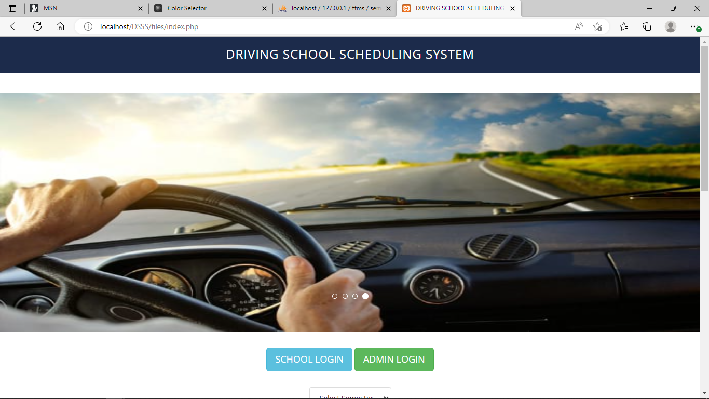

Figure 8: Homepage of the system

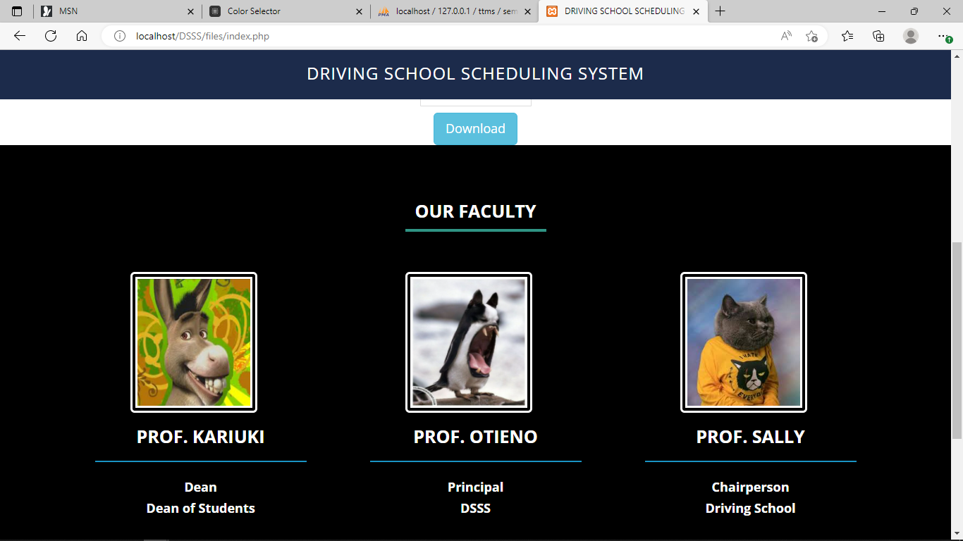

Figure 9: Sample details of the school

### 4.1.3 INTERFACE DESIGN FOR LOGIN

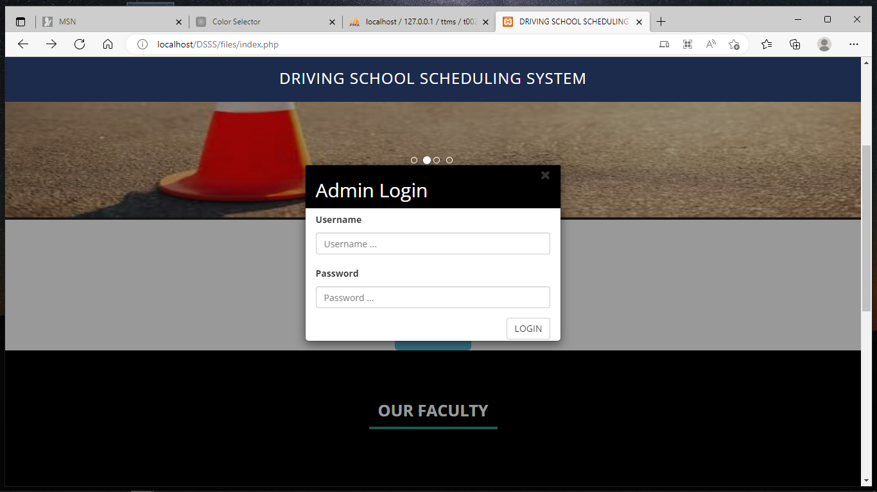

Figure 10: Login page Admin Module

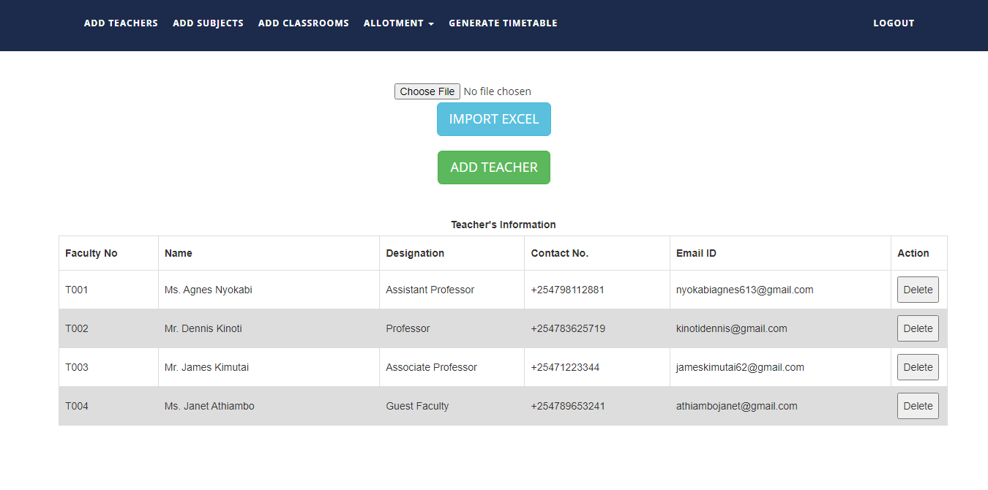

Figure 11: Admin Module

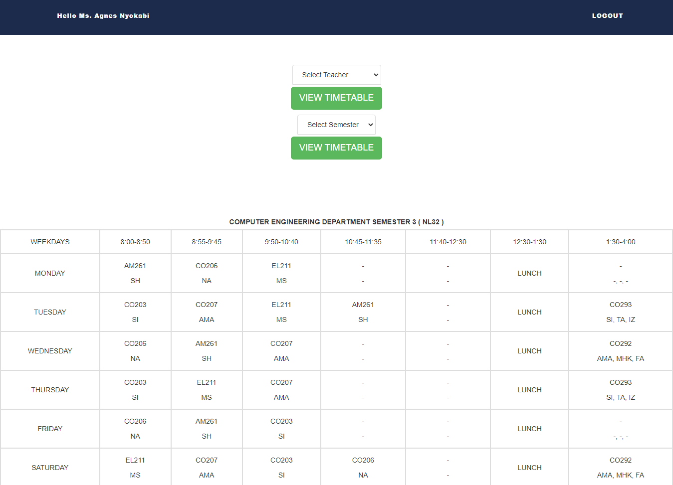

Figure 12: School Module

## 4.2 BACK-END DEVELOPMENT

The backend part of the system consist of a database that is locally hosted using XAMPP services, as well as MySQL language for the access of the data on the database. Using the guide and Luke Welling and Laura Thomson (5th Edition) - “PHP and MySQL Web Development” Addison-Wesley Professional to understand more on HTML, CSS and PHP, the PHP language to establish a connection to the database as it is the primary language used for this kind of connections.

### 4.2.1 DATABASE DESIGN MODELS

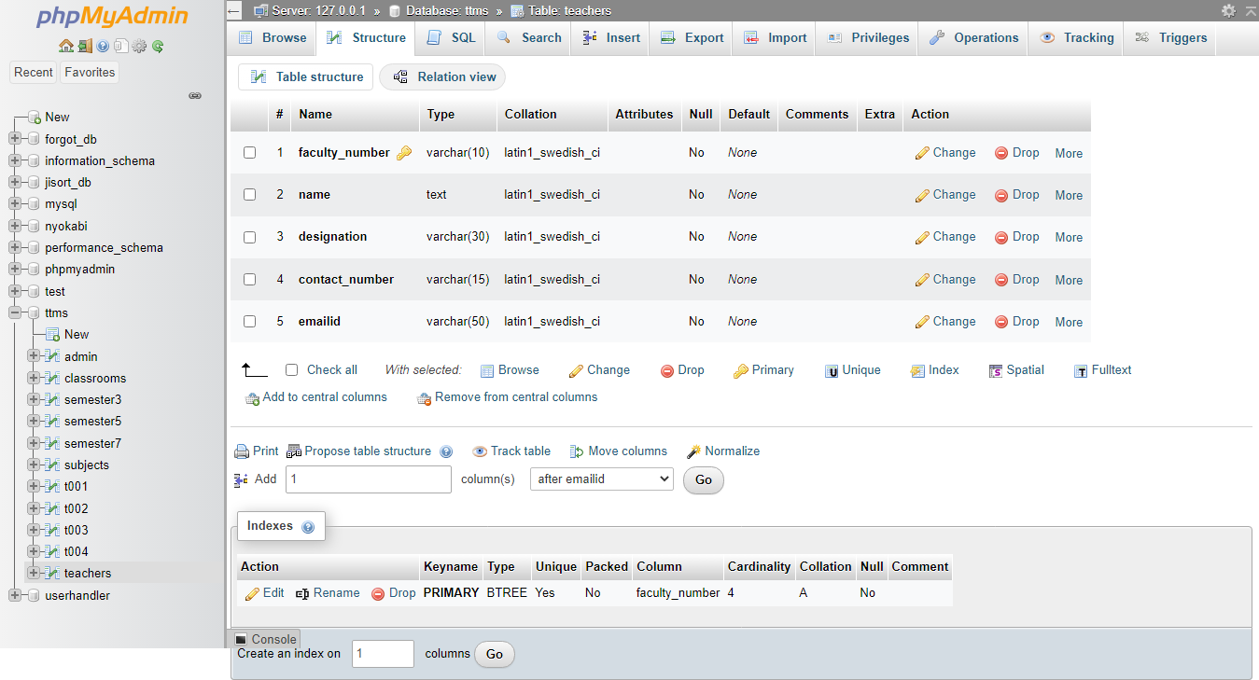

Figure 13: Teachers registration details

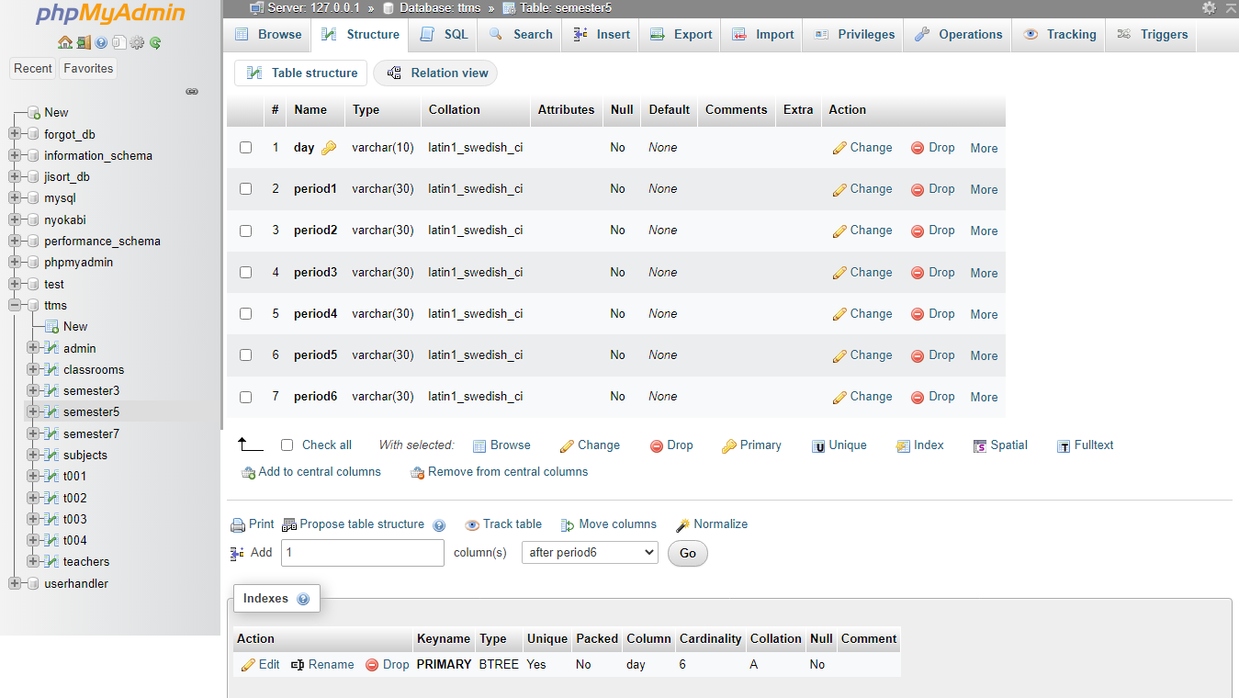

Figure 14: Semester details

### 4.2.2 BACK-END CODES

**PHP code for Home page**

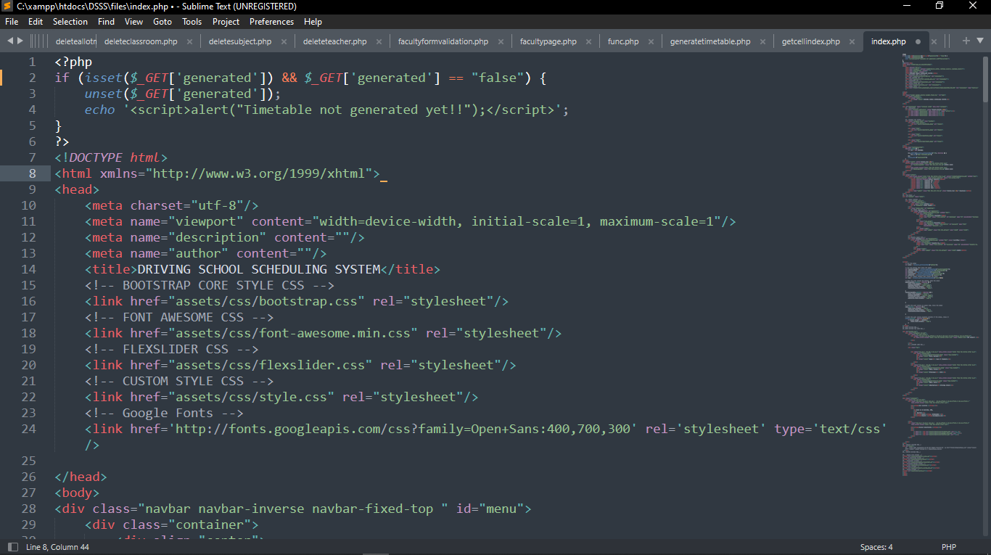

Figure 15: PHP code for Home page

**PHP code to generate scheduled timetable**

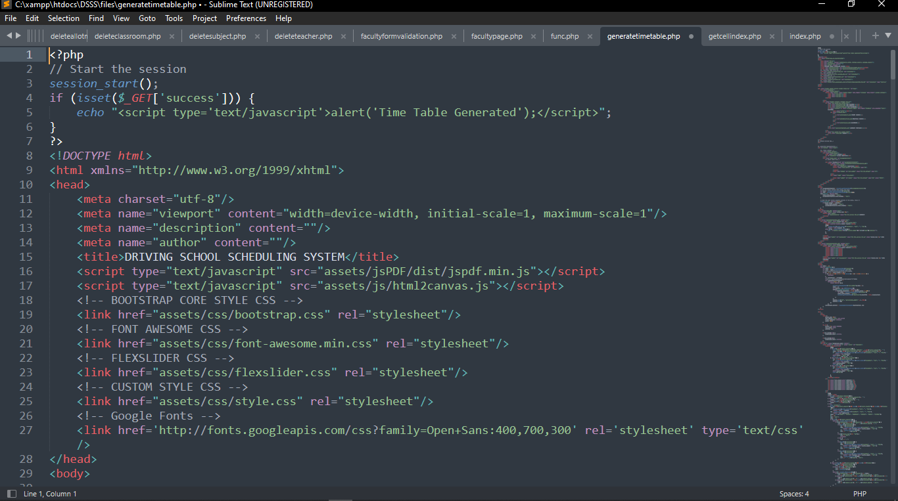

Figure 16: PHP code to Generate timetable

## 4.3 REFERENCES

1. [(PDF) Class Schedule System (researchgate.net)](https://www.researchgate.net/publication/335685036_Class_Schedule_System)
2. [www.tech-lens.net/benefits-of-scheduling-saving-you-time-money](http://www.tech-lens.net/benefits-of-scheduling-saving-you-time-money)
3. [ERIC - ED012703 - UTILIZATION OF TEACHER TIME, A SURVEY., 1965](https://eric.ed.gov/?id=ED012703)
4. Joy McGregor, Senior Lecturer and Course Coordinator of Master of Education (Teacher Librarianship), School of Information Studies, Charles Sturt University, Wagga Wagga, NSW, Australia
5. [Scheduling Software A Cost-Effective, Proven Solution For Small Businesses (ezinearticles.com)](https://ezinearticles.com/?Scheduling-Software-A-Cost-Effective,-Proven-Solution-For-Small-Businesses&id=3877988)
6. [Black Box Testing Techniques with Examples | Test bytes](https://www.testbytes.net/blog/black-box-testing/#:~:text=Black%20box%20testing%20refers%20to%20a%20software%20testing,on%20the%20specifications%20and%20requirements%20of%20the%20software.)
7. Software Engineering (Theoretical Approach) Thereon Willis wrox publications (2000) - “Beginning SQL Server”
8. [8] Gunderloy, Jorden BPB Publications (2000) - “Mastering SQL Server” San Francisco, Calif. : Sybex, 2000
9. [9] Luke Welling and Laura Thomson (5th Edition) - “PHP and MySQL Web Development” Addison-Wesley Professional

## 4.4 PROPOSED TESTING TECHNIQUE

### BLACK BOX TESTING

 Black Box Testing is a software testing method in which the functionalities of software applications are tested without having knowledge of internal code structure, implementation details and internal paths. Black Box Testing mainly focuses on input and output of software applications and it is entirely based on software requirements and specifications. It is also known as Behavioral Testing.

**How Black Box Testing is done**

* Initially, the requirements and specifications of the system are examined.
* Tester determines expected outputs for all those inputs.
* Software tester constructs test cases with the selected inputs.
* The test cases are executed.
* Software tester compares the actual outputs with the expected outputs.
* Defects if any are fixed and re-tested.

## 4.5 CONCLUSION

This project was all about creating an easier process than the current one used to store student information or even recommend them for classes and examinations. The development of this project has and will prove very convenient in terms of saving on resources and time too throughout the entire scheduling process. This is a more modernist way of sorting students and their classes. This will also ensure of less work both for the learning institution and the students themselves. The system presented in this work research also guarantees that if in a case where the student is busy can be assigned class time and examinations time according to their own schedule. This is very much easier as the current system; one would have to miss the driving classes due to being busy or occupied by another activity.

#### 4.6 RECOMMENDATION

This system was specifically aimed and dedicated to the driving schools, Kenya. This system would so much improve the current situation as it is very hectic. In this, every student who is to be assigned to a certain schedule comfortable to them would get the information before hand to avoid confusion and miscommunication. Every institution too, would have an account where they feed their school details for example the location, the motto and all that. This will ensure efficiency and will prove very helpful and important.

In future, I aim to widely spread the information about this website as it can be very useful to so many people. I also would love to improve the system via adding any other new technology to it for example using ones fingerprint as the password which would save on login time as finger prints and facial recognition are very unique identification than use of a password. This will ensure confidentiality as only the owner of the account will be able to access it. Anyone else would need permission from the owner too.

## 4.7 APPENDICES

APPENDIX 1: INTERVIEW QUESTIONS

To School:

1. Which type of system is currently used in this institution?
2. Is it time saving or time consuming?
3. Does one get accurate and detailed information about the students’ schedules?
4. Is all the information needed provided on one platform?
5. Is the system resource-saving or resource consuming?
6. Is the information provided by the school updated?
7. Do you think a more automated system would prove more convenient?

To Student:

1. What system/ strategy did you use to get placed for classes to the institution you were/ are in?
2. Was it hectic to get assigned to classes, assessments and examinations?
3. Would you say that the manual system is tiring and time consuming?
4. Do you thing the manual system is resource-saving or resource consuming?
5. Was the information provided by the variety as accurate as you would have thought it to be?
6. What would be your opinion on an automated upgraded system for placement?

APPENDIX 2: BUDGET ESTIMATE

|  |  |
| --- | --- |
| **ITEM** | **AMOUNT IN Kenya Shillings** |
| Computer | 28,000 |
| Software (OS):Windows 10 | 5,000 |
| Storage Device | 5,000 |
| Data collection process | 2,000 |
| Other expenses | 1,700 |
| **TOTAL** | **41,700** |

Table 1: Budget Estimate

APPENDIX 3: GANTT CHART

|  |  |  |  |  |  |
| --- | --- | --- | --- | --- | --- |
| Serial No. | Activity | MAY | JUNE | JULY | AUGUST |
| 1. | Software Requirement |  |  |  |  |
| 2. | Logical Design |  |  |  |  |
| 3. | Physical Design |  |  |  |  |
| 4. | Coding |  |  |  |  |
| 5. | Testing |  |  |  |  |
| 6. | Documentation And Presentation |  |  |  |  |

Table 2: Gantt chart