**Python**

**Data Structures and Algorithm challenges**

**1.1**

Let x represent the number of orders received during a certain day. Create a program that prints "A busy day" if x is greater than 100 and "A calm day" otherwise.

Start by assigning a value to x.

**Hint:**

**Time complexity: O(1)**

**Auxiliary space: O(1)**

**2.1**

A Tetrahedron is simply a pyramid with a triangular base. It is a solid object with four triangular faces, three on the sides or lateral faces, one on the bottom or the base and four vertices or corners. If the faces are all congruent equilateral triangles, then the tetrahedron is called **regular**. The volume of the regular tetrahedron can be found by using the following formula:

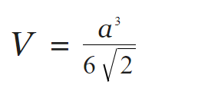

where ‘a’ is the length of one of it’s sides.

Develop a function to calculate the volume of a regular tetrahedron, with the variable 'a' set to a value of your preference.

**Hint:**

**Time complexity: O(1)**

**Auxiliary space: O(1)**

**3.1**

Create a function **Salary calculator** which will calculate **monthly** payment to be made to every individual.

The function will take in the dictionary as a parameter.

On a typical day one is expected to work for 8 hours at a rate of $75/hour; hours beyond 8hrs/per day are considered overtime which are calculated as 1.5times that of normal rate.

The function will compute the total pay and will return each individual's name and amount to be paid.

Finally, test the function with the following: -

Information of individuals with their weekly worked hours: Week 1, Week 2, Week 3 & Week 4.

employees = {"Benson" : [42, 38, 47, 44],

"Joan" : [41, 33, 49, 25],

"Stephany" : [45, 41,40, 38]}

The output for the above values should be:

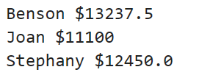

**Hint:**

**Time complexity: O(nlogn)**

**Auxiliary space: O(n)**