Tech Sisters
Data Edition
Hints for the Python Code Challenges
May 4, 2024

Received Orders
In this context, there is only one condition that should be met otherwise something else happens.
A chart of how the conditional statements flows.
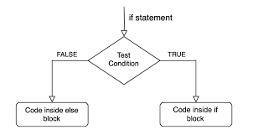

Show the pseudocode
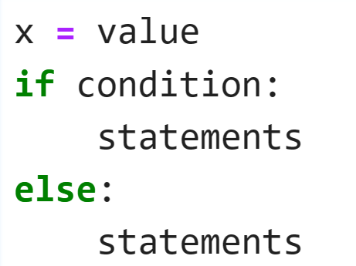
Notice the indentation
Replace the value, condition, statements with their respective syntax

Tetrahedron
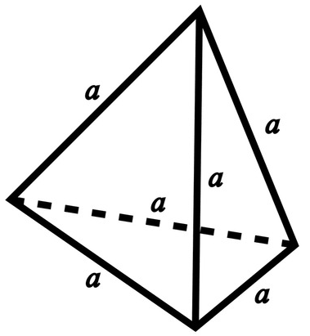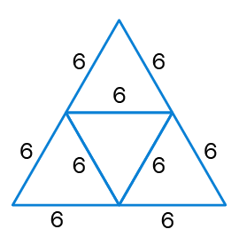
Import necessary modules: e.g math/ sqrt from math
Write a code snippet that will calculate the volume.
Then embed it in a function
Remember to round off your answer

Salary Calculator
In this exercise notice our data structure is a dictionary.
- dictionary.keys() - dictionary.values()
We have several persons, meaning iteration is most likely to happen.
Still total monthly hours are needed for each person.
To get overtime we consider anything more than160hrs/month.
Overtime have different rate so there must be a conditional statement for the normal hours and overtime hours.

Show the pseudocode
