Data Edition
Tech-sisters
Python for Data Science

Python is an open source language which is very powerful but very easy to learn.
It’s elegant syntax and dynamic typing together with its interpreted nature makes it an ideal language to use.
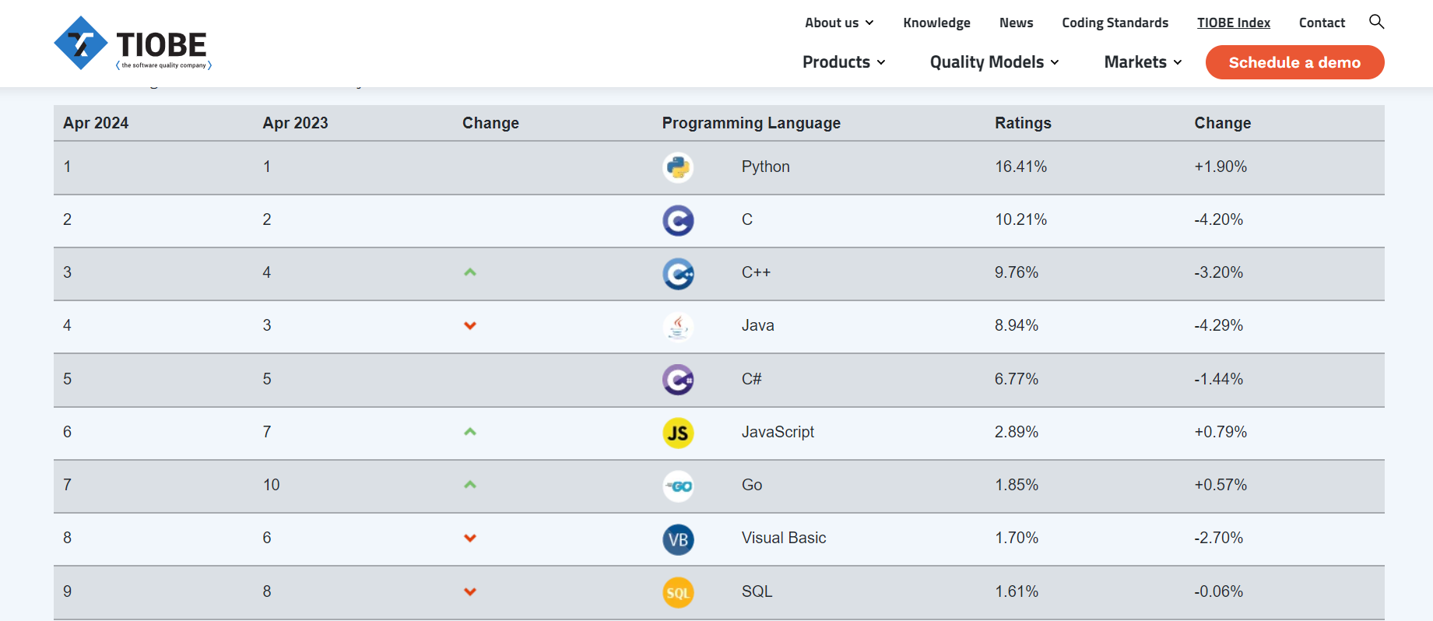
https://www.tiobe.com/tiobe-index/

PYPL
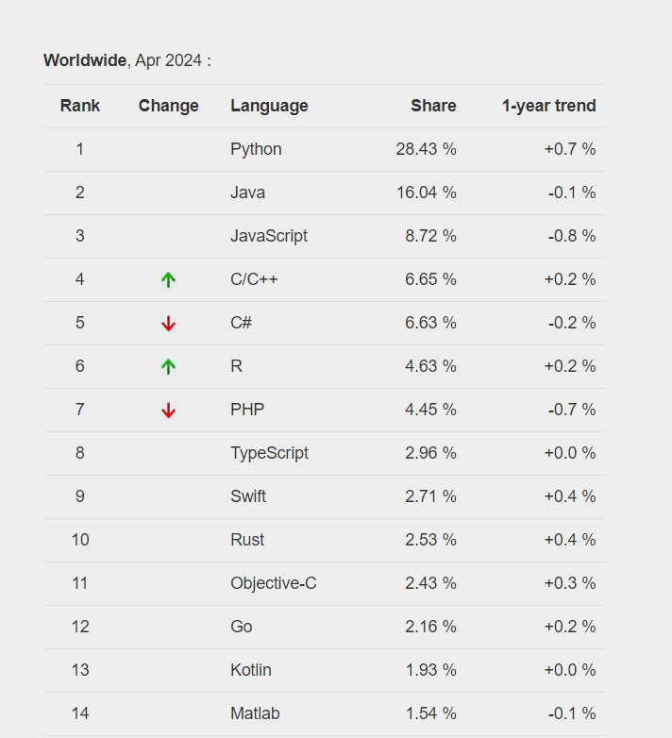
https://pypl.github.io/PYPL.html

Python Download:
https://www.python.org/downloads/

Anaconda Distribution:
https://www.anaconda.com/download/success

1.0 Integrated Development Environment (IDE)
It is a software application that helps developers to program a software code efficiently.
They are effectively used as:
- Code editor
- Debugger
- Translator
1.11 Jupyter notebook
- Pip install jupyter notebook

1.12 Visual Studio Code
https://code.visualstudio.com/
Then install jupyter notebook extension
Other include:
- Spider
- Sublime
- Pycharm
e.t.c

Overview:
- Comments
- Data types
- Operators
- Reassign variables
- Line continuation
- Indexing
- Indentation

Expressions, Operators and Procedures
Essentially expressions are combinations of values / variables / functions or other expressions
Example:
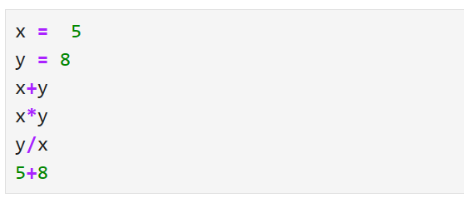

Operators are symbols or keywords that perform operations
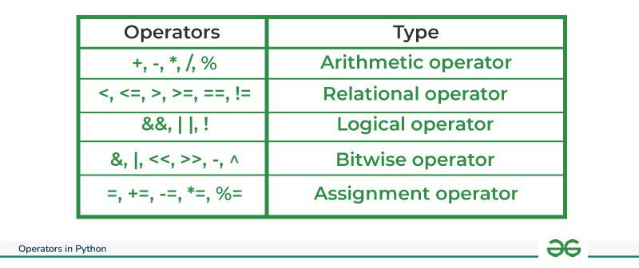 from: geekforgeeeks

Procedure/s is a set of instruction with defined steps to perform a specific task.

I/O functions
Output_function(variable)
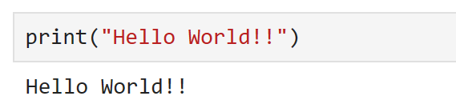

Input_function(instructions, input_area)
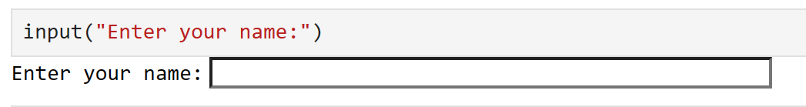

Import modules
A file containing a python code that can be reused severally through importing
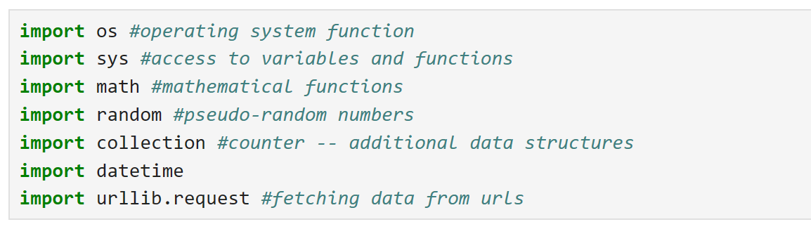
Import Libraries
Collection of multiple modules
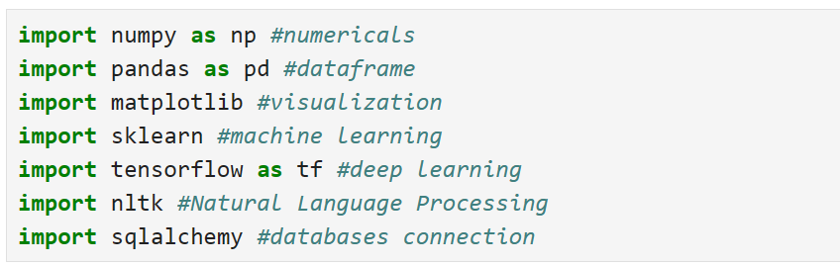
Both modules and libraries are ways for organizing and packaging code for reusability

DATA STRUCTURES AND ALGORITMS
Data structures and algorithms are basic principles that are used to solve simple and complex programming problems.
Software development/engineering: industries use these skills to optimize their systems, enhance code performance and also manage large scale data effectively.
Proficiency in data structures helps in efficient storage and organization of data while algorithms ensure the solutions are optimized.
Application of these concepts is witnessed in Machine Learning, AI, Data analytics.
Data Structures
Data structures is the format of storing data on a computer, making it easier to access, retrieve or modify.
Importance of Data structures
Data organization: they organize data in a logical manner.
Data Abstraction: allows programmers to focus on the logical aspects of data manipulation.
Reusability: Common data structures can be reused in multiple applications.
Efficient Data Management: Data structures enable efficient storage and retrieval of data, reduce processing and improving performance.
Algorthm optimization: The choice of appropriate data structure can significantly impact the efficiency of algorithms that operate on the data.

Application of Data structures
- Solving shortest problems.
- Search through large data sets easily.
- Implementation of dynamic memory allocation.

Types of Data Structures
- List
- Tuples
- Dictionaries
- Set
- Stacks
- Queues
- Linked lists

Algorithm
Termed as a set of rules that simply form a procedure or formula to solve a problem
Some problems are famous enough to have a name.
Some algorithms are famous enough that they have a name.

