**PREPARED BY:**

Benson Nyota

**Vertex Mobile Net. Telecom Analytics**

**07/08/2024**

**.......**

**TABLE OF CONTENTS**

* Introduction.
* Data Preparation.
* Dashboard design and Features.
* Key Insights.
* Recommendations.
* Conclusions.

**Introduction**

This project focuses on churn analysis for Vertex Mobile Net, a telecommunications company that provides a range of services to individuals and organizations. These services include:

- Telephone Services

- Internet Services

- Data Services

- Television Broadcasting

- Wireless Communication

- Cloud Services and Networking

To maintain and boost revenue, it is crucial to develop and implement new customer retention strategies. Using the data provided by Vertex Mobile Net, we aim to extract insights that can inform these strategies.

**Data Preparation**

**Handling Missing Values:** It is essential to impute missing values in the data to ensure viable and reliable insights. For instances where the reason for churning was missing, we filled these gaps with "N/A," indicating "Not Applicable."

**Grouping Data:** To derive meaningful information, we grouped the age data.

**Data Transformation:** Certain data had to be transformed to their correct data types to ensure accuracy.

**Dashboard Insights and Features**

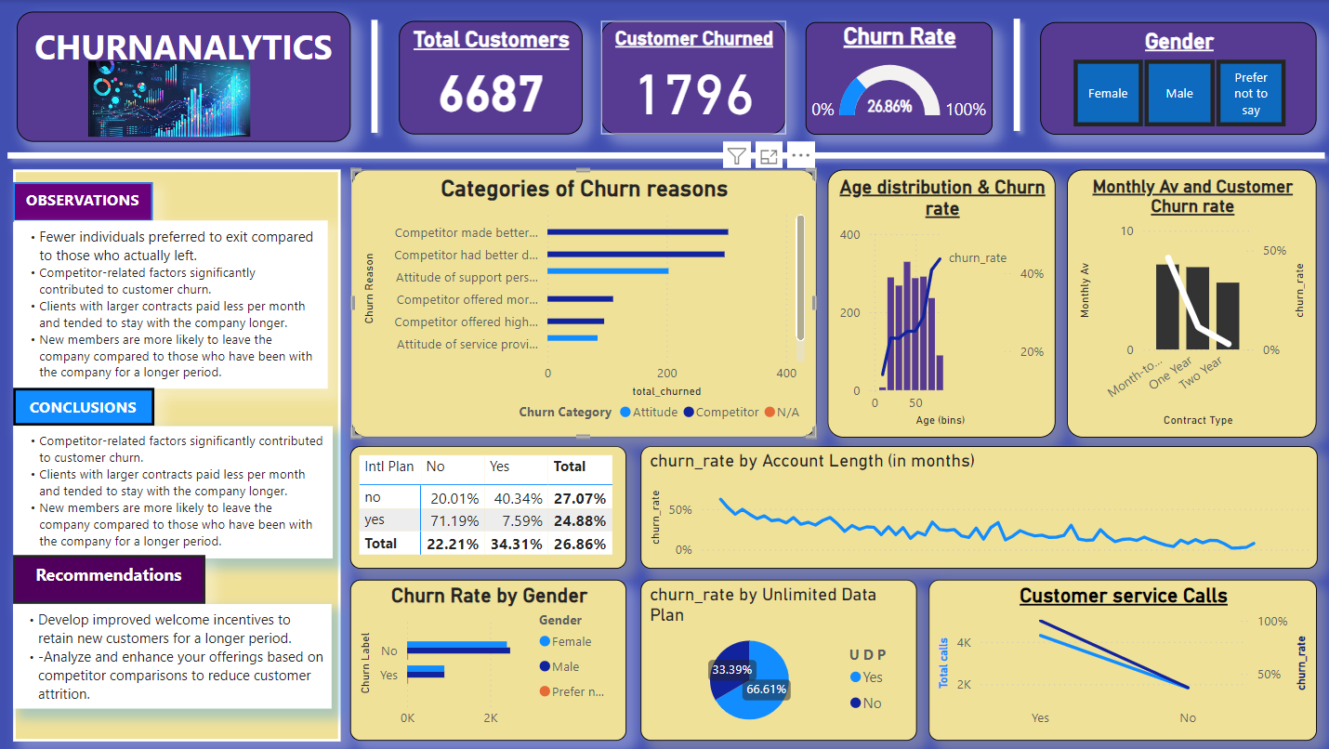

The dashboard effectively displays the dataset size, which includes a total of 6,687 customers analyzed. It also clarifies that **1,796** customers, approximately 27% of the total population, have discontinued using the company's services. Additionally, the dashboard highlights the trend of the churn rate and the duration for which individuals maintained their accounts.

**Key Insights**

* Fewer individuals preferred to exit compared to those who actually left.
* Competitor-related factors significantly contributed to customer churn.
* Clients with larger contracts paid less per month and tended to stay with the company longer.
* New members are more likely to leave the company compared to those who have been with the company for a longer period.

**Recommendations**

* Develop improved welcome incentives to retain new customers for a longer period.
* Analyze and enhance your offerings based on competitor comparisons to reduce customer attrition.

**Conclusions**

* Competitor-related factors significantly contributed to customer churn.
* Clients with larger contracts paid less per month and tended to stay with the company longer.
* New members are more likely to leave the company compared to those who have been with the company for a longer period.