Sustainability Assessment and Action Plan

For [Company Name]

April 2025

Prepared by Elia Go

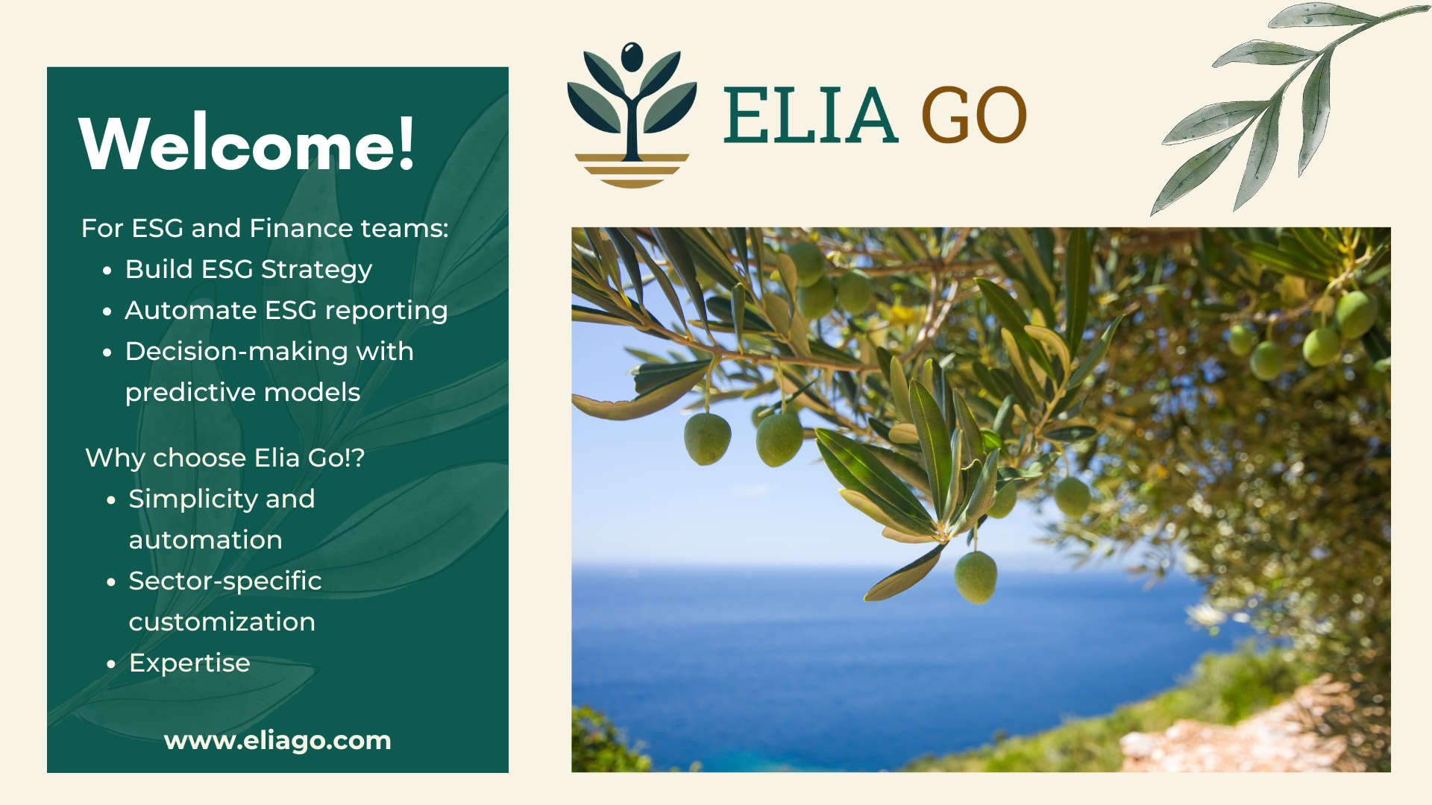

Executive Summary

Sustainability in the Mediterranean, why?

Why does this assessment matter?

Our Approach: the Elia Go Methodology

1. ESG Assessment Based on ISO 26000

2. Carbon Footprint Snapshot

3. Risk & Opportunity Matrix

3.1. Risks

3.2. Key Opportunities

4. Sustainability Action Plan

Objective:

Key Actions:

Why This Works / Expected Benefits:

Practical Action Roadmap

5. Financial Impact Projection

# Executive Summary

[Company Name]’s strengths in personalized service and local expertise position it to lead Crete’s car rental sector in sustainability. **By addressing key ESG gaps and leveraging emerging trends, [Company Name] can differentiate itself, attract premium clients, and future-proof its operations.**

# 

# Sustainability in the Mediterranean, why?

The Mediterranean faces urgent environmental challenges—rising temperatures, coastal erosion, and resource scarcity—that threaten its ecosystems and economies.

For businesses like [Company Name], sustainability is no longer optional; it’s a strategic imperative to future-proof operations, and appeal to a growing base of eco-conscious travelers. **By embracing sustainability, Mediterranean companies can turn environmental responsibility into a competitive edge, balancing ecological preservation with long-term profitability.**

## Why does this assessment matter?

This ESG evaluation, rooted in ISO 26000 and the GHG Protocol, is designed to help:

1. Stand Out in a Crowded Market
2. Future-Proof Against Regulations
3. Unlock New Revenue Streams
4. Reduce Costs
5. Leverage Existing Strengths

Let’s turn sustainability into a strong selling point. 🌿

# Our Approach: the Elia Go Methodology

Elia Go’s methodology is designed for Mediterranean SMEs.

1. **ISO 26000 alignment**:

ISO 26000 is an international standard providing guidelines for organizations to integrate social responsibility into their operations through seven core principles to foster sustainable development and stakeholder trust.

We assess 7 pillars of sustainability (environment, labor practices, community, etc.)

1. **Carbon Footprint Snapshot**:

Carbon evaluation measures an organization’s greenhouse gas (GHG) emissions to identify environmental impacts and inform sustainability strategies. The GHG Protocol is the global standard for this process, providing a structured framework to calculate emissions across three categories (scopes).

1. **Opportunity Mapping from ESG expertise**:

Prioritize actions that boost revenue, cut costs, or enhance reputation.

# 1. ESG Assessment Based on ISO 26000

**Introduction**

This ESG assessment provides [Company Name] with a comprehensive review of its current sustainability practices and identifies areas for improvement, using the ISO 26000 framework as a reference for responsible business conduct.

**ISO 26000 Core Subjects & Assessment**

|  |  |
| --- | --- |
| Pillar | Assessment & Opportunities |
| Organizational Governance | Family-owned business with informal governance; opportunity to formalize sustainability oversight and reporting. |
| Human Rights | Stable, local team; opportunity to reinforce fair employment, diversity, and respect for human rights. |
| Labor Practices | Strong team loyalty; opportunity to enhance staff training on sustainability and eco-driving. |
| Environment | No hybrid/electric vehicles; mechanical expertise extends vehicle life; opportunity to improve waste management and reduce emissions. |
| Fair Operating Practices | Strong local partnerships; potential to formalize anti-corruption and ethical business policies. |
| Consumer Issues | High customer loyalty via personalized service; opportunity to communicate sustainability efforts more clearly to clients. |
| Community Involvement & Development | Active local engagement; potential to expand community-based sustainability initiatives. |

# 

# 2. Carbon Footprint Snapshot

*Based on 80-car fleet (gasoline/diesel) and seasonal operations:*

|  |  |  |  |
| --- | --- | --- | --- |
| **Scope** | **Source** | **Annual Emissions** | **Reduction Opportunities** |
| **1** | **Fleet fuel combustion** | **~125 tons CO₂e** | **Eco-driving programs, hybrid adoption** |
| **2** | **Office electricity** | **~6.7 tons CO₂e** | **Solar panels** |
| **3** | **Partner hotels/airbnbs** | **Not measured** | **Collaborative offset programs** |
|  | ***Total*** | ***~132 tons CO₂e*** |  |

Equivalence

* Flights from London to New York (5,500 km):
  + Economy-class passenger emits 1 tonne CO₂.
  + [Company Name]’s emissions ≈ 132 passengers flying round-trip.
* Greek Household consumption:
  + Emits ~5 tonnes CO₂/year (lower heating demand).
  + [Company Name]’s emissions ≈ 26 Greek households.

# 3. Risk & Opportunity Matrix

## 3.1. Risks

|  |  |
| --- | --- |
| **Risk** | **Mitigation Strategy** |
| **Margin pressure from competition** | **Premium pricing for "Green Crete Explorer" fleet** |
| **Rising maintenance costs** | **Predictive maintenance via telematics** |
| **Regulatory shifts (EU CSRD)** | **Proactive carbon reporting** |

## 

## 3.2. Key Opportunities

*Turn sustainability into your competitive edge*

|  |  |  |  |
| --- | --- | --- | --- |
| Opportunity | Action | Expected Outcome | Cost/Effort |
| **Eco-Driving Program** | Provide clients with simple fuel-saving tips via QR code in cars | 8-12% fuel cost reduction | Low |
| **Green Fleet Branding** | Label 5 newest/low-emission cars as "Eco Explorers" (+10% premium) | Attract eco-conscious tourists | Medium |
| **Hotel Partnerships** | Offer 15% discount to guests of 3 eco-hotels | New client referrals | Low |
| **Digital Check-In** | Implement digital contracts & check-in | Save paper and time | Medium |
| **Local Storytelling** | Create "Meet Our Team" blog series highlighting expertise | Build trust & human connection | Low |

# 4. Sustainability Action Plan

## Objective:

Enable [Company Name] to meet the sustainability expectations of large companies and industry associations, and to stand out in the market, through ESG improvements and carbon footprint evaluation.

## Key Actions:

* **Conduct a detailed carbon footprint assessment** (Scope 1 and 2: vehicle fleet and operations) to be ready for requests from major clients or the car rental association.
* **Introduce eco-driving training** for staff and clients to reduce fuel consumption and emissions.
* **Develop a green fleet transition plan**: prioritize new acquisitions based on age, CO₂ emissions, and maintenance cost; consider piloting a few hybrid models as a test.
* **Enhance waste management and recycling** at operational sites (e.g., tires, oil, cleaning products).
* **Communicate sustainability efforts**: create a dedicated ESG page on the website, publish articles, and provide clients with a flyer/card on eco-driving and your sustainable approach.
* **Engage with local community and industry associations** to strengthen your sustainability network and visibility.
* **Monitor and report ESG and carbon performance** regularly to stakeholders, clients, and partners.

## Why This Works / Expected Benefits:

* **Cost-Effective**: 80% of actions require <€1,000 investment
* **Aligns with Strengths**: Leverages your loyal team and existing hotel partnerships
* **Market Differentiation**: Positions you as Crete’s "green local choice" vs big franchises
* Improved eligibility for contracts with large companies requiring ESG compliance
* Increased loyalty from eco-conscious clients

## Practical Action Roadmap

*12-Month Implementation Plan*

|  |
| --- |
| Phase 1: Quick Wins (0-3 Months)  ✅ Eco-driving **Tutorials** QR codes  ✅ **Green Storytelling :** Add "Sustainability" webpage  ✅ Partner with 1 eco-hotel  Phase 2: Brand Building (3-12 Months)  🟩 Train staff on sustainability  🟩 Design "Eco Explorer" package  🟩 Start carbon footprint tracking  Phase 3: Growth (12-24 Months)  🔲 Install solar PV at office  🔲 Paperless contracts → Reduce annual costs by €1,800  🔲 Add 2 hybrid vehicles to test and learn about the constraints  🔲 **Carbon Neutral Partnerships (**Offer Carbon offsets, Collaborate with Recycling projects for tire/oil recycling) |

# 5. Financial Impact Projection

|  |  |  |  |
| --- | --- | --- | --- |
| **Action** | **Cost** | **Annual Benefit** | **ROI Timeline** |
| **Eco-driving program** | **€500** | **€2,800 fuel savings** | **1 month** |
| **ESG communication** | **€500** | **5000€ (20 new clients)** | **2 months** |

Next Steps

1. Draft Eco-driving tutorial template
2. Begin an ESG Diagnosis and carbon footprint assessment (Elia Go support included)

*Attached*:

* ISO 26000 compliance checklist
* Eco-driving tutorial template

This plan balances [Company Name] with market demands, turning sustainability into a competitive edge while respecting operational realities. Let’s discuss implementation!



**Prepared by:**

Alex Gon, Founder @ Elia Go

[alex.gon@eliago.com](mailto:alex.gon@eliago.com)

+33 (0)7 57 91 70 64

