MACHINE LEARNING PROJECT REPORT
Early Prediction of Player Churn in Mobile Games
Gameplay event aggregation, comparative modeling, and explainable AI
CSE437 | BRAC University | August 2026

Research question: Can early level-attempt behavior identify players who will become inactive in the following week?

1. Project Goal
This project develops an early-warning machine-learning system for mobile-game player churn. The goal is to predict whether a player will become inactive in the following week using only behavior observed during the initial gameplay window, compare several classification approaches, and explain the behavioral patterns behind the strongest model so that retention teams can identify where supportive interventions may be useful.

2. Method

2.1 Dataset and prediction target
The public Prediction of User Loss in Mobile Games dataset contains anonymized player labels, level-attempt logs, and level metadata. A label of 1 indicates that the player did not log in during the following week; label 0 indicates retention. The source files use tab delimiters despite their .csv extension. The official train, development, and test memberships were preserved.
Source | Role | Records
train.csv | Model development labels | 8,158 players
dev.csv | Untouched final evaluation labels | 2,658 players
test.csv | Unlabeled final predictions | 2,773 players
level_seq.csv | Timestamped gameplay attempts | 2,194,351 events
level_meta.csv | Level difficulty and duration metadata | 1,509 levels

Dataset source: Kaggle, manchvictor/prediction-of-user-loss-in-mobile-games.

2.2 Data cleaning and integration
The pipeline parsed the five tab-separated sources with explicit date-time conversion, checked player identifiers for uniqueness within each official split, joined level metadata to every attempt using level_id, sorted attempts by player and time, and rejected any split member without gameplay events. Generated infinite values were converted to missing values and handled by median imputation inside each model pipeline. This fold-local preprocessing prevents validation information from leaking into training.

2.3 Player-level feature engineering
The 2.19 million event rows were aggregated into 41 numeric predictors per player. The feature groups cover activity volume (attempts, unique levels, sessions, active days), progression (maximum and mean level), performance (success, failure, retry, help use, remaining steps), duration, temporal behavior (weekend/night activity, observation span, recency), level difficulty, and recent-form changes computed over the last 25 attempts. user_id was retained only for joins and never entered a model.

2.4 Class balance and evaluation criteria
Churned players form 33.5% of the training set, placing the project in Group 2: mild imbalance (minority class between 5% and 40%). In accordance with the project guidance, model comparison emphasizes AUROC, precision, and recall; F1-score is also reported for direct comparison. AUPRC is retained as an additional minority-class summary. Accuracy is shown but is not used as the primary selection criterion.
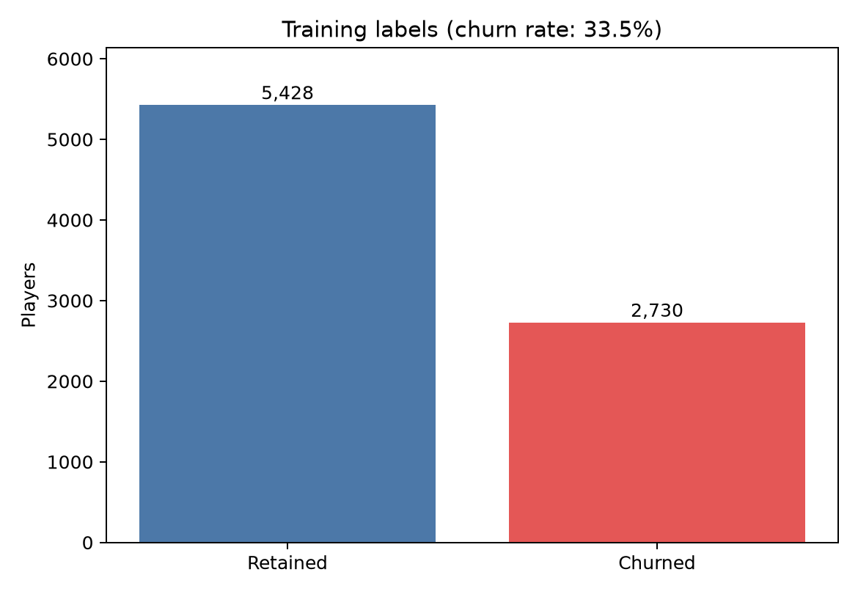
Figure 1. Training-set class distribution; the minority churn class represents 33.5% of players.

2.5 Research workflow
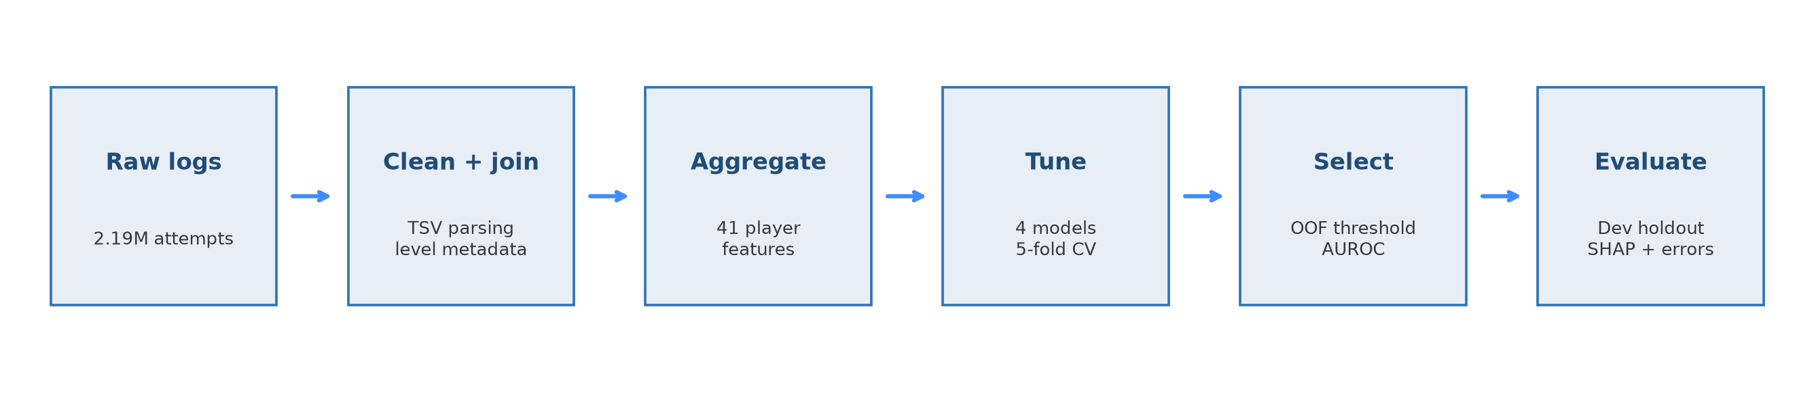
Figure 2. End-to-end research workflow with the development split isolated from all selection decisions.

2.6 Model training and selection
Four model families were compared: Logistic Regression, Random Forest, Histogram Gradient Boosting, and XGBoost. Each family received 15 randomized hyperparameter configurations evaluated through five-fold stratified cross-validation on the training split. The configuration with the highest mean cross-validated AUROC defined the winner. The Random Forest used 770 trees, maximum depth 8, square-root feature sampling, and minimum leaf size 4.

2.7 Threshold selection, uncertainty, and explanation
Cross-validated out-of-fold probabilities from the selected training model were used to choose a decision threshold that maximized churn F1, with recall used to break ties. The selected threshold was 0.320. Only after fixing the model and threshold was the official development set evaluated once. Uncertainty was estimated using 1,000 bootstrap resamples. SHAP values summarized global feature influence and an individual prediction, while false-positive and false-negative groups supported error analysis.
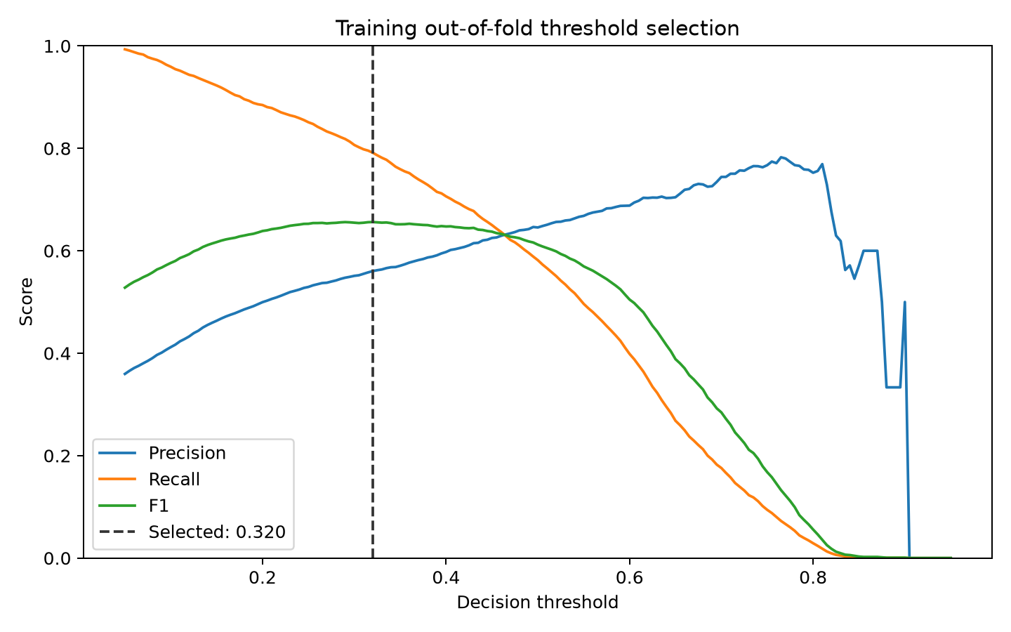
Figure 3. Training out-of-fold threshold selection; no development labels were used.

3. Results

3.1 Comparative model performance
Model | CV AUROC | Dev AUROC | Precision | Recall | F1 | AUPRC
Random Forest | 0.8067 | 0.8024 | 0.5789 | 0.7814 | 0.6651 | 0.6359
Xgboost | 0.8059 | 0.8021 | 0.6427 | 0.5649 | 0.6013 | 0.6385
Logistic Regression | 0.8051 | 0.8053 | 0.6053 | 0.7336 | 0.6633 | 0.6541
Hist Gradient Boosting | 0.7980 | 0.7959 | 0.5955 | 0.7303 | 0.6560 | 0.6301

Table 2. Training-CV selection evidence and final development-set metrics for all four model families.
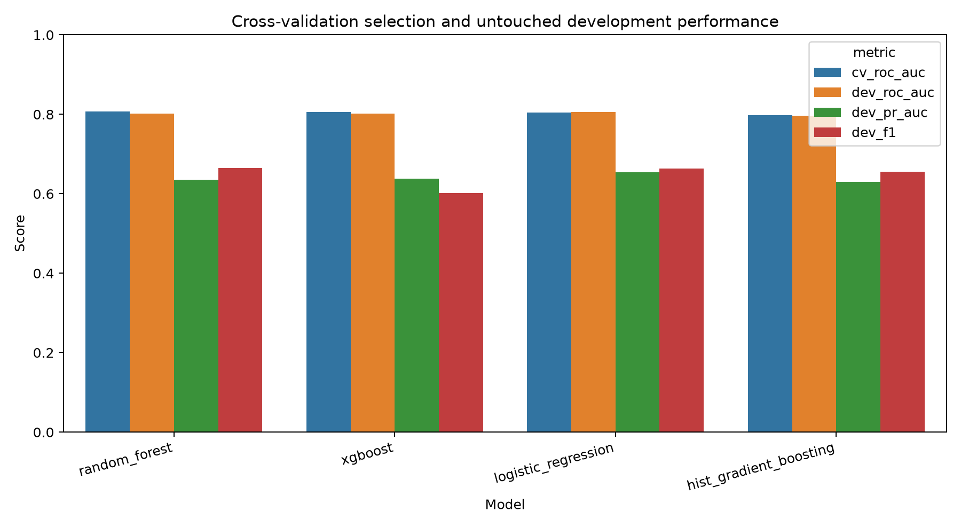
Figure 4. Comparative performance across model families.

3.2 Final Random Forest evaluation
Metric | Development result | Bootstrap 95% CI
AUROC | 0.8024 | 0.7860-0.8196
AUPRC | 0.6359 | 0.6022-0.6693
Precision | 0.5789 | 0.5523-0.6056
Recall | 0.7814 | 0.7536-0.8066
F1-score | 0.6651 | 0.6422-0.6868
Accuracy | 0.7333 | 0.7163-0.7498

Table 3. Final holdout performance using the training-only threshold of 0.320.
The model identified 704 of 901 churned development players, producing recall of 0.7814. Its precision of 0.5789 reflects 512 retained users flagged as at risk. The AUROC confidence interval (0.7860-0.8196) and similar training-CV performance indicate limited split-specific degradation, although external validation is still needed.
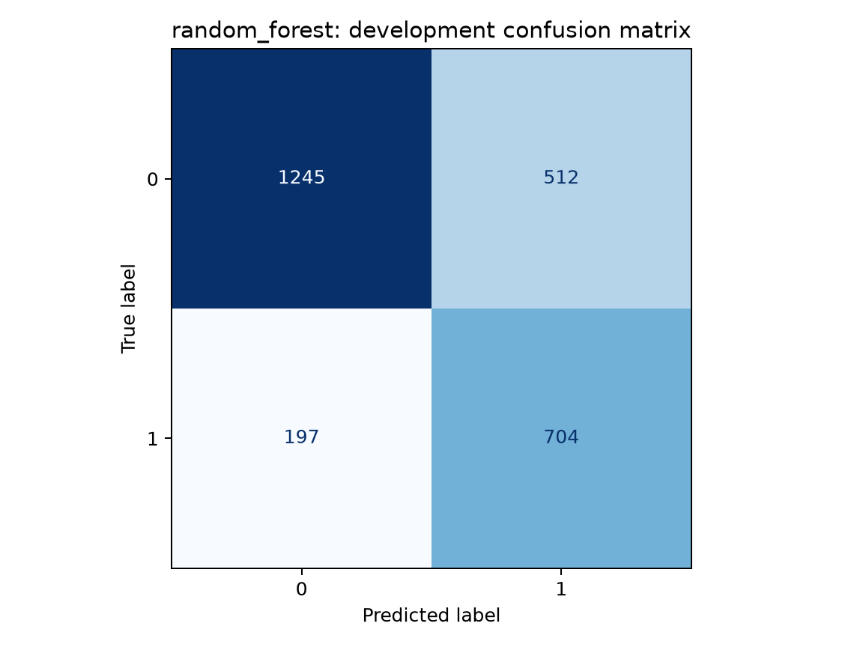
Figure 5. Development-set confusion matrix at the 0.320 decision threshold.
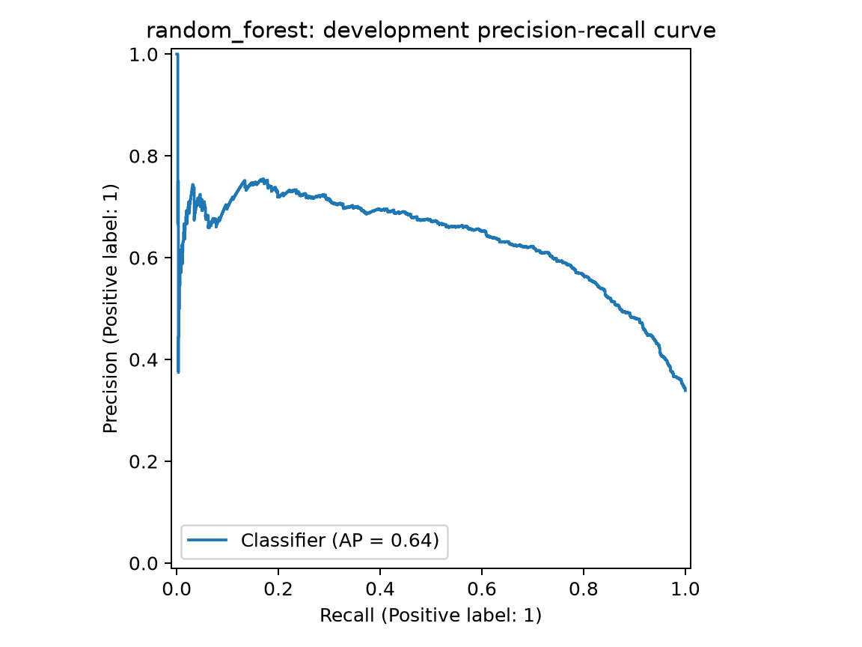
Figure 6. Precision-recall curve on the untouched development set.
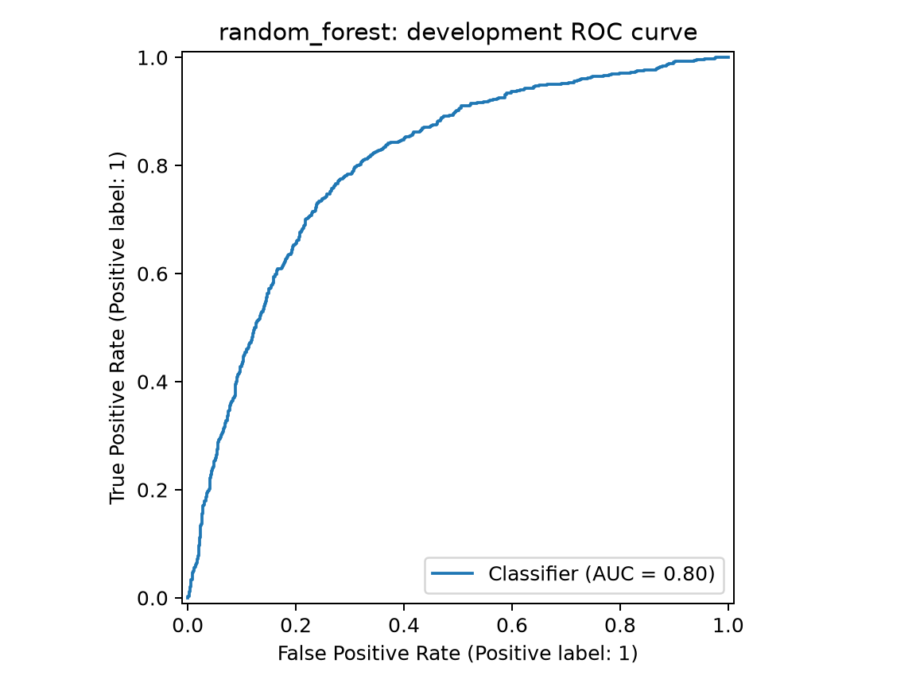
Figure 7. ROC curve on the untouched development set.

3.3 Explainability and behavioral findings
SHAP analysis ranked inactivity recency as the strongest model signal, followed by weekend concentration, observation span, active days, total duration, and session count. These results describe associations within this fitted model; they do not prove that changing any one behavior will cause retention.
Predictor | Mean absolute SHAP
Hours Since Last Activity | 0.0514
Weekend Attempt Rate | 0.0331
Observation Span Hours | 0.0315
Active Days | 0.0188
Total Duration | 0.0138
Session Count | 0.0118
Last25 Mean Level | 0.0117
Reststep Std | 0.0102
Mean Level Retrytimes | 0.0094
Mean Level | 0.0092

Table 4. Ten most influential features in the selected Random Forest.
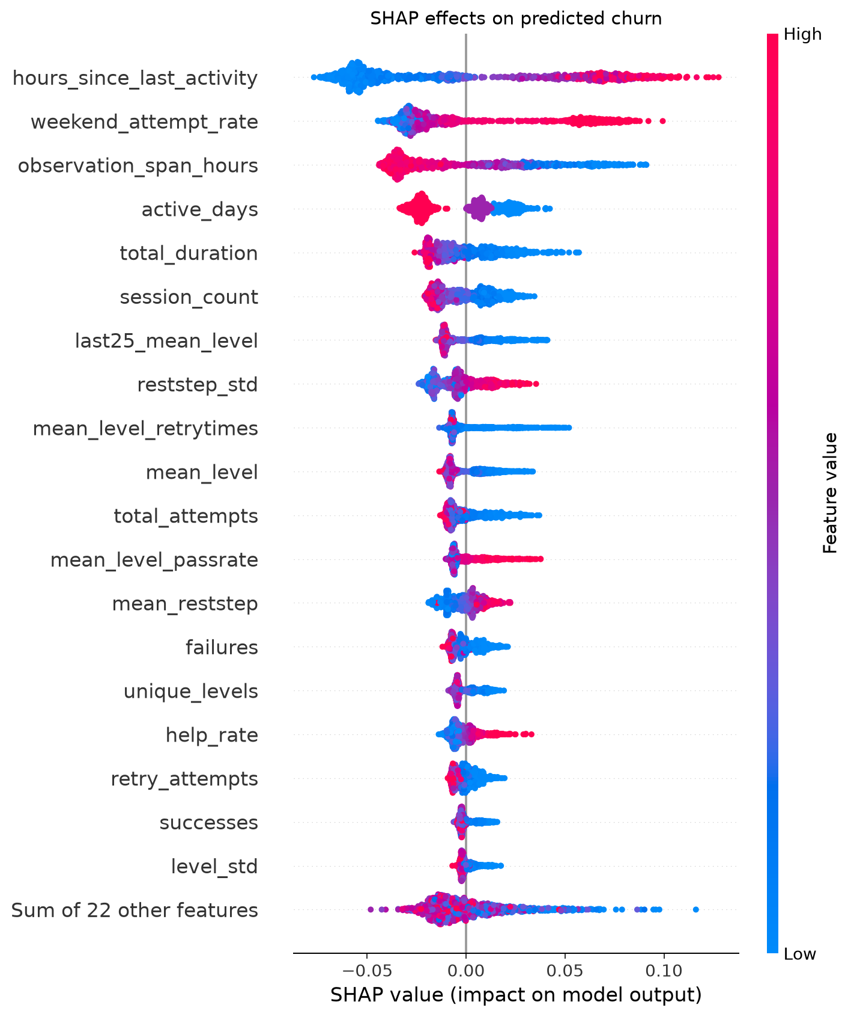
Figure 8. SHAP distribution showing feature direction and magnitude for development players.

3.4 Error analysis
Outcome | Players | Mean risk | Median recency (h) | Active days | Sessions
False Negative | 197 | 0.172 | 5.4 | 4.0 | 8.0
False Positive | 512 | 0.521 | 32.0 | 3.0 | 4.0
True Negative | 1,245 | 0.127 | 2.7 | 4.0 | 11.0
True Positive | 704 | 0.588 | 47.7 | 2.0 | 3.0

Table 5. Behavioral profile of correct and incorrect development predictions.
False negatives looked more like retained users: their median recency was only 5.4 hours, with four active days and eight sessions. False positives showed the opposite pattern, with median recency of 32.0 hours and only four sessions. This overlap explains why behavior-based churn prediction remains probabilistic and suggests that any intervention should be low-cost and reversible.

4. Conclusion
Early gameplay logs contain sufficient signal to support useful, though imperfect, churn-risk ranking. Among four tuned classifiers, Random Forest achieved the strongest training cross-validated AUROC and generalized to a development AUROC of 0.8024, recall of 0.7814, and F1-score of 0.6651. Recency, continuity of activity, and progression intensity were the most influential predictors. The model can guide supportive retention experiments, but deployment should wait for validation on another time period or game, probability calibration monitoring, and controlled testing to distinguish predictive association from causal impact.

References
ManVictor. Prediction of User Loss in Mobile Games. Kaggle dataset. https://www.kaggle.com/datasets/manchvictor/prediction-of-user-loss-in-mobile-games
Lundberg, S. M., & Lee, S.-I. (2017). A Unified Approach to Interpreting Model Predictions. Advances in Neural Information Processing Systems, 30.

