

DEPARTMENT OF COMPUTER SCIENCE AND ENGINEERING

Course: CSE391
Name: Saiful Islam Tuhin
ID: 21201547
Email: saiful.islam4@g.bracu.ac.bd
Project Title: Librarian

Project Features:
By the end of this course, the following features were implemented:

a) Authentication and role-based login system
Firebase authentication (Google + email/password)
Role-specific access for Librarian, Architect, and Fabricator

b) Reporting / data logging system
Event logging for learner interactions and quiz responses
Session-level tracking (accuracy, response behavior, progress)
Data persistence and sync support through backend APIs

c) Architect quiz authoring and assignment workflow
Create/edit quiz items (MCQ, fill-in-the-blank, dropdown, ordering)
Build multi-question quiz sets
Save quizzes to MySQL-backed backend
Assign quizzes to selected librarians

d) Librarian quiz participation workflow
View assigned quizzes
Attempt quizzes and submit answers
Integrated into role-specific learner flow

e) Fabricator request and submission workflow
Architect submits requests for narrative/content work
Fabricator claims request, updates progress, submits for review
Architect reviews and approves/rejects/revision requests

f) Explorable game world (walk-around pixel interface)
Library exploration screen
Wing/door interactions and contextual content
Approved narrative sub-wings integrated into librarian exploration

g) Backend integration (PHP + MySQL)
APIs for users, quiz save/load, assignments, request lifecycle, and workflow updates
Database-backed persistence replacing local placeholder-only flows

h) UI and navigation system
Role-based home screens and route protection
Menu-based chapter/wing navigation
Separated workflow screens for each actor role

Screenshots:
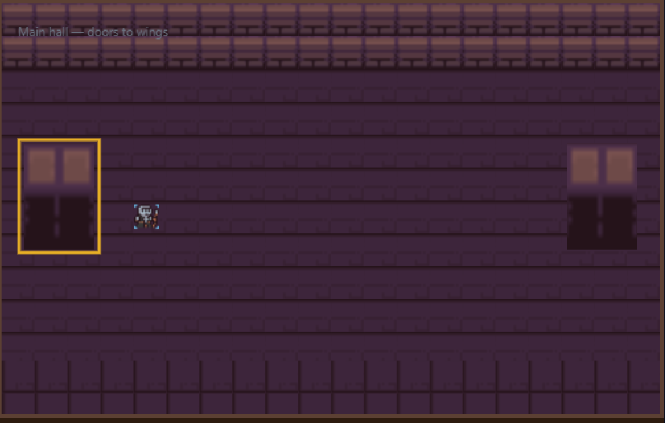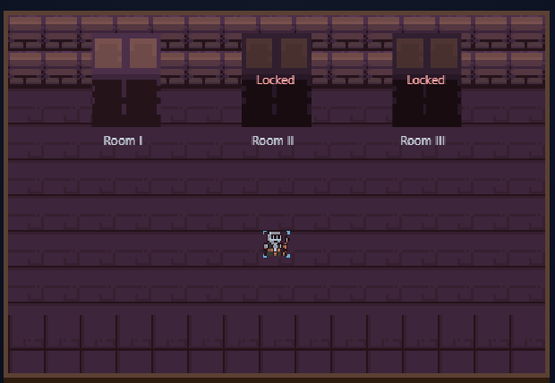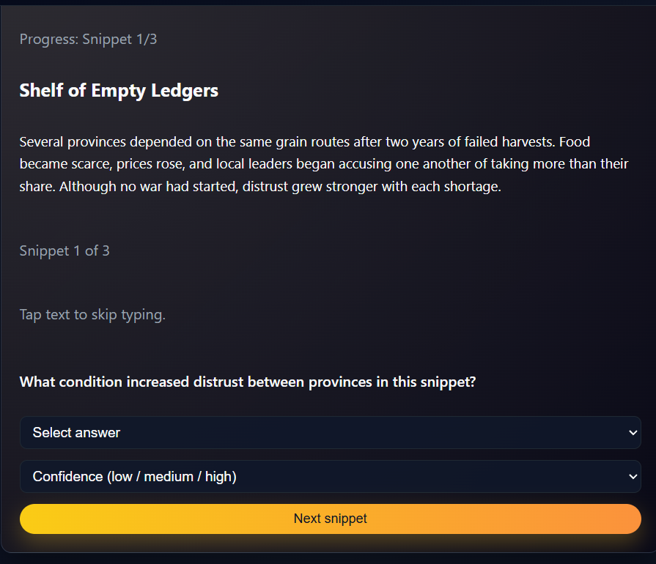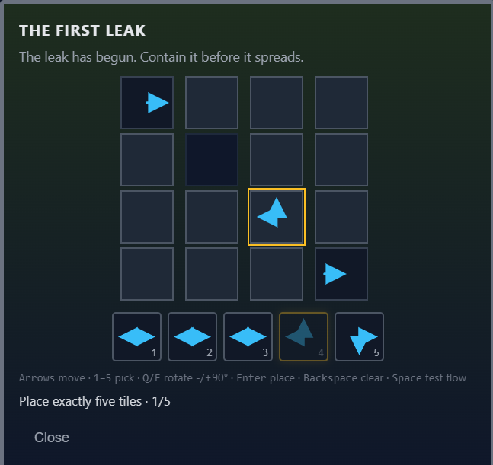
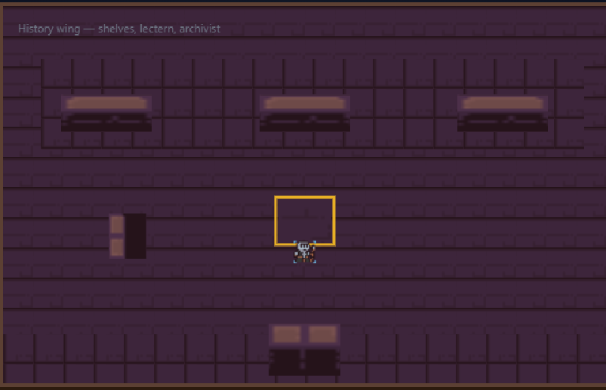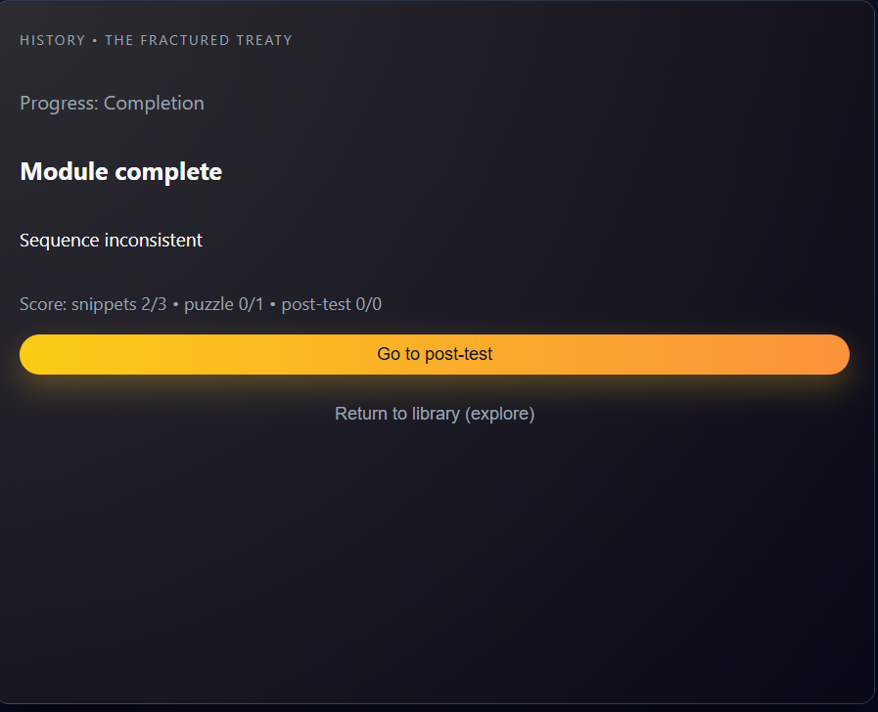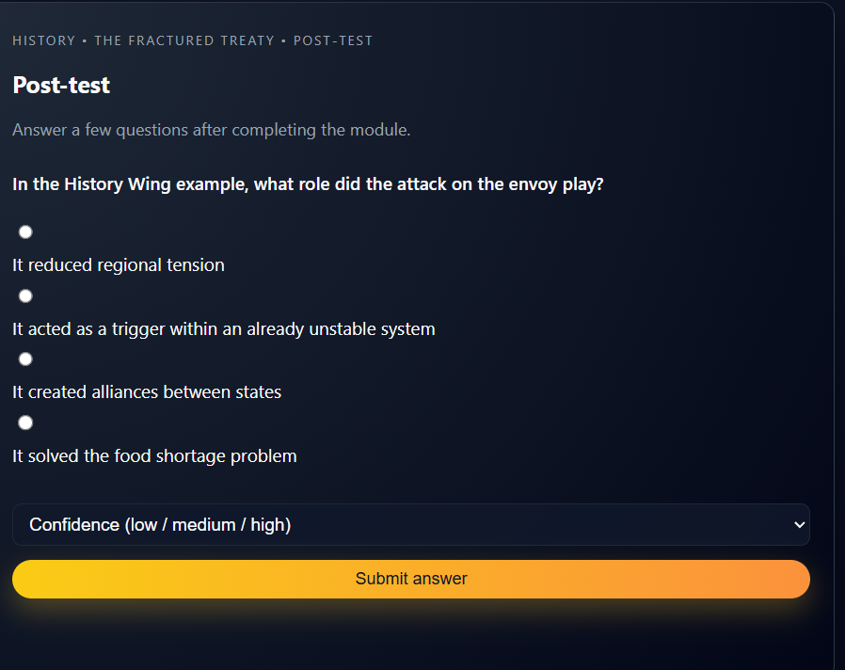

Online Resources used:
a) References
- W3Schools documentation
- MDN Web Docs
- Firebase official documentation
- PHP and MySQL documentation
- JavaScript/Frontend references via YouTube tutorials
b) Community resources
- Stack Overflow discussions for debugging and implementation ideas
- GitHub examples for architecture and UI patterns
C) Artificial Intelligence: Cursor

Future Enhancements:
Following enhancement can be added to the current system which will improve the system.

a) Full analytics dashboard for Architect (per-learner and cohort insights)
b) Group/class-based assignment management instead of individual-only assignment
c) Enhanced moderation and content versioning for quiz and narrative assets
d) Real-time notifications for request status changes (claim, submit, review)
e) Cloud-hosted narrative wing assets for fully cross-device consistency
f) Advanced reporting export (CSV/PDF dashboards) for academic analysis

