Windose 20 — Web OS
Phase 1 Technical Design Document
Audience: AI coding agents & engineers

1. Project Overview
Recreate the "Windose 20" operating system from Needy Streamer Overload as a browser-based "Playable Operating System" (POS). The app is a resource-management simulation wrapped in a fake desktop UI with a "Yami-Kawaii" (sick-cute) aesthetic.

2. Constraints & Global Rules

2.1 Viewport
- Aspect Ratio: 4:3 (CRT-style). Centered on wider screens.
- Side Fill: Mirror side-bar assets or dark room / static pattern in remaining viewport space.
- Pixel Crispness: Apply `image-rendering: pixelated;` and `-webkit-font-smoothing: none;` globally.

2.2 Color Palette
Use these exact hex values. Reference names are for quick identification.
Element | Hex | Notes
Window Background | #F0F0F0 | Standard Win95 client area
Active Title Bar | #BD64F1 | "Ame Purple"
Inactive Title Bar | #A5B0CE | Desaturated Periwinkle
Bevel Highlight | #FFFFFF | Top/Left borders
Bevel Shadow | #808080 | Bottom/Right borders
Font Color (Base) | #2B2B2B | Soft Black

2.3 Typography
- Primary UI Font: PixelMplus10 — window titles, menus, buttons.
- Secondary Font: PixelMplus12 — chat logs, JINE messages.
- System/Error Font: DinkieBitmap — BSOD, boot screens.

2.4 Art Assets
All sprite/image assets are in the `Sprites-NSO/` folder, organized by category.

3. Core Architecture ("Raincandy" Processor)

3.1 State Management
Use a global store (Redux Toolkit or Zustand) to track the following:
- Day: Integer 1–30.
- TimeSlot: Enum — NOON | DUSK | NIGHT. Derived from the user's system clock.

3.2 Time-of-Day Rendering
Desktop background and a CSS lighting overlay change per TimeSlot:
- NOON: Standard bright illumination (no overlay). Reference image attached:
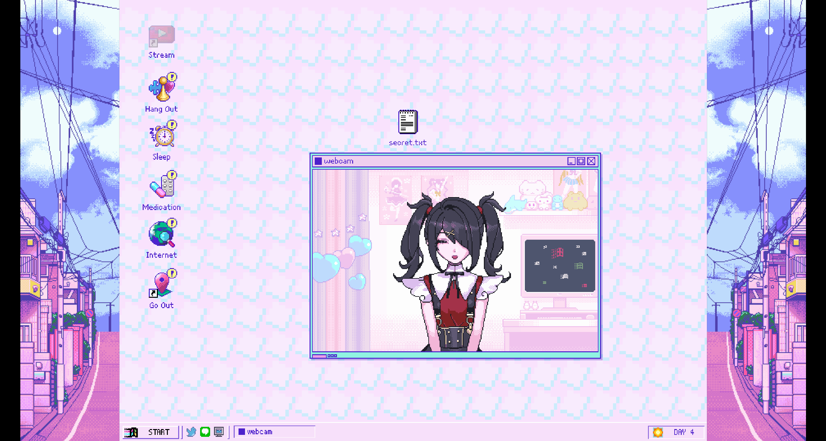
- DUSK: Orange/sunset overlay via `mix-blend-mode: multiply`.
Reference image attached: 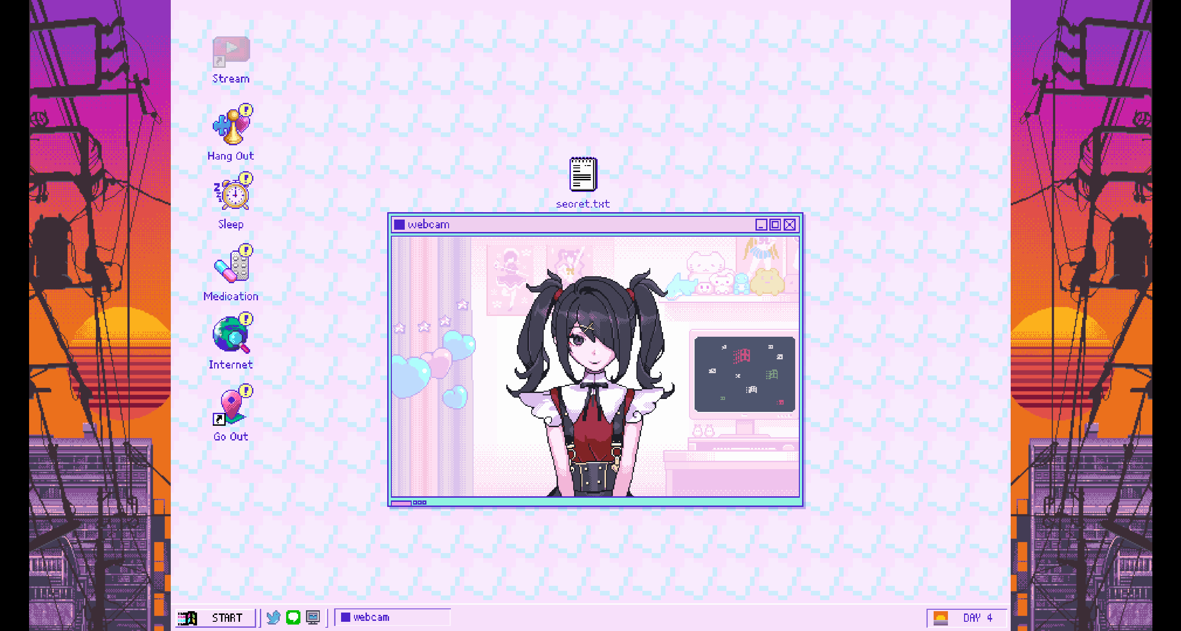
- NIGHT: Dark purple/blue tint. Streaming is ONLY unlocked at Night.
Reference image attached:
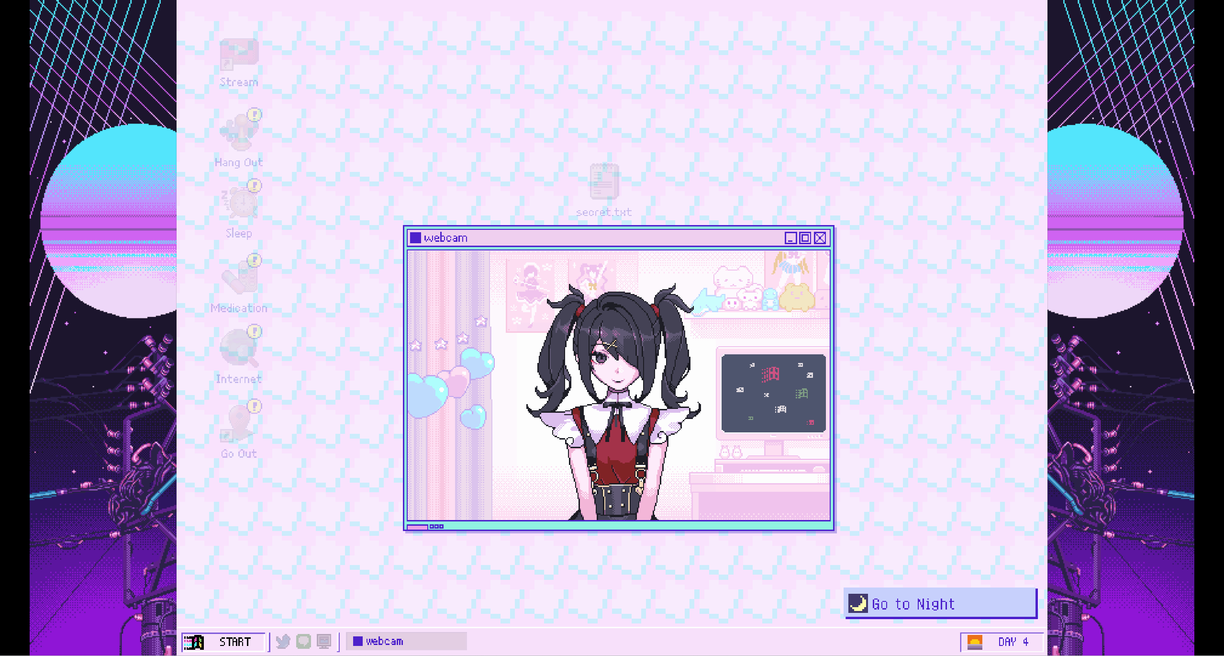

3.3 Window Manager
Implement a custom window-management hook/context that handles:
- Z-Index: Clicking a window brings it to front (`z-index: 999`).
- Focus Styling: Active window title bar → #BD64F1. Inactive → #A5B0CE.
- Dragging: Windows are draggable but constrained within the parent Desktop div.

4. Application Specifications

4.1 Desktop & Taskbar

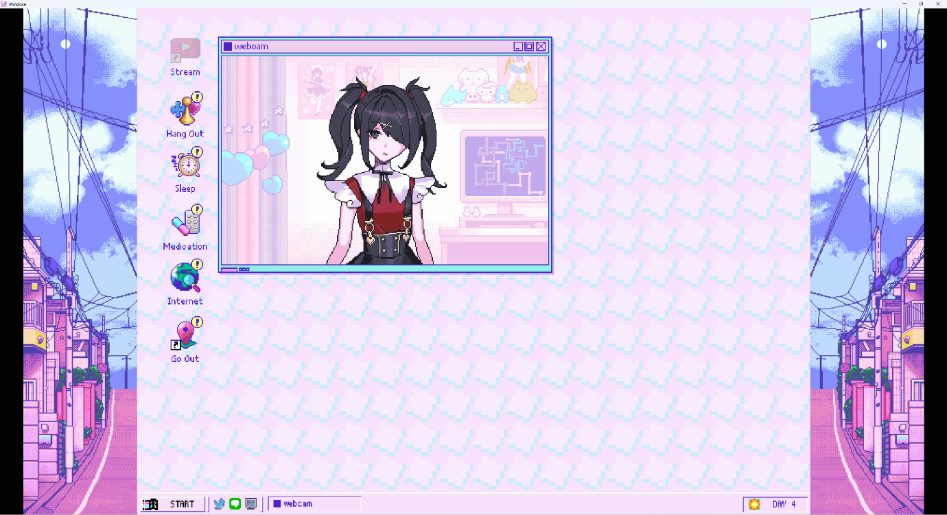

Taskbar (bottom of screen):
- Start Button (bottom-left): Opens system menu → Shut Down, Restart, Control Panel.
- Quick Launch Icons: Tweeter, JINE, Task Manager.
- Active Windows Area: Rectangular tabs for each open app.
- System Tray (bottom-right): Clock showing "DAY <n>" (day of year). Sun/Moon icon for current TimeSlot.
Desktop Shortcuts:
- Stream, Hang Out, Sleep, Medication, Internet, Go Out, Trash Bin.
- The "Stream" icon has a unique shortcut-arrow overlay.

4.2 Webcam
- Display: Shows Ame-chan sprite (randomly selected GIF; stays until window event).
- Reopen Behavior: If closed or minimized, forcefully reopens and randomizes the sprite.
- Secret.txt Guard: If user hovers over Secret.txt, the webcam window moves to cover it, making it un-interactable. User can only access Secret.txt after disabling Ame's webcam via Control Panel.
Reference image for complete webcam: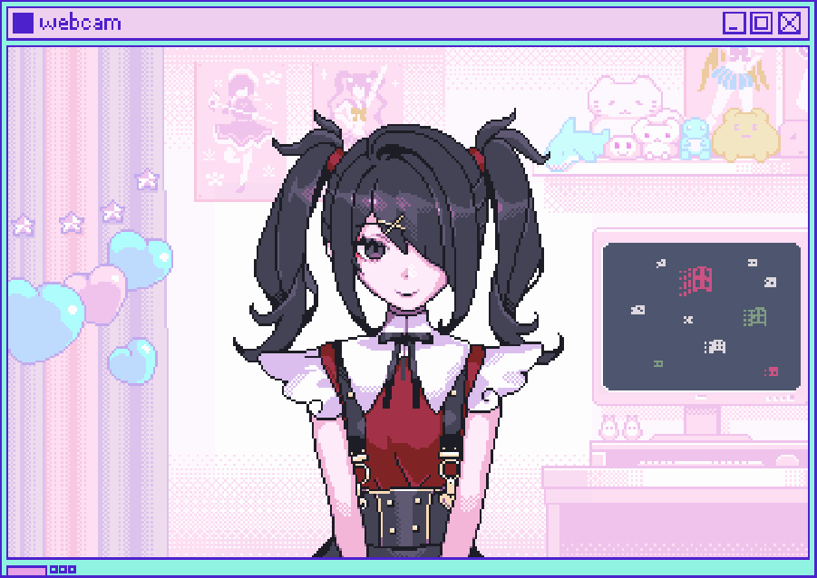

4.3 Stream App ("Metube")
Currently opens a YouTube link. Placeholder — will be replaced with custom streaming UI in a future phase.

4.4 "Go Out"
Full-size window displaying "GO OUTSIDE" in large font, filling the window. Comedic/intentional.

4.5 JINE (Messaging)
- Notifications: Icon bounces/flashes on the taskbar when a new message arrives.
- Sticker Responses: Users reply with a grid of 8+ stickers (Praise, Love, Scold, etc.).
- Chatroom: Users can write messages visible to other users. Not live — on page refresh, a notification pop-up (bottom-right of the interactive area) shows a shortened preview of new messages. Clicking the notification opens the chat.

Reference Image for complete Jine and sticker menu:
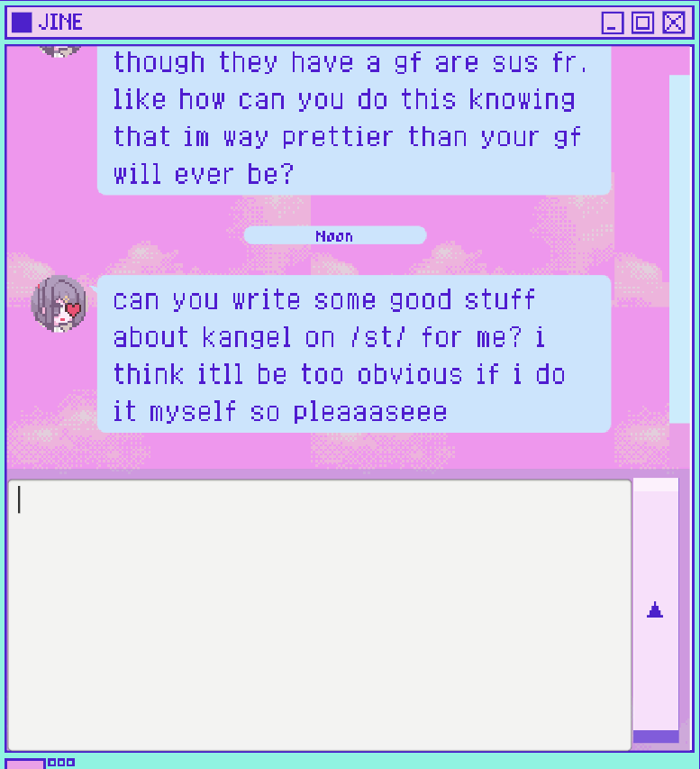

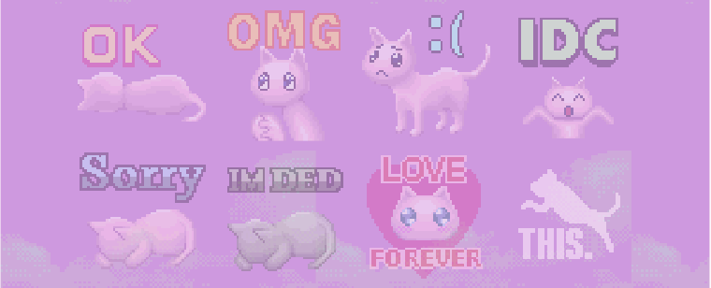

4.6 Tweeter
Phase 1: Embed link to a Twitter feed. Future: fully usable in-app Twitter clone.

4.7 Internet
No functionality in Phase 1. Create an empty application component as a placeholder.

5. Implementation Roadmap
Execute in this order. Each phase should be a deployable increment.
Phase 1 — The Shell
- Build the React (or Vue) framework with Window Manager context.
- Implement draggable window logic with z-index sorting.
Phase 2 — The Look
- Implement CSS variable system using the color palette above.
- Import PixelMplus & DinkieBitmap fonts.
- Build base `WindowFrame` component (title bar, close/minimize buttons, bevel borders).
- Load all art assets from `Sprites-NSO/`.
Phase 3 — The Brain
- Set up Redux/Zustand store for Stats and Time.
- Create "Next Day" logic function.
Phase 4 — The Apps
- Build in this order: Webcam → JINE → Stream → Tweeter → Go Out → Internet.
Phase 5 — Polish
- Add Howler.js for SFX (mouse clicks, notification chimes).
- Add CRT scanline overlay effect.

— End of Phase 1 Design Document —

