ECA5604-5G/6G COMMUNICATION SYSTEMS
NAME: N.yukeshwaran
REG NO:192412301
Ex No11: Implementation of IoT-based Smart Agriculture using MATLAB

Objective 1:
Program:
clc; clear; close all;
% Simulated soil moisture data (%)
time = 1:10;
soil_moisture = [30 35 28 25 20 18 22 30 40 45];
% Threshold for irrigation
threshold = 40;
figure
% -------- Graph 1: Soil Moisture Variation --------
subplot(2,1,1)
plot(time, soil_moisture, '-o', 'LineWidth', 2)
title('Soil Moisture Monitoring in IoT Smart Agriculture')
xlabel('Time (Hours)')
ylabel('Soil Moisture (%)')
grid on
hold on
yline(threshold,'r--','Threshold')
% -------- Graph 2: Moisture Status (Dry/Wet Level) --------
status = soil_moisture >= threshold;
subplot(2,1,2)
stem(time, status, 'filled', 'LineWidth', 2)
title('Soil Condition Status (1=Wet, 0=Dry)')
xlabel('Time (Hours)')
ylabel('Status')
grid on

Output:
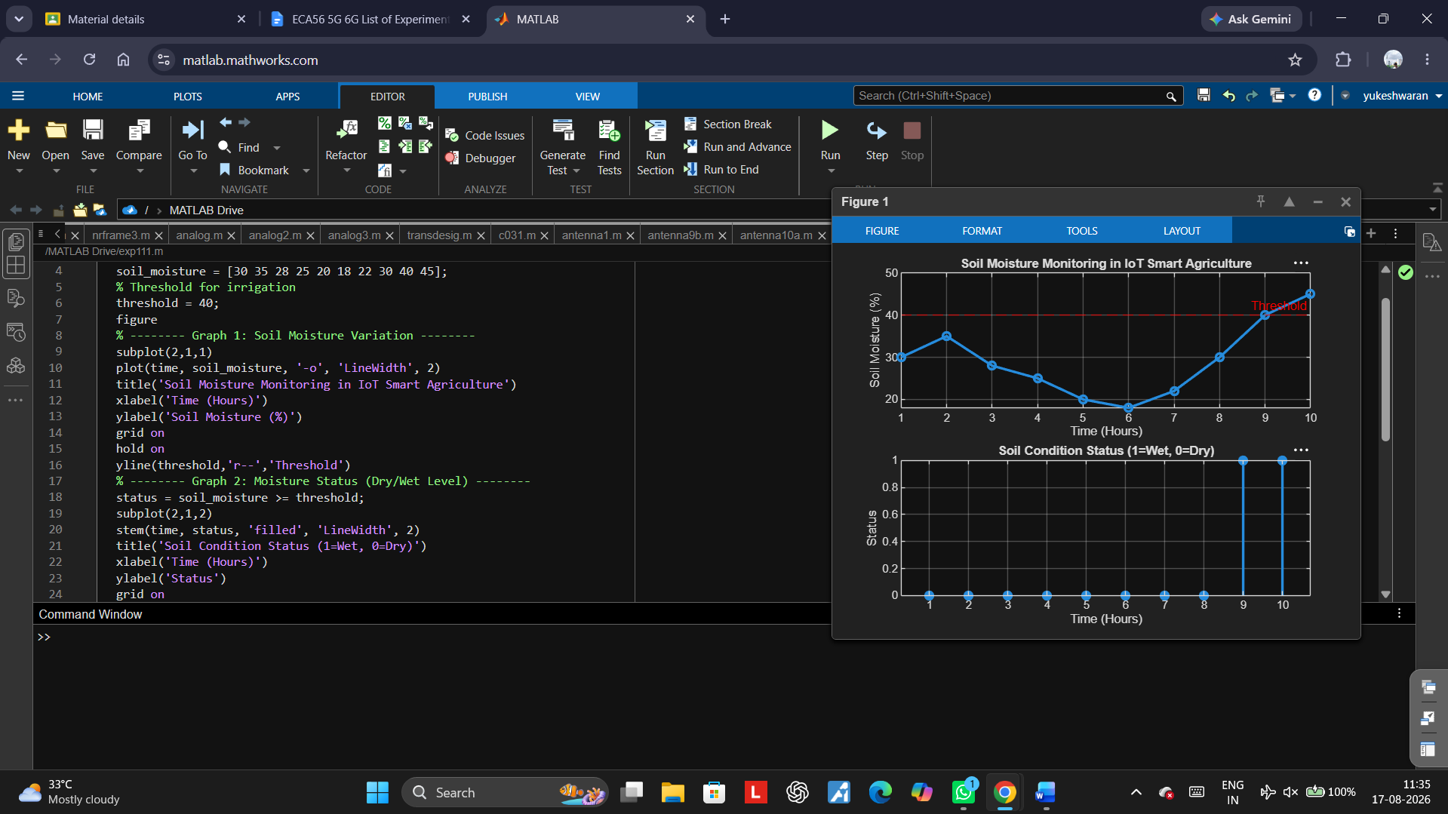

Objective2:
Program:
clc; clear; close all;
% Simulated soil moisture (%)
time = 1:10;
soil_moisture = [30 35 28 25 20 18 22 30 40 45];
% Threshold level
threshold = 40;

% Pump control logic (1 = ON, 0 = OFF)
pump_status = soil_moisture < threshold;
figure
% -------- Graph 1: Soil Moisture vs Pump Status --------
subplot(2,1,1)
plot(time, soil_moisture, '-o','LineWidth',2)
title('Soil Moisture vs Pump Control')
xlabel('Time (Hours)')
ylabel('Soil Moisture (%)')
grid on
hold on
yline(threshold,'r--','Threshold')
% -------- Graph 2: Pump Status (ON/OFF) --------
subplot(2,1,2)
stem(time, pump_status, 'filled','LineWidth',2)
title('Water Pump Status (1=ON, 0=OFF)')
xlabel('Time (Hours)')
ylabel('Pump Status')
grid on

Output:
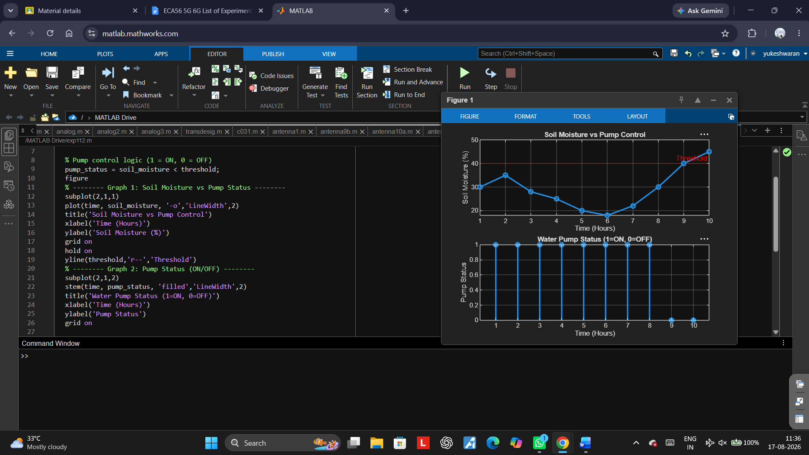

Objective3:
Program:
clc; clear; close all;
% Simulated soil moisture data (%)
time = 1:10;
soil_moisture = [30 35 28 25 20 18 22 30 40 45];
% Threshold level
threshold = 40;
% Irrigation efficiency calculation (%)
efficiency = (soil_moisture ./ threshold) * 100;
efficiency(efficiency > 100) = 100; % limit to 100%
figure
% -------- Graph 1: Soil Moisture vs Efficiency --------
subplot(2,1,1)
plot(time, soil_moisture, '-o','LineWidth',2)
title('Soil Moisture Variation')
xlabel('Time (Hours)')
ylabel('Soil Moisture (%)')
grid on
hold on
yline(threshold,'r--','Threshold')
% -------- Graph 2: Irrigation Efficiency --------
subplot(2,1,2)
plot(time, efficiency, '-s','LineWidth',2)
title('Irrigation Efficiency (%) in Smart Agriculture')
xlabel('Time (Hours)')
ylabel('Efficiency (%)')
grid on

output:
