ECA5604-5G/6G COMMUNICATION SYSTEMS
NAME: N.yukeshwaran
REG NO:192412301
Experiment 9: Massive MIMO Capacity vs SNR and Gain Using MATLAB

Objective 1:
Program:
clc;
clear;
close all;
snr = 0:5:30;
snr_linear = 10.^(snr/10);
capacity = log2(1 + snr_linear);
figure;
plot(snr,capacity,'-o','LineWidth',2,'MarkerSize',6);
grid on;
xlabel('SNR (dB)');
ylabel('Channel Capacity (bps/Hz)');
title('Channel Capacity vs SNR');

Output:
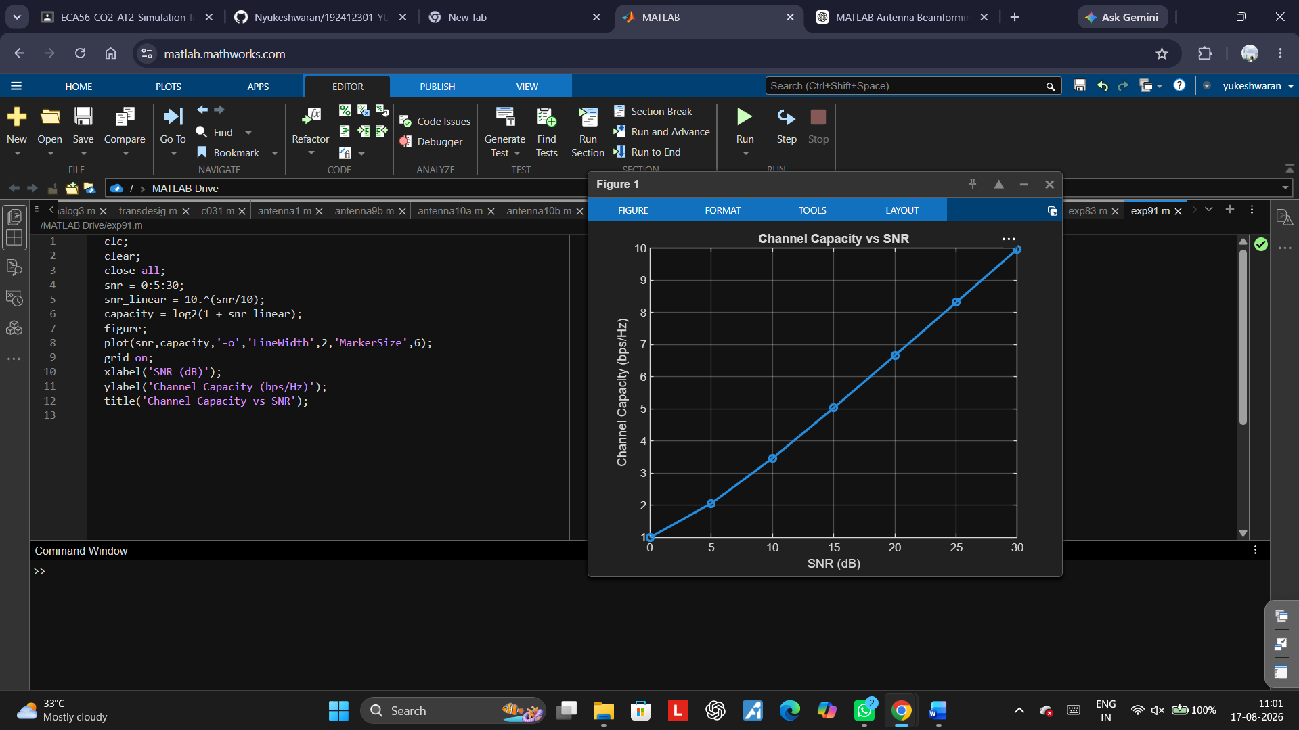

Objective2:
Program:
clc;
clear;
close all;
snr = 0:5:30;
snr_linear = 10.^(snr/10);
capacity = log2(1 + snr_linear);
figure;
plot(snr,capacity,'-o','LineWidth',2,'MarkerSize',6);
grid on;
xlabel('SNR (dB)');
ylabel('Channel Capacity (bps/Hz)');
title('Channel Capacity vs SNR');
Output:
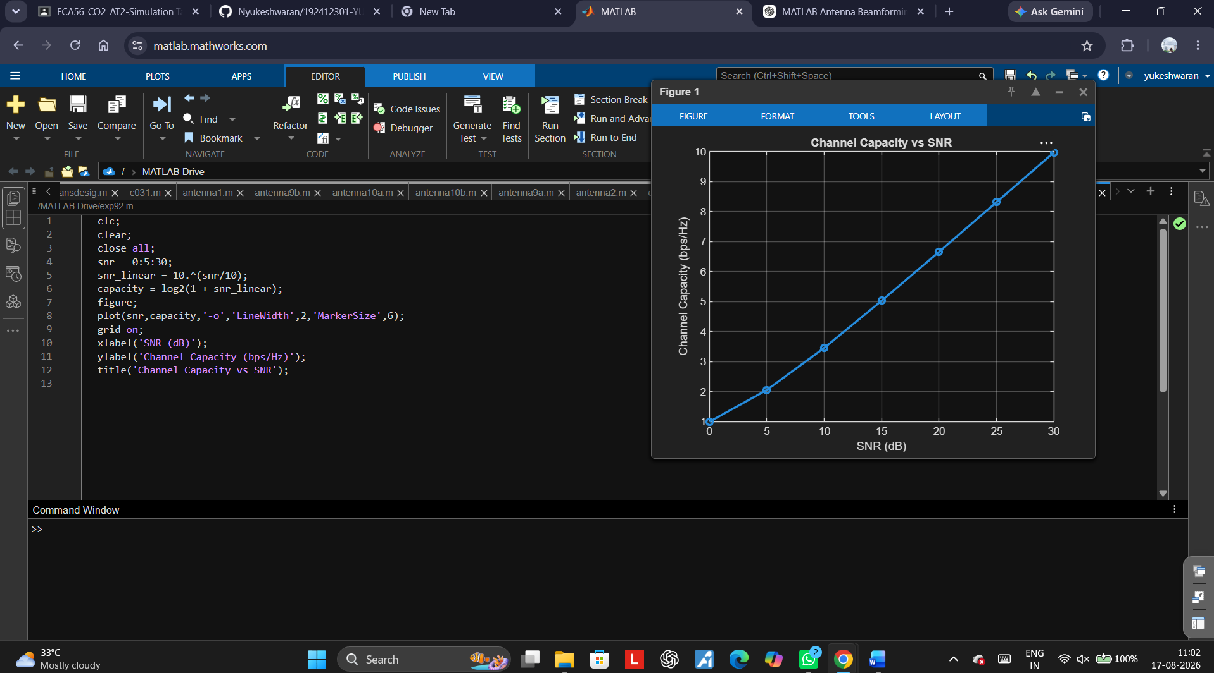

Objective3:
Program:
clc;
clear;
close all;
antennas = [4 8 16 32 64]; % Number of Antenna Elements
gain = 10*log10(antennas); % Antenna Gain (dB)
figure
bar(antennas, gain)
grid on
xlabel('Number of Antenna Elements')
ylabel('Antenna Gain (dB)')
title('Antenna Gain for Different Antenna Array Sizes')

output
