SIMATS ENGINEERING
CO3- AT2 - Design Task - Medium
COURSE NAME: Advance Wireless Communication Systems / 5G / 6G Communication Systems
COURSE CODE: ECA5604
Name yukeshwaran N
Reg no :192412301
COURSE OUTCOME COVERED
CO: 3 - Design spectrum access strategies, waveform generation methods, and multiple access techniques for efficient wireless transmission systems. (BL6)
Assessment Tool Number : CO3_AT2
Assessment Tool Weightage : 35%
Assessment Tool : Design Task
Duration : 180 Minutes
Marks : 100 Marks
Type of Assessment Conduction : At Home
Evaluation Type : GitHub
Result Generation : Students design and justify appropriate wireless communication solutions by applying engineering
principles to meet specified requirements.
Topic Covered :
Spectrum management, licensed/unlicensed spectrum, dynamic spectrum access, cognitive radio, OFDMA, resource block allocation, GFDMA, NOMA, power- domain multiplexing, SIC, and IoT applications. Advanced waveforms and wireless technologies including GFDM, FBMC, UFMC, mmWave propagation, path loss and penetration, millimeter-wave antenna systems, MIMO, and Massive MIMO fundamentals.
Short description about assessment: Students design a system / model based on given requirements to assess creativity and application skills. This question paper consists of a total of 40 questions, out of which each student is required to answer any 2 questions. Each question carries 50 marks, and the paper carries a total of 100 marks
QUESTIONS: 2 (2 X 50 = 100) Total Marks: 100 Duration: 3hrs

20. Propose a frequency allocation strategy for mixed wireless services. (BL6
40. Propose a livestock tracking communication architecture using wireless sensors(BL6)

Q20. Propose a Frequency Allocation Strategy for Mixed Wireless Services

Title: Frequency Allocation Strategy for Mixed Wireless Services

Aim:
To design and simulate an efficient frequency allocation strategy for different wireless services by assigning available frequency bands based on service requirements.

MATLAB Program:
clc;
clear;
close all;

% Frequency bands in MHz
freq = [700 800 900 1800 2100 2600];

% Wireless services
services = {'IoT','LTE','5G','WiFi','Emergency','Smart City'};

% Assigned bandwidth in MHz
bandwidth = [10 20 20 40 30 20];

% Plot frequency allocation
figure;
bar(freq, bandwidth);

xlabel('Center Frequency (MHz)');
ylabel('Allocated Bandwidth (MHz)');
title('Frequency Allocation for Mixed Wireless Services');
grid on;

% Display allocation
disp('Frequency Allocation Table');
for i = 1:length(freq)
fprintf('%s : %d MHz frequency, %d MHz bandwidth\n', ...
services{i}, freq(i), bandwidth(i));
end
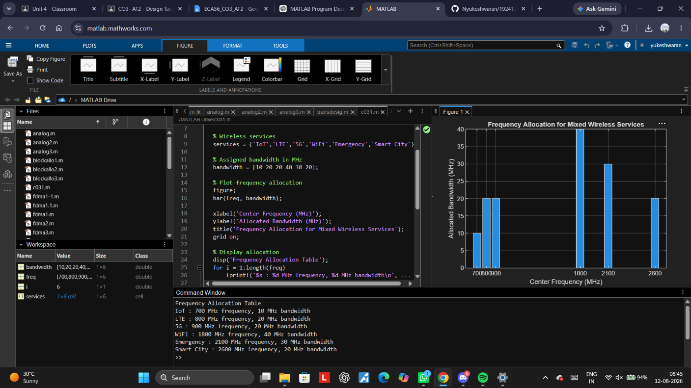

Result:
The MATLAB simulation successfully allocates different frequency bands to IoT, LTE, 5G, WiFi, emergency, and smart-city services. The bar graph shows the bandwidth assigned to each wireless service, demonstrating efficient frequency allocation.

Q40. Propose a Livestock Tracking Communication Architecture Using Wireless Sensors

Title: Livestock Tracking Communication Architecture Using Wireless Sensors

Aim:
To design and simulate a wireless livestock tracking system using sensor nodes and wireless communication for monitoring animal location and movement.

MATLAB Program:
clc;
clear;
close all;

% Number of livestock
N = 10;

% Random positions of animals
x = rand(1,N) * 100;
y = rand(1,N) * 100;

% Plot livestock sensor nodes
figure;
plot(x, y, 'o', 'MarkerSize', 8, 'LineWidth', 2);
hold on;

% Base station
baseX = 50;
baseY = 50;

plot(baseX, baseY, 's', 'MarkerSize', 12, 'LineWidth', 3);

% Communication links
for i = 1:N
plot([x(i) baseX], [y(i) baseY], '--');
end

xlabel('X Position (m)');
ylabel('Y Position (m)');
title('Wireless Livestock Tracking Communication Architecture');
legend('Livestock Sensor Nodes','Base Station');
grid on;
axis([0 100 0 100]);

% Display positions
disp('Livestock Sensor Positions');
for i = 1:N
fprintf('Animal %d: X = %.2f m, Y = %.2f m\n', i, x(i), y(i));
end

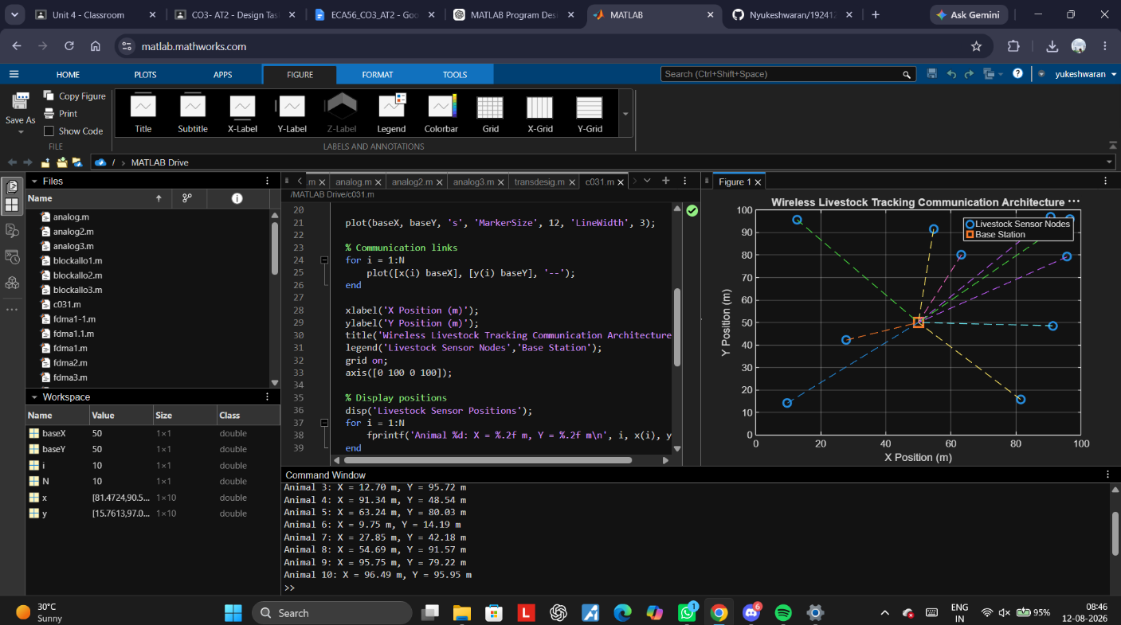
Result:
The MATLAB simulation successfully models a wireless livestock tracking system. Ten livestock sensor nodes are randomly positioned and connected to a central base station, representing wireless communication for monitoring animal locations.

Code of Conduct:
I N.yukeshwaran 192412301 (Name / Reg No) certify that this submission is my original work and that I have adhered to the guidelines specified for this assessment. I understand that any violation of academic integrity rules will result in disciplinary action.
Signature of the student:

RUBRICS FOR CALCULATION:
Design Task
Criteria | Weightag  e | Level 4  (Exemplary) | Level 3  (Proficient) | Level 2  (Developing) | Level 1  (Beginning)
Understanding of Design | 20% | Demonstrates deep  understanding of design  objectives,  constraints,  and context | Shows good  understanding with minor  gaps | Partial  understanding; misses key  aspects | Lacks  understandin g of the  design  context
Evaluation of Design | 25% | Provides in  depth critique identifying  strengths,  weaknesses, and design  gaps | Identifies key  issues with  reasonable  analysis | Limited critique; mostly  descriptive  feedback | No  meaningful  critique  provided
Justification | 20% | Supports  critique with  strong  reasoning,  evidence, and relevant  principles | Provides  justification  with some  supporting  evidence | Weak or unclear justification | No  justification  for feedback
Suggestions  for  Improvement | 20% | Offers  innovative,  practical, and well-justified  improvement  suggestions | Provides useful suggestions  with minor  gaps | Suggestions are limited or  partially relevant | No  constructive suggestions provided
Communicatio n | 15% | Communicates feedback  clearly,  professionally, and engages  actively in  discussion | Communicates well with minor issues | Communication lacks clarity or engagement | Poor  communicatio n and  minimal  participation

