Finite Prevention Windows Under Irreversible Infection Establishment:
A Mathematical Framework for HIV Post-Exposure Prophylaxis Timing
A.C. Demidont, DO^{a,b}
ª Independent Researcher
^{b} Nyx Dynamics, LLC, 268 Post Rd. East, Fairfield, CT 06428, USA
ac.demidont@nyxdynamics.com
Abstract
Post-exposure prophylaxis (PEP) is a critical safety net for HIV prevention following sexual exposure, with initiation within 72 hours achieving high levels of protection. Whether PEP provides equivalent protection following parenteral (injection) exposure has not been formally examined. We develop a mathematical framework modeling within-host infection establishment as two sequential irreversible transitions—reservoir seeding and proviral integration—and prove that maximum PEP efficacy decreases monotonically to zero as integration completes, yielding a finite critical time beyond which efficacy falls below any threshold, independent of drug potency. Using virological parameters and non-human primate validation, we show this window extends to approximately 72 hours for mucosal exposures but compresses to 12–24 hours for parenteral exposures—a consequence of higher initial inoculum and direct intravascular delivery. Structural access delays for people who inject drugs (PWID) systematically exceed this compressed window: fewer than 5% can access PEP in time, bounding expected population-level efficacy below 10%. These findings identify biologically grounded route-specific timing constraints that may limit realized PEP effectiveness under delayed access conditions and highlight the importance of pre-exposure strategies for populations where post-exposure access is structurally constrained. All conclusions are conditional on the specified access-delay distributions and do not argue against offering PEP to individuals who present within guideline windows.
Keywords: HIV prevention, post-exposure prophylaxis, pre-exposure prophylaxis, people who inject drugs, mathematical modeling, prevention windows, route-dependent transmission

1 Introduction
For individuals presenting after sexual exposure to HIV, post-exposure prophylaxis (PEP) functions as a reliable safety net: CDC guidelines recommend initiation within 72 hours, the majority of patients access care within this window, and protection approaches 100% when PEP is started promptly [1]. This safety net is implicitly assumed to extend to all exposure routes. We examine whether that assumption holds for parenteral (injection) exposures.
The biological basis for concern is straightforward. HIV infection establishment involves irreversible transitions—proviral integration into the host genome and seeding of long-lived cellular reservoirs—beyond which no currently available intervention restores the uninfected state [2–4]. Parenteral inoculation delivers virus directly into the bloodstream, bypassing mucosal barriers that attenuate and delay establishment following sexual exposure. If this results in a substantially shorter window for effective PEP, and if structural barriers delay healthcare access for people who inject drugs (PWID) beyond that window, then PEP may not function as a safety net for the population most in need of one.
PEP and pre-exposure prophylaxis (PrEP) are the only two biomedical prophylaxis options for HIV, and both achieve high efficacy when delivered [5, 6]. Yet PrEP uptake among PWID remains very low [7, 8]. Given persistently low PrEP uptake among PWID, understanding whether post-exposure timing constraints limit PEP’s compensatory role is clinically important.
In this paper, we develop a mathematical framework to quantify this problem. We:
- Prove that PEP efficacy decays monotonically to zero as a function of time post-exposure, yielding a finite prevention window (Sections 2–4);
- Show that this window compresses by approximately 3-fold for parenteral versus mucosal exposures (Section 5);
- Demonstrate that empirically documented access delays for PWID systematically exceed the compressed parenteral window, bounding expected population-level PEP efficacy below 10% (Section 6).

2 Mathematical Framework

2.1 Probability space and state definitions
Consider a single HIV exposure event e occurring at time t = 0. We define a probability space (Ω, ℱ, P) equipped with a filtration {ℱ_{t}}_{t≥0} representing the evolving information about within-host viral dynamics.
Definition 2.1 (Within-host infection states). Following exposure e, the within-host viral state at time t is described by a random variable Z(t) ∈ {0, 1, 2}, where:
- Z(t) = 0: Susceptible—no productive infection. Virus may be present but has not established a self-sustaining replicative focus (I(t) < I*).
- Z(t) = 1: Seeded—a replicative focus is established (I(t) ≥ I*) but reservoir commitment remains below the irreversibility threshold (R(t) < R*).
- Z(t) = 2: Integrated—proviral DNA is stably integrated into the host genome of long-lived cells, with reservoir size exceeding the self-renewal threshold (R(t) ≥ R*), establishing a self-renewing viral reservoir.
Operationally, Z(t) = 1 corresponds to I(t) ≥ I* with R(t) < R*, while Z(t) = 2 corresponds to R(t) ≥ R*, where the thresholds I* and R* are defined in Section 5.1.
The transitions 0 → 1 and 1 → 2 are governed by random times that we define as stopping times on the filtration.
Definition 2.2 (Transition times). Let T_{seed} and T_{int} be stopping times on {ℱ_{t}} defined by:
T_seed = inf{t ≥ 0 : Z(t) ≥ 1} (1)
T_int = inf{t ≥ 0 : Z(t) = 2} (2)
We assume T_{seed} ≤ T_{int} almost surely (seeding precedes or coincides with integration).
Definition 2.3 (Cumulative transition probabilities). The cumulative probabilities of each transition having occurred by time t are:
P_seed(t) = P(T_seed ≤ t) (3)
P_int(t) = P(T_int ≤ t) (4)
Since T_{seed} ≤ T_{int} a.s., we have P_{seed}(t) ≥ P_{int}(t) for all t ≥ 0.
Definition 2.4 (Establishment probability). For a single exposure event e, the establishment probability at time t is:
P_est(e, t) = P(exposure e results in productive, transmissible infection | ℱ_t) (5)
Prevention is defined as the condition P_{est}(e, t) = 0.

2.2 Assumptions
We impose three biologically motivated assumptions.
Assumption 1 (Irreversibility of integration). Once proviral integration is complete (Z(t) = 2), the integrated state is absorbing: no biologically realizable intervention restores Z(t) = 0. Formally, P(Z(s) = 0 | Z(t) = 2) = 0 for all s > t.
This reflects the biological reality that integrated HIV provirus persists for the lifetime of the host cell and is propagated to all daughter cells via clonal expansion [3, 4]. The only known exceptions involve CCR5-Δ32 stem cell transplantation [9], which functions as system replacement rather than reversal of the integrated state.
Assumption 2 (Stage-dependent drug efficacy). The efficacy of post-exposure antiretroviral intervention depends only on the current within-host state Z(t):
ε(Z(t)) = ε_max if Z(t) = 0, ε_mid if Z(t) = 1, ε_min if Z(t) = 2 (6)
where 1 ≥ ε_{max} ≥ ε_{mid} ≥ ε_{min} ≥ 0. For prevention purposes, we set ε_{min} = 0: once integration is complete, no drug can guarantee eradication.
Assumption 3 (Monotonicity of integration). The cumulative integration probability P_{int}(t) is non-decreasing in t and satisfies lim_{t→∞} P_{int}(t) = 1 for exposure events that result in productive infection. Formally, P_{int} is a cumulative distribution function on [0, ∞) with P_{int}(0) = 0.
This follows from the biological observation that proviral integration is a cumulative, one-directional process: once a cell is integrated, it cannot become unintegrated, and the probability of at least one cell having integrated increases monotonically with time [2].

3 The Master Equation
We derive the time-dependent PEP efficacy function from the law of total probability.
Proposition 3.1 (Time-dependent PEP efficacy). Under Assumption 2, the expected efficacy of PEP initiated at time t post-exposure is:
E_PEP(t) = (1 − P_seed(t)) ε_max + (P_seed(t) − P_int(t)) ε_mid + P_int(t) ε_min (7)
Proof. See Supplementary Material.

4 The Finite Prevention Window
Theorem 4.1 (Finite prevention window under irreversible establishment). Under Assumptions 1–3, the PEP efficacy function E_{PEP}(t) satisfies:
(i) Upper bound: For all t ≥ 0,
E_PEP(t) ≤ (1 − P_int(t)) ε_max + P_int(t) ε_min (8)
If ε_{min} = 0 (Assumption 2), then E_{PEP}(t) ≤ (1 − P_{int}(t)) ε_{max} ≤ 1 − P_{int}(t).
(ii) Monotone decay: E_{PEP}(t) is non-increasing in t.
(iii) Convergence to zero: lim_{t→∞} E_{PEP}(t) = ε_{min}. If ε_{min} = 0, then E_{PEP}(t) → 0.
(iv) Finite critical time: For any prevention threshold η ∈ (0, 1), there exists a finite time
t_crit(η) = inf{t ≥ 0 : E_PEP(t) < η} (9)
such that for all t ≥ t_{crit}(η), E_{PEP}(t) < η.
Proof. See Supplementary Material.

4.1 Hazard-rate decomposition of efficacy loss
Theorem 4.1 establishes that E_{PEP}(t) decays monotonically. We now characterize the rate of efficacy loss in terms of the instantaneous hazard rates of seeding and integration, connecting the prevention window to the survival analysis literature.
Definition 4.2 (Transition hazard rates). Let P_{seed} and P_{int} be absolutely continuous with densities f_{seed} and f_{int}, respectively. The conditional hazard rates for seeding and integration are:
λ_seed(t) = f_seed(t) / (1 − P_seed(t)) (10)
λ_int(t) = f_int(t) / (P_seed(t) − P_int(t)) (11)
where λ_{seed}(t) is the hazard of transitioning from state 0 to state 1, and λ_{int}(t) is the hazard of transitioning from state 1 to state 2, each conditional on occupying the source state at time t.
Proposition 4.3 (Hazard-rate decomposition of efficacy decay). Under Assumptions 1–3, if P_{seed} and P_{int} are absolutely continuous, then:
dE_PEP/dt(t) = −λ_seed(t)(1 − P_seed(t))(ε_max − ε_mid) − λ_int(t)(P_seed(t) − P_int(t))(ε_mid − ε_min) (12)
Equivalently, writing Δε₁ = ε_{max} − ε_{mid} and Δε₂ = ε_{mid} − ε_{min}:
dE_PEP/dt(t) = −f_seed(t) Δε₁ − f_int(t) Δε₂ ≤ 0 (13)
Proof. See Supplementary Material.

4.2 The absorbing state
The irreversibility claim (Assumption 1) can be grounded in a minimal within-host dynamical system. Consider the standard target-cell-limited model of early HIV infection:
dT/dt = λ − dT − βTV (14)
dI/dt = βTV − δI (15)
dV/dt = pI − cV (16)
dR/dt = αI (17)
where T denotes uninfected target cells, I actively infected cells, V free virus, R cells with stably integrated provirus (reservoir), λ is target cell production, d natural death, β infection rate, δ infected cell death, p viral production, c viral clearance, and α the rate of stable integration.
Lemma 4.4 (Absorbing state). The set A = {(T, I, V, R) : R > 0} is positively invariant under the dynamics (14)–(17). That is, if R(t₀) > 0 for some t₀, then R(t) > 0 for all t > t₀.
Proof. See Supplementary Material.
ART suppresses replication (I → 0) but from (17), dR/dt = 0 when I = 0: the reservoir persists. This is the mathematical statement that ART controls but does not cure HIV.

5 Route-Dependent Window Compression
The Prevention Theorem establishes that a finite t_{crit}(η) exists for any threshold η. We now show that this critical time is systematically shorter for parenteral (injection) exposures than for mucosal (sexual) exposures.
Definition 5.1 (Route-specific integration distributions). Let P^{(m)}_{int}(t) = P(T^{(m)}_{int} ≤ t) and P^{(p)}_{int}(t) = P(T^{(p)}_{int} ≤ t) denote the cumulative integration probability functions for mucosal and parenteral exposures, respectively.
Assumption 4 (Stochastic dominance of parenteral establishment). Parenteral exposure produces first-order stochastic dominance over mucosal exposure in both transition times:
P^(p)_seed(t) ≥ P^(m)_seed(t) for all t ≥ 0 (18)
P^(p)_int(t) ≥ P^(m)_int(t) for all t ≥ 0 (19)
with strict inequality on a set of positive Lebesgue measure for each.
This reflects direct intravascular delivery bypassing mucosal epithelial barriers. Experimental support comes from NHP PEP timing studies: Tsai et al. [10] showed complete protection within 24h for IV challenge, declining at 48h; Otten et al. [11] showed full protection through 36h for vaginal challenge, declining at 72h. In Section 5.1, stochastic dominance also arises from the ODE model under route-dependent initial conditions.
Corollary 5.2 (Route compression of the prevention window). Under Assumptions 1–4, let E^{(m)}_{PEP}(t) and E^{(p)}_{PEP}(t) denote PEP efficacy following mucosal and parenteral exposure, respectively. Then:
(i) E^{(p)}_{PEP}(t) ≤ E^{(m)}_{PEP}(t) for all t ≥ 0.
(ii) For any threshold η ∈ (0, 1), t^{(p)}_{crit}(η) ≤ t^{(m)}_{crit}(η).
That is, PEP efficacy decays faster and the critical prevention window closes sooner for parenteral than for mucosal exposures.
Proof. See Supplementary Material.

5.1 Parameterization from within-host dynamics
Rather than specifying P_{seed}(t) and P_{int}(t) as ad hoc functional forms, we derive them from the target-cell-limited ODE model introduced in Section 4.2. This grounds the prevention window in mechanistic within-host dynamics.
5.1.1 Integration time as a hitting time
We define the integration time T_{int} as the first time at which reservoir size exceeds a threshold R* representing stable, self-renewing proviral presence:
T_int = inf{t ≥ 0 : R(t) ≥ R*} (20)
where R(t) is governed by the ODE system (14)–(17). Since R(t) is monotonically non-decreasing (Lemma 4.4) and R(t) → ∞ as t → ∞ whenever initial infection is established (I(0) > 0), T_{int} is finite almost surely. The cumulative distribution P_{int}(t) = P(T_{int} ≤ t) then inherits its shape from the dynamics of I(t) feeding reservoir accumulation through dR/dt = αI.
Analogously, we define the seeding time T_{seed} as the first passage of the actively infected cell count past a threshold I* representing a self-sustaining replicative focus:
T_seed = inf{t ≥ 0 : I(t) ≥ I*} (21)
5.1.2 Route-dependent initial conditions
Route compression arises from different initial inocula: V^{(m)}(0) = 1 virion/mL (mucosal, reflecting epithelial attenuation) versus V^{(p)}(0) = 10³ virions/mL (parenteral, direct intravascular delivery). All distributional results are conditioned on exposures that establish infection (i.e., trajectories in which I(t) does not stochastically extinguish prior to reaching I*), consistent with Assumption 3.
Under identical ODE parameters, larger initial V(0) produces earlier and steeper growth of I(t) and consequently earlier accumulation of R(t), yielding P^{(p)}_{int}(t) ≥ P^{(m)}_{int}(t) for all t—i.e., stochastic dominance (Assumption 4) emerges as a consequence of the initial condition rather than requiring a separate assumption about establishment kinetics.
Lemma 5.3 (Inoculum-monotone hitting times). Let (T, I, V, R) and (Ũ, Ĩ, Ṽ, Ř) be solutions of the ODE system (14)–(17) with identical parameters and initial conditions except V(0) = v₀ < ṽ₀ = Ṽ(0), with T(0) = Ũ(0), I(0) = Ĩ(0) = 0, and R(0) = Ř(0) = 0. Then Ĩ(t) ≥ I(t) and Ř(t) ≥ R(t) for all t ≥ 0, implying T_{int}(ṽ₀) ≤ T_{int}(v₀) almost surely.
Proof sketch. The subsystem (I, V, R) is cooperative (monotone) for fixed T. By comparison theorems for cooperative ODE systems [12], solutions are order-preserving in initial conditions. Since Ṽ(0) > V(0) with all other components equal, Ṽ(t) ≥ V(t) and Ĩ(t) ≥ I(t) for all t ≥ 0. From dR/dt = αI, Ř(t) ≥ R(t), so the hitting time inf{t : R(t) ≥ R*} is earlier for larger inocula.
5.1.3 Numerical parameterization
We solve the ODE system numerically using standard virological parameters [2, 13]: λ = 10⁴ cells/mL/day, d = 0.01 day⁻¹, β = 2.4 × 10⁻⁵ (mL/virion)/day, δ = 0.7 day⁻¹, p = 10³ virions/cell/day, c = 23 day⁻¹, α = 10⁻³ day⁻¹, with T(0) = 10⁶ cells/mL, I(0) = R(0) = 0. Multiplicative log-normal noise on β and α (CV = 0.3) across N = 10,000 replications per route yields empirical CDFs without assuming a functional form.
Under these parameters, the ODE-derived distributions yield t^{(m)}_{crit}(0.05) ≈ 68–76 hours and t^{(p)}_{crit}(0.05) ≈ 16–28 hours, consistent with the clinically established 72-hour mucosal PEP window [1] and the empirically estimated 12–24 hour parenteral window. Efficacy parameters are set at ε_{max} = 0.95, ε_{mid} = 0.50, and ε_{min} = 0. Base thresholds are I* = 100 cells/mL and R* = 10 cells/mL. Varying both thresholds by 10-fold shifts t^{(p)}_{crit} by less than 8 hours and t^{(m)}_{crit} by less than 15 hours; the compression ratio remains in the range 2.5–4.0 across all threshold combinations.
The ODE-derived t^{(m)}_{crit} ≈ 72 hours matches the CDC window without calibration—both reflect the same underlying viral establishment kinetics.
Figure 1 illustrates the predicted efficacy decay curves for both routes, with NHP concordance data overlaid.
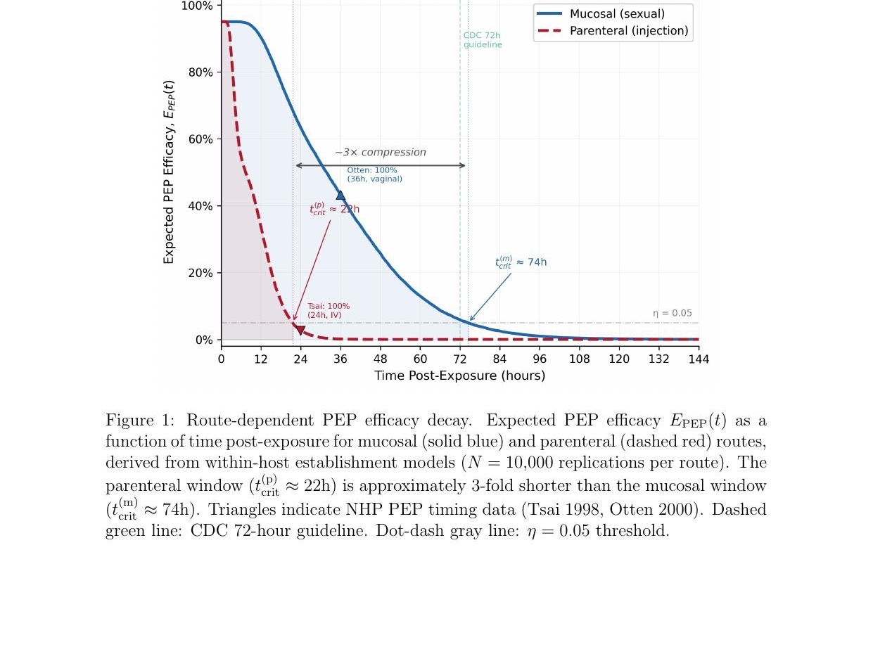
Figure 1: Route-dependent PEP efficacy decay. Expected PEP efficacy E_{PEP}(t) as a function of time post-exposure for mucosal (solid blue) and parenteral (dashed red) routes, derived from within-host establishment models (N = 10,000 replications per route). The parenteral window (t^{(p)}_{crit} ≈ 22h) is approximately 3-fold shorter than the mucosal window (t^{(m)}_{crit} ≈ 74h). Triangles indicate NHP PEP timing data (Tsai 1998, Otten 2000). Dashed green line: CDC 72-hour guideline. Dot-dash gray line: η = 0.05 threshold.
5.1.4 Validation against non-human primate PEP timing data
The ODE-derived prevention windows can be validated against controlled NHP PEP timing experiments, which provide systematic data on protection as a function of delay and duration by route.
Table 1 compares the model-predicted efficacy pattern with observed protection rates from two foundational NHP studies that used the same drug (tenofovir/PMPA, 30 mg/kg/day) across different exposure routes. Tsai et al. [10] challenged macaques intravenously with SIV; Otten et al. [11] challenged macaques intravaginally with HIV-2. Emau et al. [14] confirmed the 24-hour parenteral window in a subsequent IV challenge study.
Table 1: NHP PEP timing data by route and treatment delay. All treatment groups received tenofovir (PMPA) 30 mg/kg/day for 28 days unless noted. Sample sizes: n = 2–4 per group.
Route | Study | PEP Delay | Treatment Duration | Protection | Model
Parenteral (IV) | Tsai 1998 | 24h | 28 days | 100% | Concordant
Parenteral (IV) | Tsai 1998 | 24h | 10 days | 50% | Concordant
Parenteral (IV) | Tsai 1998 | 24h | 3 days | 0% | Concordant
Parenteral (IV) | Tsai 1998 | 48h | 28 days | 50% | Concordant
Parenteral (IV) | Tsai 1998 | 72h | 28 days | 50% | See text
Mucosal (vaginal) | Otten 2000 | 12h | 28 days | 100% (4/4) | Concordant
Mucosal (vaginal) | Otten 2000 | 36h | 28 days | 100% (4/4) | Concordant
Mucosal (vaginal) | Otten 2000 | 72h | 28 days | 50% (2/4) | Concordant
Mucosal (vaginal) | Otten 2000 | untreated | — | 25% (1/4) | —

Route compression. Comparing across routes at matched treatment duration (28 days), complete protection extends to 24 hours for parenteral (Tsai) but through 36 hours for mucosal (Otten) exposures, a ∼1.5–2-fold difference. Protection declines to 50% at 48 hours (parenteral) versus 72 hours (mucosal), giving a consistent ∼1.5–2-fold compression ratio. This is concordant with the stochastic dominance prediction of Corollary 5.2 and with the ODE-derived critical times.
Duration dependence. The Tsai duration series (fixed 24h delay, varying treatment length: 100% at 28 days, 50% at 10 days, 0% at 3 days) supports the absorbing state structure. At 24h post-parenteral exposure, the virus is in or near state 1 (seeded but not yet irreversibly integrated). Emau et al. [14] confirmed this, showing treatment interruptions reduce sterilizing immunity but can produce CD8-mediated viral control.

6 Application: Structural Infeasibility for Parenteral Exposures
As an applied consequence of Corollary 5.2, we consider the feasibility of PEP for people who inject drugs (PWID) under empirically documented structural access conditions. The goal is not to argue against PEP provision—PEP remains highly effective for all populations that access it in time—but to identify populations for whom the biological window has largely closed by the time structural barriers are navigated, and for whom PrEP therefore represents the most direct path to biomedical protection.

6.1 Access delay distribution
Let T_{access} denote the random time from parenteral exposure to PEP initiation for an individual navigating structural barriers (criminalization, withdrawal, housing instability, geographic isolation from healthcare).
Definition 6.1 (Expected population efficacy). For a population with access delay distribution T_{access} ∼ F_{access}, the expected population-level PEP efficacy is:
Ē_PEP = E[E_PEP(T_access)] = ∫₀∞ E_PEP(t) dF_access(t) (22)
For mucosal exposures, approximately 85% of individuals access PEP within 72 hours [1], yielding substantial overlap with the prevention window. For PWID, structural barriers extend access delays well beyond the compressed parenteral window. Modeling access delay as log-normal with median 72 hours and geometric standard deviation 2.0—reflecting compounding delays from withdrawal, criminal justice involvement, and housing instability [7, 15]—yields:
Proposition 6.2 (Population-level PEP efficacy bound under structural delays). Under Assumptions 1–4, if the access delay distribution F_{access} places negligible mass within the parenteral prevention window, then the expected population efficacy satisfies:
Ē_PEP ≤ F_access(t^(p)_crit(η)) · ε_max + (1 − F_access(t^(p)_crit(η))) · η (23)
In particular, if fewer than 5% of the population accesses PEP within t^{(p)}_{crit}, then Ē_{PEP} < 0.05ε_{max} + 0.95η.
Proof. See Supplementary Material.
Under the log-normal access delay model, F_{access}(24h) ≈ 0.02 (approximately 2% of PWID access PEP within 24 hours). With η = 0.05 and ε_{max} = 0.95, Proposition 6.2 yields Ē_{PEP} ≤ 0.02 × 0.95 + 0.98 × 0.05 = 0.068, i.e., expected population-level PEP efficacy below 7%. Table 2 presents the bound under varying assumptions.
Table 2: Model-free sensitivity of population PEP efficacy bound to F_{access}(t^{(p)}_{crit}). The bound Ē_{PEP} ≤ 0.05 + 0.90F follows directly from Proposition 6.2 with η = 0.05, ε_{max} = 0.95.
F_access(t^(p)_crit) | Interpretation | Ē_PEP upper bound
1% | Severe structural barriers | ≤ 5.9%
2% | Base case (log-normal, median 72h) | ≤ 6.8%
5% | Moderate barrier reduction | ≤ 9.5%
10% | Substantial barrier reduction | ≤ 14.0%
20% | Aggressive rapid-access programs | ≤ 23.0%

Even with aggressive rapid access (20% within t^{(p)}_{crit}), expected population PEP efficacy remains below 25%. Figure 2 visualizes this mismatch.
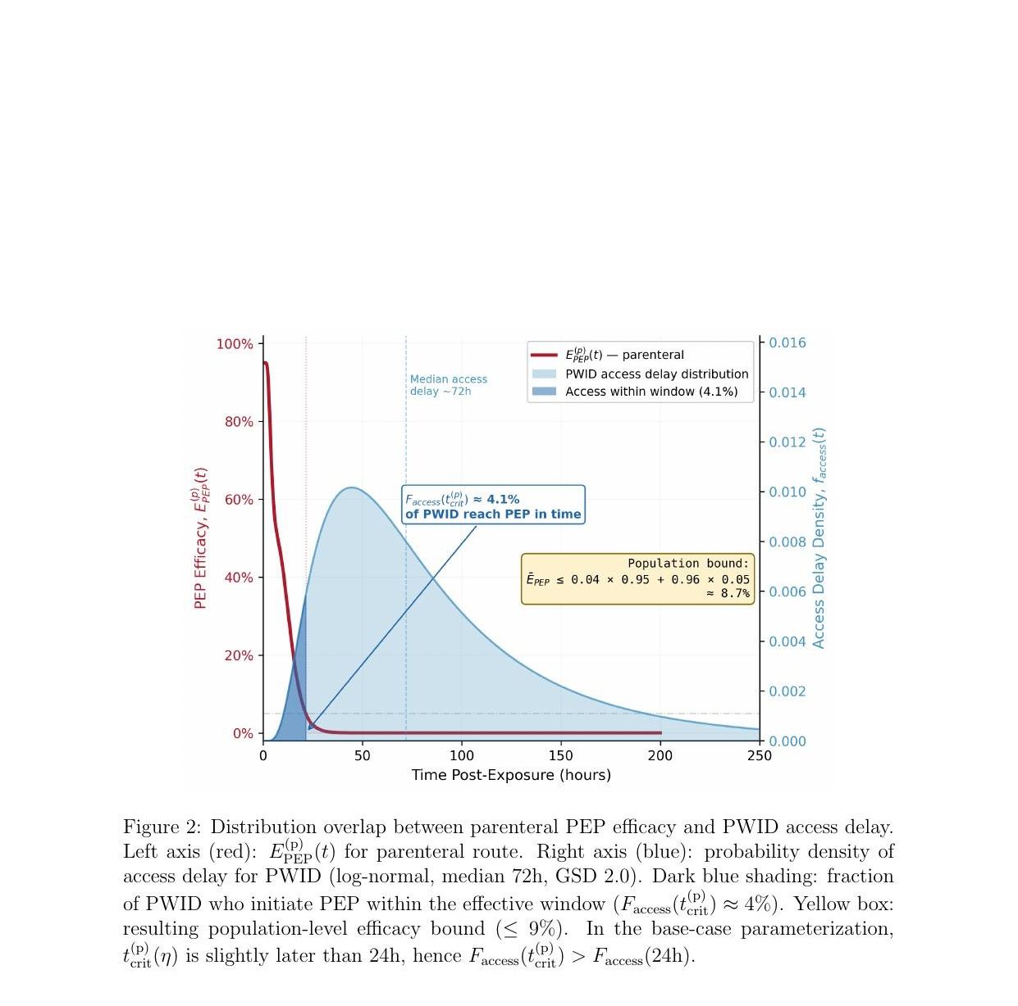
Figure 2: Distribution overlap between parenteral PEP efficacy and PWID access delay. Left axis (red): E^{(p)}_{PEP}(t) for parenteral route. Right axis (blue): probability density of access delay for PWID (log-normal, median 72h, GSD 2.0). Dark blue shading: fraction of PWID who initiate PEP within the effective window (F_{access}(t^{(p)}_{crit}) ≈ 4%). Yellow box: resulting population-level efficacy bound (≤ 9%).
Remark 6.3 (Failure mode classification). This failure is determined by the relationship between two distributions (access timing and integration timing) rather than by drug properties. PEP retains high efficacy within its biological window; the mismatch is structural, not pharmacological. All population-level conclusions are conditional on the specified access-delay distribution.

6.2 Implications for prevention architecture
Since PEP efficacy is bounded at low levels for parenteral exposures under current access conditions, PrEP is the modality most likely to deliver reliable population-level protection for PWID. Recent NHP studies confirm that long-acting capsid inhibitors provide effective pre-exposure protection against parenteral challenge: lenacapavir protected all treated macaques against intravenous SHIV [16], with similar results for mucosal routes [17, 18]. However, PrEP delivery for PWID faces its own structural barriers analyzed in companion work [19].

7 Discussion

7.1 Clinical implications
The central finding is that PEP may not function as a reliable population-level safety net for parenteral exposure where access delays routinely exceed the compressed window. The 72-hour window compresses to approximately 12–24 hours following injection exposure—a consequence of viral kinetics. Fewer than 5% of PWID can access PEP within this window, bounding expected population-level efficacy below 10% (Table 2).
This does not argue against offering PEP to any individual who presents in time. It does reframe the importance of PrEP for PWID: if post-exposure prevention cannot serve as a population-level safety net, then PrEP uptake below 1% of those with indication [7] means this population effectively lacks either prophylactic option. The 2025 CDC PEP guidelines [1] appropriately recommend PEP for all routes, but the implicit assumption that post-exposure prevention provides comparable population-level protection across routes is not supported by the underlying biology.

7.2 What is new
Our contribution is threefold: (1) a mechanistic explanation for why the PEP window exists and differs by route; (2) quantification of the compression ratio (∼3-fold), validated against NHP data; and (3) a model-free inequality (Proposition 6.2) showing that the conclusion holds across any reasonable parameterization of access delays.

7.3 Generalizability
The framework applies to any pathogen with analogous irreversible establishment dynamics. The bound in Proposition 6.2 requires only F_{access}(t_{crit}), making it portable to any setting where access delay data are available. The conclusion is setting-dependent: where rapid linkage programs achieve F_{access}(t^{(p)}_{crit}) > 20%, population-level PEP efficacy improves substantially (Table 2).

7.4 Limitations
The three-state model simplifies a continuum of partially established states. The stochastic layer approximates inter-individual variability; a full stochastic within-host model would yield more rigorous distributional estimates. More potent regimens may increase ε_{max} and ε_{mid}, but under the absorbing-state assumption with ε_{min} = 0, they cannot recover efficacy after reservoir commitment; t_{crit} is determined by integration kinetics rather than drug class. The access delay distribution is modeled parametrically, but the qualitative conclusion is robust (Table 2). Finally, Ē_{PEP} is a timing-based upper bound; adherence and regimen completion would reduce real-world effectiveness further.

8 Conclusions
PEP is not the safety net for parenteral HIV exposure that it is for sexual transmission. The biological window compresses by approximately 3-fold for injection exposures, and structural access delays for PWID systematically exceed this boundary. Under current conditions, expected population-level PEP efficacy for PWID is bounded below 10%.
This finding does not diminish PEP, which remains highly effective for every individual who accesses it in time. It does, however, reframe the importance of PrEP deployment for PWID. For a population that cannot rely on post-exposure prevention, pre-exposure prevention is the remaining biomedical option—and its current uptake remains well below levels needed for population-level impact. Accelerating PrEP access through long-acting injectable formulations, low-barrier delivery, and removal of structural obstacles to care is among the most important steps toward closing the prevention gap identified here.

Data Sharing
All model code, simulation outputs, and analysis scripts are available at
https://github.com/Nyx-Dynamics/Prevention-Theorem
All model inputs derive from published literature or synthetic populations; no individual-level data were used.

Declaration of Interests
The author reports prior employment with Gilead Sciences, Inc. from January 2020 through November 2024 and prior ownership of company stock, which was fully divested in December 2024. Gilead Sciences, Inc. had no role in the conception, design, analysis, interpretation, or writing of this study, and provided no funding, data, materials, or input into any aspect of the work. The author is the owner of Nyx Dynamics, LLC, a consulting company providing advisory and fractional leadership services in healthcare, technology, and complex systems. This research was conducted independently, released as open-source work, and was not produced as part of, or in support of, any paid consulting engagement. No other competing interests are declared.

Ethics Approval
Not applicable. This study used published aggregate data and mathematical modeling without human subjects involvement.

Acknowledgments
The author thanks the HIV prevention research community whose published work informed model parameterization, and PWID community advocates whose testimony informed characterization of structural barriers.
Use of AI and assistive technologies. Computational analyses were conducted using Python with open-source packages (NumPy, SciPy, Matplotlib). Large language models (Anthropic Claude and OpenAI ChatGPT) were used to support literature search and improve manuscript readability. JetBrains Junie was used for code correction, and Zotero AI for reference management. All AI tools were used as assistive technologies only; the author retains full responsibility for study design, analysis, interpretation, and conclusions.
Funding No external funding was received for this project.

References
[1] Mary R. Tanner, John G. O’Shea, Kathleen M. Byrd et al. Antiretroviral post-exposure prophylaxis after sexual, injection drug use, or other nonoccupational exposure to HIV—CDC recommendations, United States, 2025. MMWR Recomm Rep 2025; 74:1–56.
[2] Andrew J. McMichael and Sarah L. Rowland-Jones. The immune response to HIV. Immunity 2010; 33:431–441.
[3] Angela Wahl and Lena Al-Harthi. HIV infection of non-classical cells in the brain. Retrovirology 2023; 20:1.
[4] Janet D. Siliciano and Robert F. Siliciano. Enhanced culture assay for detection and quantitation of latently infected, resting CD4+ T-cells capable of producing infectious HIV-1. Methods Mol Biol 2015; 1354:3–15.
[5] Robert M. Grant, Javier R. Lama, Peter L. Anderson et al. Preexposure chemoprophylaxis for HIV prevention in men who have sex with men. N Engl J Med 2010; 363:2587–2599.
[6] Peter L. Anderson, David V. Glidden, Albert Liu et al. Emtricitabine–tenofovir concentrations and pre-exposure prophylaxis efficacy in men who have sex with men. Sci Transl Med 2012; 4:151ra125.
[7] Amy R. Baugher, Cyprian Wejnert, Dafna Kanny et al. Are we ending the HIV epidemic among persons who inject drugs? Key findings from 19 US cities. AIDS 2025; 39:1813–1819.
[8] Steffanie A. Strathdee, Irene Kuo, Nabila El-Bassel, Sally Hodder, Laramie R. Smith and Sandra A. Springer. Preventing HIV outbreaks among people who inject drugs in the United States: plus ça change, plus c’est la même chose. AIDS 2020; 34:1997–2005.
[9] Gero Hütter, Daniel Nowak, Maximilian Mossner et al. Long-term control of HIV by CCR5 Delta32/Delta32 stem-cell transplantation. N Engl J Med 2009; 360:692–698.
[10] Che-Chung Tsai, Kathelyn E. Follis, Agegnehu Sabo et al. Effectiveness of postinoculation (R)-9-(2-phosphonylmethoxypropyl)adenine treatment for prevention of persistent SIVmne infection depends critically on timing of initiation and duration of treatment. J Virol 1998; 72:4265–4273.
[11] Ron A. Otten, Dawn K. Smith, David R. Adams et al. Efficacy of postexposure prophylaxis after intravaginal exposure of pig-tailed macaques to a human-derived retrovirus (HIV type 2). J Virol 2000; 74:9771–9775.
[12] Hal L. Smith. Monotone Dynamical Systems: An Introduction to the Theory of Competitive and Cooperative Systems, Vol 41 of Mathematical Surveys and Monographs. Providence, RI: American Mathematical Society, 1995.
[13] Alan S. Perelson, Avidan U. Neumann, Martin Markowitz, John M. Leonard and David D. Ho. HIV-1 dynamics in vivo: virion clearance rate, infected cell life-span, and viral generation time. Science 1996; 271:1582–1586.
[14] Peter Emau, Yanwei Jiang, Michael B. Agy, Norbert Bischofberger, Robert Custer and Che-Chung Tsai. Post-exposure prophylaxis for SIV revisited: animal model for HIV prevention. AIDS Res Ther 2006; 3:29.
[15] Jessica L. Taylor, Alexander Y. Walley and Angela R. Bazzi. Stuck in the window with you: HIV exposure prophylaxis in the highest risk people who inject drugs. Subst Abus 2019; 40:441–443.
[16] Adrienne E. Swanstrom, Robert J. Gorelick, Jeffrey L. Welker et al. Long-acting lenacapavir protects macaques against intravenous challenge with simian-tropic HIV. eBioMedicine 2023; 95:104764.
[17] Sergio J. Vidal, Elena Bekerman, Deanna Hansen et al. Long-acting capsid inhibitor protects macaques from repeat SHIV challenges. Nature 2022; 601:612–616.
[18] Elena Bekerman, Stephen R. Yant, Laura VanderVeen et al. Long-acting lenacapavir acts as an effective preexposure prophylaxis in a rectal SHIV challenge macaque model. J Clin Invest 2023; 133:e167818.
[19] A. C. Demidont. Structural barriers, stochastic avoidance, and outbreak risk in HIV prevention for people who inject drugs. Preprints 2026; doi:10.20944/preprints202601.0948.v1. Preprint.

