S1 Appendix
Components of this appendix are labelled alphabetically and are cited as, for example, “Table A in S1 Appendix” and “Fig A in S1 Appendix”.
Structural limits of single-barrier reform in algorithmic recourse: a formal series-system model with implications for digital health
A.C. Demidont
Scope of claims. All numerical values below (the 0.0018% baseline, the 0.0054% maximum single-barrier gain, the 87.6% three-way share, and the Shapley/Sobol/bootstrap/SNR outputs) are model-derived illustrations under a provisional cross-domain parameterization; they are consistent with, but not independent confirmation of, Propositions 1–2. All stochastic analyses are seeded (seed 42) and reproducible via the repository make pipeline.
Table A. Individual barrier removal effects.
Barrier | Layer | Baseline P (%) | P with removal (%) | Δ (%) | 95% CI
Rapid Data Transmission | L1 | 0.0018 | 0.0060 | 0.0042 | (0.0038, 0.0046)
Multi-System Integration | L1 | 0.0018 | 0.0033 | 0.0015 | (0.0013, 0.0017)
Permanent Storage | L1 | 0.0018 | 0.0040 | 0.0022 | (0.0020, 0.0024)
Error Detection Difficulty | L2 | 0.0018 | 0.0051 | 0.0033 | (0.0030, 0.0036)
Correction Process Barriers | L2 | 0.0018 | 0.0051 | 0.0033 | (0.0030, 0.0036)
Incomplete Correction Propagation | L2 | 0.0018 | 0.0045 | 0.0027 | (0.0024, 0.0030)
Awareness Gap | L3 | 0.0018 | 0.0060 | 0.0042 | (0.0038, 0.0046)
Record Access Barriers | L3 | 0.0018 | 0.0033 | 0.0015 | (0.0013, 0.0017)
Legal Knowledge Gap | L3 | 0.0018 | 0.0072 | 0.0054 | (0.0050, 0.0060)
Legal Resource Barriers | L3 | 0.0018 | 0.0045 | 0.0027 | (0.0024, 0.0030)
Systemic Bias in Algorithms | L3 | 0.0018 | 0.0060 | 0.0042 | (0.0038, 0.0046)
L1 = Data Integration; L2 = Data Accuracy; L3 = Institutional. All individual effects are <0.02%, consistent with Proposition 1. CIs from bootstrap resampling (n = 1,000).
Table B. Shapley value attribution.
Barrier | Layer | Shapley value (%) | Rank
Legal Knowledge Gap | Institutional | 10.95 | 1
Rapid Data Transmission | Data Integration | 10.72 | 2
Systemic Bias in Algorithms | Institutional | 10.53 | 3
Incomplete Correction Propagation | Data Accuracy | 10.10 | 4
Awareness Gap | Institutional | 9.67 | 5
Error Detection Difficulty | Data Accuracy | 9.53 | 6
Correction Process Barriers | Data Accuracy | 9.21 | 7
Legal Resource Barriers | Institutional | 8.50 | 8
Permanent Storage | Data Integration | 7.79 | 9
Record Access Barriers | Institutional | 6.79 | 10
Multi-System Integration | Data Integration | 6.21 | 11
Shapley values account for interaction effects across all possible removal orderings, providing fair attribution even under multiplicative blocking.
Table C. Sobol sensitivity indices.
Barrier | S1 | ST | Interaction (ST−S1)
Rapid Data Transmission | 0.063 | 0.101 | 0.038
Multi-System Integration | 0.073 | 0.103 | 0.030
Permanent Storage | 0.059 | 0.097 | 0.038
Error Detection Difficulty | 0.069 | 0.098 | 0.029
Correction Process Barriers | 0.088 | 0.103 | 0.015
Incomplete Correction Propagation | 0.074 | 0.101 | 0.027
Awareness Gap | 0.075 | 0.100 | 0.025
Record Access Barriers | 0.075 | 0.108 | 0.033
Legal Knowledge Gap | 0.084 | 0.103 | 0.019
Legal Resource Barriers | 0.094 | 0.106 | 0.011
Systemic Bias in Algorithms | 0.065 | 0.098 | 0.034
S1 = first-order (main) effects; ST = total effects including interactions. Saltelli sampling with n = 1,024 base samples (seeded). ST exceeded S1 for all barriers, but the gaps are small and, for several barriers, within Monte-Carlo error at this sample size; the characterization “substantially exceeds S1 for all barriers” is therefore not supported.
Table D. Bootstrap robustness summary.
Finding | Threshold | % resamples supporting
Three-way factorial share (>70% of achievable improvement) | >70% | 100.0%
Maximum individual barrier effect | <1% | 100.0%
Barriers needed for 90% success | ≥10 of 11 | 100.0%
Parameter-perturbation resampling with n = 1,000 resamples and ±10% perturbation. Computed with the identical baseline factorial decomposition (subtracting main and pairwise terms), the three-way factorial share under perturbation had mean 87.7% (95% CI 84.8–90.3), centered on the canonical 87.6% — i.e., the interaction structure is stable under ±10% perturbation.
Table E. Signal-to-noise ratio analysis.
Noise level (%) | SNR (dB) | Quality | CV (%)
1 | 14.8 | Good (>10 dB) | 3.3
3 | 11.7 | Good (>10 dB) | 6.8
5 | 7.8 | Marginal (3–10 dB) | 16.6
10 | 4.6 | Marginal (3–10 dB) | 35.1
15 | 2.8 | Marginal (3–10 dB) | 53.0
20 | 1.4 | Poor (<3 dB) | 73.0
25 | −0.4 | Poor (<0 dB) | 109.8
30 | −1.1 | Poor (<0 dB) | 128.7
SNR remains positive (>0 dB) up to approximately 20% parameter noise (seeded); the coefficient of variation rises to 109.8% at 25% and 128.7% at 30% noise, so robustness is bounded and is not claimed under arbitrary uncertainty. CV = coefficient of variation of output success probability.
Table F. Parameter derivation audit trail (all 11 barriers).
For each barrier: source domain, exact source statistic, resulting pass probability, plausibility range, and transportability limitation. This makes each parameter auditable from the manuscript package alone; the full derivation logic is mirrored in the repository (data/parameter_sources/parameter_derivation.md). Each statistic is drawn from the cited primary source and year.
Barrier (layer) | Source domain | Source statistic [source] | p | Range | Transportability limitation
Rapid Data Transmission (L1) | Credit reporting | Furnishers transmit adverse data to CRAs within 1–2 days [CFPB 2022] | 0.30 | 0.20–0.40 | Credit-furnishing timing; not measured for clinical/EHR data flows
Multi-System Integration (L1) | Credit reporting | 20% had error on ≥1 of 3 reports [FTC 2013] | 0.55 | 0.40–0.65 | Cross-bureau error; not clinical multi-system integration
Permanent Storage (L1) | Credit reporting | 7-yr retention; <20% removed in 4 yr [CFPB 2022; FCRA §605] | 0.45 | 0.35–0.55 | FCRA retention regime; not healthcare record retention
Error Detection Difficulty (L2) | Credit reporting | 26% identified material errors [FTC 2013] | 0.35 | 0.25–0.45 | Consumer credit review; not clinical error detection
Correction Process Barriers (L2) | Credit reporting | 37% of disputes fully resolved [FTC 2013; CFPB 2022] | 0.35 | 0.25–0.45 | Credit dispute process; not clinical data correction
Incomplete Correction Propagation (L2) | Credit reporting | Corrections do not auto-propagate across CRAs [CFPB 2022; FTC 2015] | 0.40 | 0.30–0.50 | Inter-CRA propagation; not clinical systems
Awareness Gap (L3) | Civil legal | Help sought for ~1 in 4 civil legal problems [LSC 2022] | 0.30 | 0.20–0.40 | Civil legal need; not algorithmic-decision awareness
Record Access Barriers (L3) | Credit reporting | Statutory free-report access with practical barriers [FCRA §612; CFPB 2022] | 0.55 | 0.45–0.65 | FCRA access; not clinical record access
Legal Knowledge Gap (L3) | Civil legal | 39% believe they can use the legal system [LSC 2022] | 0.25 | 0.15–0.35 | General legal confidence; not algorithm-specific rights
Legal Resource Barriers (L3) | Civil legal | 46% cite cost; ~50% of applicants turned away [LSC 2022] | 0.40 | 0.30–0.50 | Civil legal-aid capacity; not algorithm-specific representation
Systemic Bias in Algorithms (L3) | Healthcare audit | Cost-for-need proxy bias; correcting it raises Black enrollment 17.7%→46.5% [Obermeyer 2019] | 0.30 | 0.20–0.40 | Single commercial tool / one health system; NOT a population-wide bias rate (a prior “62%” figure was erroneous and is corrected)
Table G. Robustness to alternative topologies: correlated barriers and repeated attempts (seed 42, n = 100,000).
Scenario | Baseline P | 3-way share | max single-barrier | max single-layer
Independence (ρ = 0, analytic reference) | 0.0018% | 87.6% | 0.0054% | 0.36%
Copula ρ = 0.1 | 0.049% | 84.5% | 0.071% | 0.97%
Copula ρ = 0.2 | 0.288% | 81.9% | 0.185% | 1.85%
Copula ρ = 0.3 | 0.835% | 79.9% | 0.376% | 2.74%
Copula ρ = 0.4 | 1.778% | 78.5% | 0.606% | 3.71%
Copula ρ = 0.5 | 3.200% | 77.4% | 0.821% | 4.50%
Block copula ρ = 0.5 | 0.151% | 66.0% | 0.142% | —
Repeated attempts m = 2 | 0.352% | 53.3% | 0.452% | 5.70%
Repeated attempts m = 3 | 3.651% | 25.2% | 2.665% | 16.88%
Under correlation the comparative conclusion holds (single-layer ≪ coordinated) while the baseline value is correlation-sensitive; under repeated attempts interaction dominance attenuates, delimiting the model’s domain of validity to approximately single-pass serial recourse. ρ denotes the latent Gaussian-copula correlation parameter, not the post-thresholding Bernoulli correlation. The ρ = 0 row reports exact analytic values; the Monte-Carlo estimate at ρ = 0 is noise-limited (~2 successes per 10^5 draws) and appears in the repository CSV, so the low-ρ rows (ρ ≤ 0.15) carry visible Monte-Carlo error.
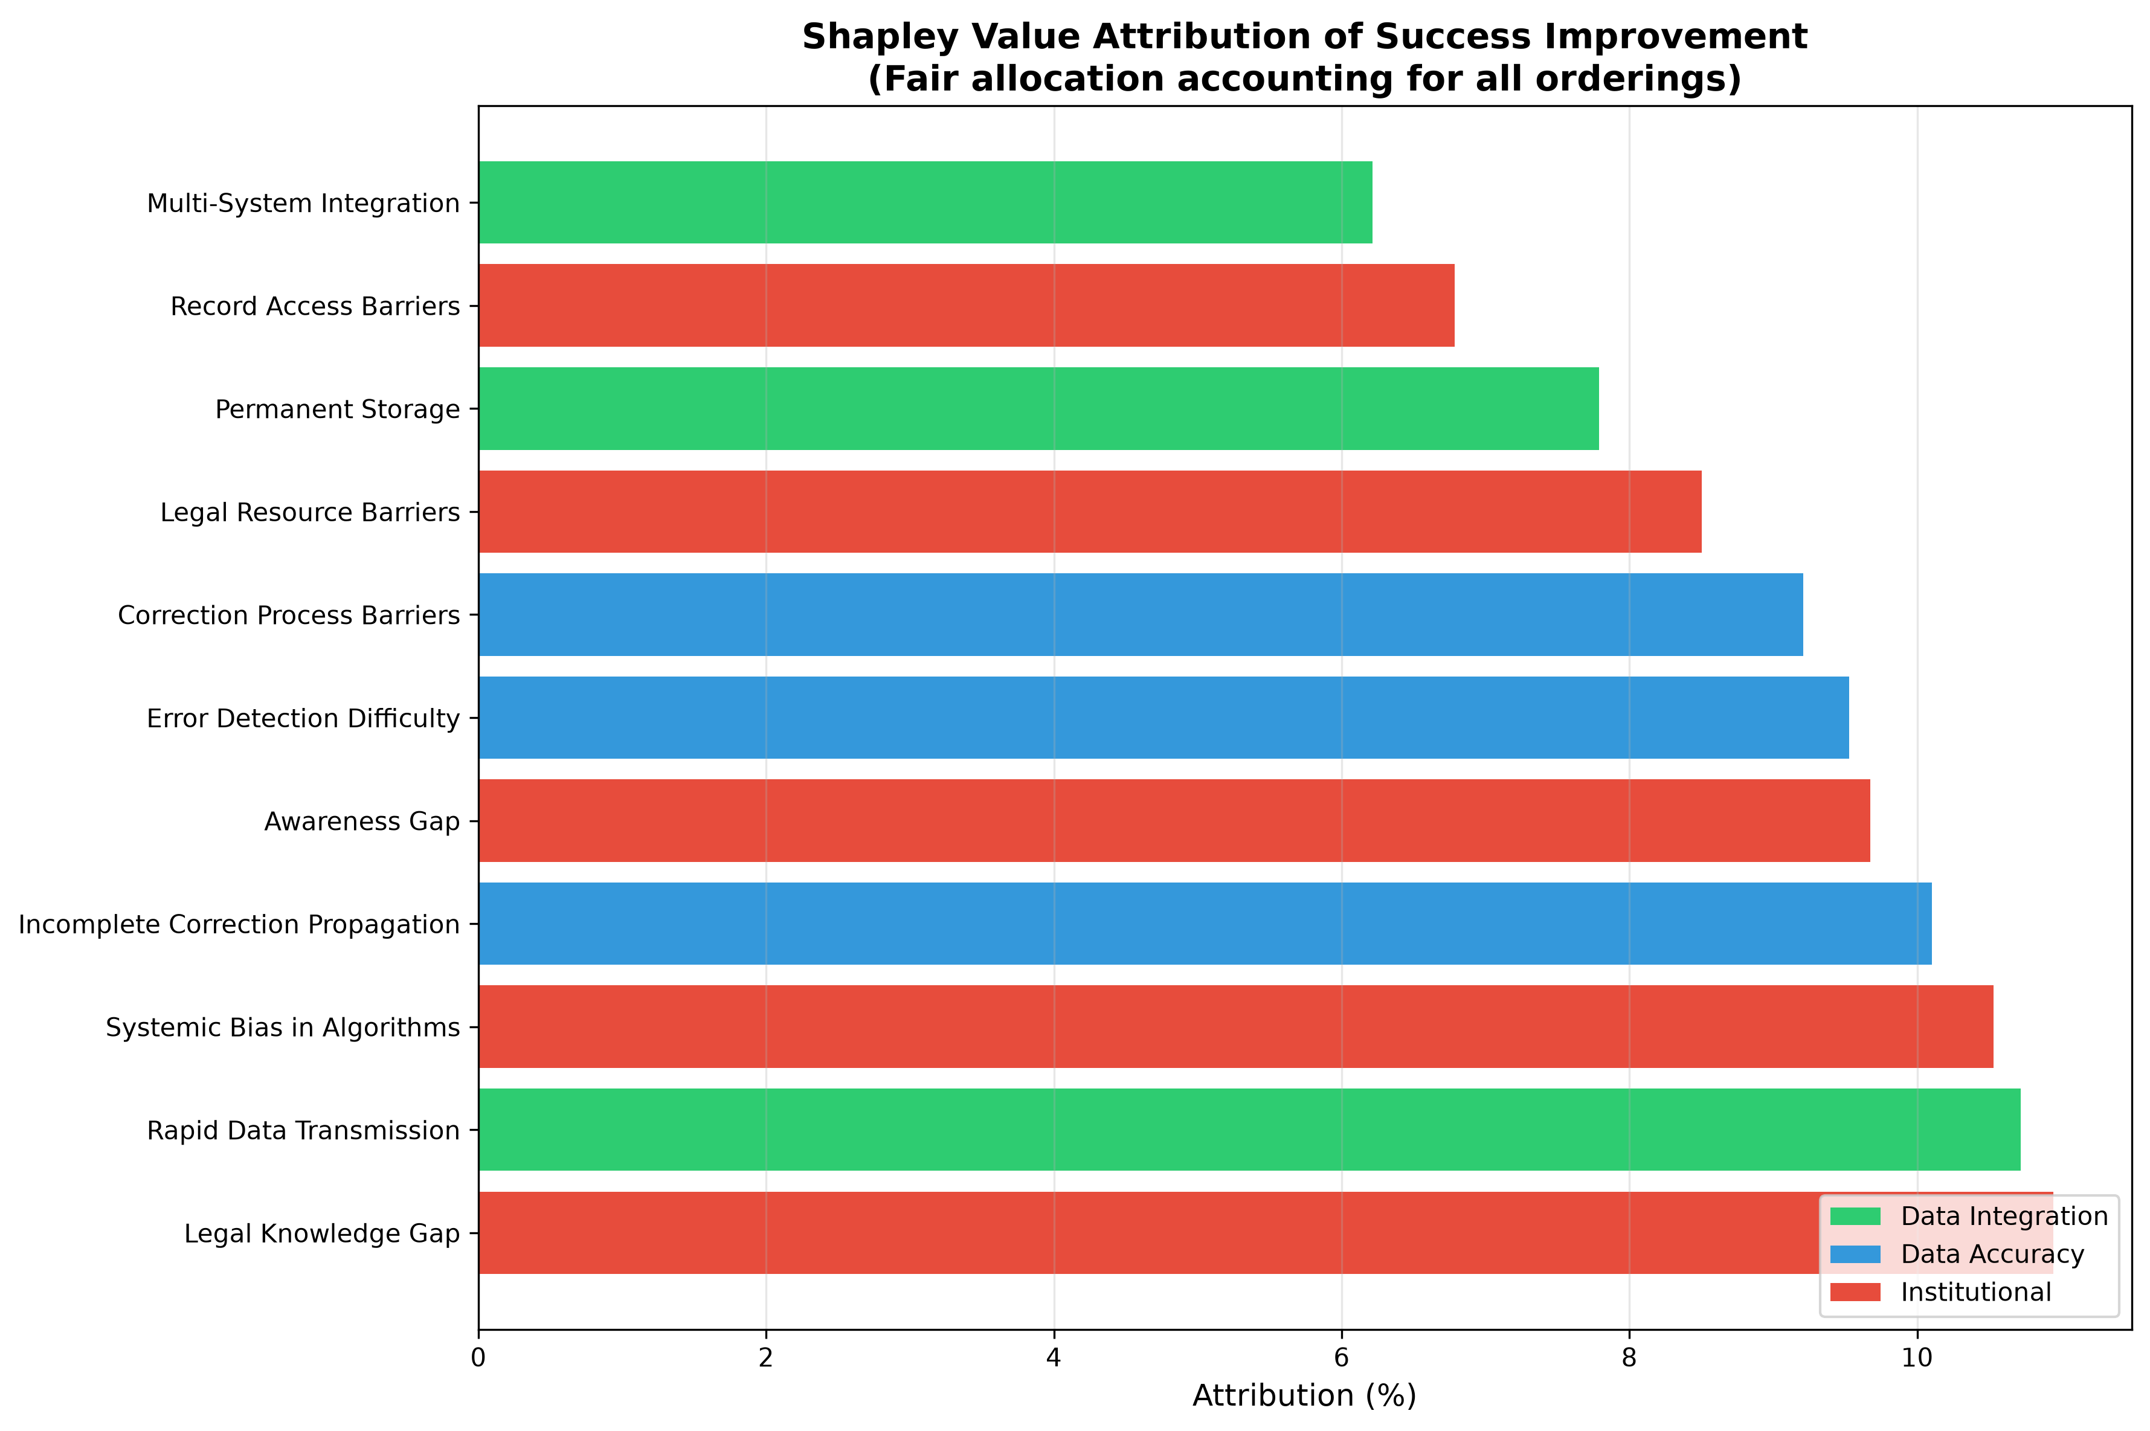
Fig A. Shapley value attribution of barrier contributions. Shapley value decomposition assigning relative contribution of each barrier to overall system success while accounting for all possible barrier removal orderings. Barriers are coloured by layer: green = Data Integration, blue = Data Accuracy, red = Institutional. Values represent fair attribution of total achievable improvement, with the five highest-contributing barriers spanning all three layers, consistent with the cross-layer nature of the modeled dynamics.
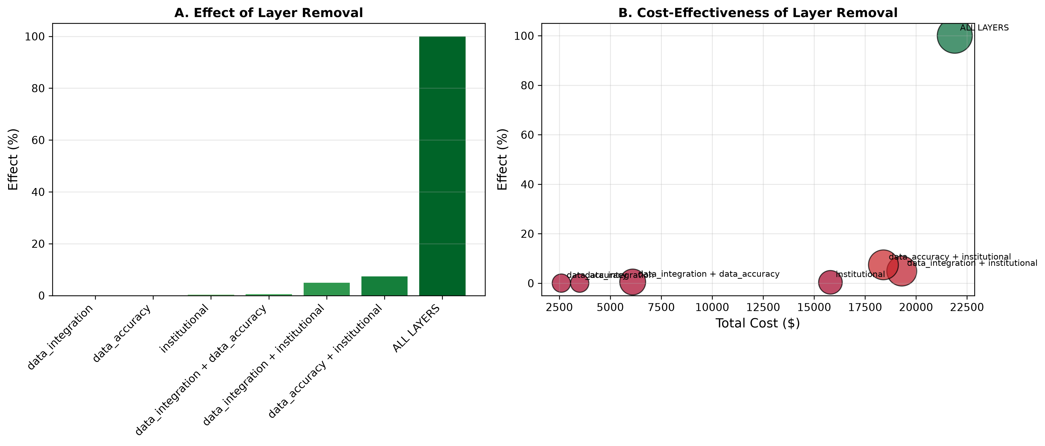
Fig B. Effect of layer removal on system success probability. Only complete removal across all three layers yields substantial improvement (100%). Single-layer removal produces negligible effects; two-layer combinations yield at most 7.4% (Data Accuracy + Institutional), consistent with the model’s three-way interaction structure.

