CROI 2026 · abstract submission
Temporary Loss of Eligibility Cancels Exactly in Cross-Sectional HIV Incidence Estimation
A. C. Demidont, Nyx Dynamics LLC. ORCID 0000-0002-9216-8569.
BACKGROUND: Cross-sectional recency assays increasingly reconstruct counterfactual placebo incidence for HIV prevention trials, where placebo arms are seldom ethical. They condition on eligibility at survey, yet eligibility often changes between acquisition and sampling through incarceration, migration, hospitalization, or disengagement from care. Existing frameworks assume the moving fraction is small rather than characterizing what movement does. Whether temporary loss biases incidence, and in which direction, is unestablished.
METHODS: We refined the Gao-Bannick eligibility indicator A(t) as the observable state of a finite-state Markov process admitting temporarily unobservable states and an absorbing state. We derived the expected recent-infection count allowing acquisition in every living state, not only while observable, and obtained the estimator's probability limit as an integral against a historical observability weight w(u). We composed this process with the Pan-Bannick-Gao model of survey attendance and prior-testing exclusion. Results were verified by three implementations sharing no code: matrix exponential, adaptive quadrature, and a generative individual-level simulator.
RESULTS: Temporary eligibility loss did not itself bias estimation. Under five conditions, stable living-state composition, a demographically stationary observable susceptible pool, state-invariant acquisition hazard, infection-independent movement, and no absorbing loss, losses and returns cancelled exactly: lambda-hat/lambda-E = 1 to machine precision across nine occupancy-by-sojourn combinations, independently of the recency function, and at occupancies to 15%. Cancellation held within each stationary stratum and therefore under arbitrary mixtures of movement propensity, so recurrent movement concentrated in a high-propensity subgroup did not break it. Bias required a specific symmetry failure. Absorbing mortality at 0.040/year attenuated estimates by 2.1% (0.979); moving the composed zero-bias boundary above unity required 0.085/year, 2.1-fold sourced rates. Acquisition while unobservable attenuated or inflated estimates depending on relative hazard (0.944 at eta=0, 1.007 at eta=1.8). Setting w(u)=1 recovered the published Pan-Bannick-Gao limiting expression exactly.
CONCLUSIONS: Eligibility loss should not be treated as inherently biasing. Transient, bidirectional movement cancels under identifiable symmetry conditions; correction is warranted only where a named condition fails. Absorbing and temporary loss are therefore not interchangeable, and the parameter governing sensitivity is the state-specific acquisition hazard, not the occupancy of unobservable states. Occupancy alone cannot establish that an estimate is biased.
Body: 348 words (limit 350). Figure: 1.

Figure
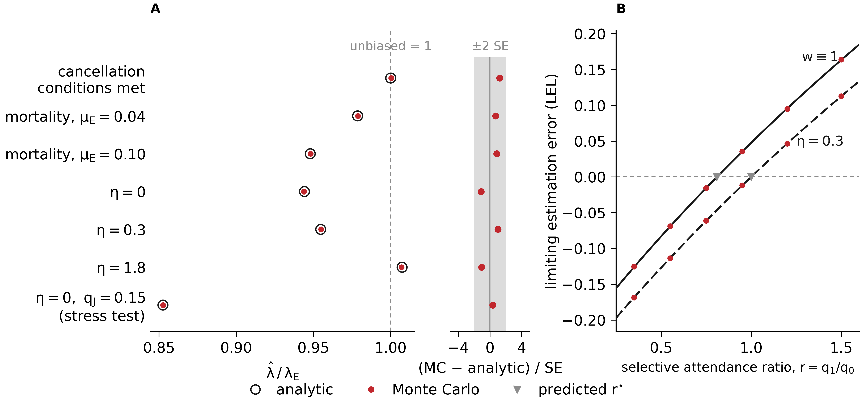
FIGURE. Analytic predictions and independent Monte Carlo validation of eligibility-dynamic bias.
(A) Estimated-to-target incidence ratio under the exact-cancellation conditions and selected violations. The dashed line denotes no bias. Open circles are analytic limits; red points are Monte Carlo means over 24 independent replicates of 15 million individuals each, whose 95% confidence intervals are narrower than the plotting symbols; standardised Monte Carlo minus analytic discrepancies are shown at right, with the shaded band at plus or minus two standard errors. When all five conditions hold (stable living-state composition, demographically stationary observable susceptible pool, state-invariant acquisition, infection-independent movement, no absorbing loss), temporary losses and returns cancel exactly at 1.000. Absorbing loss at all-cause mortality mu-E attenuates the estimate to 0.979 at 0.04/year and 0.948 at 0.10/year. Acquisition in temporarily unobservable states at relative hazard eta attenuates when eta is below one (0.944 at eta = 0, 0.955 at eta = 0.3) and inflates when eta exceeds one (1.007 at eta = 1.8), so the direction of bias is set by the acquisition hazard rather than by occupancy. The final row is a stress test raising unobservable occupancy to 15% (0.853); elsewhere jail and prison occupancies are 3% and 5% with mean sojourns of 32 days and 2.7 years.
(B) Limiting estimation error across the screening-attendance ratio r, without upstream eligibility distortion (w = 1, solid) and with state-dependent acquisition (eta = 0.3, dashed). Triangles denote analytically predicted zero-bias boundaries, which the simulator reproduces without being given them; points are independent Monte Carlo estimates. Without dynamics the boundary is exp(-theta c) = 0.810. Background HIV testing rate theta = 0.844/year, testing-based exclusion cutoff c = 90 days, and a gamma recency function with window parameter 163 days and shadow 260 days, giving MDRI (Omega_T*) = 151 days over the T* = 2 year window; the window parameter and the MDRI are distinct quantities and are easily conflated.
All 19 comparisons agree within |t| = 2.20 on 23 degrees of freedom. The simulator shares no code with the analytic derivation and every cell uses a disjoint block of random seeds.

Submission notes
Not part of the abstract. Decisions, provenance and the boundaries of what is claimed — for co-author review, not for the portal.
Title
Submit: Temporary Loss of Eligibility Cancels Exactly in Cross-Sectional HIV Incidence Estimation
Eleven words. Three changes from the draft title:
- "Temporary" for "Transient." The whole point is a contrast with absorbing loss, and "temporary" carries that to a clinical reader without a definition. "Transient" also has a competing technical sense in Markov theory (a transient state), which is not what is meant.
- "Cancels" for "Can cancel." "Can" invites the reader to file this as a theoretical possibility. The result is an equality under stated conditions, and the conditions are named in the first line of Results. Assertive titles also survive CROI's programme listing better.
- Dropped "Bias" phrasing entirely so the title states the finding, not the topic.
Two alternates, if a co-author objects to an assertive title:
# | Title | Note
B | Eligibility Dynamics in Cross-Sectional HIV Incidence Estimation: Exact Cancellation and Its Failure Modes | Neutral, more conventional; buries the finding after a colon
C | When Does Leaving the Observable Population Bias HIV Incidence Estimates? | Question form; good for a poster walk-up, weaker in a citation

Avoid the original's "Can Cancel Exactly" — reviewers read hedged titles as preliminary work.
---
——————————————————————————————————————————————
Category
Primary: Epidemiology — HIV incidence estimation / surveillance methods. This is a methods abstract submitted into an epidemiology track, so the Background does the work of establishing why a clinician should care (counterfactual placebo incidence for trials that cannot randomize to placebo). Do not submit it as a basic-science or statistics-only abstract; the audience that needs the result is the one designing and interpreting PURPOSE-style trials.
---
——————————————————————————————————————————————
Figure choice
Submit outputs/figures/croifalsification.pdf (vector; .png at 600 dpi alongside). This is the only figure the script emits — deliberately, so there is nothing to pick between at submission time.
A sparse register was built and rejected: bare parameter labels, no in-plot annotation, the original "nothing in the plot" brief. It was the better-looking figure and the worse abstract figure, because it left a dashed vertical line, a grey band, and a bare r axis undefined in the plot while pushing a five-key legend at a reader who has ten seconds. The version here spends nine words — "unbiased = 1", "±2 SE", "(stress test)", and the two curve tags — to remove every one of those ambiguities, and deletes two legend keys in exchange, so the total quantity of text is lower, not higher. Recoverable from git history at 6583d3a if wanted.
Typography is up ~25% from the first draft (8 pt to 10 pt): 8 pt is legible on screen and not on a printed programme page. Caption in FIGURECAPTION.txt, 406 words, regenerated by the same script that draws the figure so the two cannot drift apart. Two panels:
- A. Census sampling. λ̂/λE by condition: the five-condition case pinned at 1, then each symmetry failure one at a time. Open circles analytic, red points Monte Carlo. A narrow attached strip shows the same seven comparisons studentised, band at ±2 SE — because at the value scale the 95% intervals are ~0.3% of the axis and disappear under the markers. A figure whose claim is agreement has to show agreement at the resolution it was tested at, not at one where any result would look fine.
- B. Composed with the Pan screening and prior-testing stages. Limiting estimation error against the attendance ratio r, for w ≡ 1 and with dynamics; triangles mark the predicted zero-bias boundary, which the simulator reproduces without being given it.
All 19 comparisons agree within |t| = 2.20 on 23 df. Regenerate with make croi-figure (~20 min, 5.7e9 draws); restyle without re-simulating via python3 falsificationfigure.py --redraw, which rebuilds from the committed tables.
This is the falsification, not a sensitivity surface: it shows that two independent implementations agree, that the cancellation is exact rather than approximate, and that each named mechanism moves the estimate in the predicted direction. The abstract's credibility claim is "three implementations sharing no code," and this is the only figure that makes that visible.
Plot text is deliberately minimal, per the brief: no in-plot title, no annotations, no inline numbers. Only tick labels (bare parameter values), two axis labels, and a shared legend below both panels. Everything interpretive — mechanism names, the five conditions, sojourn lengths, θ, c, MDRI — is in the caption.
Rejected alternatives
The (ηJ, ηP) contour surface. The best figure in the project and the wrong one here. It is a sensitivity object about a parameter that has never been measured, so in a 348-word abstract headlining an exact equality it moves attention from the theorem to "what is η in your population?" — where the honest answer is that no contemporary PWID-specific estimate exists. Fine in discussion, poor in review. It also carries the jail/prison site work, held out of v1. Build it for the poster, where there is room to say what η is and is not.
A cancellation schematic. A flow diagram of E leaving to O and returning restates one sentence of Results. Schematics earn space when a mechanism is hard to hold in words.
---
——————————————————————————————————————————————
Held out of version 1
- the jail/prison site-level occupancy surface and the eight-state PURPOSE 4 distribution;
- the county-specific age denominators and per-site break-even reductions in qj;
- everything from the superseded manuscript, including the mean-duration deflation range and the joint intervention-arm bias factor.
The abstract is intelligible without all of it. Adding any of it converts a clean methods abstract into an empirical-parameterization abstract, which is a different submission with a different reviewer pool and a weaker headline.
---
——————————————————————————————————————————————
Number provenance
Every quantitative claim in the body, the script that regenerates it, and the test that asserts it.
Claim in body | Value | Regenerated by | Asserted by
Exact cancellation | 1.0, dev 0.0 at 4001-pt grid | analysis/validatetheorems.py | testexactcancellation
Nine occupancy x sojourn combinations | 9 cells | same | same
Independent of the recency function | 3 bases | same | testcancellationisphiindependent
Occupancies to 15% | qJ = 0.15 | analysis/etasurface.py | testmontecarlomatchesanalytic[highoccupancy]
Frailty-stratum cancellation | 1.00000000 | analysis/frailtymixture.py | testfrailtymixturecancellation
Mortality attenuation | 0.9786, 2.1% | analysis/mortalitythreshold.py | testabsorbingonlyclosedform
mucrit | 0.0852/yr, 2.13x | same | testmucritisaroot
eta = 0 | 0.9442 | analysis/etasurface.py | testetazerorecoversrestrictedmodel
eta = 1.8 | 1.0074 | same | testetaaboveoneinflates
Pan expression recovered at w = 1 | 9/9 cells, <0.03e-3 | analysis/reproducepan.py | testpanrecovery

Figure numbers
As plotted, from the committed tables.
condition | analytic | Monte Carlo | SE | t
cancellation conditions met | 1.00000 | 1.00031 | 0.000255 | 1.22
mortality, muE=0.04 | 0.97857 | 0.97878 | 0.000287 | 0.73
mortality, muE=0.10 | 0.94794 | 0.94813 | 0.000222 | 0.85
eta=0 | 0.94417 | 0.94391 | 0.000239 | -1.11
eta=0.3 | 0.95470 | 0.95493 | 0.000229 | 1.00
eta=1.8 | 1.00736 | 1.00696 | 0.000381 | -1.05
eta=0, qJ=0.15 (stress test) | 0.85262 | 0.85272 | 0.000268 | 0.35
——————————————————————————————————————————————
Claims deliberately not made
Listed so nothing gets added back under deadline pressure.
- No claim that any specific published trial estimate is biased, or by how much. The abstract says when correction is and is not warranted.
- No claim about eta's value in any real population. It is a free parameter shown in both directions.
- No claim that the cancellation requires reversible or detailed-balanced movement. It needs stationarity only, and saying otherwise understates the result.
- No claim of exactness for the boundary beyond the Poisson inter-test case, where it holds exactly. Under a uniform inter-test process invariance is approximate (<=0.6%).

——————————————————————————————————————————————
This document is generated. It is built by manuscript/croi2026/build_docx.py from body.txt, FIGURE_CAPTION.txt, README.md, CITATION.cff and the rendered figure; edits made here are overwritten on the next build, so change the sources instead.
Reproduction: github.com/Nyx-Dynamics/nyx-eligibility-dynamics — make verify (72 tests), make figures, make croi-figure, make docx.

