A+ Computer Science NET SMASHER

Lab Goal: This lab was designed to teach you more about Objects and the Jeroo environment. You will analyze a problem and determine the steps needed to solve it. You must determine how many times to hop, when to pick the flower, when to toss the flower, and when to stop. Calculate the number of hops and when to pick or toss the flower. Use care that you do not end up in the net.

Lab Description: This lab requires you to use 3 command methods – hop(), pick(), and toss(). Using these commands, clear the top row of the three islands and stop at the position where the last fence was.

Files Needed:
Nets.jsc
Nets.jev

Starting Screen:

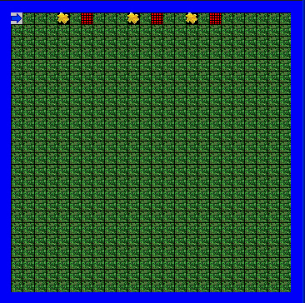
algorithm help

Analyze – what tasks do I need to do.
- When to hop??
- When to pick flowers?
- When to toss flowers?
- When to stop?

Preconditions –
- Where do I start

Postcondition –
- Successful hopping
- Successful flower picking.
- Successful flower tossing.
- Fences all gone.
- Flowers all gone.

Ending Screen:

