**Megan Bond**

**Bondmegan@csu.fullerton.edu**

**CPSC 386 Final Project Summary and Design Report**

**Introduction:**

Dig Deeper is a game in which the player must devise a stable series of tunnels, ladders and supports to extend downward through a procedurally generated cross-section of underground terrain, with careless mining threatening to cause a deadly cave in.

**Rules and Win/Lose State:**

The player controls a miner, who starts in the top left tile in an 11 by 14 grid of tiles, which at the start of any level are either tiles representing regular soil or soil bearing a large rock. The player may perform three actions as they play. They may attempt to move up, down, left or right. If the tile they are attempting to move into is horizontally adjacent to them and is a soil tile, a ladder tile or a tunnel tile, they move into it, changing the tile type to tunnel if it was soil. If the tile is horizontally adjacent to them and is a rock tile or a support tile, they fail to move in that direction and stay in place. If the player is attempting to move vertically, they do so only if the tile they are in and the tile below them are ladder tiles. The player may place down ladder tiles in their current tile and the tile below them, but may only do so if both tiles are either soil or tunnel tiles. The player may finally build supports to the left and right of them, building them into soil tiles exclusively. Supports are used help to prevent either of the lose scenarios in the game. Deadly cave-ins, the lose scenarios, are caused by moving the player under a rock tile or building a ladder directly underneath another ladder, which can be prevented in both cases by either doing so more than three tiles below the offending tile, or by placing a support between the rock/top ladder and the player/bottom ladder. The goal of the game is to guide the miner to the bottom of the screen, which starts a new level with an increased number or rock tiles, six times, triggering the win state.

**Scoring:**

There is no scoring. The player makes their way through the 6 levels to win.

**Controls:**

The game is controlled using the arrow keys for movement, the ‘z’ key placing supports to the left of the miner, the ‘c’ key placing supports to the right of the miner and the ‘x’ key putting down ladders. The player is assumed to be comfortable moving orthogonally with the arrow keys.

**Expected Play-Time:**

On average, a successful game will likely take 10 minutes, with an unsuccessful game being cut short earlier.

**Expected Skills:**

Player is expect to be able to operate a keyboard, mouse, and computer. Player should be able to recognize a path through the “maze” of boulders.

**Algorithms:**

The most nontrivial of the algorithms used in the game is the generation of the levels, specifically the hazardous rock tiles, accomplished by checking out from a random tile in all directions to assure that they are a certain distance from another rock tile. The algorithm places more rocks linearly as the level increases.

**Uncertainty:**

The path down to the bottom of each map is potentially different each time as the placing of the boulders is random.

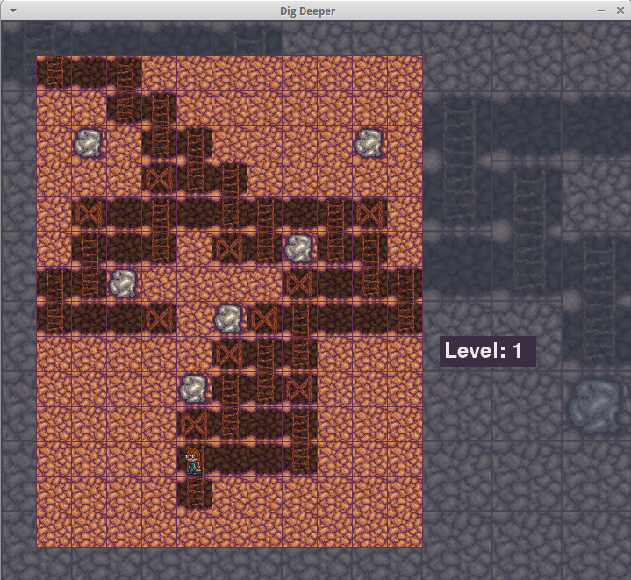

Here you can see the game as it might look towards the end of the first level. You can clearly note the strategic placement of the x-shaped supports, and how they simultaneously limit and permit movement in the environment. The level display is also clearly indicated to the left, along with a pleasing background.

**Bibliography**

**Pygame Documentation** http://pygame.org/docs/

**Python 3 Documentation** https://docs.python.org/3/