<https://fonts.google.com/specimen/Bebas+Neue> = Titre / Important | <https://fonts.google.com/specimen/Quicksand> = Texte général

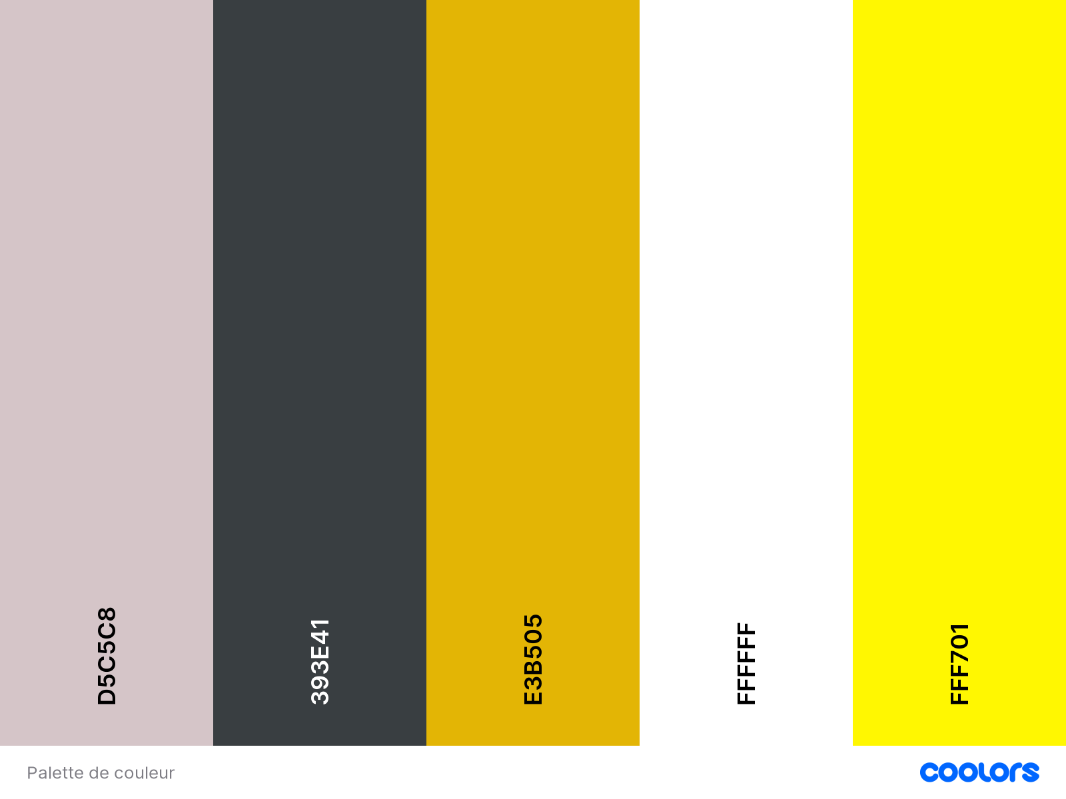<https://fontawesome.com/search?m=free&o=r> = icones | <https://getwaves.io/> = formes

<https://getbootstrap.com/docs/5.3/getting-started/introduction/>