VidyaSetu
Implementation and Feasibility Note
Team Zenith
NISHTHA TIWARI
ABHIRAJ PRATAP SINGH
NAMAMI TRIVEDI
SHRASTI KASHYAP

Implementation Overview
VidyaSetu will be implemented as a phased, offline-first learning platform. The first release will focus on one complete learning journey: course download, offline lesson access, quiz completion, local progress storage, doubt submission, and mentor visibility.
The implementation strategy prioritizes a reliable prototype before adding advanced features or large-scale deployment.

Implementation Flowchart
Student selects language and accessibility preferences
↓
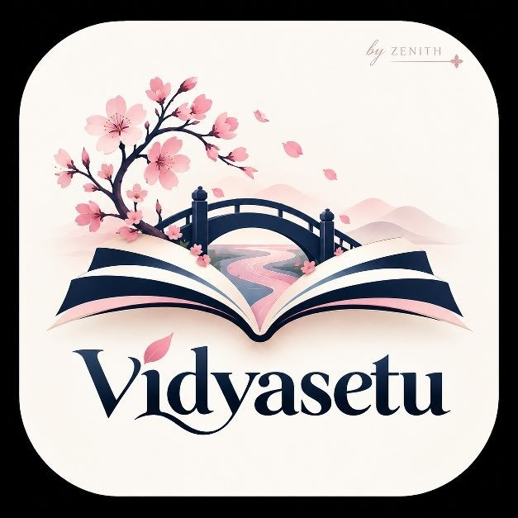
Student connects to internet or VidyaSetu local Wi-Fi hub
↓
Student downloads a course pack
↓
Student studies lessons and audio offline
↓
Student completes quiz and submits a doubt
↓
Progress and doubts are saved locally
↓
Connectivity returns and data synchronizes
↓
Mentor dashboard displays progress and pending support

Phased Implementation Plan
Phase | Activities | Deliverable
Phase 1: MVP | Build frontend, one course, offline lesson reader, quiz, local storage, and basic mentor dashboard. | Working hackathon prototype.
Phase 2: Testing | Test with 30–50 learners on different devices and connectivity conditions. | Usability feedback and bug fixes.
Phase 3: Pilot | Deploy in 2–5 colleges or community hubs with 200–500 students. | Pilot report and learning results.
Phase 4: Scale | Add regional languages, more courses, institutional dashboards, and opportunity pathways. | Multi-institution deployment model.

Technical Implementation
Layer | Prototype technology | Purpose
Frontend | React, TypeScript, Tailwind CSS | Responsive student and mentor interfaces.
Offline storage | IndexedDB and service worker | Store lessons, progress, quizzes, doubts, and cached app files.
Local backend | Python Flask and SQLite | Serve local content and store prototype results.
Local hub | Laptop or Raspberry Pi with Wi-Fi | Distribute content without continuous internet.
Future backend | FastAPI, PostgreSQL, cloud storage,  Docker | Support secure, multi-college deployment.

Feasibility Analysis
Feasibility area | Why VidyaSetu is feasible
Technical | Uses mature, open-source, low-cost technologies and a modular architecture.
Operational | Can run through existing colleges, libraries, CSCs, and community centres.
Financial | Reduces data costs and can reuse laptops, Raspberry Pi devices, and existing infrastructure.
User adoption | Simple mobile-first design, local-language support, mentor guidance, and offline access reduce barriers.
Scalability | Can expand from one course and hub to multiple institutions and districts.
Sustainability | Can be supported through colleges, CSR programmes, NGOs, government partnerships, and institutional services.

Prototype Demonstration Plan
The live demonstration will show the complete offline journey: open VidyaSetu, connect to a local hub, download a course, turn off the internet, open a lesson, complete a quiz, submit a doubt, reconnect, and view the updated result on the mentor dashboard.
Backup plan: keep a screen recording and a local laptop demo ready in case the venue network is unavailable.

Risks and Mitigation
Risk | Mitigation
Weak connectivity | Offline course packs, local Wi-Fi hubs, and queued synchronization.
Risk | Mitigation
Limited device storage | Text/audio-first content, selective downloads, and storage management.
Low digital literacy | Simple navigation, icons with labels, onboarding, and peer mentors.
Language barriers | Hindi/English support and reviewed regional-language content.
Low engagement | Short lessons, progress indicators, mentor check-ins, and practical skills.
Privacy concerns | Minimal data collection, consent, access controls, and local-data protection.

Success Criteria
The implementation will be considered successful when students can access a downloaded course without internet, complete a lesson and quiz, save their progress, submit a doubt, and synchronize the result later. Pilot evaluation will also measure completion, learning improvement, retention, accessibility usage, mentor response time, and data saved.

Conclusion
VidyaSetu is technically practical, financially conscious, operationally adaptable, and scalable. Its phased implementation reduces risk: first prove the offline learning journey, then validate it with learners, and finally expand through institutional and community partnerships.
The project is feasible because it is designed around the conditions in which rural learners actually study.

