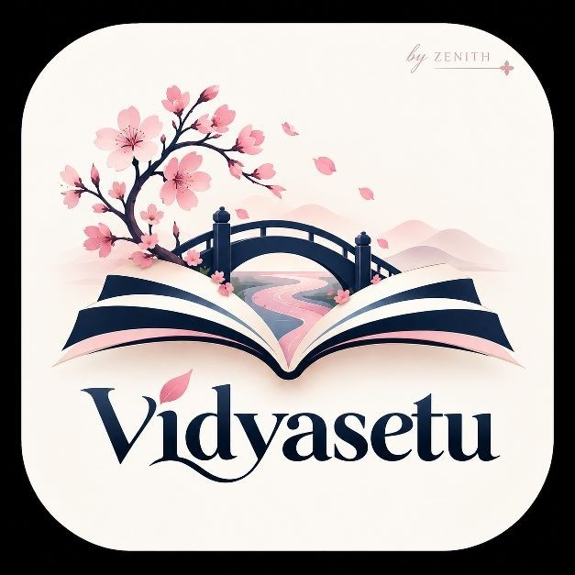
VidyaSetu
Innovation and Differentiation Note
Team Zenith
NISHTHA TIWARI
ABHIRAJ PRATAP SINGH
NAMAMI TRIVEDI
SHRASTI KASHYAP
1
. Innovation Overview
VidyaSetu redesigns digital higher education for rural conditions. It does not assume continuous internet,
personal devices, or English fluency. It combines offline-first learning, local Wi-Fi hubs, multilingual support,
accessibility features, and human mentoring in one ecosystem.
The innovation is the integration of practical solutions into one dependable learning
journey.
. Key Innovations
2
Innovation
How VidyaSetu applies it
Offline-first learning
Lessons, quizzes, progress, and doubts remain available without continuous
internet.
Local learning hubs
A laptop or Raspberry Pi provides course access through local Wi-Fi.
Multilingual learning
Hindi and English support with future regional-language expansion.
Accessibility by design
Captions, transcripts, text-to-speech, speech-to-text, adjustable text, and contrast
controls.
Human mentoring
Text or voice doubts reach faculty, peers, or local mentors.
Low-data delivery
HTML, PDF, MP3, and compressed video with selective downloads.
Learning-to-opportunity
Skills, progress, scholarships, internships, and projects are connected.
3
. Differentiation from Conventional Platforms
Area
Conventional platform
VidyaSetu
Connectivity
Needs frequent internet.
Works offline after download and supports
local hubs.
Devices
Assumes a personal smartphone or laptop.
Supports low-end, shared, and community
devices.
Data
Streaming and repeated downloads may
be costly.
Text/audio-first content and selective
downloads.
Language
Often English-dominant.
Hindi and English with future regional
languages.
Accessibility
May be added later.
Built into onboarding and learning.
Support
Forums or automated responses.
Faculty, peer, and local mentor support.
Outcome
Mainly content completion.
Learning, skills, progress, and opportunities.
VidyaSetu | Team Zenith
1
/
2
4
. Technical Innovation
The prototype uses React, TypeScript, IndexedDB, and a service worker for offline frontend functionality.
Flask and SQLite provide a lightweight local server. The system can later scale to FastAPI, PostgreSQL, cloud
storage, secure authentication, and synchronization services.
Prototype demonstration: Connect to the hub, download a course, turn off the
internet, complete a lesson and quiz, submit a doubt, reconnect, and view progress on
the mentor dashboard.
5
. Social and Educational Differentiation
VidyaSetu treats inclusion as more than device access. It addresses connectivity, affordability, language,
disability, mentorship, motivation, and employability together. This makes it useful for students, colleges,
communities, and institutions seeking practical digital equity.
6
. Scalability and Sustainability
The model can start with one course and one hub, then expand to colleges, libraries, Common Service
Centres, and community locations. Open-source software, lightweight content, reused devices, CSR support,
NGO partnerships, and institutional participation keep deployment practical.
7
. Why This Matters
VidyaSetu changes the question from “Is online education available?” to “Can the learner actually use it?”
By designing for offline conditions and diverse users from the beginning, it turns digital learning into a
dependable service rather than an internet-dependent privilege.
VidyaSetu makes inclusion the foundation of the product—not an additional feature.
8
. Conclusion
VidyaSetu combines practical technology and community support to bridge the gap between educational
content and real access. Its offline-first design, local hubs, inclusive interface, mentor ecosystem, and
learning-to-opportunity pathway provide a strong foundation for rural higher-education transformation.
VidyaSetu | Team Zenith
2
/
2

