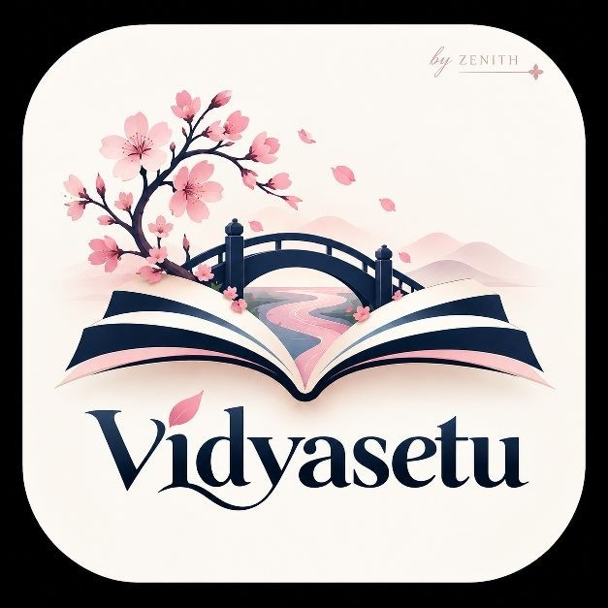
VidyaSetu
Problem Statement & Proposed Solution
Team Zenith
NISHTHA TIWARI • ABHIRAJ PRATAP SINGH • NAMAMI TRIVEDI • SHRASTI KASHYAP

Problem Statement
Rural higher-education students often cannot use digital learning consistently because of unreliable internet, high data costs, shared or low-end devices, limited access to laptops, language barriers, inaccessible content, irregular study schedules, and a lack of timely mentoring.
Many existing online-learning platforms assume continuous connectivity, individual devices, sufficient storage, English proficiency, and strong digital literacy. When these assumptions fail, students miss lessons, cannot stream content, struggle to understand course material, and have limited ways to ask for help.
Core problem: How can higher education be made accessible, affordable, and adaptable for rural learners who may not have continuous internet, personal devices, local-language content, accessible resources, or reliable academic support?

Proposed Solution
VidyaSetu is an offline-first, multilingual, and accessible learning platform designed for rural higher education. It allows students to download course packs, learn without continuous internet, complete quizzes offline, submit doubts, track progress, and synchronize their data when connectivity returns.
The platform is supported by local Wi-Fi learning hubs in colleges, libraries, Common Service Centres, and community locations. These hubs distribute course content locally, reducing repeated mobile-data costs and making learning available even when the wider internet is weak or unavailable.

Proposed Features
Solution area | Features provided by VidyaSetu
Offline learning | Downloadable course packs, offline lessons, audio, notes, quizzes, and progress saving.
Affordable access | Low-data HTML, PDF, MP3, and compressed-video content; local hub distribution; reusable devices.
Multilingual support | Hindi and English interface and content, with future regional-language support.
Accessibility | Text-to-speech, speech-to-text, captions, transcripts, adjustable text size, high contrast, and readable layouts.
Assessment | Offline quizzes, immediate feedback, saved attempts, revision recommendations, and later synchronization.
Solution area | Features provided by VidyaSetu
Mentor support | Text or voice doubts, mentor replies, peer support, and doubt status tracking.
Learning hubs | Local Wi-Fi access through a laptop, Raspberry Pi, library, college, CSC, or community centre.
Progress and opportunities | Course progress, quiz performance, skill profile, scholarships, internships, projects, and employability pathways.

User Workflow
1. Select language and accessibility preferences. 2. Connect to the internet or a VidyaSetu learning hub. 3. Download a course pack. 4. Learn and complete quizzes offline. 5. Save progress and doubts locally. 6. Synchronize when connected. 7. Receive mentor support and continue the course.

Target Users
Primary users: Rural undergraduate students, first-generation learners, women learners, distance learners, students with disabilities, and students using shared or low-end smartphones.
Supporting users: Faculty members, colleges, universities, NGOs, CSR programmes, libraries, Common Service Centres, panchayats, local employers, and student volunteers.

Differentiation
VidyaSetu is not only a course platform. It combines offline-first learning, local Wi-Fi distribution, multilingual content, accessibility by design, human mentoring, progress tracking, and pathways to skills and opportunities. The solution is practical for rural conditions, affordable to pilot, and scalable through existing educational and community infrastructure.

Technical Approach
Prototype technology | Future scalability
React + TypeScript, Tailwind CSS, IndexedDB, service worker | FastAPI, PostgreSQL, cloud/object storage
Flask + SQLite local server | Authentication, Docker, secure synchronization
Laptop or Raspberry Pi Wi-Fi hub | Multi-college and district-level deployment
The prototype demonstrates the complete offline journey: connect to the local hub, download a course, turn off the internet, complete a lesson and quiz, submit a doubt, reconnect, and view the updated result on the mentor dashboard.

Expected Outcomes
- Greater access to higher education in low-connectivity areas.
- Reduced data and learning-material costs.
- Better support for Hindi, regional languages, and diverse abilities.
- Improved participation, completion, skills, and employability.
- Earlier intervention by colleges and mentors.
- A repeatable learning-hub model for rural communities.

Implementation Plan
MVP: One course, offline lesson reader, quiz, local storage, accessibility controls, and mentor dashboard.
Testing: Validate usability with 30–50 learners across different devices and connectivity conditions.
Pilot: Deploy in 2–5 colleges or hubs with 200–500 students.
Scale: Add regional languages, more courses, institutional dashboards, scholarships, internships, and district partnerships.

Conclusion
VidyaSetu bridges the gap between digital content and real access. It makes learning usable—not merely available—for rural students by combining offline access, low-data content, inclusive design, local hubs, mentor support, and career pathways.
VidyaSetu offers a practical and scalable way to make higher education more inclusive, affordable, and adaptable.

