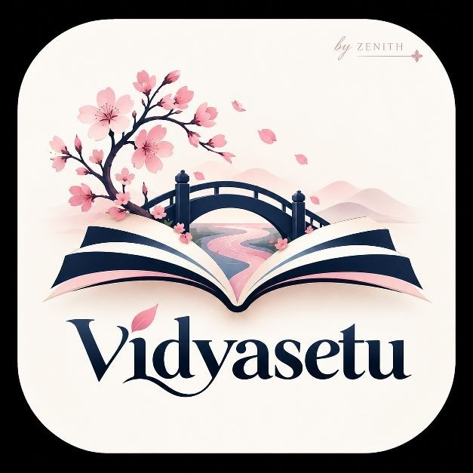
VidyaSetu
Refined Solution Synopsis & Executive Summary
Team Zenith
NISHTHA TIWARI • ABHIRAJ PRATAP SINGH • NAMAMI TRIVEDI • SHRASTI KASHYAP

Digital Inclusion for Rural Higher Education
VidyaSetu is an offline-first, multilingual, and accessible digital learning platform for rural higher-education students. It enables learners to download courses, study without continuous internet, complete quizzes offline, submit doubts, track progress, and synchronize data when connectivity returns.
“No student’s future should depend on the strength of their internet connection.”

Problem Statement
Rural higher-education learners face unreliable internet, high data costs, shared or low-end devices, language barriers, inaccessible content, irregular study schedules, and limited mentoring. Many online platforms assume continuous connectivity, personal devices, English proficiency, and high digital literacy. Therefore, content may be available but still difficult to use consistently.
Challenge: How can higher education become accessible, affordable, and adaptable for learners without continuous internet, personal devices, local-language content, or reliable academic support?

Proposed Solution
VidyaSetu combines offline course delivery, local Wi-Fi learning hubs, accessible content, multilingual support, offline assessments, and human mentoring. Students download course packs containing text, PDFs, audio, transcripts, captions, compressed videos, and quizzes. Learning activity is saved locally and synchronized later through the internet or a community hub.

Core Offerings
Offering | What VidyaSetu provides
Offline learning | Downloadable courses that remain available without continuous internet.
Low-data access | Lightweight text, PDF, audio, and compressed-video options.
Inclusive content | Hindi/English support, captions, transcripts, text-to-speech, speech-to-text, adjustable text, and contrast modes.
Offline assessment | Quizzes, scores, and progress saved locally.
Mentor support | Text or voice doubts routed to faculty or local mentors.
Community hubs | Course access through a college, library, CSC, or community Wi-Fi server.
Offering | What VidyaSetu provides
Skills and opportunities | Progress tracking plus employability skills, scholarships, internships, and projects.

How It Works
1. Select language and accessibility preferences. 2. Download a course from the internet or local hub. 3. Learn and complete quizzes offline. 4. Save progress and doubts locally. 5. Synchronize when connectivity returns. 6. Mentors review progress and provide support.

Innovation and Value
VidyaSetu is more than a conventional LMS. It combines offline-first delivery, community-based access, local-language learning, accessibility by design, human mentoring, and pathways from learning to opportunity. It is affordable to pilot, practical for low-connectivity environments, and scalable from one course and one hub to colleges, districts, and states.

Technology Approach
Prototype | Scalable version
React + TypeScript, Tailwind CSS, IndexedDB, service worker | FastAPI, PostgreSQL, cloud/object storage
Flask + SQLite local server | Secure authentication, Docker, synchronization service
Laptop or Raspberry Pi Wi-Fi hub | Multi-college cloud and hub deployment
The prototype demonstrates the complete offline journey: connect to a local hub, download a course, turn off the internet, complete a lesson and quiz, submit a doubt, reconnect, and view synchronized progress on the mentor dashboard.

Expected Impact
Beneficiary | Expected value
Students | Affordable, flexible, local-language, and accessible learning.
Colleges | Progress monitoring and earlier learner support.
Mentors | Centralized doubts and actionable learning insights.
Communities | Reusable digital-learning infrastructure.
Society | Improved rural participation, skills, employability, and equity.

Implementation Roadmap
MVP: One course, offline lesson reader, quiz, local storage, and mentor dashboard.
Field test: 30–50 learners across different devices and connectivity conditions.
Pilot: 2–5 colleges or hubs with 200–500 students.
Scale: Regional languages, more courses, institutional dashboards, scholarships, internships, and district partnerships.

Feasibility and Success Measures
The solution uses open-source software, low-cost hardware, lightweight content, and existing college or community infrastructure. Proposed pilot measures include student enrolment, course completion, learning improvement, offline activity usage, mentor response time, retention, and active learning hubs.

Conclusion
VidyaSetu transforms digital education from a connectivity-dependent service into a dependable learning utility. By combining offline access, inclusive content, local hubs, mentoring, and career pathways, it gives rural students a realistic way to continue higher education and build skills.
VidyaSetu should be selected because it solves a genuine problem with a practical prototype, measurable impact, low-cost implementation, and a clear path to scale.

