Lab7 homework: Ex5-8
5. Advanced Search
- User fills in Advanced Search fields (name, category, minPrice, maxPrice)
- Browser → GET /products/advanced-search with query parameters
- ProductController.advancedSearchProducts() receives request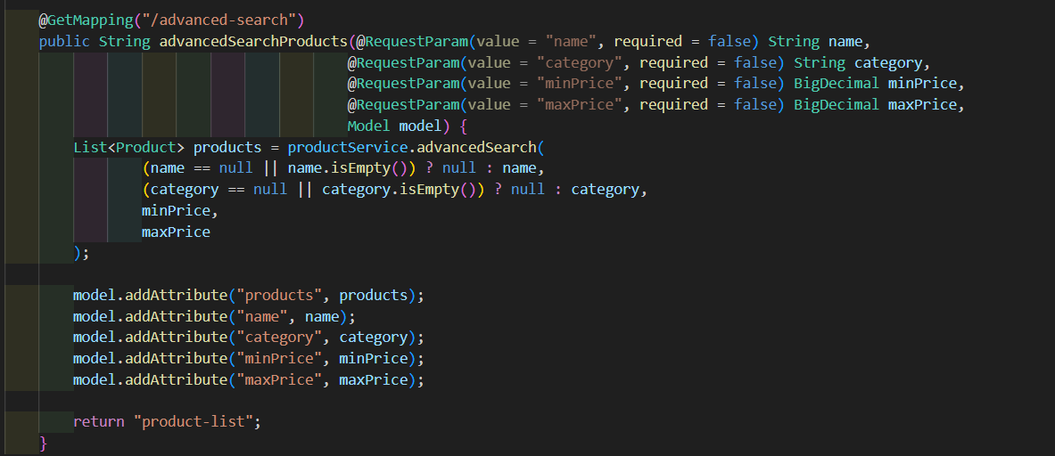
- Controller calls productService.advancedSearch(name, category, minPrice, maxPrice) 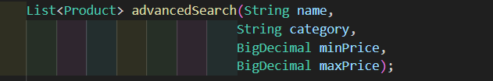
- Service calls productRepository.advancedSearch(name, category, minPrice, maxPrice)
- JPA executes the custom @Query in the repository with given parameters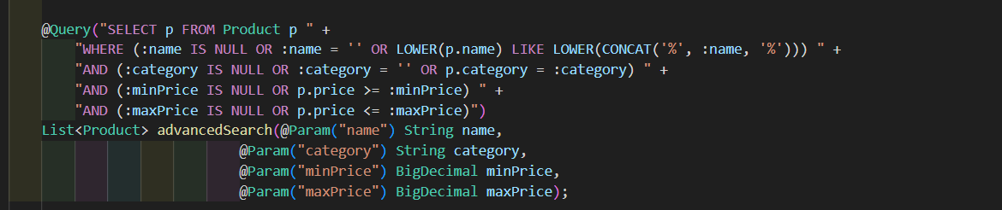
- Database returns a filtered list of products
- Repository returns data to Service
- Service returns data to Controller
- Controller adds products and search parameters to the Model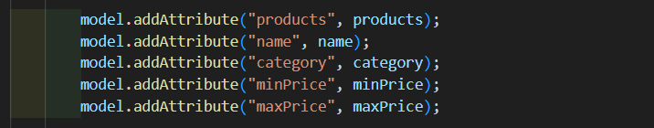
- Returns view name product-list
- Thymeleaf renders product-list.html with filtered product table
- Generated HTML is sent back to browser

7.1. Sort Products
- User clicks on a column header (e.g., Name) to sort
- Browser → GET /products?sortBy=name&sortDir=asc/desc
- ProductController.listProducts() receives request with sortBy and sortDir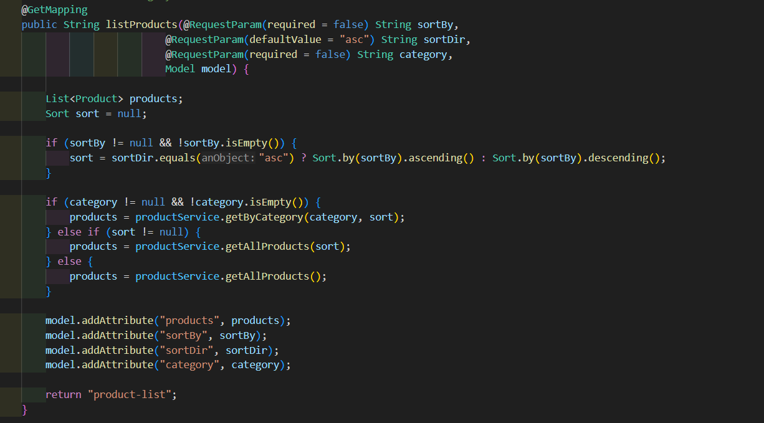
- Controller prepares Sort object depending on parameters
- Controller calls productService.getAllProducts(sort) or getByCategory(category, sort) if filtered
- Service calls repository method (findAll(Sort sort) or findByCategory(String category, Sort sort)) 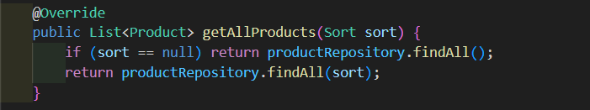
- JPA executes SQL query with ORDER BY clause
- Database returns sorted list
- Repository returns data to Service
- Service returns data to Controller
- Controller adds products, sortBy, sortDir, category to the Model
- Returns view product-list
- Thymeleaf renders sorted table with arrows showing sort direction
- Generated HTML is sent back to browser

6. Validation
- User opens product form (Add Product or Edit Product)
- ProductController.showNewForm() receives request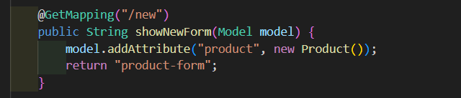
- Controller adds empty product to Model
- Thymeleaf renders product-form.html with form fields (including validation placeholders)
- User fills form and submits
- ProductController.saveProduct() receives request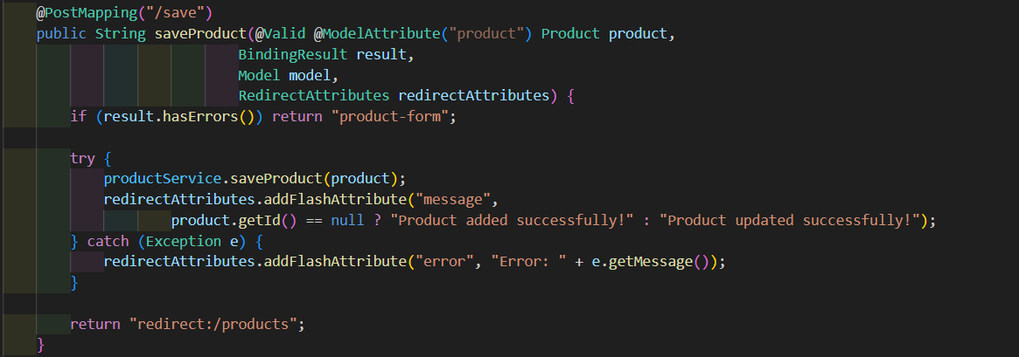
- Controller validates product using @Valid and BindingResult
- Controller calls productService.saveProduct(product)
- Service calls productRepository.save(product)
- Controller redirects to /products after successful save
- Browser receives updated product list
- Thymeleaf renders product-list.html

7.2. Filter by Category
- User clicks a category button or selects category from dropdown
- Browser → GET /products?category=Electronics&sortBy=name&sortDir=asc (category + optional sort)
- ProductController.listProducts() receives request with category and optional sort 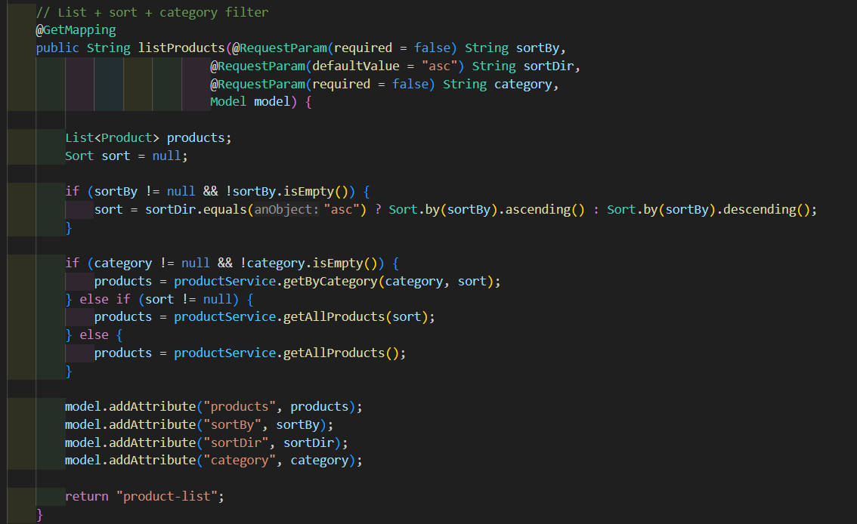
- Controller checks if sort is null and calls productService.getByCategory(category, sort) 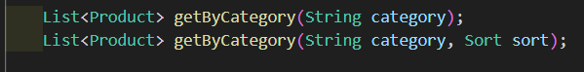
- Service calls productRepository.findByCategory(category)
- JPA executes SQL query with WHERE category = ? and ORDER BY if applicable
- Database returns filtered products
- Repository returns data to Service
- Service returns data to Controller
- Controller adds products, category, sortBy, sortDir to the Model
- Returns view product-list
- Thymeleaf renders product table with active category highlighted
- Generated HTML is sent back to browser

8. View Dashboard
- User clicks Dashboard button
- Browser → GET /dashboard
- DashboardController.showDashboard() receives request 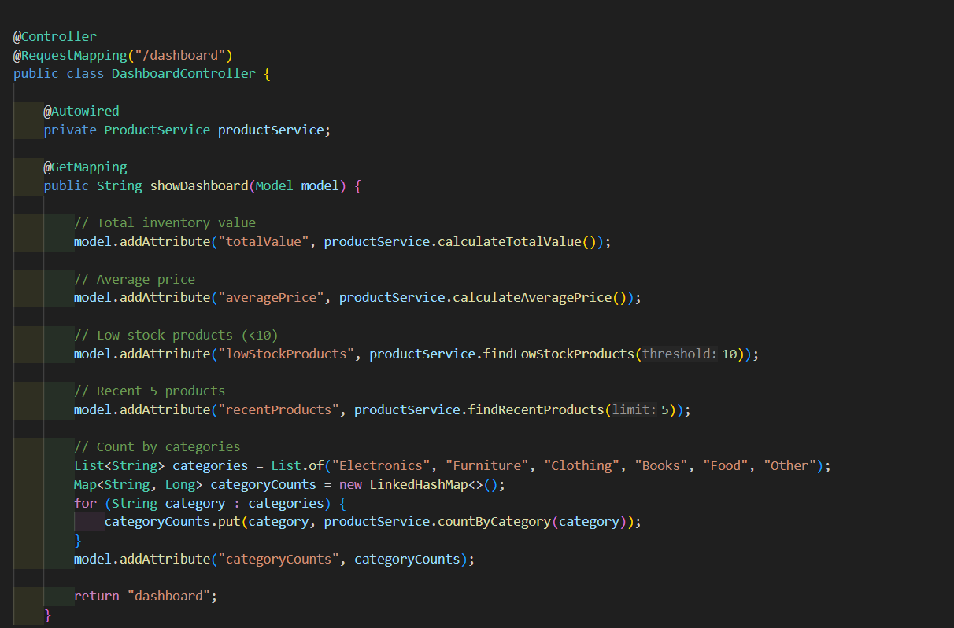
- Controller calls various productService methods
- Service calls corresponding productRepository queries
- JPA executes SQL queries and retrieves statistics
- Repository returns results to Service
- Service returns statistics to Controller
- Controller adds statistics to the Model
- Returns view dashboard
- Thymeleaf renders dashboard.html with charts, total count, average price, low stock alerts, recent products
- Generated HTML is sent back to browser

