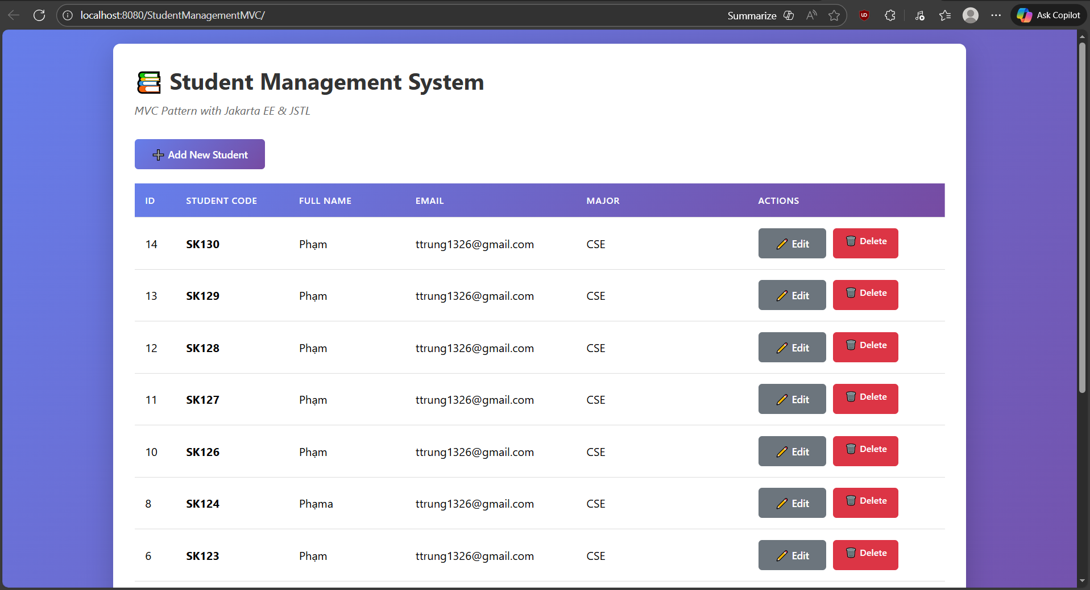
Nyxx1326/Lab05Practice

The code flow:
- User open web
- Web requests the student list
- Using servlet, and doGet() to get the student-list
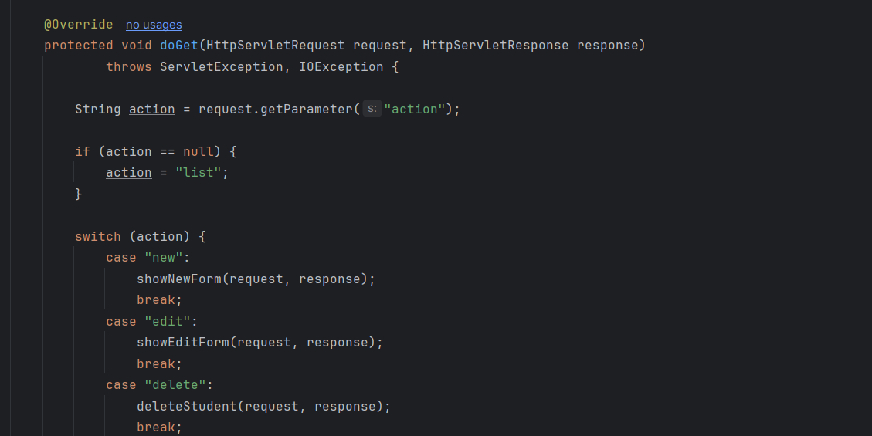
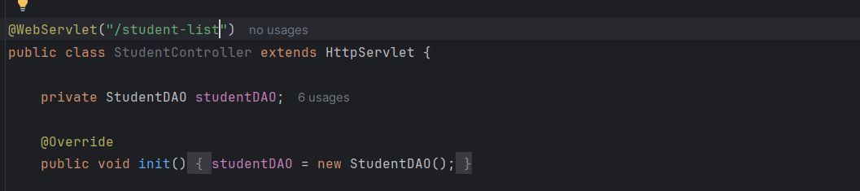
- Next is the studentDAO, access the database to get the data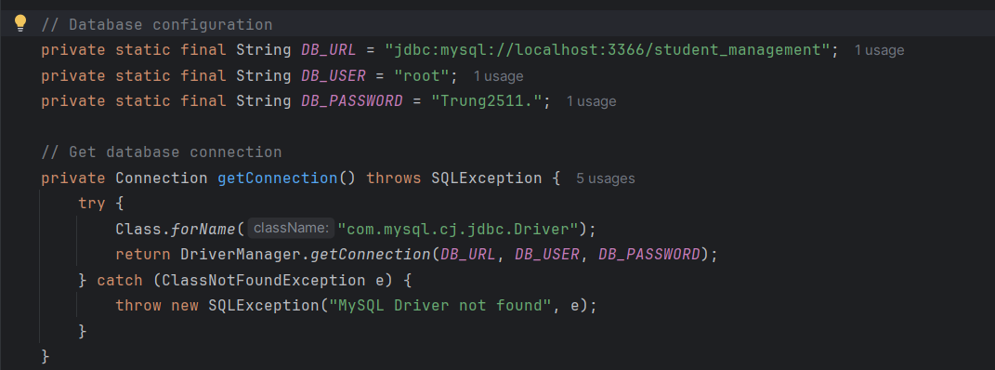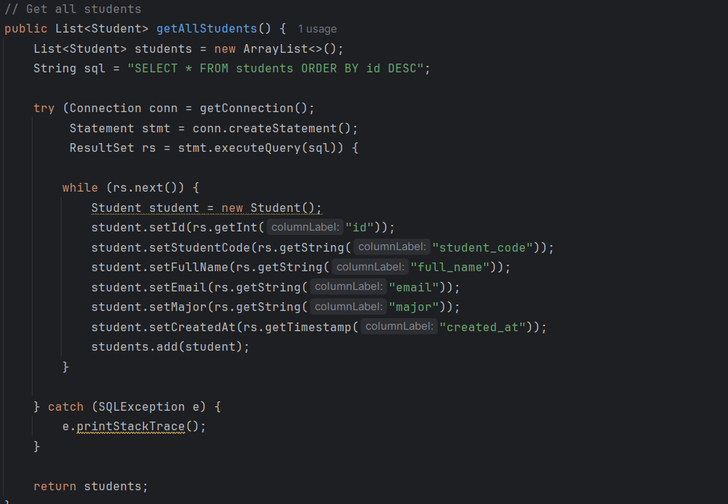
- Coming up to the controller, it will store the data and send it to the student-list.jsp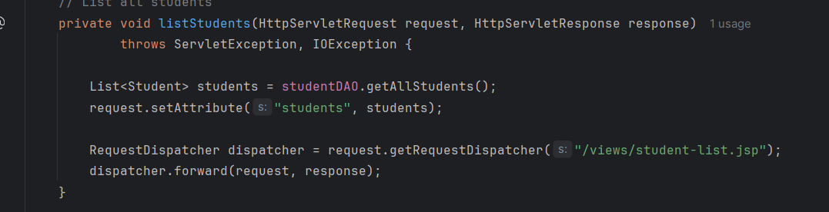
- Last is the student-list.jsp, it will receive the data, check if is not empty, then display it to the user