Ex5:
- When you put the keyword into search box, it will call doGet() -> searchStudent() in Controller -> searchStudent() in DAO -> show result 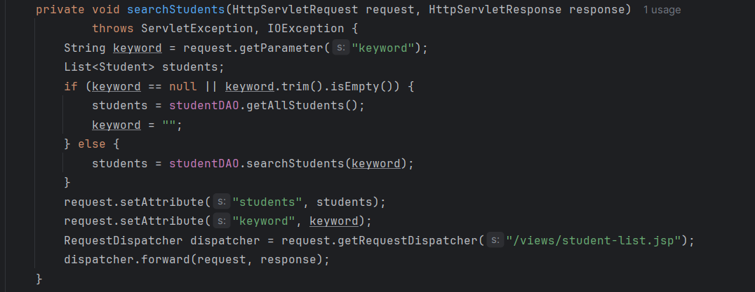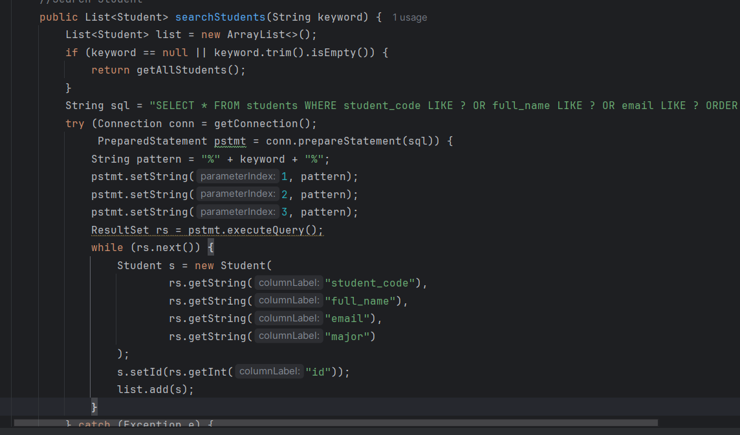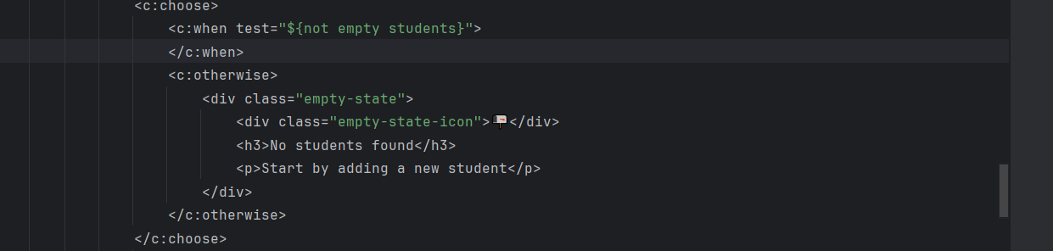
Ex6:
- When you add new student or edit student, the controller is active, and it will test your input if valid or not, and then call the DAO to save your data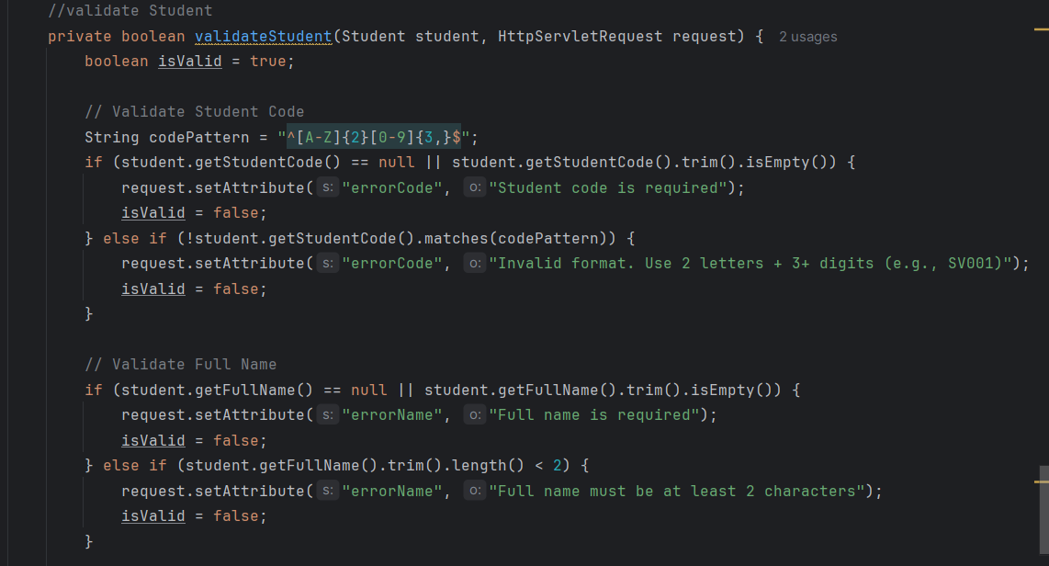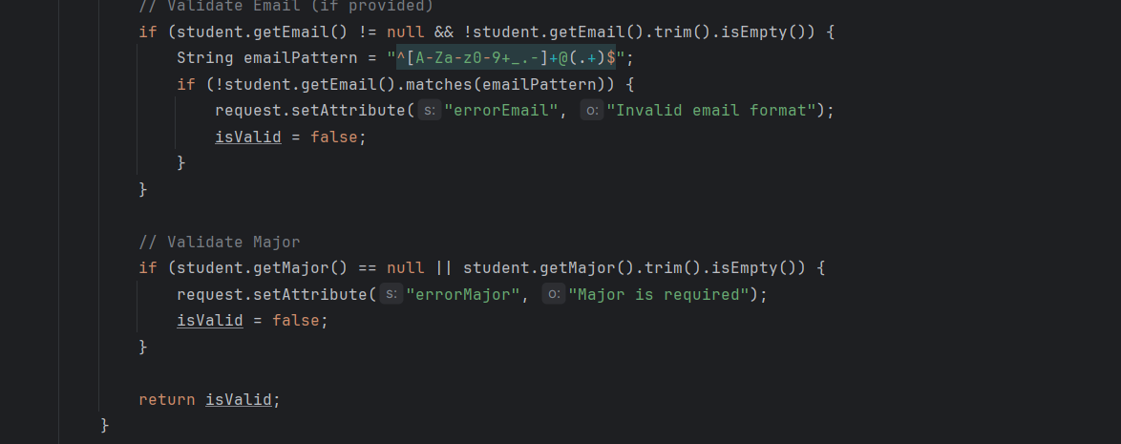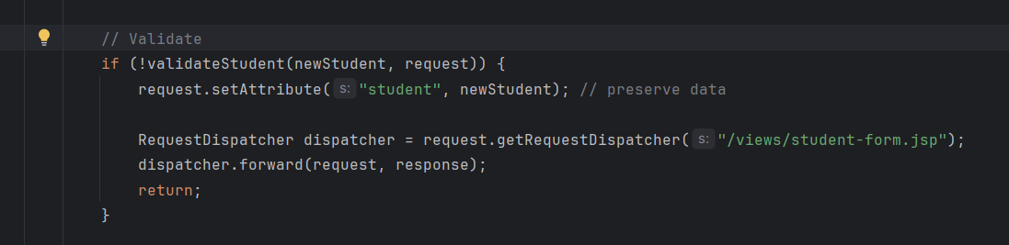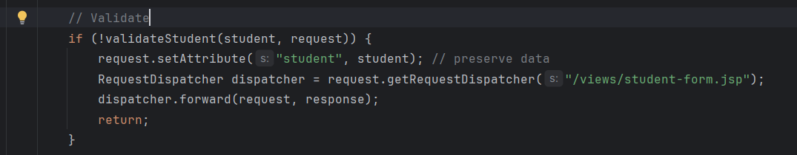
- And when it is not valid, the error message will appear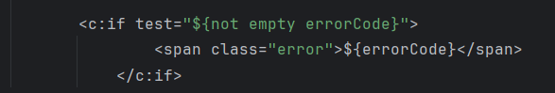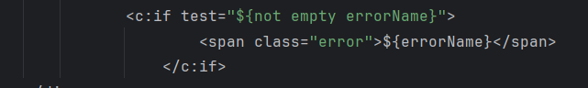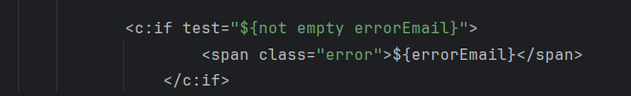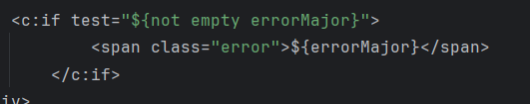
Ex7:
- Sorting: method: 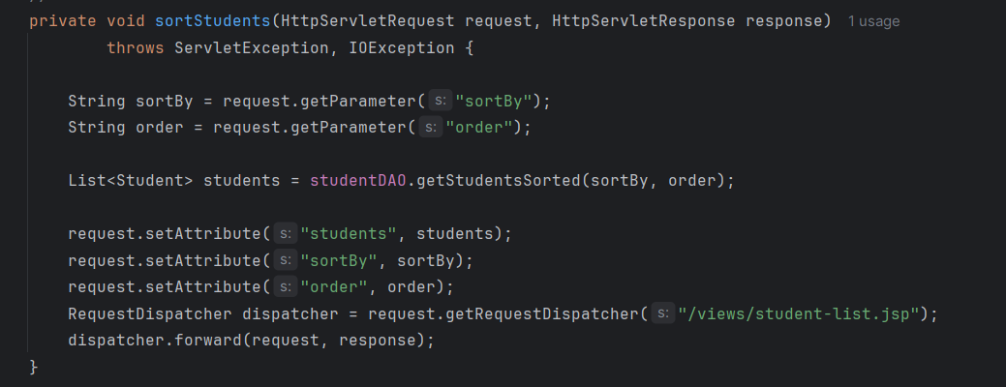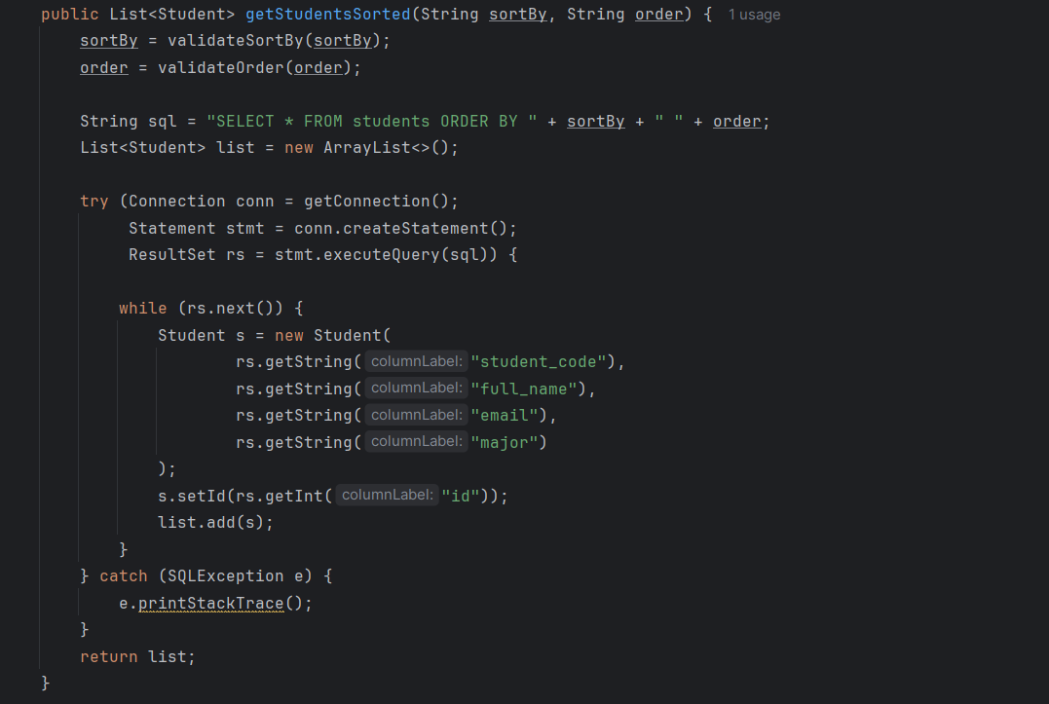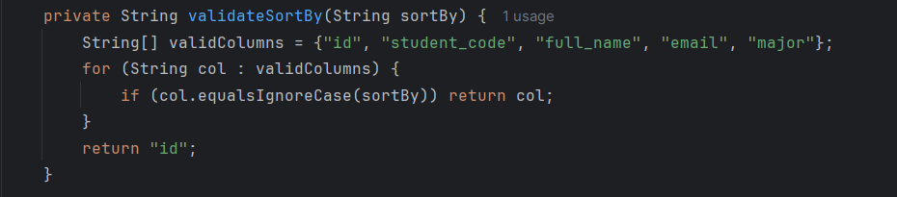
  - When the user clicks to the heading of the table, if will send request to controller to sort, and then the DAO sorting from database, send back to Controller, and controller send to the jsp.
- Filter: method: 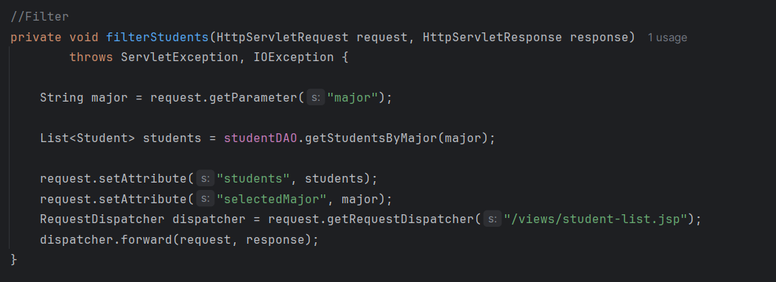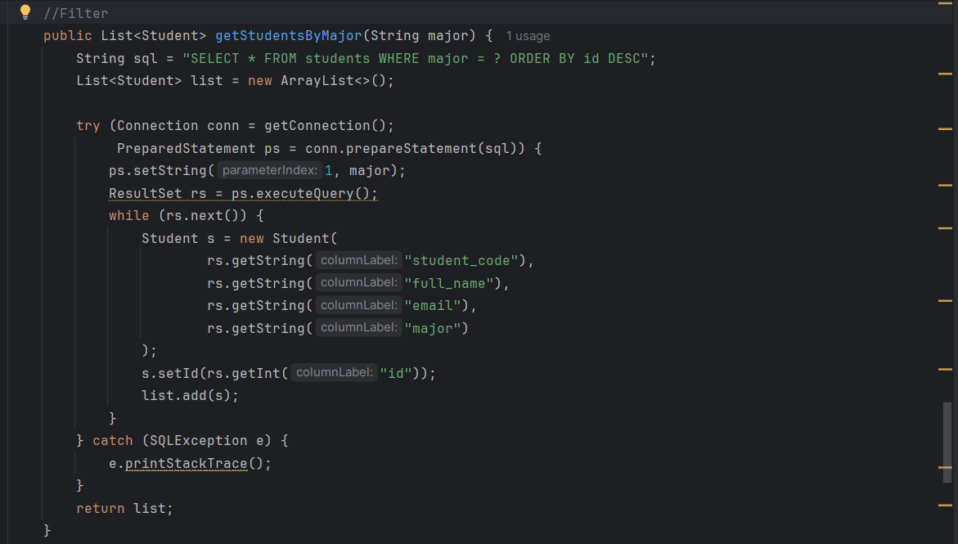
  - When the user clicks to the Major, it will send request to controller to Filter which student have the same major and list it and send to Controller-> jsp.
Ex8:
- Method: 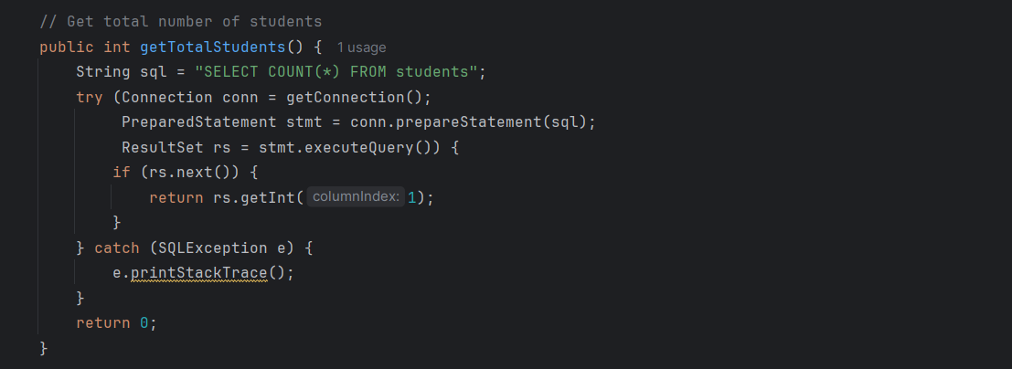 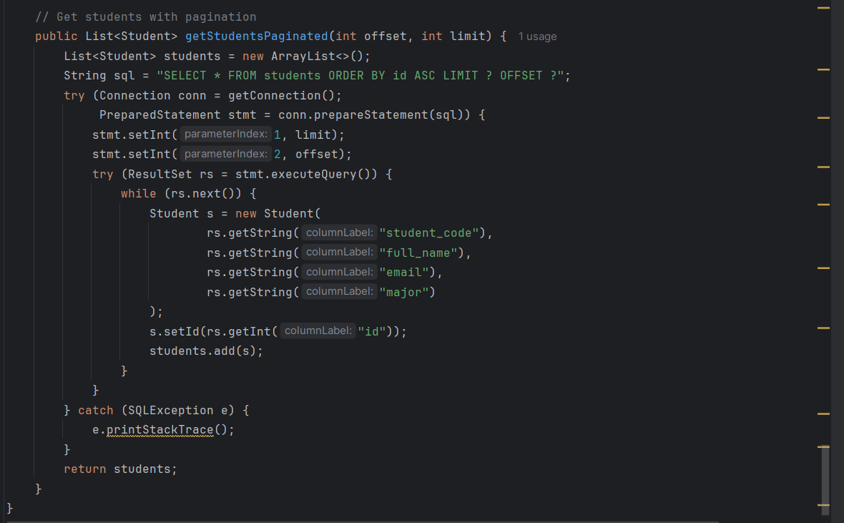 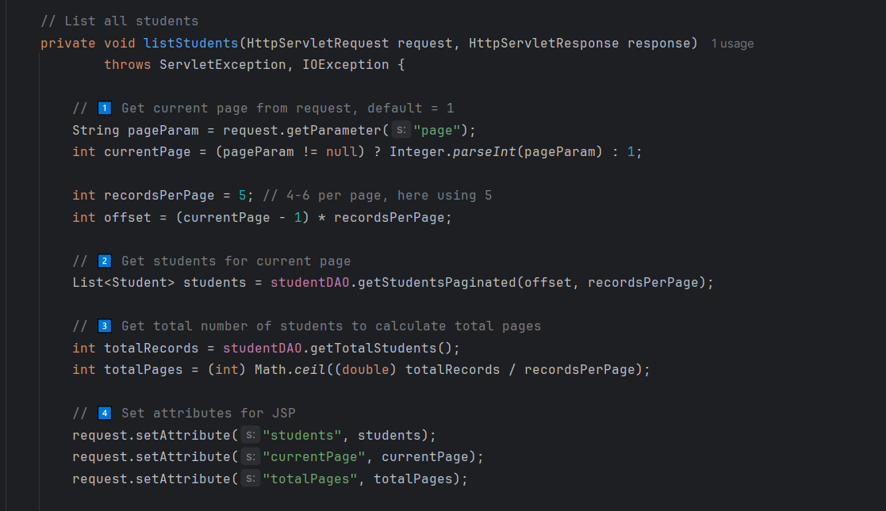 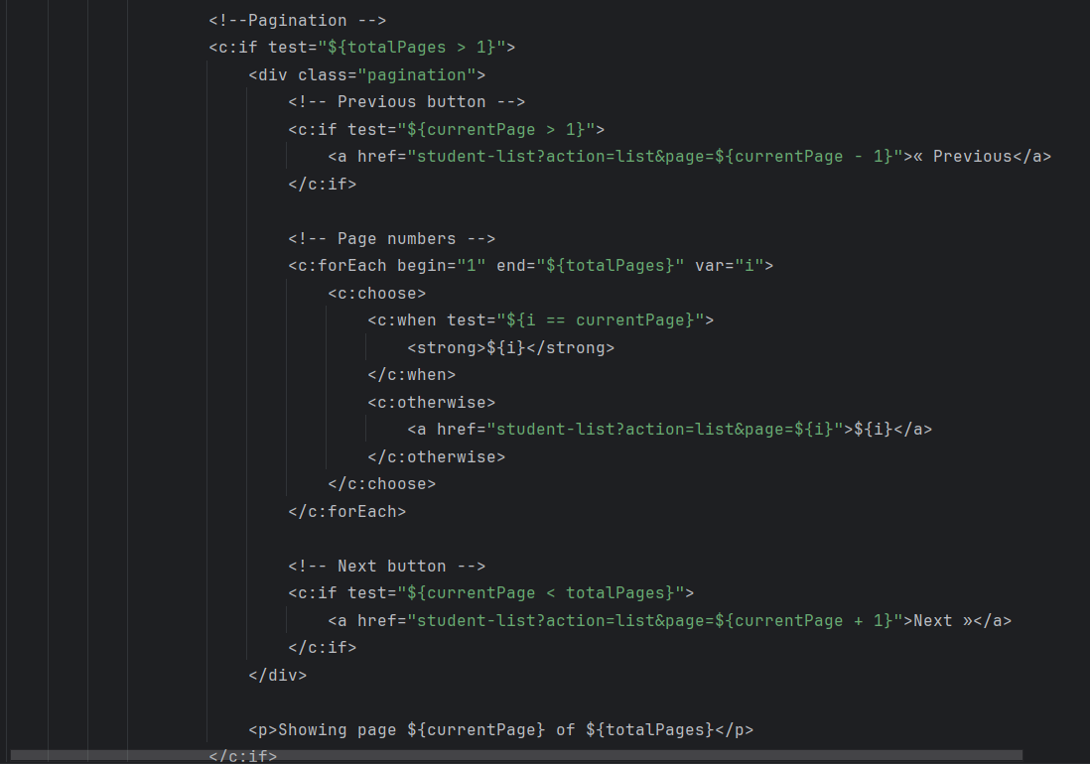
- Update listStudent
- When user open, it automatically open page 1 of the list, each page has 5 students, when user click next, move to page 2, and it will have the previous and next, it’s because the test “currentPage >1”
- When the user clicks on page X, the website goes to /student-list?page=X, the controller reads the page number and works out which students should appear on that page, it asks the DAO to get only those students, and also asks how many students exist in total so it can know the number of pages, then it sends the students, the current page, and the total pages to the JSP, finally, the JSP shows that page to the user.

