Concept of my project

# Theme

I instantly knew that I would choose my holidays in England as the theme, because they were only a year ago and I have enough photos and videos of it.

# Tools/Languages

For development I used JavaScript, CSS and HTML, because I know these tools well and use them often.

# Styling/Structure

I don’t like websites that are too colorful. I prefer a black and white scheme so the images stick out more. I used Monaco as the font. I stumbled upon it when looking for a good font and I think that it fits into my project really well. I often used flexbox in the CSS because it’s a modern, nice and easy way to move and position your content.

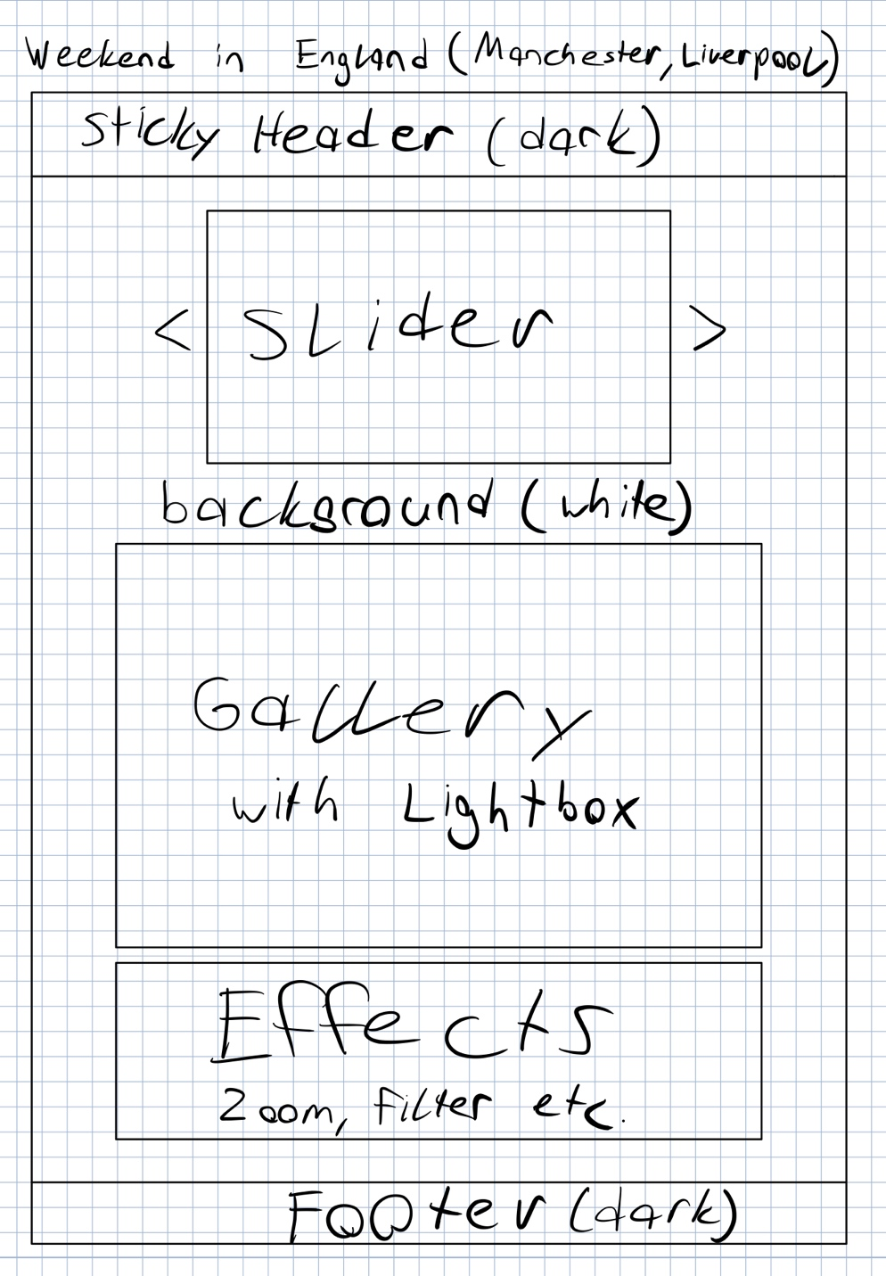

# Videos

On my trip we went to a game of football, the cavern club where The Beatles used to play and more interesting places. I recorded some footage along the way. I’m planning to include them in a new section below the images. I will use an image for the background and put some other videos over it. One of the videos will be included directly, the other one through YouTube.

