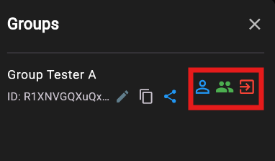
Placeholder Member Exit
Placeholder Member Exit
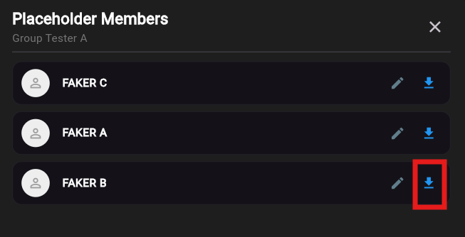
Inherit Request

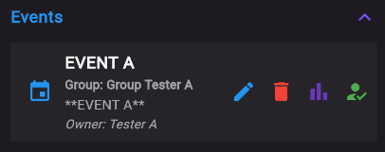
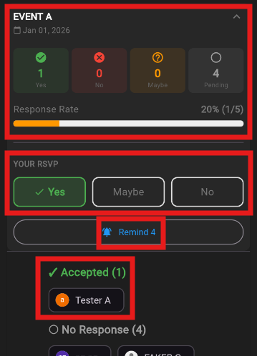
RSVP Status
Change your decision
Send Reminder
Accepted Member

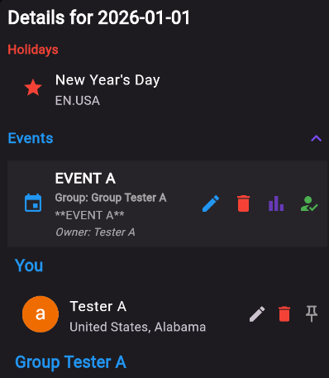
Pinned yourself
Revert to default location for today
Edit your location for today
Cancel Event
Edit Event details

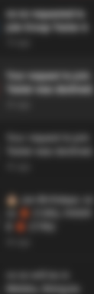
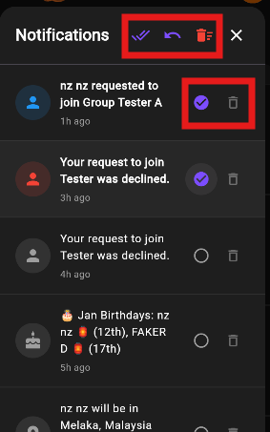
Mark All unread
Mark as Read Delete
Mark All as Read
Delete All

