- Ocean.jpg
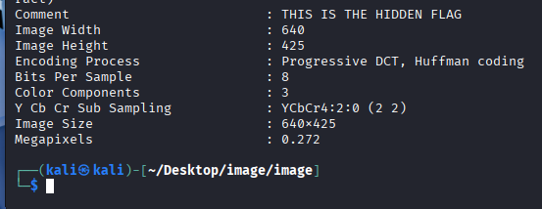
- Running “exiftool ocean.jpg” to find the hidden flag

- Computer.jpg

- dog.jpg
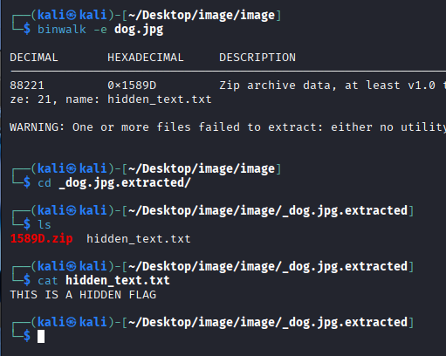
- Go into image directory and use cat to read the flag

- Computer.jpg

