1. Both Departure airport IATA code and Arrival airport IATA code

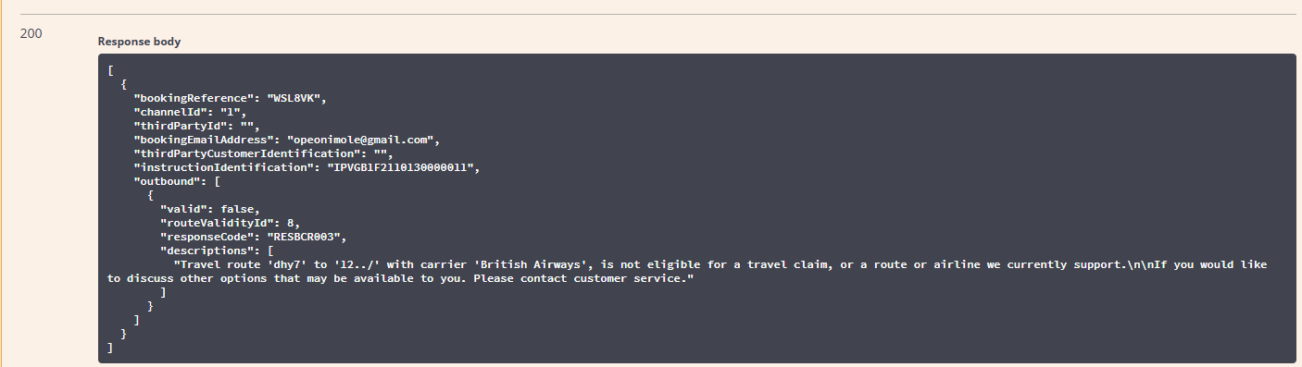

"routeValidityId": 8, "responseCode": "RESBCR003"

1. IF Departure airport IATA code from step 1 ***matches*** an IATA code record from step 2a,

**WHERE** corresponding Departure airport Region = ‘UK’

**AND** Region of Carrier from step 2b = ‘UK’ **OR** ‘EU’, **OR** ‘OTHER’  
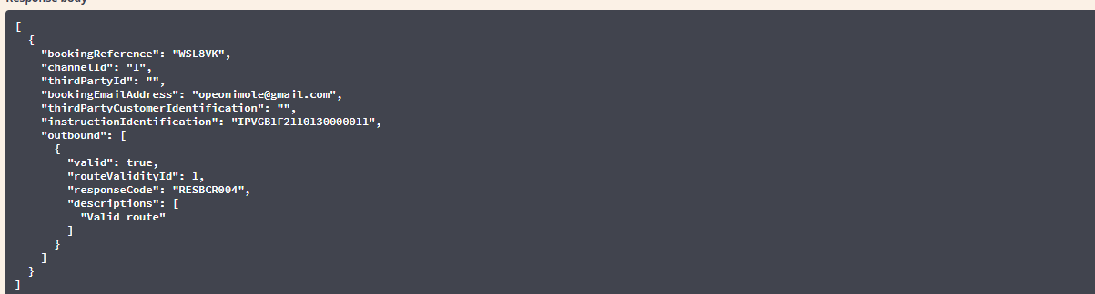

routeValidityId": 1, "responseCode": "RESBCR004",

1. IF Departure airport IATA code from step 1 ***matches*** an IATA code record from step 2a,

**WHERE** corresponding Departure airport Region = ‘UK’

the (Carrier Code) from step 1, ***cannot be matched*** to any (Operator Code)

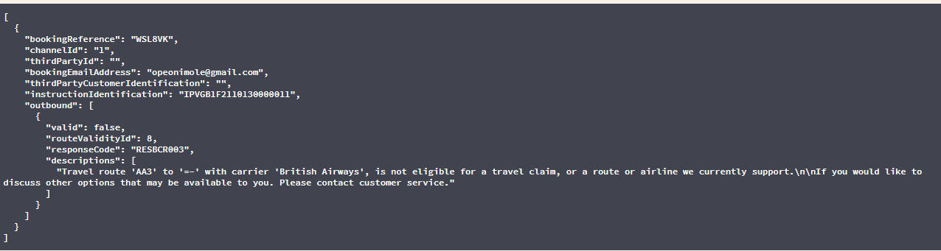

Failed  
Expected: routeValidityId": 9, "responseCode": "RESBCR004"  
Actual: routeValidityId": 8, "responseCode": "RESBCR003"

1. IF Departure airport IATA code from step 1 ***cannot be matched*** to any IATA code record from step 2a

**AND** arrival airport IATA code from step 1 ***matches*** *an* IATA code record from step 2a, **WHERE** corresponding arrival airport Region = ‘UK’

**AND** Region of Carrier from step 2b = ‘UK’ **OR** ‘EU’,

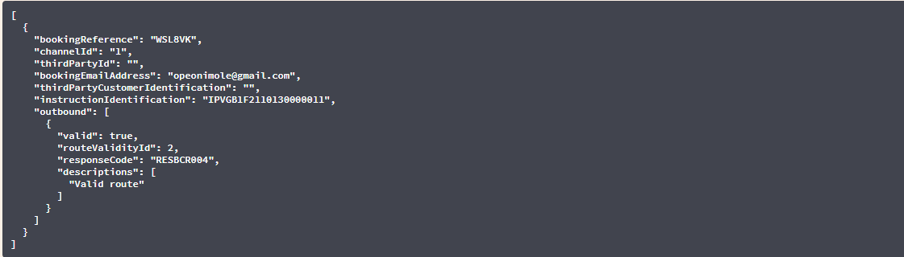

routeValidityId": 2, "responseCode": "RESBCR004"

1. IF Departure airport IATA code from step 1 ***cannot be matched*** to any IATA code record from step 2a

**AND** arrival airport IATA code from step 1 ***matches*** *an* IATA code record from step 2a, **WHERE** corresponding arrival airport Region = ‘UK’

**AND** Region of Carrier from step 2b = ***cannot be matched*** to any (Operator Code)

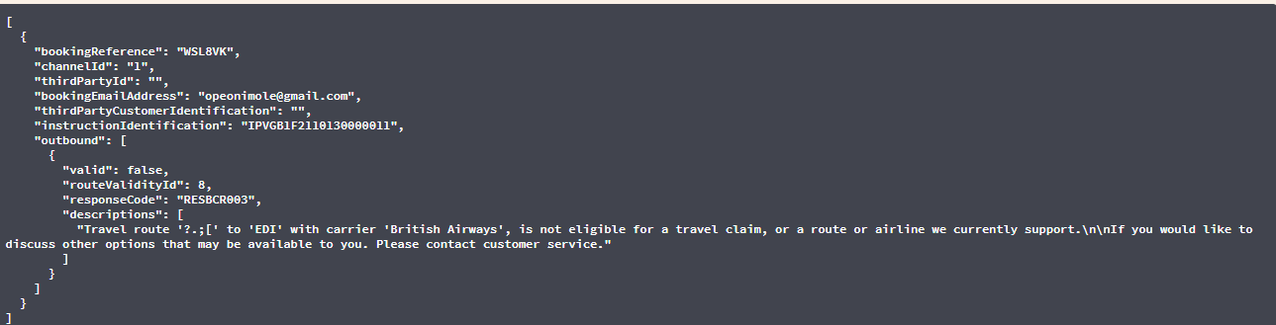

Failed  
Expected: routeValidityId": 92, "responseCode": "RESBCR004"  
Actual: routeValidityId": 8, "responseCode": "RESBCR003"

1. IF departure airport IATA code from step 1 ***matches*** an IATA code record from step 2a,

**WHERE** corresponding departure airport Region = ‘EU’

**AND** arrival airport IATA code from step 1 ***matches*** *an* IATA code record from step 2a, **WHERE** corresponding arrival airport Region = ‘UK’

**AND** Region of Carrier from step 2b = ‘UK’ **OR** ‘EU’,

"routeValidityId": 3, "responseCode": "RESBCR004"

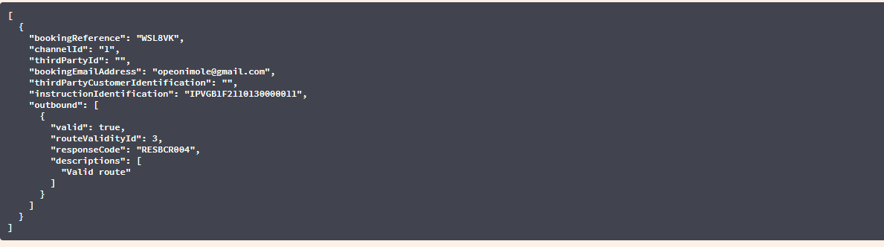

1. IF departure airport IATA code from step 1 ***matches*** an IATA code record from step 2a,

**WHERE** corresponding departure airport Region = ‘EU’

**AND** arrival airport IATA code from step 1 ***matches*** *an* IATA code record from step 2a, **WHERE** corresponding arrival airport Region = ‘UK’

**AND** Region of Carrier from step 2b = ***cannot be matched*** to any (Operator Code)

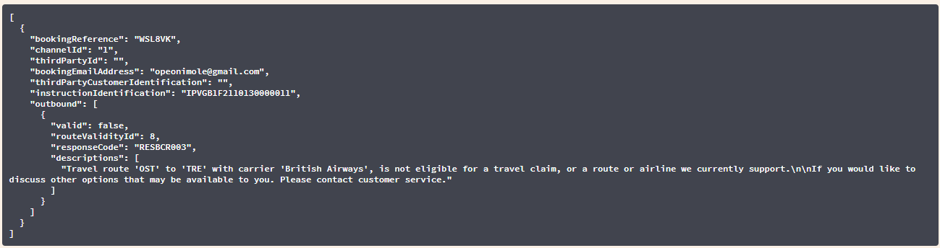

Failed: Expected: "routeValidityId": 93, "responseCode": "RESBCR004"  
 Actual: "routeValidityId": 8, "responseCode": "RESBCR003"

8.IF departure airport IATA code from step 1 ***cannot be matched*** to an IATA code record from step 2a

**AND** arrival airport IATA code from step 1 ***matches*** *an* IATA code record from step 2a, **WHERE** corresponding arrival airport Region = ‘EU’

**AND** Region of Carrier from step 2b = ‘UK’

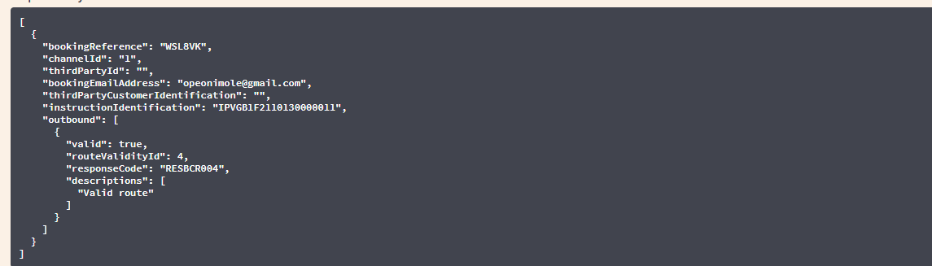

"routeValidityId": 4, "responseCode": "RESBCR004"

1. IF departure airport IATA code from step 1 ***cannot be matched*** to an IATA code record from step 2a

**AND** arrival airport IATA code from step 1 ***matches*** *an* IATA code record from step 2a, **WHERE** corresponding arrival airport Region = ‘EU’

**AND** Region of Carrier from step 2b = ***cannot be matched*** to any (Operator Code)

Failed: Expected: "routeValidityId": 94, "responseCode": "RESBCR004"  
 Actual: "routeValidityId": 8, "responseCode": "RESBCR003"

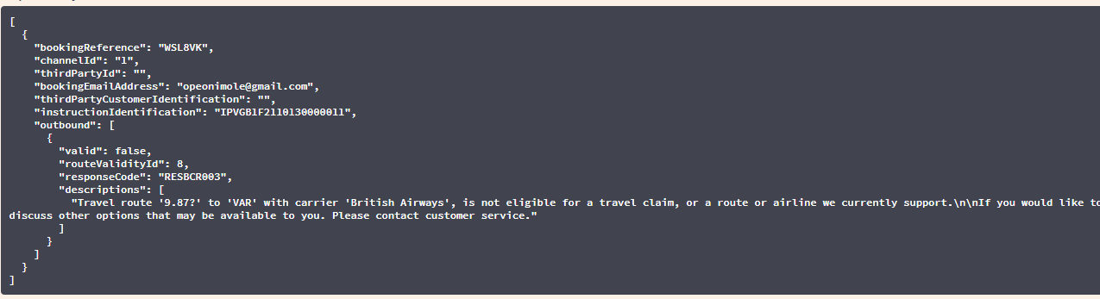

10. IF departure airport IATA code from step 1 ***matches*** an IATA code record from step 2a,

**WHERE** corresponding departure airport Region = ‘EU’

**AND** arrival airport IATA code from step 1 ***matches*** *an* IATA code record from step 2a, **WHERE** corresponding arrival airport Region = ‘EU’

**AND** Region of Carrier from step 2b = ‘UK’



11.IF departure airport IATA code from step 1 ***matches*** an IATA code record from step 2a,

**WHERE** corresponding departure airport Region = ‘EU’

**AND** arrival airport IATA code from step 1 ***matches*** *an* IATA code record from step 2a, **WHERE** corresponding arrival airport Region = ‘EU’**AND** Region of Carrier from step 2b = ***cannot be matched*** to any (Operator Code)



If I use other carrier code:

Failed: Expected: "routeValidityId": 95, "responseCode": "RESBCR004"  
 Actual: "responseCode": "RESBCR005"

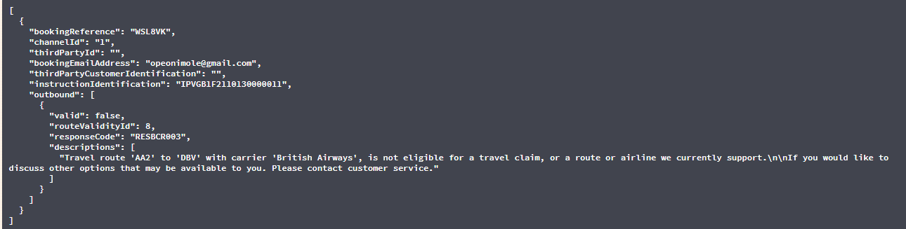

When I use random carrier code:  
 Failed: Expected: "routeValidityId": 95, "responseCode": "RESBCR004"  
 Actual: "routeValidityId": 8, "responseCode": "RESBCR003"

12. IF departure airport IATA code from step 1 ***matches*** an IATA code record from step 2a, **WHERE** corresponding departure airport Region = ‘EU’**AND** arrival airport IATA code from step 1 ***cannot be matched*** to an IATA code record from step 2a

**AND** Region of Carrier from step 2b = ‘UK’ **OR** ‘EU’, **OR** ‘OTHER’

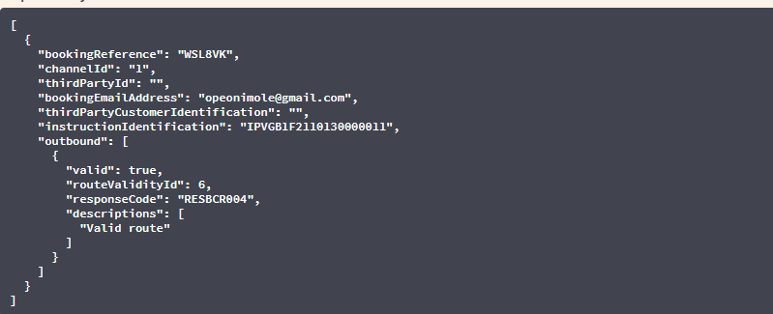

13. IF departure airport IATA code from step 1 ***matches*** an IATA code record from step 2a, **WHERE** corresponding departure airport Region = ‘EU’**AND** arrival airport IATA code from step 1 ***cannot be matched*** to an IATA code record from step 2a

**AND** Region of Carrier from step 2b = ***cannot be matched*** to any (Operator Code)

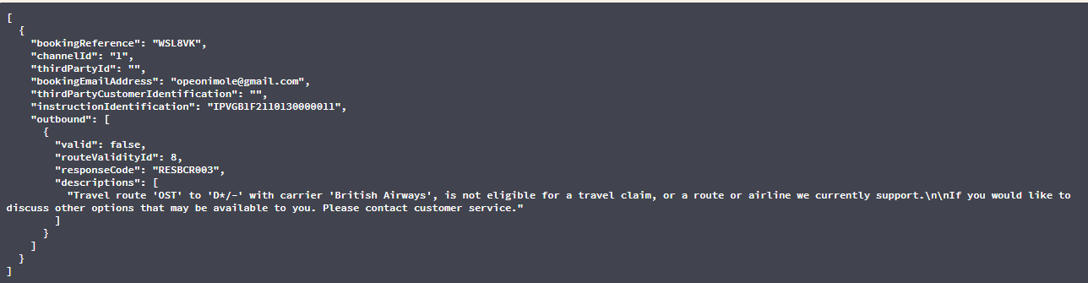Failed: Expected: "routeValidityId": 96, "responseCode": "RESBCR004"  
 Actual: "routeValidityId": 8, "responseCode": "RESBCR003"

14. IF departure airport IATA code from step 1 ***cannot be matched*** to an IATA code record from step 2a **AND** arrival airport IATA code from step 1 ***matches*** *an* IATA code record from step 2a, **WHERE** corresponding arrival airport Region = ‘EU’

**AND** Region of Carrier from step 2b = ‘EU’,

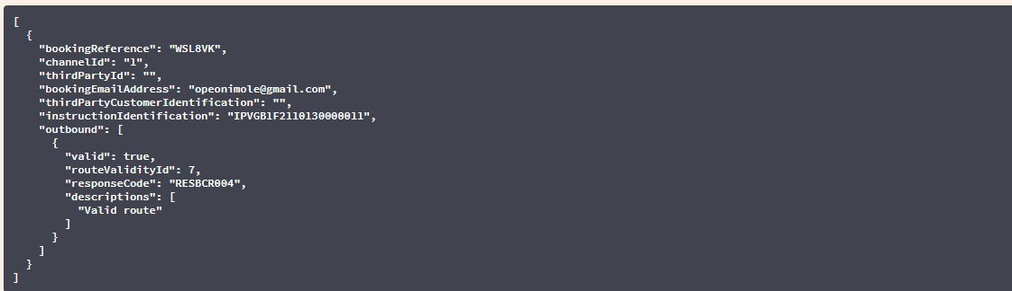

15. IF departure airport IATA code from step 1 ***cannot be matched*** to an IATA code record from step 2a **AND** arrival airport IATA code from step 1 ***matches*** *an* IATA code record from step 2a, **WHERE** corresponding arrival airport Region = ‘EU’

**AND** Region of Carrier from step 2b = = ***cannot be matched*** to any (Operator Code)

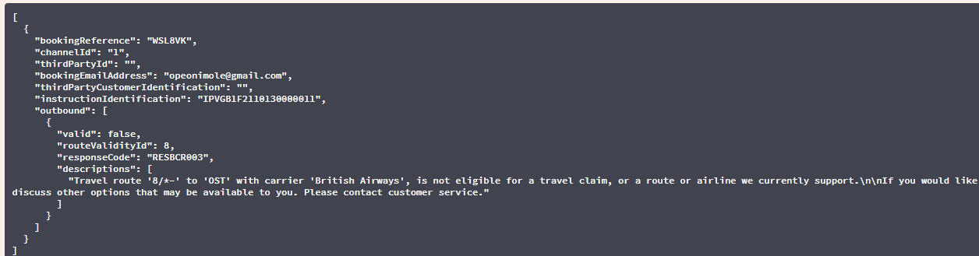

Failed: Expected: "routeValidityId": 97, "responseCode": "RESBCR004"  
 Actual: "routeValidityId": 8, "responseCode": "RESBCR003"