# **Transaction Flow Report(JPAY)**

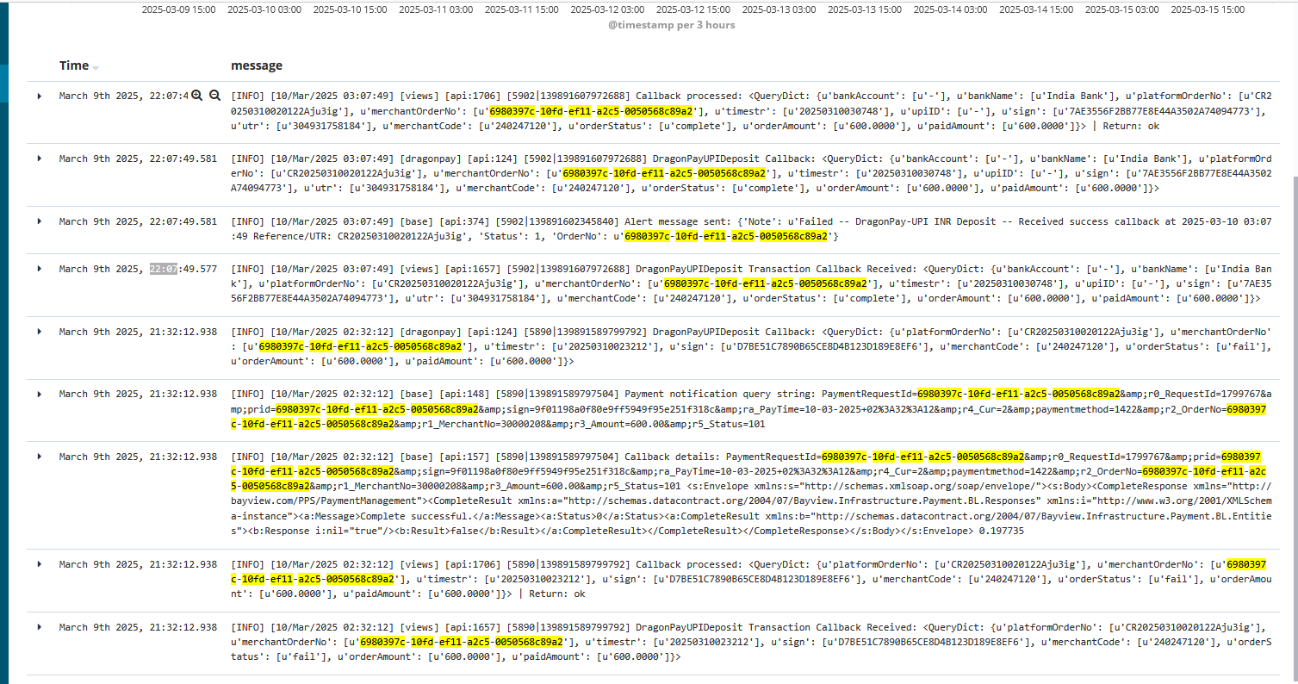

The above log showcases 2 fundamental issues that might affect transactions  
  
**1**. 3rd Party sends a second callback after sending an initial terminal status(Failed Status).  
In this case, JPay’s logic does not update the second status which might cause a mismatch of status between 3rd party BO and Taurus .  
  
**Recommendation:**  
Both Jpay and Business operations should look into this issue to see how to handle any subsequent callback after the initial failed status  
  
**2**.As per the above log, the 3rd party had two fields mapping different Reference/UTR number  
In this case JPay had to reconfigure the right field to map the UTR numbers.  
  
**Recommendation:**  
Follow up with 3rd Party to make sure the correct fields are mapped as per the documentation.

To prevent this, we are currently doing UAT for any new PSPs to ensure correct mapping

**3**. [[ITSM-146102] P2 | HTPay-Netbanking Mobile Mismatch Status Transactions - Jira](https://asianlogic.atlassian.net/browse/ITSM-146102)  
HTTPSConnectionPool(host='jpay-ppsws.elysium-dfbt.com', port=443): Max retries exceeded with url: /PaymentManagement.svc (Caused by ConnectTimeoutError(<urllib3.connection.HTTPSConnection object at 0x7f66ec3cc290>, 'Connection to jpay-ppsws.elysium-dfbt.com timed out.'))  
  
  
[[ITSM-145391] P1 | Payrush Mismatch Status Transactions - Jira](https://asianlogic.atlassian.net/browse/ITSM-145391)  
HTTPSConnectionPool(host='[jpay-ppsws.elysium-dfbt.com](http://jpay-ppsws.elysium-dfbt.com/)', port=443): Read timed out.

On the above 2 Issues, we had a mismatch of status due to a connection timeout between JPay and Taurus. Investigation is still ongoing to check the system responsible for the timeout issue, hence affecting a number of transactions.  
  
**Recommendation:**

Investigation between Jpay and Taurus connection to identify the root cause of the time out issue and how best to monitor and prevent it from recurring.