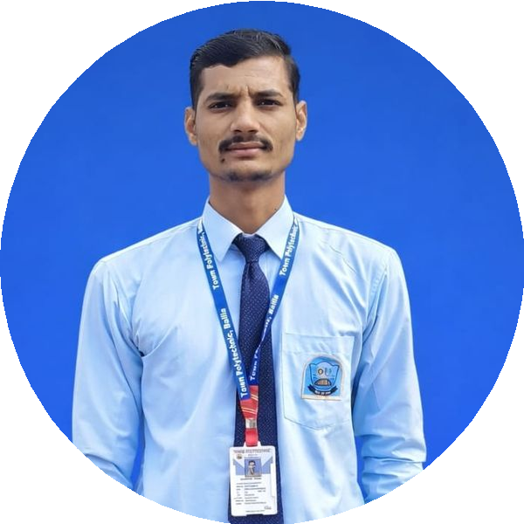
Rambabu Yadav
Automobile/Mechanical Engineering

​ ¦91 7007847540
@ rambabuy2002@gmail.com
​ LinkedIn/Portfolio
9 Ballia, Uttar Pradesh, India

SUMMARY
I am a passionate and diligent Polytechnic student pursuing a Diploma in Automobile/Mechanical Engineering. I seek an internship or entry-level opportunity to apply my technical knowledge and practical skills, contributing to organizational goals while gaining hands-on industry experience

EDUCATION

Diploma - Automobile/Mechanical Engineering

Town Polytechnic -68%
05/2023 - 05/2026

Higher Secondary Certificate-PCM

L D I C Sitaram Nagar Shobha Chhapra- 50.8%
06/2020 - 05/2022

Secondary School Certificate

L D I C Sitaram Nagar Shobha Chhapra- 61.8%
05/2020 - 06/2022

SKILLS

Mechanical Tools:

Vernier Caliper Micrometer Torque Wrench

Design Software:

AutoCAD CATIA SolidWorks

Other Skills

Microsoft Word Excel PowerPoint

EXPERIENCE

Mechanical Engineering Intern

G.B. Automobiles
07/2025 - 07/2025 Ballia, Uttar Pradesh
Automobile service workshop
- Completed an internship as part of the academic curriculum
- Gained hands-on exposure to automobile servicing and maintenance operations
- Learned basic automobile diagnostics, repair procedures, and workshop practices
- Worked under departmental supervision and followed safety and operational guidelines
- Demonstrated punctuality, sincerity, and adaptability during the training period

LANGUAGES

ENGLISH
Intermediate

www.enhancv.com

HINDI
Native

BHOJPURI
Native

Powered by ​

